TBN

Solution Architecture Description

Contents

2 Document 1

2.1 Section Synopsis 1

2.2 Version, Consultation, Distribution, Review & Approval Schedule 1

2.3 Document Purpose 1

2.4 Document Conventions & Standards 1

2.5 Document Length (TLDR) 1

2.6 Documentation Location 2

2.7 Document Structure 2

2.8 Document Terminology 3

2.8.1 Business Terminology 3

2.8.2 IT Terminology 4

2.9 Related Document Context 5

3 Business Context View 7

3.1 Section Synopsis 7

3.2 Problem Description 7

3.3 Background Summary 7

3.4 Analysis 7

3.4.1 SWOT 7

3.4.2 Business Goals & Objectives, Strategies & Tactics (GOST) 7

3.5 Strategic Alignment 7

3.6 Business Requirements 8

3.7 Scope Exclusion 8

3.8 Stakeholder & Responsibility Context 8

3.9 Schedule Context 9

3.10 Business Constraints Context 10

3.10.1 Laws & Regulations 10

3.10.2 Agreements 10

3.10.3 Organisation Principles 12

3.10.4 Project Principles 12

3.11 Assumptions 12

3.12 Risks 13

3.13 Deliverables 13

3.13.1 Principled Behaviour and Decisions 13

3.13.2 Lifecycle Process over Product 14

3.14 Governance 14

3.15 Business Decisions 14

3.16 Motivational Context 15

3.17 Systems 15

4 Architectural Forces 16

4.1 Section Synopsis 16

4.2 Services and Systems 16

4.3 Architectural Constraints 16

4.4 Architectural Principles 16

5 Architectural Views 17

5.1 Standard Architectural View Descriptions 17

6 System Context View 18

6.1 Section Synopsis 18

6.2 Legal, Regulation & Agreements Context 18

6.2.1 Principles 18

6.3 Sector, Partner, Organisation System Context 18

6.4 Technical Platform Options Considered & Preferred 18

6.4.1 Options Considered 18

6.4.2 Custom Ad-hoc development 19

6.4.3 Reusable Base development first 19

6.4.4 Preferred Option 19

6.5 Domain Context 19

6.6 System Integration Context 21

6.7 Hosting Environment Context 21

7 System User View 22

7.1 Section Synopsis 22

7.2 User Access 22

7.3 User Capabilities & Universal Design 22

7.3.1 Risks 23

7.4 Access Goal Schedule 23

7.4.1 Access by Voice Devices 24

7.4.2 Easier to comprehend content 25

7.4.3 More equitable distribution of Service via lower cost devices 25

7.5 User Characteristics 25

7.6 Individual User Focused 26

7.6.1 Individual Access Context 27

7.7 User Group 27

8 Resource View 29

9 Delivery View 31

9.1 Section Synopsis 31

9.2 Deliverables 31

9.3 Software Development Life cycle 31

9.3.1 ISO-15288 32

9.3.2 Traditional 32

9.3.3 ISO-29110-4-4 & 4-5 Agile & Agile DevOps Life cycle 33

9.4 Risks 34

9.4.1 Risk Register 34

9.4.2 Categories 34

9.4.3 Risks to consider 35

9.5 Reporting 35

9.6 WorkItem Management 35

9.6.1 Waterfall Model versus Agile Model 36

9.6.2 Agile 37

9.7 Application Lifecycle Management Service (AML) Suite 38

9.7.1 Work Item Management Service 39

9.7.2 Agile WorkItems (Epics, Features, User Stories). 39

9.7.3 User Stories 40

9.7.4 Documentation Management Service 41

9.7.5 Source Code Management Service 41

9.7.6 Build & Deployment Pipeline 41

9.7.7 Related Documents 41

9.8 Capability 42

9.9 Deliverables 42

10 Requirements View 45

10.1 Section Synopsis 45

10.2 Source of Requirements 45

10.3 Standards 46

10.4 SMART Objectives 46

10.5 Levels Used 47

10.6 Volatility of Requirements 47

10.6.1 Changes 47

10.6.2 New Requirements 48

10.7 Associated Documents 48

11 Service Information Model View 49

11.1 Section Synopsis 49

11.2 Service Network Information Sets 49

11.3 Service Lifecycle Information Types 50

11.4 Service Lifecycle Information Stages 50

11.5 Information System Information Types 51

11.6 Entity Relationship Model (ERM) Diagrams 52

11.6.1 Overall 52

11.6.2 System Module Management 54

11.6.3 Diagnostics Management 55

11.6.4 Error Management 55

11.6.5 Disclosure and T&C Management 55

11.6.6 Settings Management 55

11.6.7 System Status Management 56

11.6.8 Session Management 56

11.6.9 User Management 57

11.6.10 Identity Management 58

11.6.11 Access Management 59

11.6.12 Notification Management 60

11.6.13 Group Management 60

11.6.14 Organisation Management 60

11.6.15 Resource Collection Management 60

11.7 Resource Lifecycle Management ERM Diagrams 61

11.7.1 High level ERM 61

11.7.2 XXX 65

11.7.3 YYY 66

12 Service Messages View 67

13 Service Information Development View 70

13.1 Synopsis 70

13.2 Qualities 70

13.3 Metadata 71

13.4 Processes 71

13.5 Intellectual Copyright Types 71

13.6 Custom Access & Usage Terms & Conditions 71

14 Service Qualities View 72

14.1 Section Synopsis 72

14.2 Qualities versus Non-Functional Requirements 72

14.3 Constraints 72

14.3.1 ISO-25022:2016 72

14.3.2 ISO-25012 72

14.3.3 ISO-25010 73

14.4 Security Qualities 73

14.5 Functionality Qualities 74

14.6 Usability Qualities 74

14.7 Compatibility Qualities 75

14.8 Reliability Qualities 76

14.9 Performance Qualities 77

14.10 Maintainability Qualities 77

14.11 Portability Qualities 78

14.12 Supportability Qualities 78

15 Service Functionality View 80

15.1 Section Synopsis 80

15.2 Overview 80

15.3 System Management Functionality 80

15.3.1 High Level System Information Management Groups 80

15.3.2 System Configuration Management Operations 81

15.3.3 System Mutable Configuration Management Operations 85

15.3.4 System Module Management Operations 86

15.3.5 System Module Permissions Management Operations 86

15.3.6 System Diagnostics Management Operations 87

15.3.7 System Information Management Operations 88

15.3.8 System Error Management Operations 89

15.3.9 System Status Management Operations 90

15.3.10 Session Management Operations 91

15.3.11 System Authorisation Management Operations 91

15.3.12 System Authentication Management Operations 91

15.3.13 System Auditing Management Operations 91

15.3.14 System Search Management Operations 91

15.3.15 System User Management Operations 92

15.3.16 Notification Management Operations 93

15.3.17 Group Management Operations Organisation Management Operations Group Role Assignment Operations 94

15.3.18 Media Resource Management Operations 94

15.3.19 Media Resource Role Assignment Operations 94

15.3.20 Reporting Operations 94

15.3.21 Monitoring & Alerting Operations 94

15.3.22 Dashboard Management Operations 94

15.4 Media Management Functionality 95

15.4.1 High Level Overview 95

15.4.2 Media Metadata Functionality 96

15.4.3 Media Validation Functionality 97

15.4.4 Media Feedback Validating Functionality 97

15.4.5 Media Semantic Structure Enforcement 97

15.4.6 Media Association Functionality 98

16 Service Workflows View 102

16.1 Section Synopsis 102

16.2 Command Queue 102

16.3 Async Operations 102

16.4 Batch Operations 102

16.5 System Workflows 102

16.5.1 Onboarding 103

16.5.2 Group Membership Invitations Workflow 103

16.5.3 Develop & Publish Parent Group (or Organisation) Terms & Conditions 104

16.5.4 System Notification Publishing 105

16.5.5 Parent Group (or Organisation) Notification Publishing 106

16.6 Media Management Workflows 107

16.6.1 Media States 107

16.6.2 Media Development Workflow 107

16.6.3 Resource Approval Workflow 108

16.6.4 Collecting Resource User Voice 110

16.6.5 Using Resource User Feedback 111

17 Service Integration View 112

17.1 Section Synopsis 112

17.2 Integration Authentication Patterns 112

17.3 Constraints 113

17.3.1 Integration Principles 113

17.4 Protocols 114

17.4.1 ISO-27001 Stage 2+ Physical Environment 116

17.5 Network 116

17.6 Message 116

17.7 Service Devices 116

17.8 Components 116

17.9 Services 116

17.9.1 Storage Services 118

17.9.2 Caching Service 118

17.9.3 Notification (SMTP) Service 118

17.9.4 Identity Service 118

17.9.5 Malware Detection Service 118

17.9.6 Search Service 118

17.10 Enterprise Services 119

17.10.1 Analysis & Reporting Database Development 119

17.10.2 Data Warehouse 120

17.11 Integration Schedule 121

18 Service Interoperability View 123

18.1 Section Synopsis 123

18.2 About APIs 123

18.2.1 Service Façade 123

18.2.2 Web based APIs 123

18.2.3 Service Web Redirection 123

18.2.4 Service DTOs 123

18.2.5 Service DTO Security 124

18.2.6 Service Versioning 124

18.2.7 Service Information Queryability, Selection, Projection and Paging 124

18.2.8 Service Headers 124

18.2.9 Service Discoverability 124

18.2.10 Modular APIs 124

18.3 Base Module REST APIs 125

18.3.1 Diagnostics Management Service Facade API Schema 125

18.3.2 Error Management Service Facade API Schema 125

18.3.3 Session Management Service Facade API Schema 126

18.3.4 Session Operations Management Service Facade API Schema 126

18.3.5 Tenancy Management Service Facade API Schema 127

18.3.6 Group Management Service Facade API Schema 127

18.3.7 Organisations Management Service Facade API Schema 128

18.3.8 Member Management Service Facade API Schema 128

18.3.9 [Origin] Country Management Service Facade API Schema 129

18.3.10 Parent Group Role Management Service Facade API Schema 129

18.3.11 Data Category Management Service Facade API Schema 130

18.3.12 Notification Type Management Service Facade API Schema 130

18.3.13 Notification Management Service Facade API Schema 131

18.3.14 Invitation Management Service Facade API Schema 131

18.3.15 Search SynopsisItem Service Facade API Schema 132

18.4 Media Functionality Service Façade REST APIs 133

18.5 OCH Functionality Service Façade APIs 133

19 Service Deployment View 135

19.1 Section Synopsis 135

19.2 Environments 135

19.2.1 Common Resource Groups 136

19.3 Packages 137

20 Service Operations View 139

20.1 Synopsis 139

20.2 Project Documentation 139

20.3 Internal Corporate Registries 139

20.4 Operations Manual 139

20.5 Domain Name Service (DNS) 139

20.6 Host Environments 139

20.7 Key System components 139

20.8 Service Accounts 140

20.8.1 Deployment Service Account 140

20.8.2 Service System Service Account 140

20.9 Service Credentials 140

20.9.1 Certificate Development 140

20.9.2 Cloud Provider Services 141

20.9.3 3rd Party Services 141

20.10 Certificates 141

20.11 Infrastructure as Code 142

20.11.1 In Azure 142

20.11.2 In Amazon 142

20.12 Operating System and Execution Environment Patching 142

20.12.1 Azure 142

20.13 System Configuration 142

20.14 System Diagnostics Tracing 142

20.15 System Monitoring 143

20.15.1 Deploying to Azure 143

20.15.2 Deploying to Amazon 143

20.16 System Alerting 143

20.16.1 Deploying to Azure 143

20.16.2 Deploying to Amazon 144

20.17 Data Archiving 144

20.18 Reports 144

21 Service Security View 145

21.1 Section Synopsis 145

21.1.1 Overview 145

21.2 Behaviour 145

21.2.1 Non-Access to Production Data 145

21.3 Production Tools 146

21.4 Physical Environment Security 146

21.4.1 Confidentiality 146

21.4.2 Integrity 146

21.4.3 Availability 146

21.5 Network Security 147

21.5.1 Azure Cloud Service Network Environment Characteristics 147

21.5.2 Amazon Cloud Service Environment Network Environment Characteristics 147

21.6 Host Security 147

21.6.1 Azure PaaS Characteristics 147

21.6.2 Azure Container Characteristics 147

21.7 System Information Security 147

21.7.1 Confidentiality 147

21.7.2 Integrity 151

21.7.3 Availability 152

21.7.4 Data Classification 155

21.8 Roles to Permissions Schedule 156

22 Service Privacy View 157

22.1 Section Synopsis 157

22.2 Constraints 157

22.2.1 Regulation 157

22.2.2 Principles 157

22.3 Use Cases 157

22.3.1 Privacy & Minimum Data Collection 157

22.3.2 Privacy & Tracking Policy 157

22.3.3 PII & Analysis and Reporting Requirements 158

22.3.4 PII & Data Warehouse 158

22.3.5 PII & "Right to be Forgotten (R2BF)" Requests 158

23 Service Quality Assurance View 159

23.1 Section Synopsis 159

23.2 Background 159

23.3 Constraints 159

23.3.1 Testing Principles 159

23.4 Decisions 159

23.5 Technologies 160

23.6 Test Types 160

23.7 Best Practice 161

23.8 Test Data 162

23.8.1 Data Migration Testing 162

23.9 Process 162

23.10 Examples 164

23.10.1 Desires 164

23.10.2 Work Item 164

23.10.3 Acceptance Tests 165

23.11 Functional Testing 165

23.11.1 API Service Façades 165

23.11.2 Web User Interface 167

23.12 Quality Testing 167

23.12.1 Prioritization of Quality Testing 168

23.13 Summary 169

24 Service Data Storage Development View 170

24.1 Section Synopsis 170

24.2 Governance 170

24.2.1 Self-Governance 170

24.3 Technologies 170

24.3.1 Object/Relational Mapping (ORM) 170

24.4 Security 170

24.4.1 Service Account 170

24.4.2 Connection Strings 170

24.4.3 Security in Transit 171

24.4.4 Security at Rest 171

24.4.5 Database Backups and Restorations 172

24.4.6 XXXX: TODO 173

25 Service Development View 174

25.1 Section Synopsis 174

25.2 Governance 174

25.2.1 Self-Governance 174

25.3 Principled Design 174

25.4 Principled Development 174

25.4.1 Technical Decision Registry 175

25.4.2 Standards 175

25.5 Constraints 179

25.5.1 Regulations 180

25.5.2 Principles 180

25.6 Best Practices 180

25.6.1 Test Driven 180

25.6.2 Documented 181

25.6.3 Loose Coupling, High Cohesion 181

25.6.4 Real-time Notification over Delayed Batch notification 181

25.7 Protocols 181

25.8 Development Patterns 181

25.8.1 Pull-Requests 183

25.8.2 Verified Code Branch Integration 183

25.8.3 Automated Tests 183

25.8.4 Component Design Patterns 184

25.8.5 Object Oriented Development 188

25.8.6 SOLID Object Oriented (OO) Development Patterns 188

25.8.7 Test-Driven Development 189

25.9 Technologies 190

25.9.1 .NET Core Based Development 190

25.10 Stakeholders 190

25.10.1 Testers 190

25.11 Components 191

25.11.1 Packages 191

25.11.2 Classes 191

25.12 Security 191

25.12.1 Configuration Information 192

25.12.2 Service Integration Credentials & Key Vaults 192

25.12.3 In Transit 192

25.12.4 OWASP 192

25.13 API Development 192

25.13.1 API Versioning 192

25.13.2 Notification & Redirection 193

25.14 Services 193

25.14.1 Base Infrastructure Services 193

25.15 Service Façade 194

25.15.1 Base Module 194

25.16 Business Module's Service Facade 195

26 Service Client Development View 196

26.1 Constraints 196

26.1.1 International Standard Technologies and Protocols 196

26.1.2 Non-International Standard Technologies 197

26.2 Technologies 197

26.2.1 Accessibility Devices 197

26.2.2 Smallest Channel Device 198

26.2.3 Mobile Web Channel 199

26.2.4 Service Client Stack 199

26.3 Best Practices 200

26.3.1 MVC Pattern 200

27 Service Client User Interface Development View 202

27.1 Section Synopsis 202

27.2 Web Channel 202

27.2.1 Constraints 202

27.3 Web Channel Structure 202

27.3.1 Semantic Web 202

27.3.2 WAI-ARIA 203

27.3.3 Role HTML Attributes 203

27.3.4 ARIA Form Attributes 204

27.3.5 Combined Semantic and ARIA Example 205

27.3.6 Additional Information 206

27.4 Theming Framework 207

27.5 View Copy 207

27.5.1 Plain Language 207

27.5.2 Copyright Material 208

27.5.3 Localisation 208

27.6 View Framework 210

27.6.1 Angular 210

27.6.2 Vue.JS 210

27.6.3 React 210

27.7 Navigation 210

27.7.1 Action Based Design 210

27.7.2 View Flows 210

27.8 Security 212

27.8.1 In Transit 212

27.8.2 Cookies 212

27.8.3 Redirection 213

27.8.4 OWASP 213

27.9 Related Documentation 213

28 Service Client View Development View 214

28.1 Synopsis 214

28.2 View Types 214

28.3 Shell Container View 215

28.4 The Overlay Container View 215

28.4.1 Splash Screen View 215

28.4.2 Synchronous Flash Status View 216

28.4.3 Modal Confirmation View 216

28.4.4 Login Container View 216

28.5 Content Container View 216

28.6 Context Container View 217

28.7 Navigation Context View 218

28.8 Status Container View 218

28.8.1 System Status Output View 219

28.8.2 Tenant Status Output View 219

28.8.3 Organisation Status Output View 219

28.8.4 Group Status Output View 219

28.8.5 Operation Queue Status Output View 220

28.8.6 Operation Status Output View 220

28.9 Body Container View 220

28.10 Public Module Container View 221

28.10.1 Home Page View 221

28.10.2 Other Public Views 221

28.11 Base Module Container View 222

28.11.1 Diagnostics & Error Content View 222

28.11.2 Session Auditing Container View 223

28.11.3 System Container View 224

28.11.4 Settings Container View 225

28.11.5 Dashboard Container View 226

28.11.6 Search Container View 227

29 Service Client User Interface View Flow View 229

29.1 Dashboard View and Related Flows 229

29.1.1 Customizable Dashboard & Dashboard Tiles 230

29.2 Group View & Related Information Flows 231

29.3 Invitation of a Member to a Group Role 231

29.4 Editing Group Roles 232

30 Service Client User Interface Design View 234

30.1 Avoiding Delivery Risk 234

30.1.1 Identical displays are not an objective 234

30.1.2 Mobile Web Screen Size First 234

30.2 Action Driven 234

30.3 Action Copy 234

30.4 Behaviour 234

30.4.1 Scrolling 234

30.5 Colours 235

30.5.1 Colour Blindness 235

30.5.2 Colour Contrast 235

30.6 Images 235

30.6.1 Large images 235

30.6.2 Colourful background Images 236

30.7 Icons 236

30.7.1 Single Tone, Outline Icons 236

30.7.2 Fonts & Vector based Icons 237

30.8 Space 238

30.8.1 Wasted Space 238

30.8.2 Effective Space 238

31 Appendices 239

31.1 Section Synopsis 239

31.2 Document 239

31.2.1 Document Conventions 239

31.2.2 Document Structure 239

31.2.3 Document Audience 239

31.2.4 Document Asides 240

31.2.5 Document Formatting Conventions 241

31.3 Project 241

31.3.1 Background History (Extended) 241

31.4 Acronyms & Terms 241

31.4.1 Terms 241

31.4.2 Mōari Terms 244

31.4.3 Acronyms 248

31.5 Risks 250

31.5.1 Direction 250

31.5.2 Delivery 250

31.5.3 Discovery 250

31.5.4 Definition 251

31.5.5 Design 251

31.5.6 Development 251

31.5.7 Quality Assurance 251

31.5.8 Deployment 251

31.5.9 Support 251

31.5.10 Operations 251

31.5.11 Maintenance 252

31.5.12 Decommissioning 252

31.6 Principles 252

31.6.1 Summary of Principles Applicable to NZ National Services 252

31.6.2 NZ Privacy Principles 252

31.6.3 NZ Specific - Digital Standards Principles 253

31.6.4 NZ National Service Specific – Digital Service Design Standards Principles 253

31.6.5 NZ National Service Specific – Data and Information Management Principles 254

31.6.6 NZ MOE Enterprise Design Principles 255

31.6.7 Universal Design Principles 256

31.6.8 Organisation Principles 258

31.7 Delivery Methodologies 267

31.7.1 Comparison of Methodologies 267

31.7.2 Agile 268

31.8 Requirements 269

31.8.1 Functional Requirements 269

31.8.2 Quality Requirements 270

31.9 Required Effort expressed as Work Items 272

31.9.1 Delivery Service 272

31.9.2 Information Service 272

31.9.3 Service Client 273

31.9.4 Epics 276

31.9.5 Features 277

31.9.6 Tasks 279

31.10 Development 279

31.10.1 Integration 279

31.11 Integration 282

31.11.1 Security 282

# Document

This section of the document describes the history, conventions and structure of the rest of the document.

## Section Synopsis

This document follows industry standards to describe a complex model of an project in multiple views for review by domain specialists prior to committing development resources.

## Version, Consultation, Distribution, Review & Approval Schedule

* Version 0.1: 5 Aug 2010, Draft

## Document Purpose

The purpose of a SAD is to diminish the risk of non-delivery of the expected service & system outcomes of a project.

Risk is reduced by making available to domain specialists a common resource to review, raise concerns before work commences, avoiding later re-litigation or mistakes from lack of forethought and review.

Risk is further reduced by maintaining this resource up to date to provide different stakeholder groups current trustable reviewed instructions.

## Document Conventions & Standards

This document uses ISO specified industry conventions and standards for structure, notation, diagrams and delivery approach.

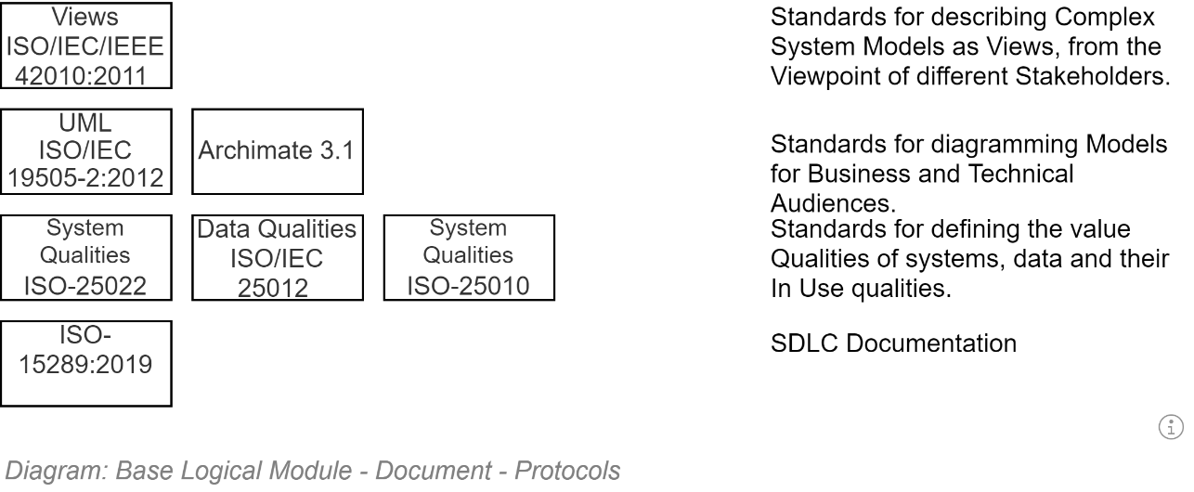

**Note:**  
ISO:42010:2011 specifies that complex systems – such as the system described within this description document – are described in a series of Views (in other words, chapters) from the perspective of different Stakeholders.   
In this document, Views / Chapters have been developed to address concerns of Stakeholders interested in Organisation Strategy, Business Services, Security, Privacy, Information, Development, Infrastructure, Deployment, Communications, etc.

## Document Length (TLDR)

*“It’s too long!”*

As described in the next section, the document is not meant to be read in its entirety by any stakeholder group – including reviewers.

It is not a novel. Nor a summary. It is a manual to reduce unnecessary risks to deliver a software project.

There is duplication between view sections, as information relevant to one stakeholder group may be also relevant to another stakeholder group.

The S in the title stands for Solution – not Short. Its length should be the length necessary to decrease the risk of misunderstanding how to implement the Solution. Depending on the project, it can get long[1].

**Warning**  
Writing a shorter presentation summary description document may produce something that is easier to carry around. But would be insufficient to demonstrate two key aspects:   
- whether sufficient thought was invested in discovering and designing for the interaction between different systems and stakeholders  
- whether sufficient thought has been invested in addressing common project risks and defining controls and mitigations to not expose the project and its stakeholders to unnecessary risk of failure.

## Documentation Location

This manual’s contents would be best served being hosted as a publicly accessible project wiki, ensuring stakeholders can find, access and keep current its contents.

## Document Structure

Solution Architecture Descriptions (SADs) are generally too large to be effectively read in their entirety by all stakeholders.

As per ISO 42010:2011 this SAD is divided into different sections (“Views”) for review and reference by different stakeholder groups.

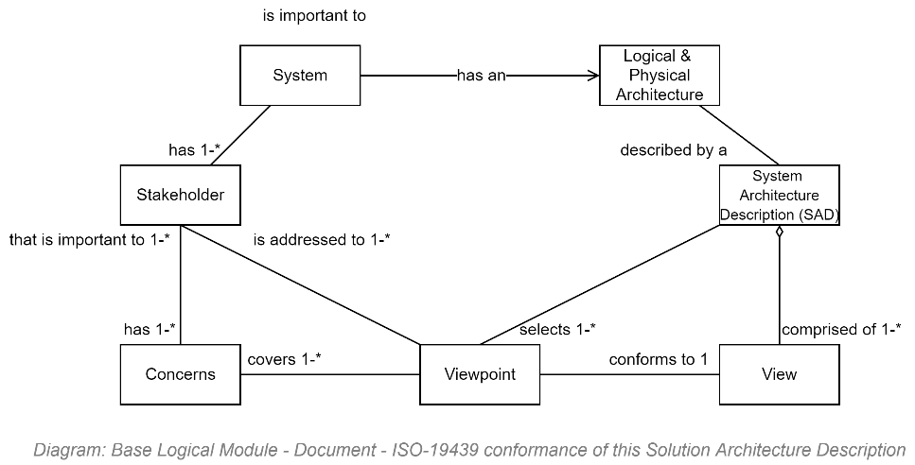

The sections are divided to answer the concerns from different perspectives.

Standard Key Views include but are not limited to:

* A **Strategic & Business Context View**, addressing the system’s strategic expected value
* A **System Context View**, addressing where the system is within existing systems
* A **System User Context View**, addressing who can access the system
* A **System Information View**, addressing the types of information the system manages
* A **Requirement Definition View**, addressing how stakeholder desires are captured as Work Items.
* A **Security View**, addressing how the systems key asset – it is information – is protected
* A **User Privacy View**, addressing concerns about system user privacy.
* A **Functionality View**, addressing the functionality developed to change the information
* A **System Qualities View**, answering what level of quality to expect of the system
* An **Integration View**, addressing how the service will be integrated & reuse other services
* A **Deployment View**, addressing how the service will be delivered to target host devices
* A **Testing Definition View**, addressing how the system’s qualities & functionality targets are defined as testable outcomes
* A **Development View**, addressing how the test targets are automated and then system is developed to meet the automated test targets
* Etc – dependent on the project.

## Document Terminology

Below are listed a minimal preliminary selection of terms that may facilitate reading of this document.

  
**Note:**  
the appendices provide a more complete listing of terms.

### Business Terminology

TODO: Suggestions:

* Business Capability
* Business Service
* Business Function
* Business Process
* RASCI: Responsible, Accountable, Supporting, Consulted, Informed.   
  CRIMEAS is a similar acronym standing for: Consulted, Responsible, Informed, Managing, Everyone else, Accountable, Supporting.
* Role: a logical assembly of Responsibilities and Permissions, which are conferred on one or more Persons within a purposeful Group of persons.
* Stakeholder: an RASCI member of a purposeful Group of Persons.
* Steward: acting on behalf of an Owner, has the same responsibilities and opportunities as an Owner, bar the Accountability.
* Owner: the single Accountable person.

### IT Terminology

* **Agile [delivery methodology]:** a respected approach to technology delivery at pace by experienced resources working together with minimal planning, oversight & documentation overhead. The methodology emphasises rapid and iterative delivery of change for user stakeholders to respond as quickly as possible, informing future development direction decisions.  
  It is a core concept of the more mature and complete DevOps and SecOps delivery methodologies.   
  See *MVP*.

 **Warning:**  
  
Agile does not mean system development must be begun immediately at the expense of planning in order to get something in front of stakeholders.   
  
The first iterations are used to set up an online project collaboration space, where project documentation -- including this manual -- are available to all stakeholders. This project space is the first service lifetime **deliverable**.  
  
The next iterations should be a used to develop a bare-bones, “just-enough”, achievable, technical design for review and consensus by appropriate stakeholders before starting. Such a technical design roadmap, although not the final information service itself, **is also a deliverable**.  
  
The next iteration(s) are used to focus on developing an automated test and delivery pipeline**.** This too **is a deliverable**.  
  
Only after the above deliverables are well on their way, start iteratively delivering the next deliverable -- the information service itself.  
  
Finally, when the backend service is starting to expose usable APIs, start developing the final deliverable – the service client user interface.   
  
**Important:**  
Whatever you do, don’t start from the interface (that’s akin to designing a car starting with the panelling, expecting it to be a good source of information on which to design the internal engine).

* **Domain**: an area of specialised knowledge.   
  Generally used to keep separate and solve business domain independently from technology domains. All IT systems are the merging of several different domains, including the following common distinct domains: Business, (Business Information and Business Processes), Users & Group management, User Support, Technology Automation & Integration, and Security, Privacy & Accreditation.
* **Domain Driven Design**: a system design approach to developing systems to equally meet the domain requirements of multiple stakeholder groups. The alternative is addressing one group above others (e.g.: Business, or IT) making it difficult for other stakeholder groups to assist with providing value to users.
* **MVP**: Minimal Viable Product. Due to misunderstanding and/or misapplying Agile methodology concepts too often ends up instead becoming an outcome demonstrating “*Missing Valuable Planning*”.
* **DevOps**: a more holistic approach to technology delivery which also addresses ongoing operational needs and the collection of feedback to inform ongoing iterative development and delivery of changes to better meet expectations and changing circumstances.   
  See *SecOps*.
* **SecOps**: a delivery methodology: an enhancement of DevOps, emphasising the Security, Privacy and optionally Accreditability of every system delivery.
* **Test Driven Development**: an approach to development which emphasises Test Analysts defining automatable test conditions to prove work item objectives are being met.

## Related Document Context

This document relies on other artefacts.

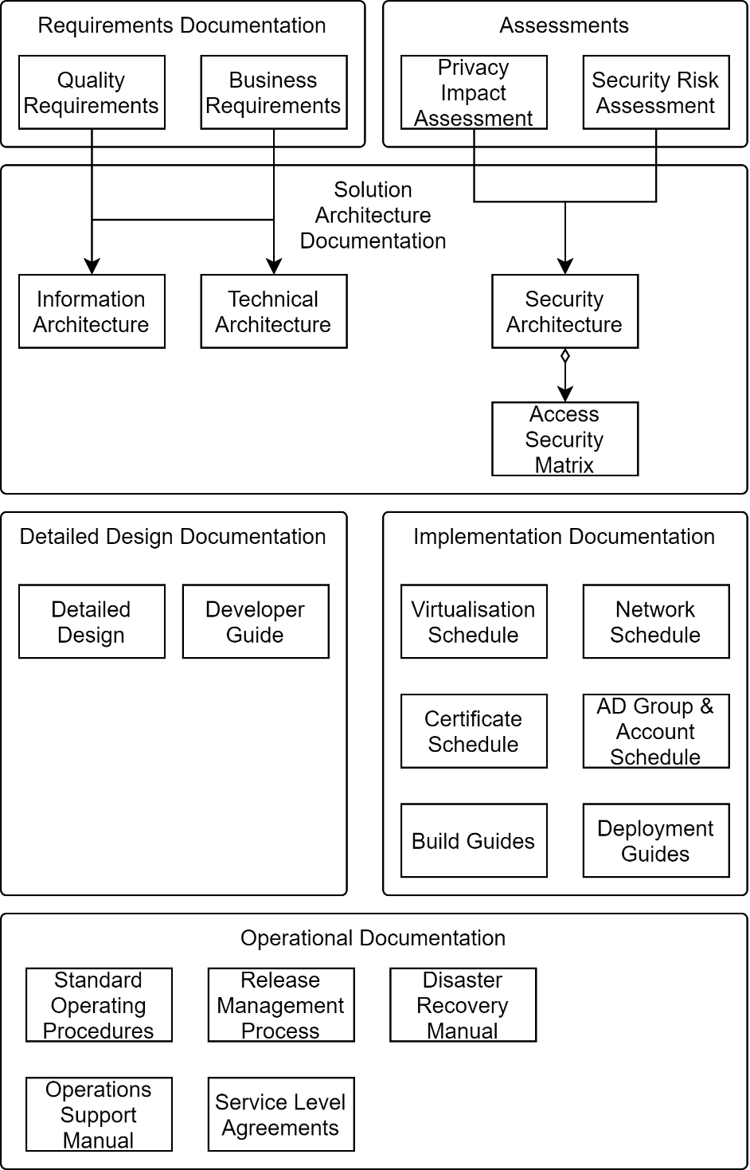

* Delivery Service SAD.

This document is foundational to business specific, light SADs.

# Business Context View

The purpose of this section is to summarize a problem being addressed and the proposed solution, traced to motivational stakeholders and their concerns.

## Section Synopsis

TODO:

## Problem Description

As per the Assessments below

## Background Summary

TODO: Summarize the background.

Note:  
The Appendices provides a longer explanation of prior history.

## Analysis

### SWOT

TODO:

### Business Goals & Objectives, Strategies & Tactics (GOST)

TODO:

## Strategic Alignment

Deliver to the Ministry of Education Four Year Plan 2016-2020:

Better targeting of investment, resources, support and expertise to drive innovation and improve results

Deliver on our intentions to deliver to business the means to:

* + 1. “Provide tailored services to support and to raise achievement”
    2. “Invest more effectively to raise achievement”

By putting in place stated enabling conditions that are required to be in place first:

* + 1. “Information technology”.

Deliver to Government’s ICT 2017 Strategy and Action Plan:

Support for “Better public services – Result 9 “Better for Business is making it easier for business customers to deal with Government”

Support for “Better public services – Results 10 “New Zealanders can complete their transactions with government easily in a digital environment”

* + 1. Deliver to the Integrated Work Programme to support the Government ICT Strategy:

Removing barriers to the adoption of cloud services

Development of infrastructure and capability to produce new insights to improve government services and to inform government policy and investment

Ensuring that ICT investments are targeted to support digital services, and that benefits are realised

## Business Requirements

Business Requirements clarify how the Solution is to meet the Goals and Objectives, are summarized below:

## Scope Exclusion

TODO: Scope Exclusions.

Excluded from this project is:

* Content Migration

## Stakeholder & Responsibility Context

The following primary and supporting Stakeholders have been identified as having relevant Concerns addressed by the Solution:

TODO

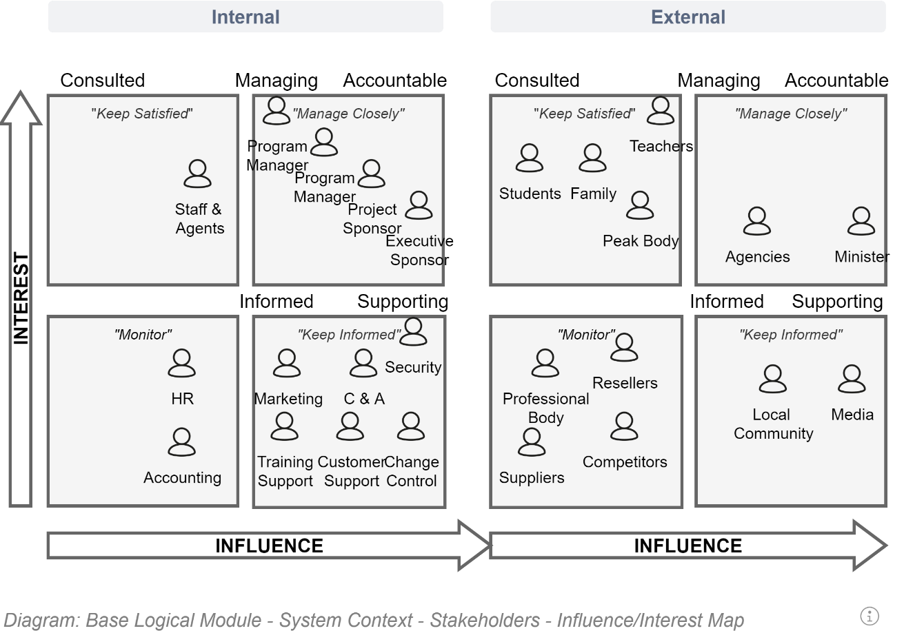

An alternate layout of the much of the information available in the above map is presented below:

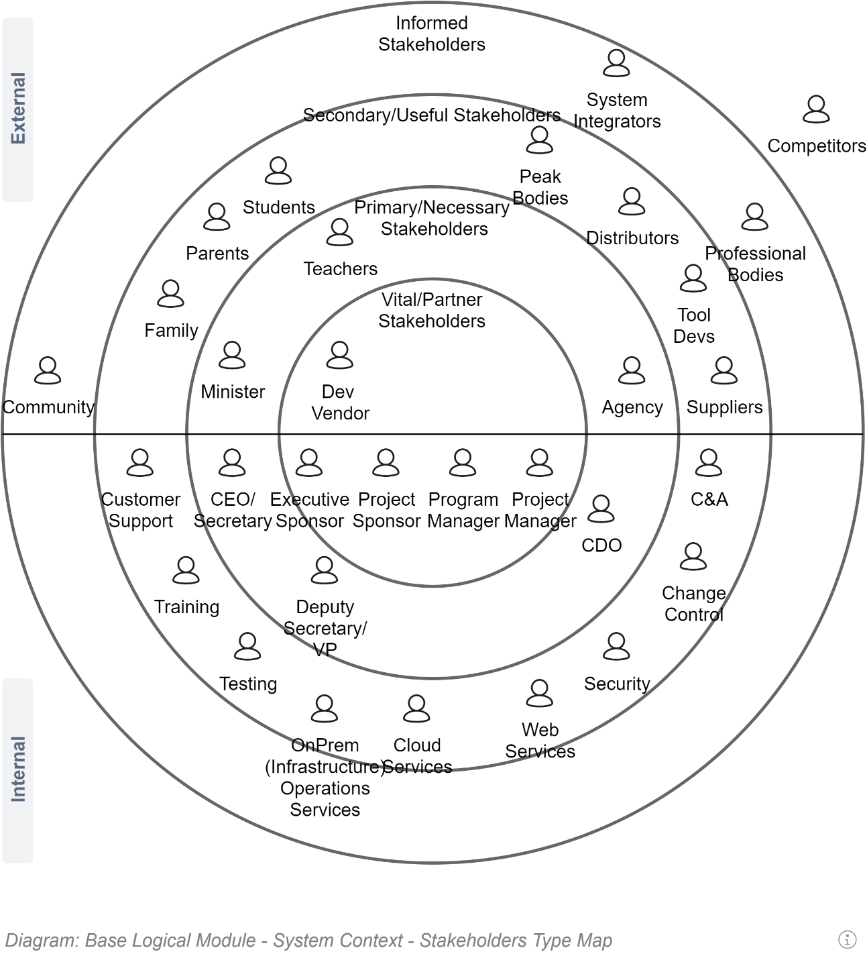

## Schedule Context

TODO: Describe schedule as to when to expect the following, approximately.

* Business Case
* RFx review
* Requirements Gathering
* Solution Architecture Description
* Technical Designing
* Certification & Accreditation
* MVP
* Feedback driven changes
* Ongoing Operations
* TODO

## Business Constraints Context

Systems are simply the automation of tasks that must be implemented in a legal manner. As such, the following laws and regulations apply.

### Laws & Regulations

To meet public expectations, the system will only be accreditable if it meets obligations, including but not limited to:

* **The Public Records Act**, which mandates public sector entities maintain full, accurate and accessible records.
* **The Official Information Act**, which mandates facilitating the public right of access to information held by a public sector entity.
* **The Privacy Act** which governs how all individuals and organisations collect, use, disclose, store and give access to personal information (PI).

In addition to the above legislation already in effect, the following initiatives have a high chance of taking effect (and are worth aiming for anyway).

* **Accessibility for New Zealanders Act**

  
**Note:**  
in the meantime, both the NZ Government Web Accessibility Standard and NZ’s being a signatory of the United Nation’s (UNs) Convention on the Rights of Persons with Disabilities remain in effect for all public sector entities and their web supported services.

### Agreements

Whereas some constraints are enforceable laws and regulations, some constraints exist due to previous agreements with other persons or organisations.

As a Government Agency we are by default bound to apply a small set of principles which have been mandated to all government agencies. These are listed below.

As a system within an organisation, the project is by mandated to adhering to organisation specific principles. These are listed after the AoG Principles.

#### Guiding Principles

The Projects and goals and objectives are to be achieved in a Principled manner.

The business domain of this service is mandated to adhere to All of Government (AoG) principles:

* Privacy Principles
* Digital Service Design Standards
* Digital Data and Information Standards

Specific to IT based services the following apply:

* Digital Standards

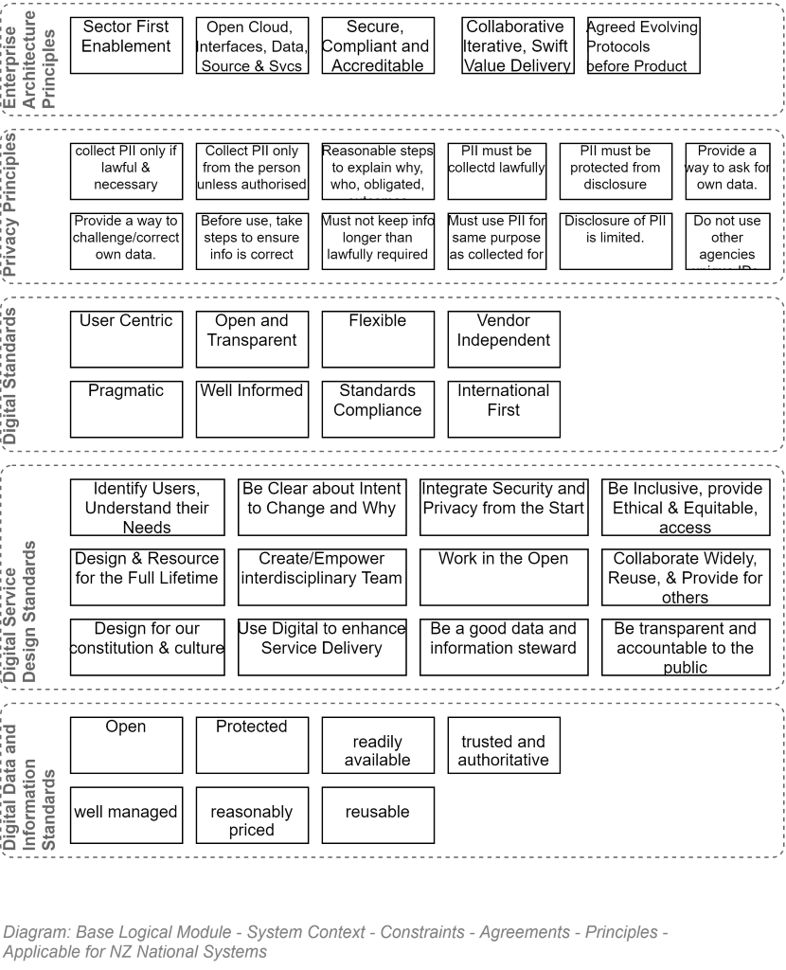

  
**Note:**  
The appendices include high-level descriptions of each of the above Principle sets’ sub aspects.

### Organisation Principles

In addition to the above AoG[2] Principles, this solution is guided by this organisation’s Principles which cover key concepts of Purpose, Safety, Transparency, Reuse, Delivery

They are, namely:

* **Sector First** (versus internal only)
* **Open Cloud, Interfaces, Data, Source and Sync**, ensuring that effort is applied to ensure all information, unless it contravenes the Privacy Act, is to be made available to stakeholders who paid for it (the taxed public).
* **Secure, Compliant & Accredited**, ensuring that the system remains available while being actively maintained to improve over its service lifetime, all while keeping it always within its legal obligations to protects their personal information which they entrusted to the service.
* **Collaborative, Iteratively, Swift, Delivery of Value**, ensuring that a valued service is made available for secure use as soon as available – but on a sound design foundation! – by following a DevOps or SecOps methodology.

### Project Principles

In addition to both the AoG and organisation’s principles, this solution is guided by this specific project’s Principles:

* **[Delivery] Pipeline First**: the primary deliverable is not the Service system – it is the automated pipeline that can deploy a fully configured service system to a designated target environment.
* **Security First:** there is absolutely no benefit from providing an information service that is insecure in transit or at rest.
* **Web Interface API First**: design the service to be delivered to users via distinct Service and Client Tier, with the interface Tier consuming the Service’s APIs. This ensures that all APIs needed by a 3rd party provider are available to develop a new interface or additional functionality.
* **Multiple Channels:** design to store structured information -- separate from display formatting – to later project the information via different channels (API, screen, print, voice) as needed.
* **Accessible, Universal Design First:** we are all only temporarily enabled.
* **Smallest Visual Interface First**: design for delivery via the smallest web interface first, so that it is succinct and fits while being easily understandable and actionable while concentrating on other tasks (e.g.: walking).
* **Succinct, Summarized, Actionable, Forgiving, Views First**: design interfaces to facilitate quicker understanding and actioning the view’s intended primary action.
* **Forgive First:** allow users to make mistakes and learn, as all Operations should be undoable.

## Assumptions

Organisations are constantly in flux. Decisions are required to be made while information is not available or can be verified.

Decisions are made on the basis of the following assumptions.

ASS-0001: Azure Service continues to meet the Organisation’s C&A requirements.

Note:   
Microsoft

* holds several current accreditations[3]: ISO-27001, ISO-27018 Certifications
* undergoes SOC1 and SOC2 reporting of the Azure platform,
* has FedRAMP Authority to Operate (includes Azure AD),
* has Australian Government Information Security Registered Assessors Program (IRAP)
* Singapore Multi-Tier Cloud Security (MTCS) granted to Azure’s Datacentres, O365, Azure AD, and Azure.

ASS-0002: Near-Shore cloud storage remains acceptable for Data classified as SENSITIVE.

ASS-0003: The organisation will be capable of providing a partner and client accessible OIDC compliant authentication service of some kind.

## Risks

* **Unprincipled Decisions:** An inability to deliver in a Principled manner, preferring achieving tactical wins devoid of strategic value. Namely, focusing on the wrong deliverable (see Deliverables), not adhering to defined Obligations and Agreements, or avoiding the use of one or more of the above listed AoG, Organisation or Project Principles.
* **Inappropriate Platform:** the choice of an inappropriate foundation (e.g.: a customized commodity cloud service for client facing services) will put the delivery of this project at risk.

## Deliverables

The deliverables of the system are described in detail within the Delivery View.

### Principled Behaviour and Decisions

An important observation of the above deliverables list is the primacy of the Principles.

**Note:**  
Principles encapsulate decision making rules that have proven over time and many similar projects to produce correct outcomes. In most cases a group of individuals can rely on them, and in doing so can reduce the ratio of low value discussions as to which individual opinion is better.

Deviation from Principles is entirely possible but should not be taken lightly. Proposals to do so should be argued before governance boards and the decision outcome be recorded as a Project Decision.

### Lifecycle Process over Product

Another crucial observation of the above deliverables list is its complete reversal from many other IT projects which focus primarily -- if not solely -- on the last 2 deliverables (the service and its interface), and only maybe every getting to the other deliverables (delivery pipeline, documents, etc.) over time[4].

The reasons for the reversal are multiple:

* focus is always kept on the *whole* service lifespan (generally 7 years or more) – rather than just on the development period (e.g.: 1 year) and leaving the next 7 years to someone else’s problem. This holistic approach is in recognition that over the service lifespan the Product will requires ongoing support, changes, testing, and deployment.
* Resources leave. The knowledge developed by the resources that developed and tested the product will be lost when they leave. The most effective way to persist this IP is to encode it – in an automated pipeline – so that it provides an automated demonstration as to what is expected behaviour versus unexpected system behaviour.

## Governance

Strategic, technically, architecturally and/or cost relevant proposals are reviewed first by this project’s governance board. and then by this organisation’s appropriate governance boards.

Business and Technical/Architecturally relevant Decisions are recorded in the appropriate sections of this SAD.

## Business Decisions

* **Preferred Technical Platform Option:** the preferred option is accepted.

## Motivational Context

This Solution is a composed of Systems to provide Services to meet a certain number of Principled Goals defined to address Assessments *(*Problems*/*Opportunities*)* which impacted on Stakeholders and their Concerns (internal and external Drivers).

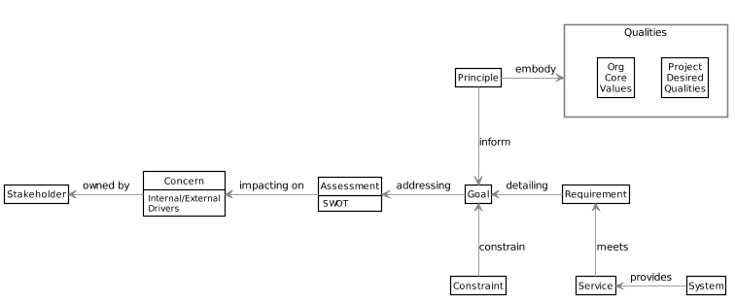

## Systems

The services defined above are met by the following Systems, which are described within this document.

# Architectural Forces

The purpose of this document section is to outline architectural forces – as to business forces outlined in the previous section – that underlined the design of the solution.

## Section Synopsis

## Services and Systems

## Architectural Constraints

The previous document section listed Constraints and limiting Decisions which impacted the Goals and informed the High-Level Business Requirements.

Below are listed Architectural and Technical Constraints and Decisions which limited architectural options.

* **TODO:** TODO

## Architectural Principles

The solution was developed to meet requirements to meet (business) *Principle*d (business) *Goals*.

The architecture itself of the solution was informed by a set of Architectural Principles.

These are listed below.

[](http://skysigal.com/lib/plugins/plantuml/img.php?width=0&height=0&title=PlantUML%20Graph&align=&version=2011-07-16&md5=d473b763638cb10ffdd81830827e9b31)

Core System Architecture *Principles* are:

* **TODO:** TODO

# Architectural Views

## Standard Architectural View Descriptions

The following sections outline this solution's system(s) in a series of industry recommended curated *views*.

[](http://skysigal.com/_media/resources/images/00/sad/views.png)

The Rozanski and Woods View/Viewpoint document structure describes the complexity of the solution's systems by describing in a series of curated views, prepared from the point of view – the viewpoint – of key stakeholders.

# System Context View

The purpose of this view is to describe the solution's context in terms of architecture, technologies and licenses – and the people, devices and systems it interacts with.

## Section Synopsis

Sandy inserted this dummy statement

## Legal, Regulation & Agreements Context

### Principles

## Sector, Partner, Organisation System Context

TODO

## Technical Platform Options Considered & Preferred

The solution

TODO

### Options Considered

#### Configurable Product or Service

Building upon a customisable cloud-based commodity service was considered.

**Analysis Summary:**  
Assuming accessibility obligations can be met, Internal and collaborator facing services are often best served by building upon readily available cloud-based commodity services (Microsoft Office 365 Suite, Google Apps, etc.) managed and supported by others for a service fee.

Configurable commodity services are most often *in-*appropriate for customer facing services for multiple reasons, including but not limited to:

* being unable to readily configure the solution to sufficiently differentiate oneself from competitors or the underlying commodity service,
* Being unable to be configured the solution to meet all obligations (the Official Information Act, The Public Records Act, The Privacy Act, etc.)
* being unable to configure the solution sufficiently for it to meet organisation-unique strategic objectives without assistance. This often leads to trying costly workarounds that often do not meet customer expectations in terms of usability, understandability, or service.
* In some circumstances being unable to be readily integrate with other organisation IT services. This can be due to an inability to replicate custom integration patterns, or an inability to work around missing application interfaces.

### Custom Ad-hoc development

Assembling a development team to follow an Agile approach to developing at pace a Minimum Viable Product (MVP) was considered.

**Analysis Summary:**  
The Agile methodology relies on certain conditions being adhered to improve the odds of successfully delivering to expectations.

* To minimise decision making drag, all stakeholders are expected to be skilled and experienced at software delivery and fluent in the specific business domain.
* The core of the system design is developed and documented first, to provide all stakeholders a collective understanding of the key functionality that needs to be developed, and how components will be assembled. The level of completion needed of the blueprints depends on the experience of the development stakeholders (developers, testers, etc.) and their experience working together. Development stakeholder group-based assessments of what needs to be developed to complete the system are invariably incomplete (100% or more off).
* It is my professional opinion that custom development projects run this way will fail in most cases and should be avoided.

In addition, being designed for a single business outcome, practically all of the solution’s components, tests, etc. will be unusable in any other context.

### Reusable Base development first

TODO

### Preferred Option

TODO

## Domain Context

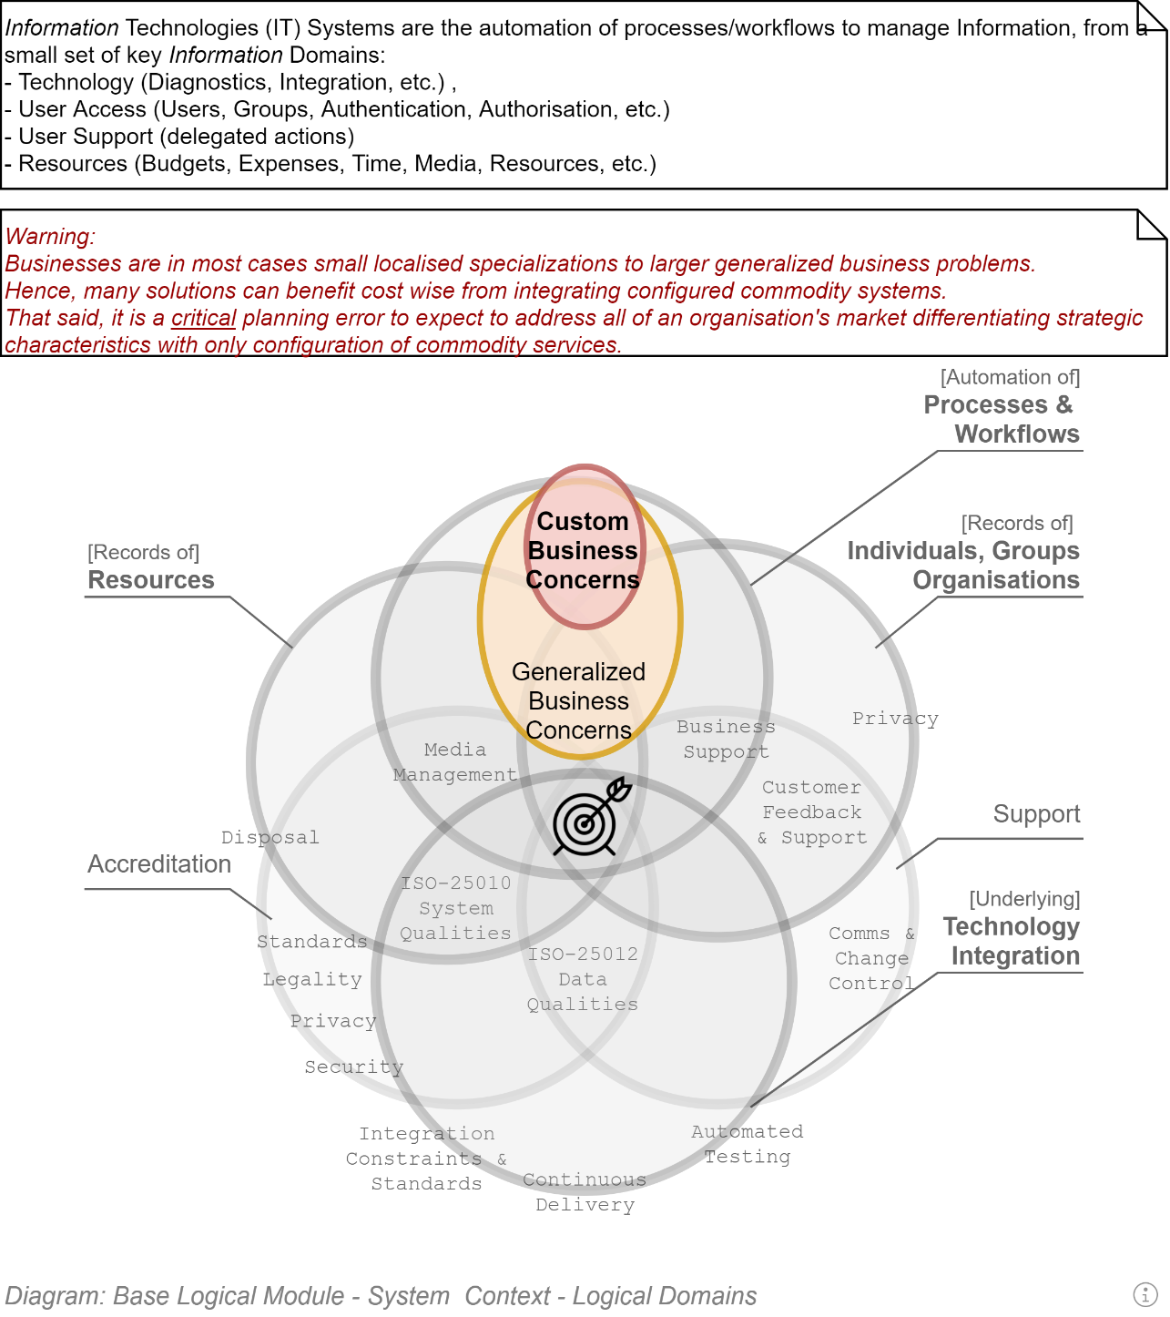

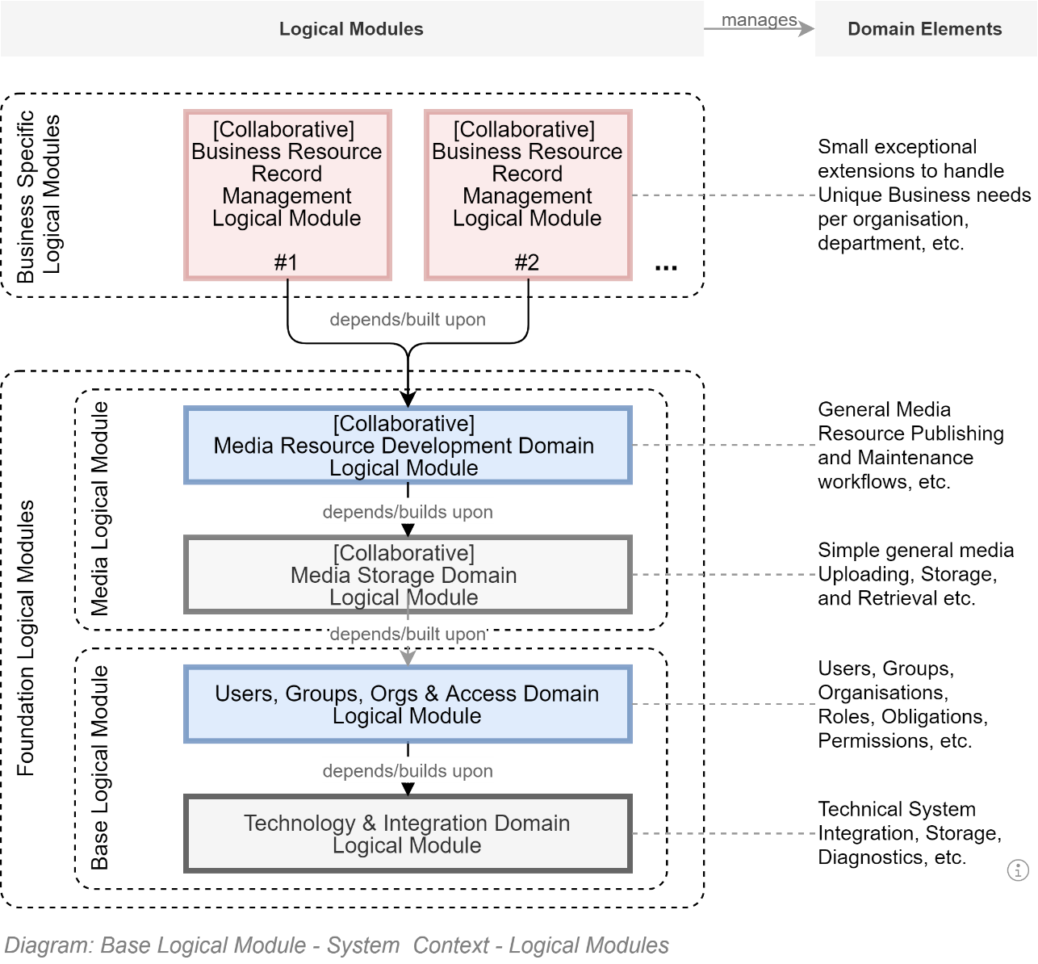

## System Integration Context

## Hosting Environment Context

The solution is hosted within one of the primary cloud hosting providers accredited by this organisation (Azure, or Amazon).

Key reasons for the above specification include:

* The hosting environment must be managed in a mature manner, proven by having achieved ISO-27001 Stage 2+ certification granted by an impartial 3rd party. Both Azure and Amazon have achieved this.
* In addition to providing Platform as a Service (PaaS) capabilities on which to deploy the logic of an Information Service, they provide a large selection of secondary cloud services that can be integrated with by the application, significantly decreasing the complexity of the logic, removing the need to deploy components, simplifying billing and maintenance complexity.

# System User View

This section describes the type of Users the solution must cater for.

## Section Synopsis

In addition to being obligated o meet this organisation’s accessibility obligations, adherence to making simple, recognisable, understandable services designed for use by the broadest user base, on the broadest range of devices, from anywhere, at any time, decreases the cost of support over the service’s lifetime.

## User Access

Current (2020) common service usage patterns are presented below, along with design decisions that assist with achieving this level of base line availability.

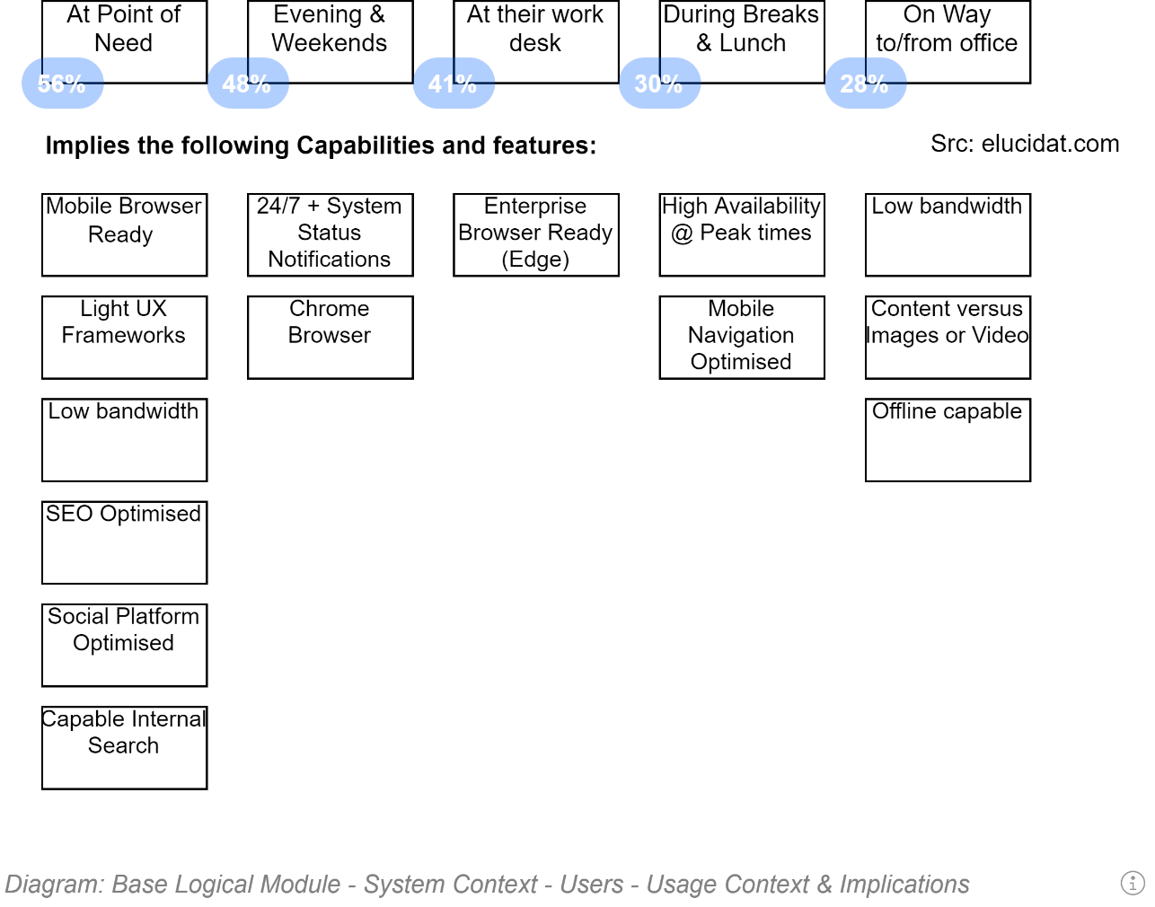

  
**Note:**  
the recommended steps are not ordered by priority.

## User Capabilities & Universal Design

Design any custom UX according to at least the first 5 principles of the Universal Design guiding Principles.

  
**Note:**   
The appendices list the principles.

A good starting point is understanding that all users are only “Temporarily Abled” – all users age, become less and less able in all areas. Some start having physical challenges of one sort or another earlier than others.

Designing for a wider base of users decreases support costs over the service’s lifetime. It also decreases the scope of analysis, reporting, and correction functionality needed to track down and correct errors made.

Designing for simplicity of understanding and use decreases error input enabling better business decisions later.

  
**Note:**  
Requirements to adhere to Universal Design principles are part of the project’s Quality Requirements.

### Risks

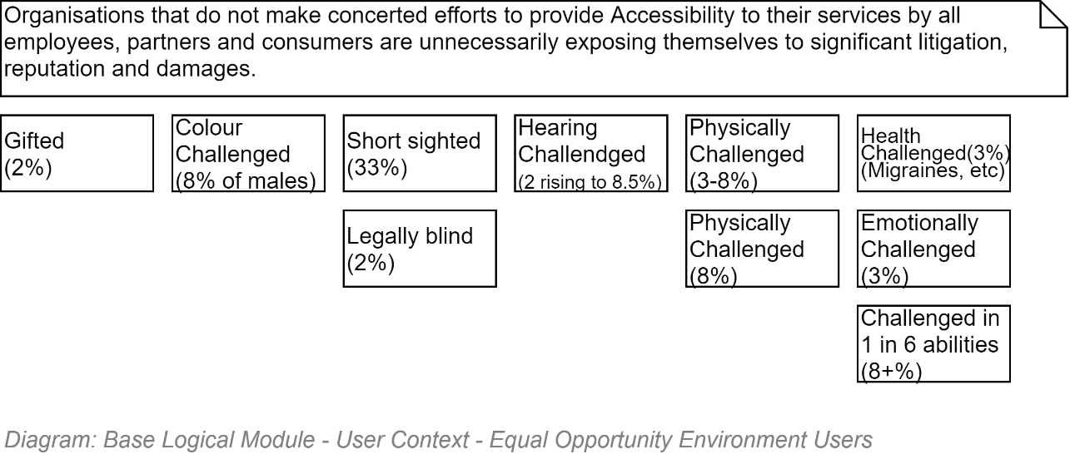

## Access Goal Schedule

The first principle of Universal Design is to make the service as widely available.

The following schedule lists different scopes of access – and the target options that are technical decisions of this project.

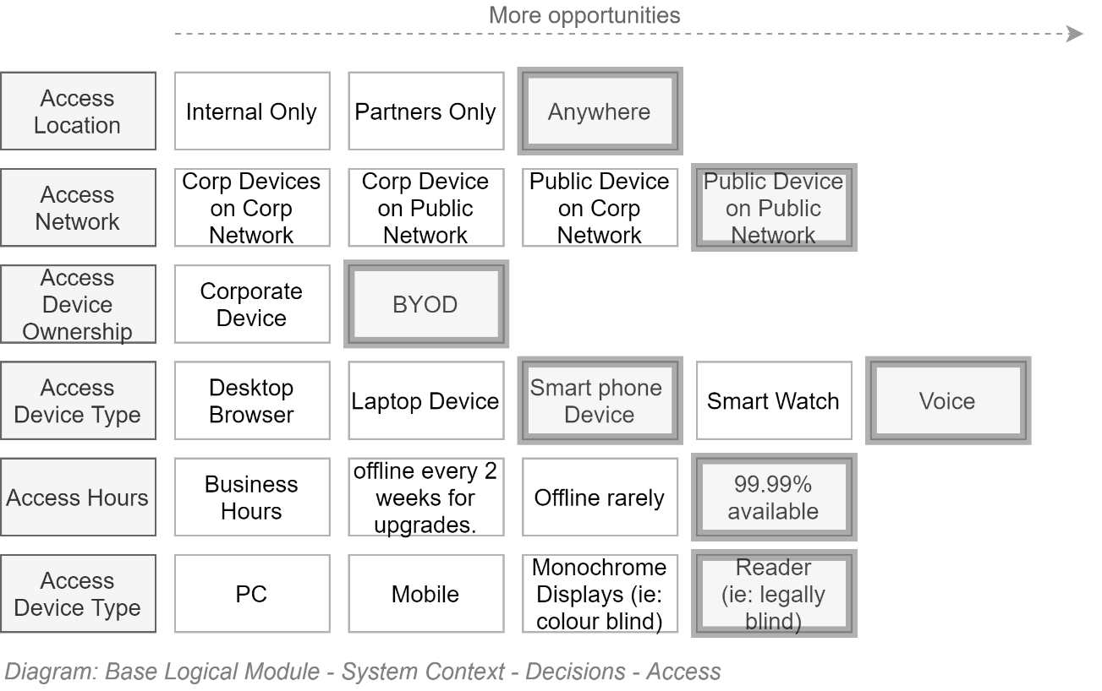

**Note:**  
The above choices are the basis of security, disaster recovery, user interface design decisions described over the following pages.

### Access by Voice Devices

Voice is an emergent (Q3/2020) channel which at first glance may appear to be somewhat premature targeting. This is not the case.

#### Accessibility

Voice allows greater participation by low-vision users who can use it anywhere, rather than be required to sit in front of a screen and use a reader.

Universal Principles 1 (Equity), 2, 6 & 7 guide one to make concerted effort to design a service that minimises the effort and requirements to access a service.

#### Market Demand

But it’s also common sense to design to meet expectations: Gartner predicts that, by 2023, 25 percent of employee interactions with applications will be via voice[5], up from under 3 percent in 2019.

Even within an error range of 8%, it is a strategically impactful decision to consciously decide to not be able to address 1 in 6 interactions.

Statistics[6] of interest backing the above direction:

* 13% of all US households owned a smart speaker in 2017, predicted to rise to 55% by 2022 (OC&C Strategy Consultants) / (Edison Research & NPR).
* 52% of smart speakers are in the living room, 25% in the bedroom, 22% in the kitchen (Google).
* 72% of user state their voice activated devices are part of their daily routine (Google)
* 65% of users can’t imaging going back to their days before getting a smart speaker (GeoMarketing).
* 41% of users feel they are talking to a friend, or another person (Google).
* 40% of millennials use digital voice assistants at least once a month in 2019 (eMarketer).
* Individuals aged 25-35 are the highest percentage of smart home device owners (Global Web Index). (Target workforce age group).
* 30% of all searches will be done without a screen by 2020 (Gartner).

### Easier to comprehend content

Strategically targeting Voice as an input and delivery channel – i.e., beyond traditional web screen channels – has other benefits: it impacts copy and media development. It forces developers to develop clearer and concise copy (as opposed to waffling) that Alexa, Cortona, etc. can read, understand, summarise and read aloud -- without droning on. In doing so, traditional web screens become easier to recognise and utilise.

Developing content to be read aloud naturally leads to the use of Plain Language, as opposed to text that sounds stilted and alienating.

**Note:**A strong driver to put in effort to develop resources using Plain Language within education system digital services is that only 16% of New Zealand adults are considered to have literacy levels[7]. I.e., approximately 75% of parents are not.

### More equitable distribution of Service via lower cost devices

Indicative costs for current (Q3/2020) devices are:

* Full use laptop: $3000
* Student Windows Laptop: $300
* Student Chrome Device: $300
* Google Nest: $50

**Note:**In addition to the 1/6th cost of a student Chrome/Windows laptop, a Vocie device can currently (Q3/2020) be configured to recognize the voice of 8 individual students and respond to them individually, representing a device/student cost of 1/48th the cost of low end student laptops, whether they be Windows or chrome OS based.

## User Characteristics

Providing accessibility to users by channel and device is one aspect of defining usability.

Another important aspect is qualifying the scope of types of users the service is to be designed for.

The following schedule captures decisions as to the scope of service users and the functionality they require.

These decisions in turn form the basis of technical decisions made later.

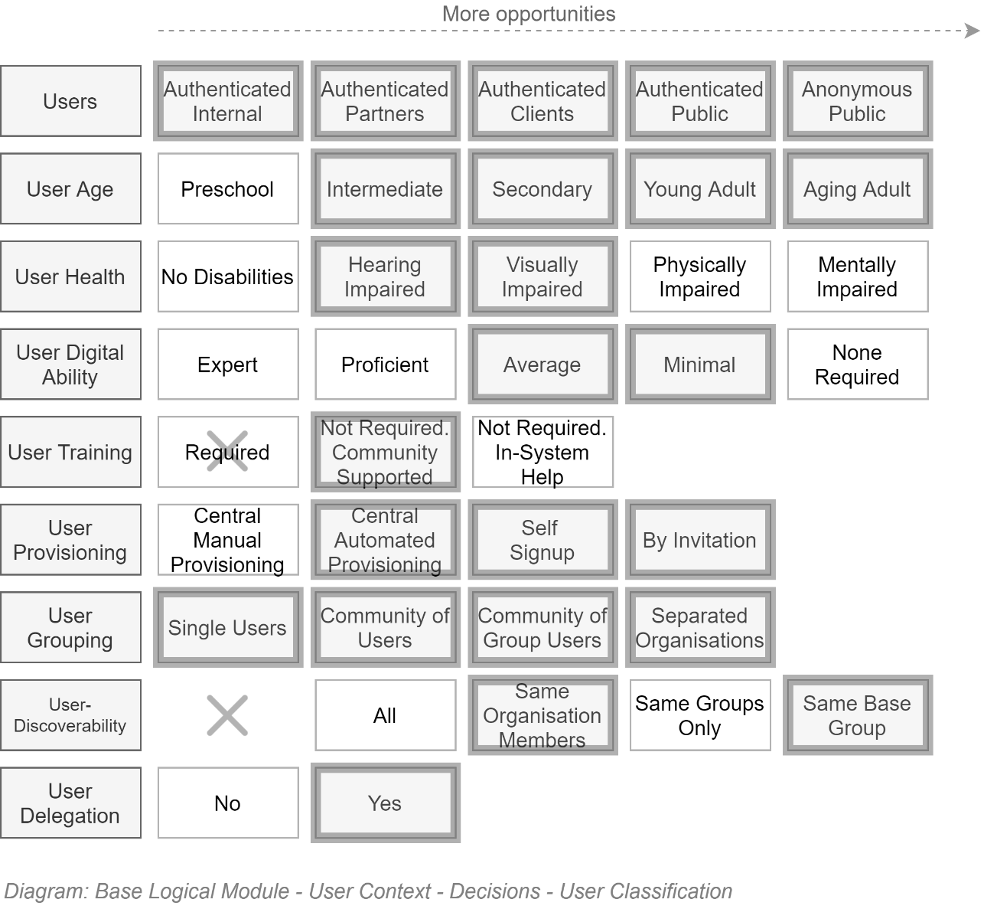

Note:  
For example, the above captures that the service must include the address of the following scenarios:

* single parents, who are not associated with any education organisation
* users may not list and browse all users in the system (their privacy is protected from random contact from people they don’t know), although the system is configurable to allow searching within the same school, or limiting it to members within the same group (e.g.: class room) only.
* Users – including external users – can be invited to join a group.   
  Note that the service is configurable such that users outside an organisation or invitations to specific group role may require validation before the invitation is issued.

## Individual User Focused

A key design difference of the system is its focusing on empowering individual users first, as opposed to focusing the design on organisations first.

Traditional software solutions have trouble allowing users to belong to two different contexts/organisations.

Whereas this is currently the more prevalent scenario.

### Individual Access Context

The following trivial diagram demonstrates current conditions, where an individual almost always belongs to multiple groups at the same time.

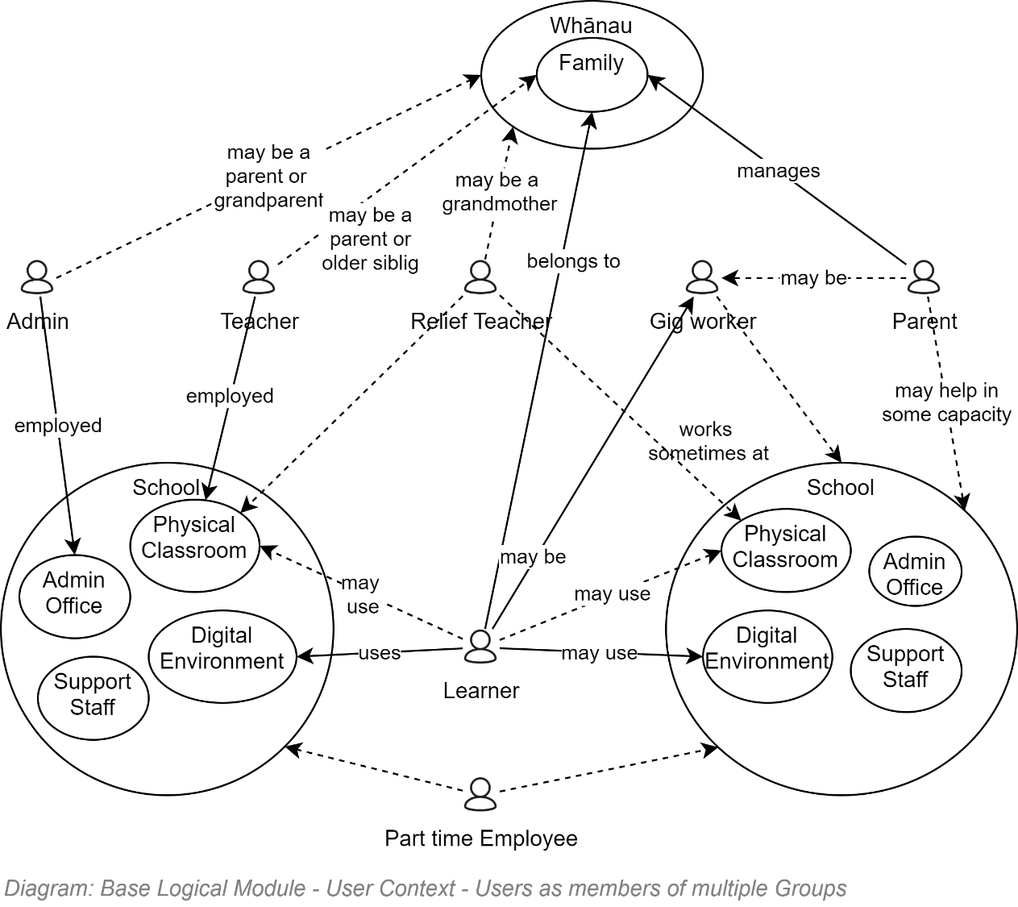

## User Group

It is a design error to design for Individuals *belonging* to groups -- Individuals *join* [multiple] groups.

Groups that Individuals join can be ad-hoc organisations of any size (1 or more individuals).

Some Groups can be further categorised as legal Organisations.

A list of some of the different types of Groups of Individual Users this Information Service is expected to cater for include the following:

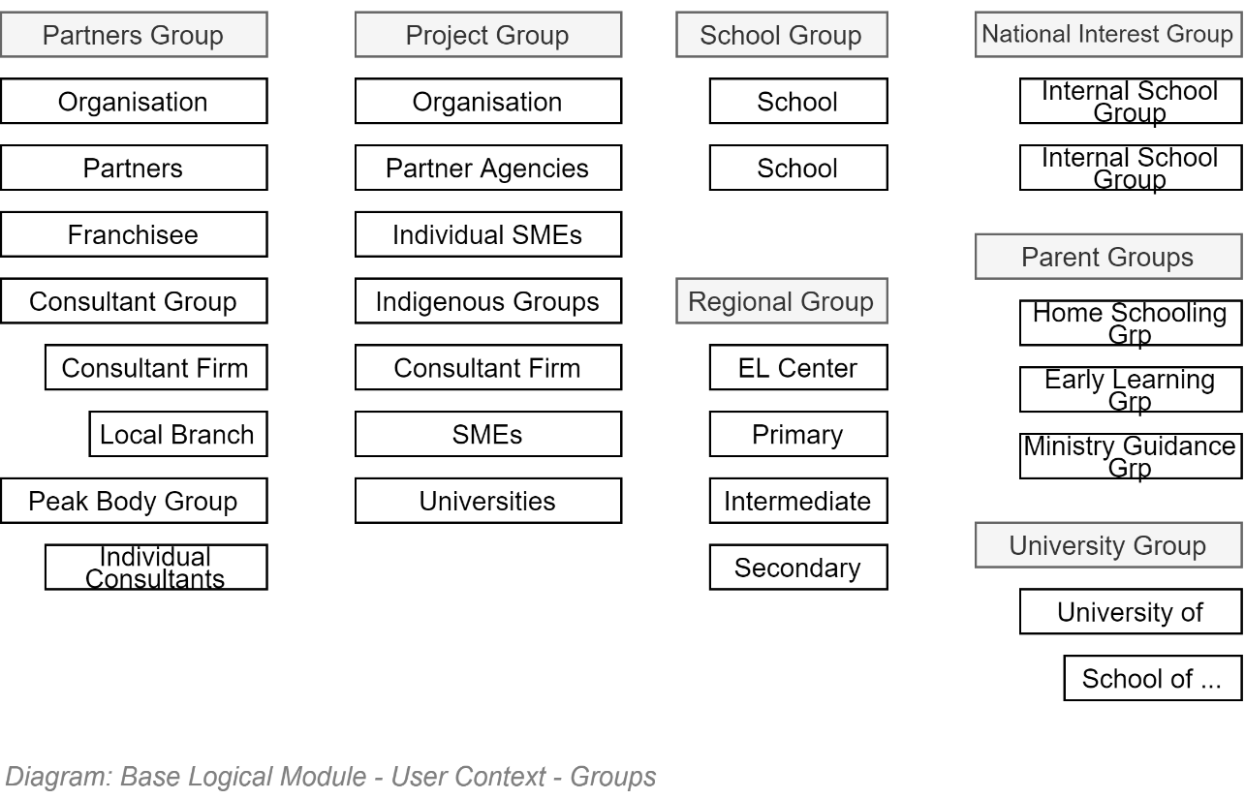

  
**Note:**  
The above list is indicative -- not exhaustive.

# Resource View

The primary purpose of an Information Service is to manage Information as Resources.

Correct, timely, accessible and integrated Information is the basis of making sound estimates and necessary decisions by stakeholders.

As such, it is important to clearly define the information management requirements of stakeholders – in essence capturing how information is expected to be collected, collaborated on, verified, published for access by others, used to gather feedback, improved based on the feedback, retired.

The following diagram captures key capabilities required to manage the system’s information.

Not all information elements need every single aspect to be implemented, but if developed as a core functionality, the more functionality can be re-used to manage different forms of resources, with the least duplication of delay, cost, bugs, and remediation.

The following diagram captures the capabilities necessary for a group of individuals to collaborate (as different roles) on common records/resources to be eventually published for others to consume. Beyond this basic workflow to validate information before it is made available for us, collaborators can work on draft resources that are kept in case they have to roll back to an older copy. Records/Resources can be tagged with a mix of pre-defined or custom tags for easier classification and later finding. The resources are made available to others via the system’s interfaces, as well as made available for consumption/submittal by other systems via Service Faced Application Programming Interfaces (API)s.   
  
In addition, some Records/Resources can be linked together in meaningful groups and sequences.

Resources are expected to be easy to find using a provided full text and metadata-based search functionality that is forgiving, easy to use and multi-culturally capable.

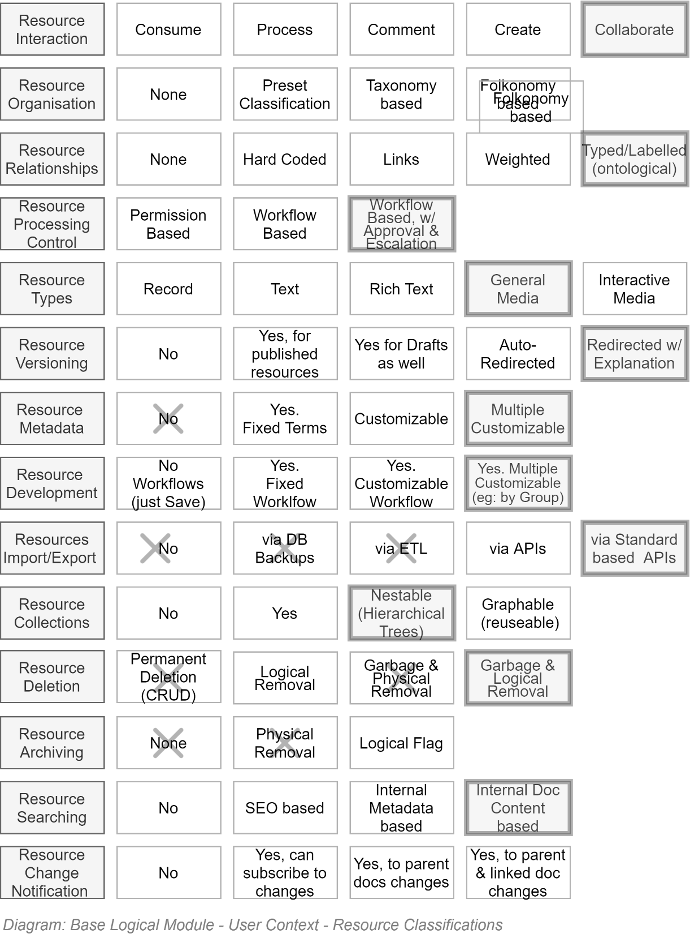

# Delivery View

This section describes how the internal stakeholder project will be delivered within the above described Business Context to address the needs of service user stakeholders, described within the User Context.

## Section Synopsis

To decrease multiple risks – unexpected concerns, poor design, cost overruns, unserviceability, un modifiability, to name a few -- Delivery is planned over the *complete* service lifecycle, of which design, development and initial deployments are only an early part.

TODO: Add a picture showing time scale 1 year compared to 10 years.

## Deliverables

1. **A succinctly documented principle and objective based guide for all stakeholders**
   * To guide stakeholder’s behaviour and expedite actions by reducing governance requirements throughout the service’s lifecycle, till the service is decommissioned.
   * To guide the development of comms, usage terms & conditions & behaviour expectations
2. **This description document and associated technical implementation artefacts**
   * To communicate to all stakeholders the known and expected outcomes
   * To demonstrate how to achieve them depending on technologies and governance decisions.
3. **A configured Application Lifecycle Management (ALM) Service based Project space**: the primary deliverable is a correctly configured project space within an application lifecycle management (ALM) service.  
   The project space is configured to
   * Manage the project's Work items,
   * Manage the project's source code in a code repository management,
   * Manage the system’s documentation required for ongoing development, maintenance, enhancement.
   * Manage the automated functionality and quality reporting to stakeholders.
   * Manage the continuous compilation of the source code, unit testing, deployment, quality testing and functional testing of the deployed artefacts, via an of an approval-based workflow managed automated delivery pipeline of:
     1. **A publicly accessible information service**, which passes automated tests developed to ensure the service meets the constraints of the functional and quality requirements.
     2. **A publicly accessible, independent, information service client of the above service's APIs,** which passes automated tests developed to ensure the service meets the constraints of the functional and quality requirements.

## Software Development Life cycle

### ISO-15288

ISO-29110

ISO 12207

ISO-29011

### Traditional

ISO:12207:2017 captures aspects specific to software systems (as opposed to the older general system focused ISO-15288).

It outlines and advices the various Processes of software development that can be run, from procurement through Organisational integration, Project management processes (Risk Management, Decisions, Assessments, etc.) through to various development processes.

There is high value in ensuring that this project has considered each recommend process and determined if applicable, and if so, has addressed it.

**Important:**ISO 12207:2017 emphasising that they can and often run in parallel (rather than be done in sequential order) and even iteratively – laying the groundwork for ISO-XXXX, which describes the Agile process.

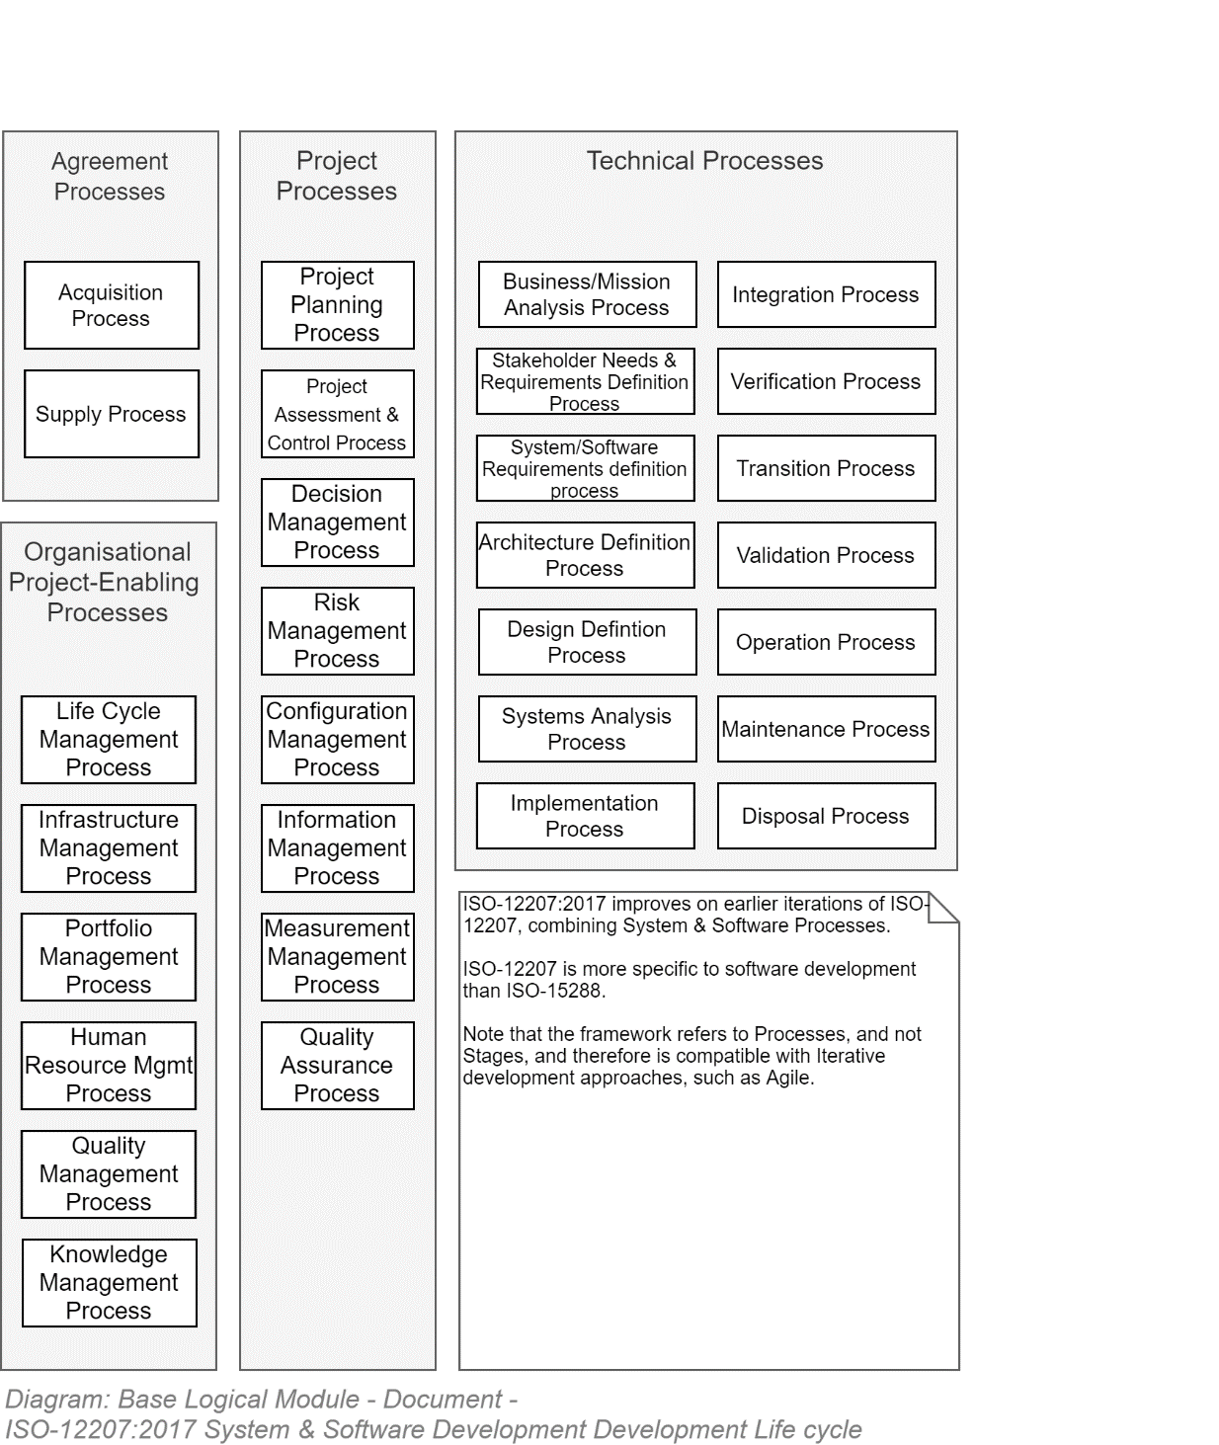

### ISO-29110-4-4 & 4-5 Agile & Agile DevOps Life cycle

In spite of any project members who may have had been involved with a delivery process that was *called* Agile but maybe wasn't, it is a mature delivery methodology that has been around long enough to have been tried in a multitude of conditions, enough so to have warranted its own ISO.

TODO: Add diagram summarising ISO.

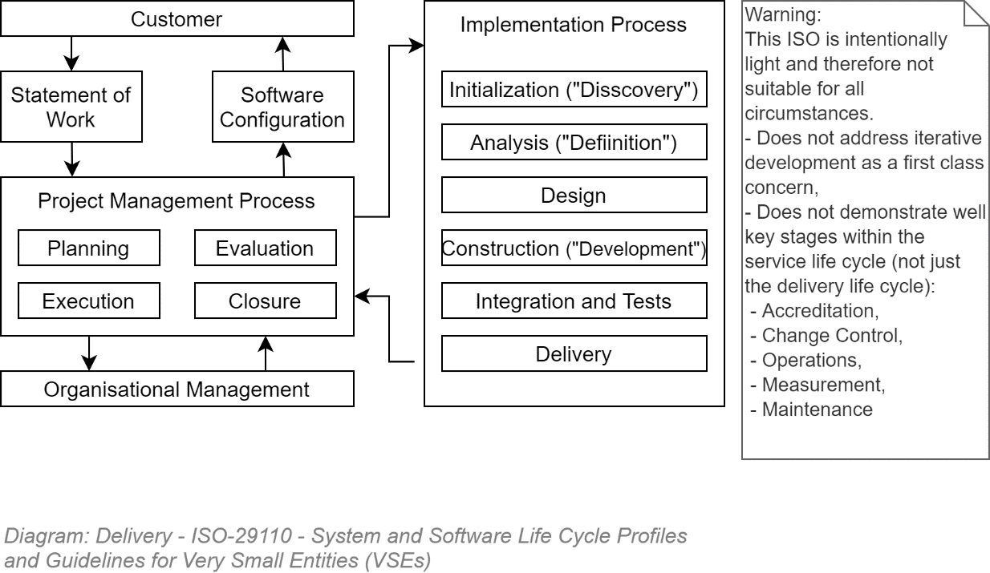

## Risks

Projects with an IT component have a high chance of failing.

### Risk Register

A risk register collating known risks, their impact, likelihood and available mitigations, and residual risk

A risk registers key purposes include:

* to communicate to all stakeholders – including governance – the overall current likelihood of the project not meeting expectations.
* To allow stakeholders to record areas of concern that require addressing by automation, or failing that, process.

It should be made available to view by all stakeholders and stakeholder group leads to edit.

### Categories

Common source of risks come from several internal and external categories:

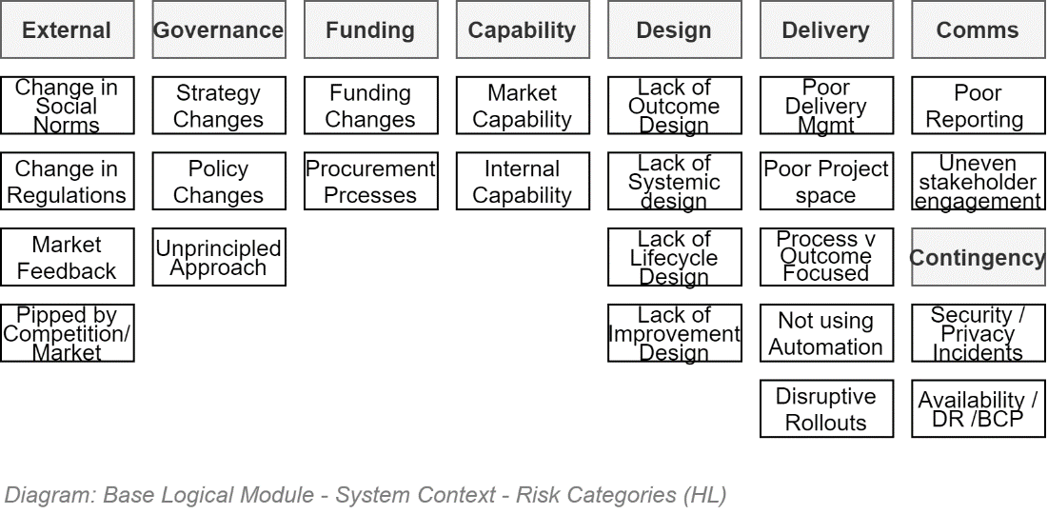

### Risks to consider

A list of common risks is available in the Appendices.

## Reporting

To provide an insightful overview to governance boards, one must summarise

* whether still on course,
* still progressing at the planned pace or better,
* expecting to have enough resources (time, budget & capabilities) to complete the project

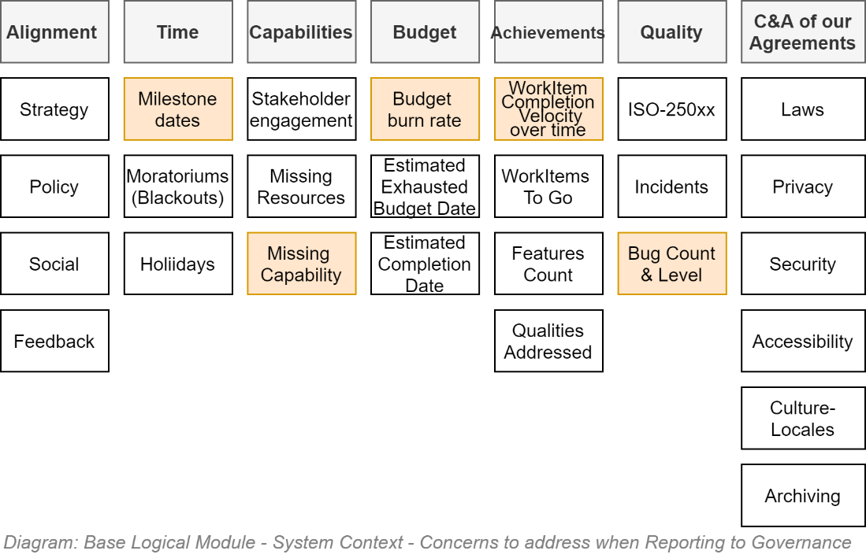

The above information is based upon known schedules, budget burn rate, effort velocity and quality assessments – which can be extracted from an available and kept current WorkItem Management Service.

## WorkItem Management

A key aspect of decreasing risk of non-delivering is ensuring that correct and non-ambiguous or contradictory requirements are researched and developed as soon as possible, across all stakeholders, allowing for cohesive design earlier than later.

WorkItems – whether managed in sequential phases, an ad hoc Agile way or recursively in a Agile scrum way, are just blocks of work to progress through the following classic phases of effort:

* Discovery,
* Definition,
* Design,
* Deciding [effort estimation & prioritisation],
* Development
* Delivery [of comms of changes and product itself]
* Supporting [users]
* Operating & Measuring [to report and influence future work effort prioritisation decisions].
* Disestablishment

### Waterfall Model versus Agile Model

Whether a sequential heavy design/PoC up-front Waterfall approach or a recursive Agile approach will largely depend on the team’s consensus of what each approach means and implies.

Each has advantages and disadvantages, some of which are -- very broadly -- summarised below:

|  |  |
| --- | --- |
| **Waterfalll** | **Agile** |
|  |  |
| **Advantages:**   * Emphasis on requirements gathering, definition and design up front reduces uncertainty as to what the team is building. * A formality of roles and processes can lead to a better understanding of responsibilities.   **Considerations:**   * Focuses on the delivery of a system – and not the continuous delivery of a service (so changes post go-live are difficult to implement).   **Disadvantages:**   * One of the few controls a manager has is to reduce scope right from the start. * The process resists requirement changes. * Development of complex systems take time. While the world moves on. There is a very high chance that by the time the system is delivered, stakeholders will have expected more, and are dissatisfied. This leads to rework.  Note: almost all waterfall-based projects fail meeting schedule and cost estimates by the time stakeholders are satisfied with the delivery of requirements. | **Advantages:**   * Releasing often allows for feedback from stakeholders, permitting a responsiveness to redirecting subsequent effort as desired. * Keeps stakeholders engaged, leading to better quality feedback. * Managers can manage scope per iterations   **Considerations:**   * Agile can be used for the initial Delivery phase as well as the subsequent ongoing Service delivery phase (e.g.: 10 years) – but existing poor industry habits still too easily forsake the larger picture to focus on the delivery of a system – and not the continuous delivery of a service (so changes post go-live remain slow to be implemented).   **Disadvantages:**   * Design will not be finalised before work starts. Due to hype and misunderstandings in the industry, work – and costs -- may start *before* any substantive discovery, definition or design has been started, when the "Cone of Uncertainty" is large, and Risk is proportional to that. * Poor understanding of which stakeholders address first (don't start with the UI!!!) can easily lead to excessive requirement and work churn, and therefore cost. * The requirement for flexibility leads to a confusion of responsibilities. * Vocal stakeholders can distort the process of collaborative resolution of objectives. |

**Note:**the Appendices contains a more complete comparison of the two methodologies.

### Agile

The most common management approach IT is currently some variation of Agile due to its reputation of removing unnecessary communication & documentation friction, allowing starting early, and repriotising effort upon feedback.

#### Objective

Key objectives of Agile include:

* allowing capable professionals to perform at pace by minimising unnecessary communication, documentation, and preparation of reports for external review during the development phase,
* Being able to deliver results to end users iteratively at a high cadence to collect feedback which is used to inform and redirect the next iteration’s effort.

#### Risks

Agile has a well-deserved, but also much-hyped reputation – which it risks not meeting if the following are not understood and managed:

* **Capability**: the team is not comprised of a high ratio of competent resources that have the experience to self-direct their effort when provided minimal documented guidance (junior and intermediate staff can participate *if* they are mentored).
* **Automation**: the use of automation for compilation, deployment and testing is not understood to be essential to keep up with the pace required of the expectation of deploying often to end users for feedback.
* **Planning**: Agile is intended to allow starting projects while the cone of uncertainty has been narrowed, but not closed -- but cannot solve Adventures. Aiming to deliver an MVP (Minimum Viable Product) without adequate discovery and planning, expecting the team to pivot in any direction potentially at every sprint meeting ensures only the delivery of an MVP of the Missing Valuable Planning type.
* **Documentation**: Agile is a methodology for the delivery phase of a service, less so for the full-service lifecycle. Documentation is required to be developed for other users. Just less, as well as kept current within the Project Wiki rather than getting stale in reviewed Word documents.
* **Deliverables**: the largest risk to Agile projects is the common misconception of what it means to get something new in front of users at every iteration.

**Warning:**Agile does not mean system development must be begun immediately at the expense of planning in order to get something in front of stakeholders.   
  
The first iterations are used to set up an online project collaboration space, where project documentation -- including this manual -- are available to all stakeholders. This project space is the first service lifetime **deliverable**.  
  
The next iterations should be a used to develop a bare-bones, “just-enough”, achievable, technical design for review and consensus by appropriate stakeholders before starting. Such a technical design roadmap, although not the final information service itself, **is also a deliverable**.  
  
The next iteration(s) are used to focus on developing an automated test and delivery pipeline**.** This too **is a deliverable**.  
  
Only after the above deliverables are well on their way, start iteratively delivering the next deliverable -- the information service itself.  
  
Finally, when the backend service is starting to expose usable APIs, start developing the final deliverable – the service client user interface.   
  
**Important:**  
Whatever you do, don’t start from the interface (that’s akin to designing a car starting with the panelling, expecting it to be a good source of information on which to design the internal engine).

## Application Lifecycle Management Service (AML) Suite

An ALM is a suite of integrated services commonly used on software projects.

The Code Management Service relies on the Work Item Service to make it easy to navigate from code directly back to the work item that commissioned it. The build pipeline relies on the code management service to retrieve the code it needs to compile, and the delivery pipeline relies on the build pipeline to retrieve compiled artefacts to deploy.

Some ALM suites also provide tools to facilitate old-school manual testing processes.

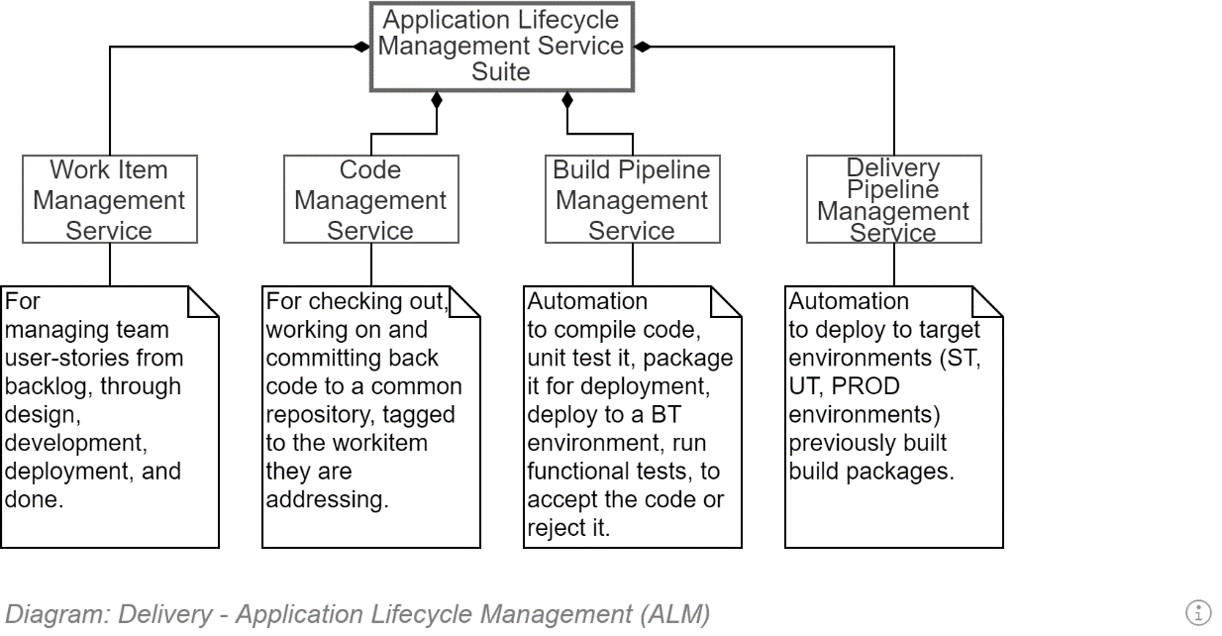

### Work Item Management Service

To manage Desires, Requirements, Epics, Features, User Stories, Tasks – and manage their conversion into deliverables, a WorkItem Management Service is required.

Many such services exist as stand-alone products (Trello), some of which can be automatically updated by code repository activities (e.g.: JIRA).

High value Work Item Management Services have most or all of the following characteristics:

* are integrated with other development services (code repository, build and deployment pipeline, etc.) *by default*,
* Allow work items to be accessible internally and externally (by vendors, consultants and collaborators) on any device, as well as being printed.
* Work items can be viewed as Kanban staged boards or lists, preferably both approaches allowing filtering/sorting and printing as needed.
* are viewable by users outside the production team, can accept Users submitting Requests as unformatted Desires/Issues.
* Can report on velocity at which work items are completed -- filtered by project, group and individual -- to inform the estimation of durations of future work items.
* Can create dependencies between work items to inform prioritisation and sequencing of tasks.

### Agile WorkItems (Epics, Features, User Stories).

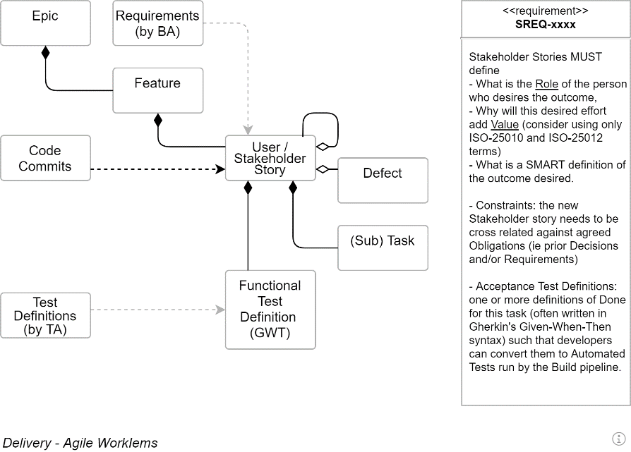

#### EPICs

Epics, as the name suggests, are large conceptual divisions of the service that is to be delivered.

  
**Warning:**  
It’s a common error for developers to think of Epics as very large sets of User Stories/Tasks. Whereas they’re not – they’re more of a Classification system of ongoing key concepts needed to be worked on over many releases.

#### Features

Whereas Epics are never-ending – or at least exceptionally long -- workstreams, Feature [Sets] are large but finite clumps of User Stories, focused on specific functionality, probably not completable within one iteration/sprint.

### User Stories

The raw basics of a User Stories – it's title -- is a 3-part statement expressing a Desire, written from the perspective of a stakeholder role willing to sponsor it, expressed as a valuable outcome.

The default formats used are either

* As a <stakeholder>, I would like <feature>, So that <outcome>
* For <1+ valued objectives>, As a <sponsor>, I would like <feature>

Both approaches have merit – the first expresses the action the role will be able to accomplish – the second expresses an expected Value making it easier to evaluate prioritisation of tasks.   
The project may adopt merge of the two main formats:

For <1+ value objectives>, As a <sponsor>, I desire <feature> So that <outcome>

**Tip:**  
An interesting aside is that whereas an Epic is as defined above, a Journey comes from the French word “journée”[8] (day) -- as in a guild member’s day’s work. A User Story should not take a professional Journeyman (as opposed to the modern-day equivalent of an Apprentice) longer than a journée, during which several sub-Tasks will be accomplished.

#### Stakeholder Story Attributes

The following is a diagram of some of the attributes a well developed Stakeholder story has.

Valuable stakeholder stories reduce misunderstandings, discussions and risk to the project, while improving group cohesion around well designed, communicated and agreed outcomes.

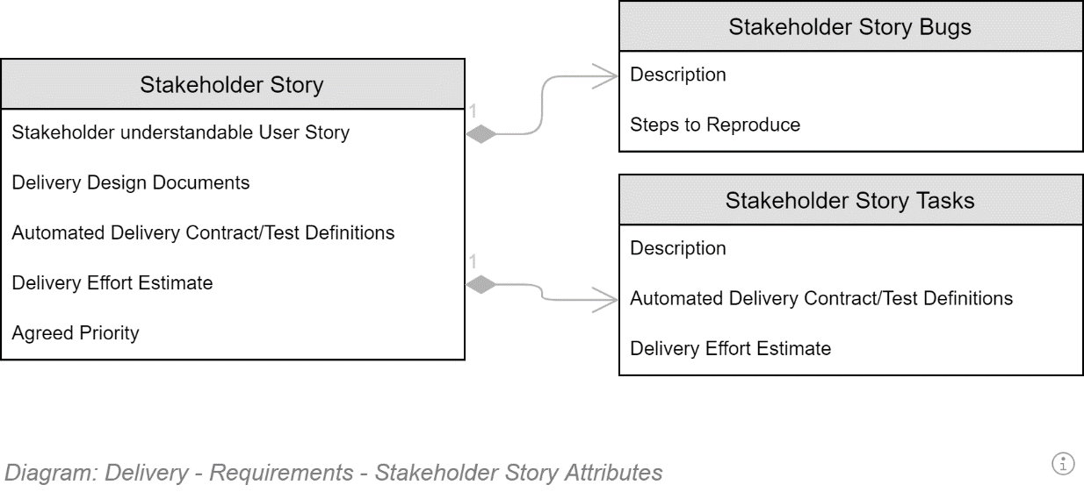

### Documentation Management Service

A deliverable from a software delivery project is documentation to permit operations, maintenance, improvement over its service lifetime.

A hierarchically organised wiki is the most appropriate documentation tool.

Note:  
The irony is not lost on me: the information within this description document should be available in a wiki, rather than as only available within an archaic desktop publishing tool artefact.

### Source Code Management Service

TODO

### Build & Deployment Pipeline

TODO

### Related Documents

## Capability

The best plans can be undone by lack of capability.

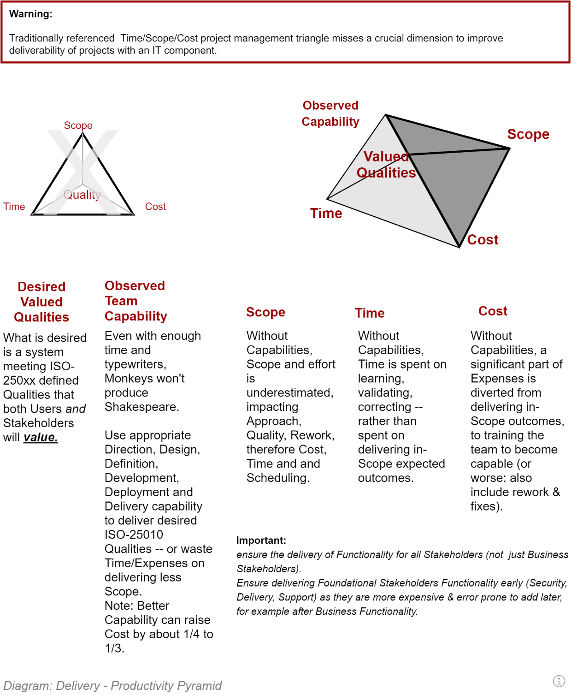

## Deliverables

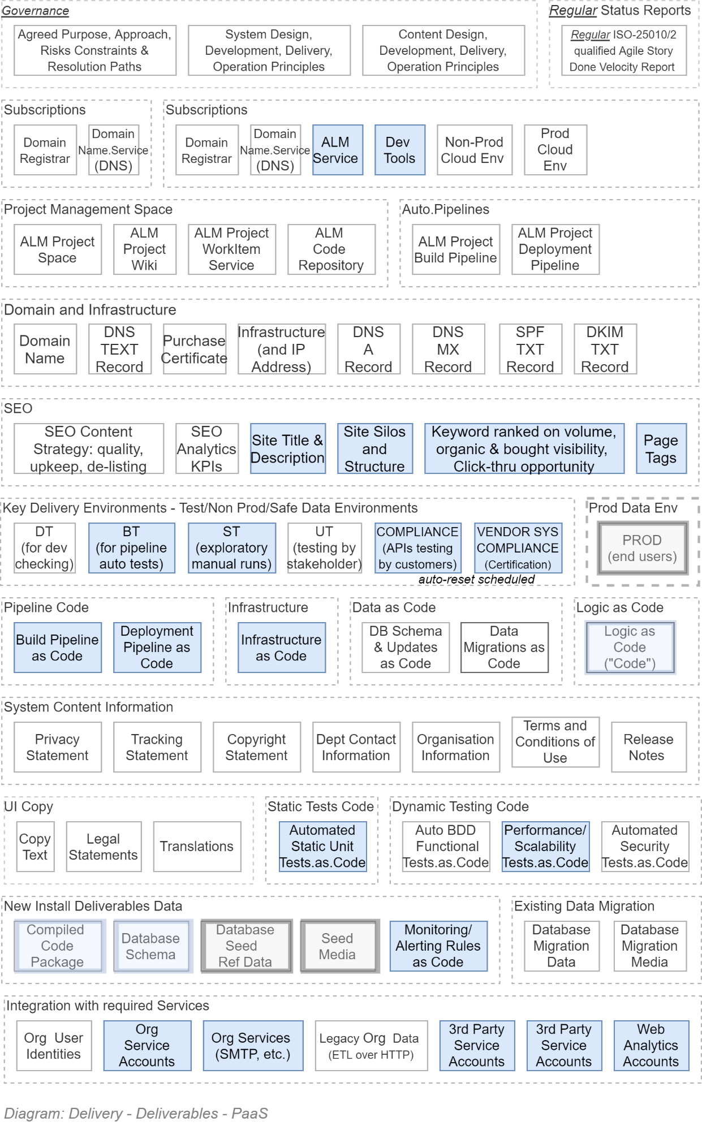

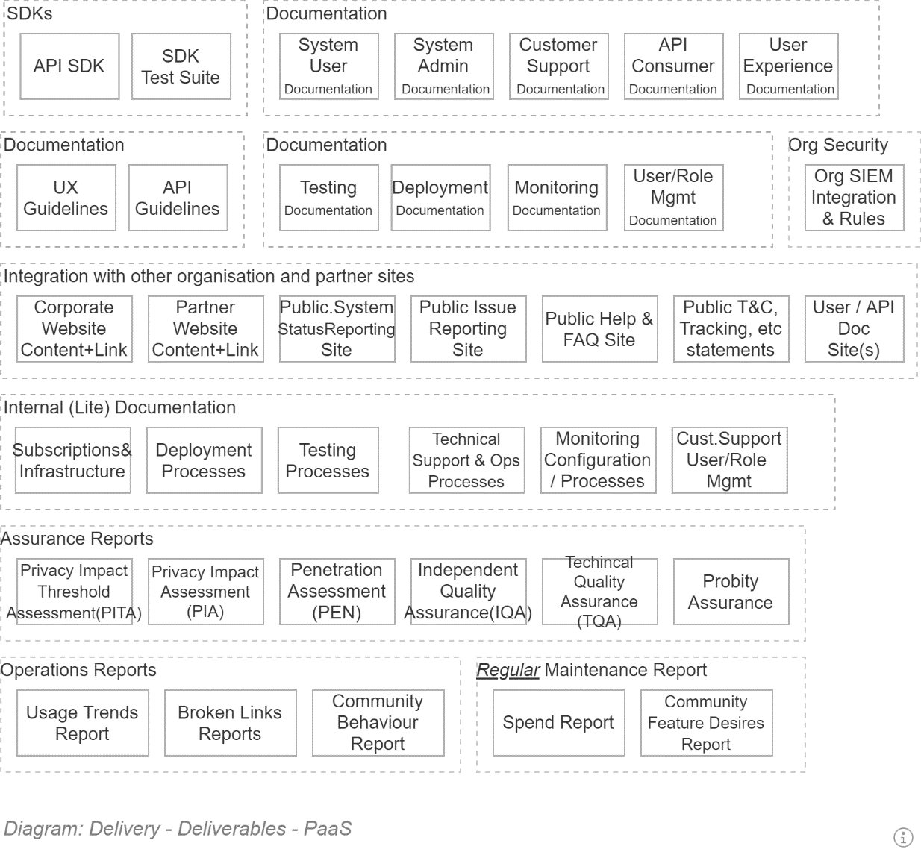

# Requirements View

In order to reduce risk, this section clarifies from whom and what type of information is to be collected, from whom, then developed, by whom into valuable requirements before work commences on them.

## Section Synopsis

Correct development is contingent on correct definition of the problem. Correct definition is contingent on correct requirements correctly and concisely capturing the needs of relevant stakeholders.

Note:  
There is no greater risk to a project than the capturing, defining and communicating ambiguous or even incorrect objectives.

## Source of Requirements

Requirements for a project are generally defined as one of

* Functional Requirements, or
* Quality Requirements (previously defined as Non-Functional Requirements).

Quality Requirements are requirements which describe how the target qualities -- as defined in ISO-25022, ISO-25012 and ISO-25010 – are to be met by the solution. Quality Requirements are generally developed by the Solution Architect.

Functional Requirements are a combination of Requirements from different User Stakeholder groups:

* Security Specialist Users,
* Public Users,
* Customer Users,
* Business Users,
* Support Users,
* Maintenance/Operations Users,
* Training Services,
* Etc.

It is important that a Business Analyst has captured the requirements from all these Stakeholder Groups. Budget, Resource availability and other aspects will determine in what order the various Functionality is addressed – but it is important that every group’s functionality is captured, and all considered when defining changes.

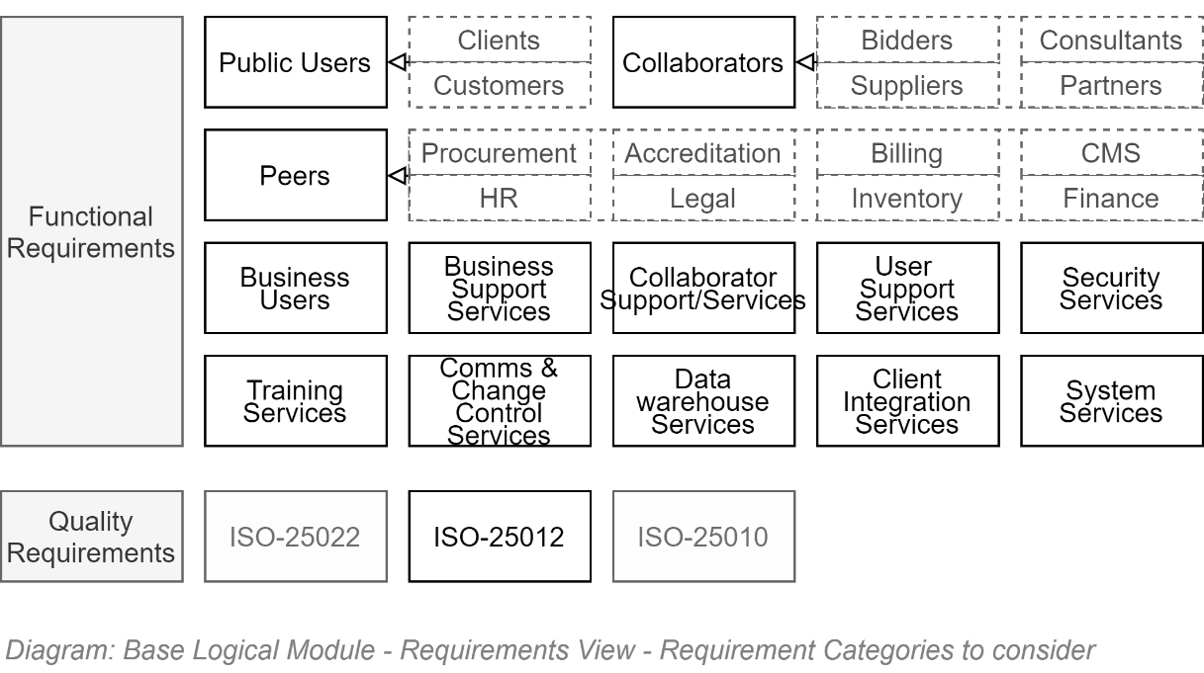

## Standards

In addition to knowing the type of requirements to capture, and whom to capture them from, it is important that Requirements are developed according to high value Standards.

The most important Requirement for valuable Requirements is that they are all “CLEAR” and “SMART”:

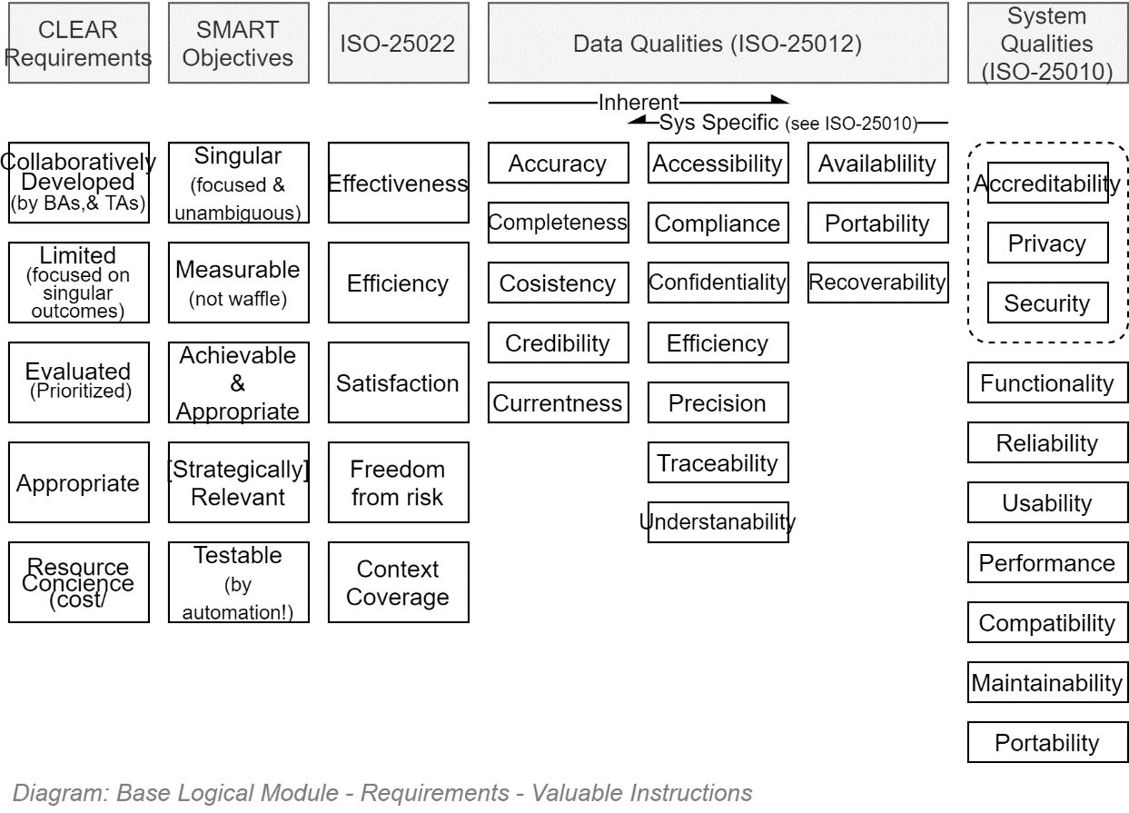

## SMART Objectives

The following diagram is captures a small set of recommendations to ensure Requirements are developed as SMART objectives:

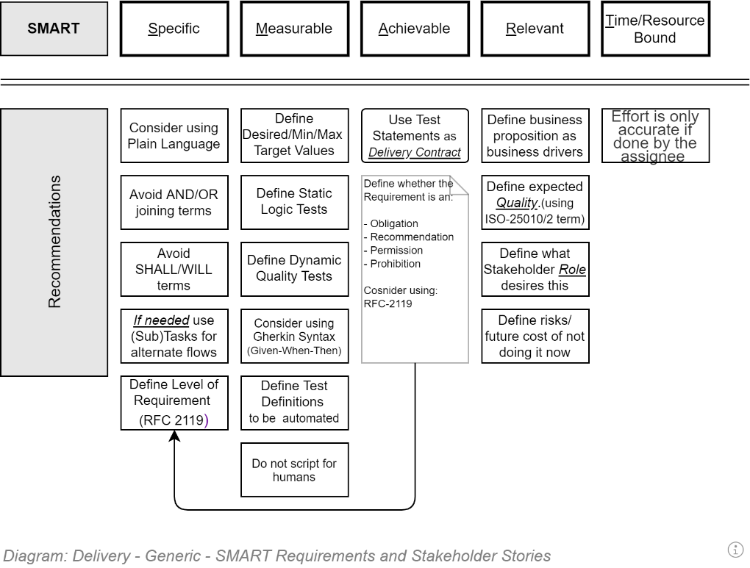

## Levels Used

Valuable Requirements must not be ambiguous as to their importance to stakeholders and therefore the success of the project.

The following is a table defining the precise meaning of the terms used to define the importance of Requirements:

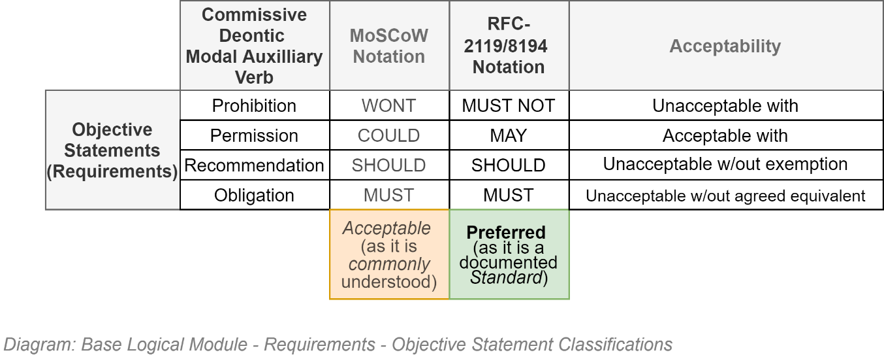

## Volatility of Requirements

### Changes

Requirements are not permanent. Functional requirements are often just best guesses developed at the beginning of projects when the cone of uncertainty is large. They are expected to be refined and made more appropriate as more information becomes available.

Changes mutually agreed and accepted by customer and provider are permitted.

### New Requirements

A key value of Agile based delivery methodologies is the focus on iteratively and rapidly delivering new features for end users to use the system and provide feedback which influences the prioritisation of subsequent development effort.

New requirements are developed from new user Desires and reported Issues.[9]

This volatility of Requirements is to be embraced.

The iterative delivery should match the rate of change of requirements. A commonly used iteration period is 2 weeks. A period longer than 4 weeks is to be actively avoided.

## Associated Documents

TODO: Refer to the Deployment View / Delivery Pipeline SAD.

# Service Information Model View

This section defines the information elements that must be accounted for over the whole service lifecycle.

## Section Synopsis

Before investigating a system's information Entity Relationship Model diagrams, it is important to recognise that a system's information set is but a small subset of a business service's information set.

Knowledge of this larger scope allows for better process development, risk mitigation, integration and extensibility of the system.

## Service Network Information Sets

The solution's information set fits within a larger whole-system information context:

* **Clients:** Identity, Demographics, Choices, Goals & Aspirations, Enrolment, Attendance, Schedule, Learning Plan, Status, Achievements & Progress, Evidence of Learning, Support, Wellbeing, Health, Comments/Complaints, Exemptions, Interventions, Judgements, Scholarships, Loans, Allowances.
* **Products:** Curricula, Pathways, Standards, Outcome Design, Program design, Course plans, Class plans, Assessment design, Learning resources, Curricula research, Compliance, Quality assessment.
* **Experiences:** Usage Data, User commentary & feedback.
* **Providers:** Provider information, Registration, Licensing, Governance, Network, Property, Funding, Performance, Quality Assurance, Risk Management, Interventions, Comments/Complaints, Incidents,
* **Workforce:** Identity, Demographics, Registration, Licensing, Governance, Qualifications, Skills, Status, Role, Performance Plan, Performance Data, Schedule, Scholarships, Incentives, Awards, Pay
* **Organisation:** Government Priorities, Sector Priorities, Legislations, Regulation, Strategy, Policy, Sector Performance Data, Best practices, Demographics, Demand & Forecasting, Stakeholder Contact, Requests, Equity & Excellence.

Within the above information sets, this solution addresses Product & Experience concerns.

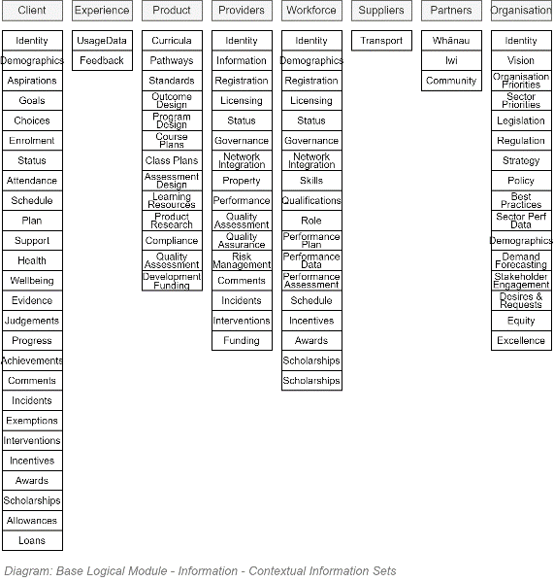

## Service Lifecycle Information Types

The solution’s Information Service’s primary business function’s records is only one type of information that must be managed during the lifecycle of this project.

Information is developed to govern and direct the project, information is collected during the discovery phase, various forms of information are synthesised during the definition and design phase, information is developed during delivery stage, and more information is developed by using the information service.

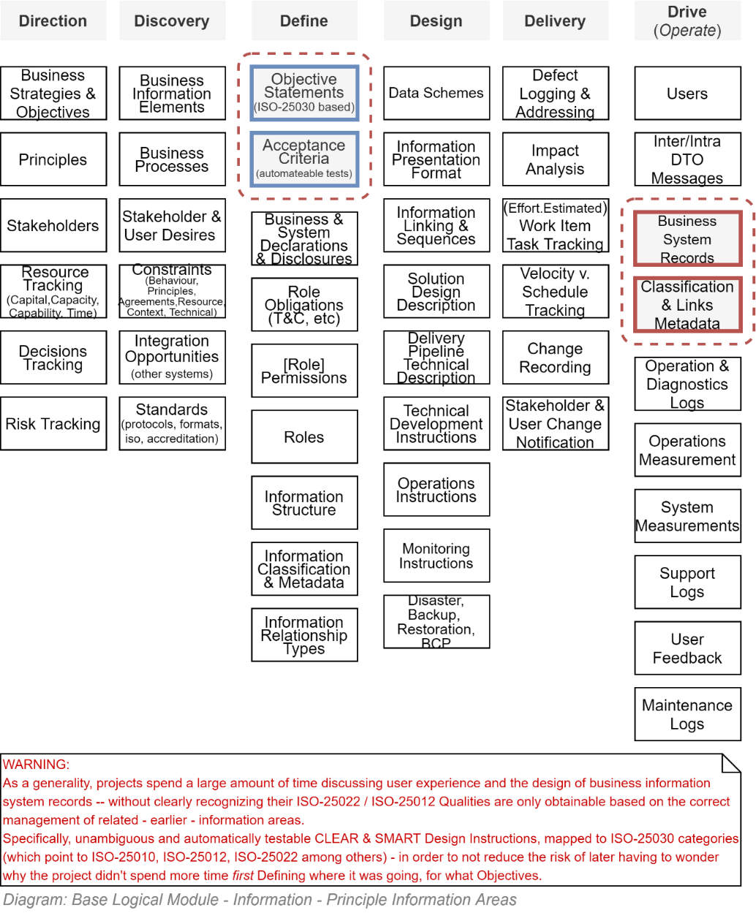

## Service Lifecycle Information Stages

The information types are developed at different stages of the project, which can loosely be mapped out as follows:

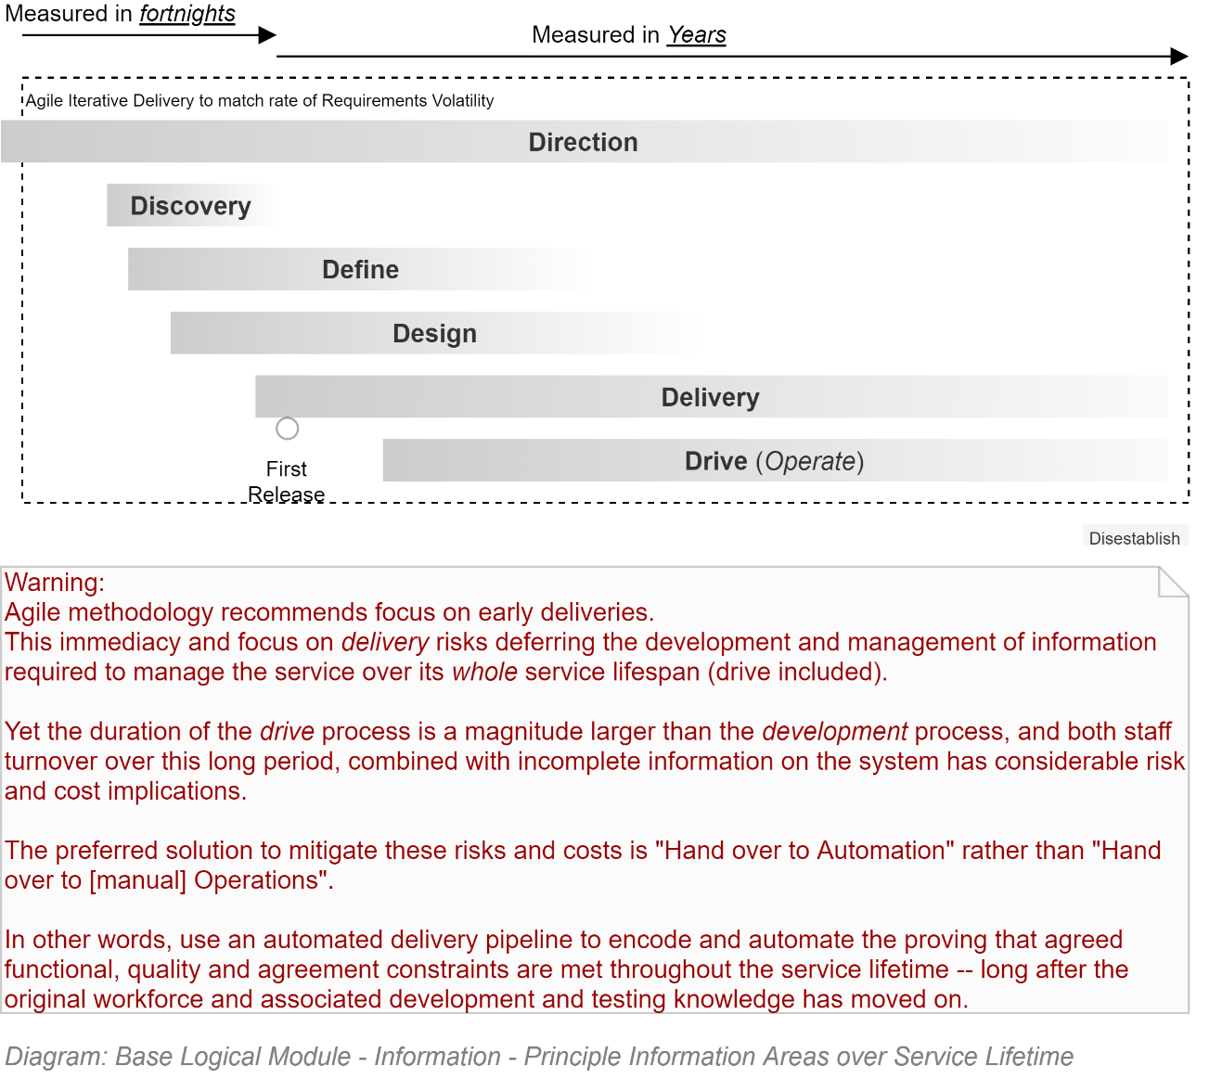

## Information System Information Types

A specific aspect of the Service Lifetime Information is the Solution’s Information *System’s managed* Information.

The Information Service’s Records can be categorised as being developed to address different concerns.

All mature Systems manage information related to the following core concerns:

* **Immutable System Configuration**, to manage the configuration of sub-components and integration of local and remote services
* **Diagnostics Trace Logging Management**, to trace activity for later review by technicians
* **Error Management**, for alerting to unintended behaviour for later review by technicians
* **Session Management**, to manage and keep track of the interactions of users in one or more service client interfaces, whether authenticated or not.
* **Auditing Management**, to permanently record public or identified user activity for non-repudiation reasons.
* **User Management**, to manage system users for association to Sessions and Auditing.
* **Group Management**, the management of groups of users.
* **System, Group & Profile Management**, the management of system and user preferences and settings.
* **Access & Permission Management**, to manage the access and changing of system information by Users
* **Notifications Management**, to manage the synchronous notification of users in system
* **Message Management**, to manage the asynchronous delivery of messages to users.
* **Operation Queue Management,** to manage the recording, synchronous or asynchronous processing, or later replay of user operations.
* **Workflow Management**, to coordinate asynchronous sequences of operations by users.
* **Record/Resource Management**, to manage the creating, updating or deleting system information.

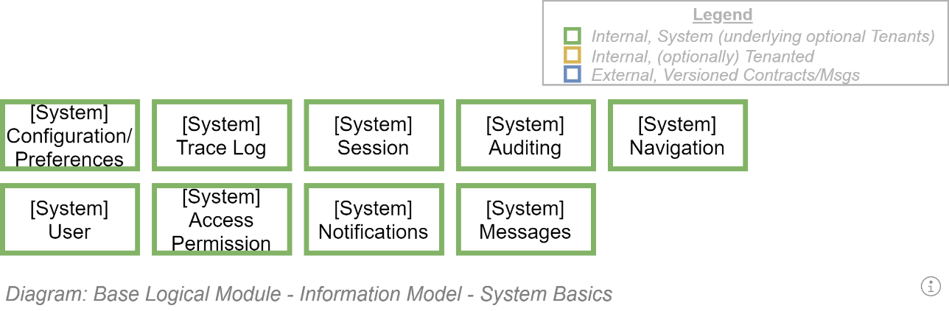

TODO: Ensure diagrams relate

## Entity Relationship Model (ERM) Diagrams

### Overall

An overall view of the Entities which this system manages is shown below.

  
**Note:**  
An ERM model is a database schema diagram which shows different aspects than what would be documented on an ORM class model (see Development View for such).

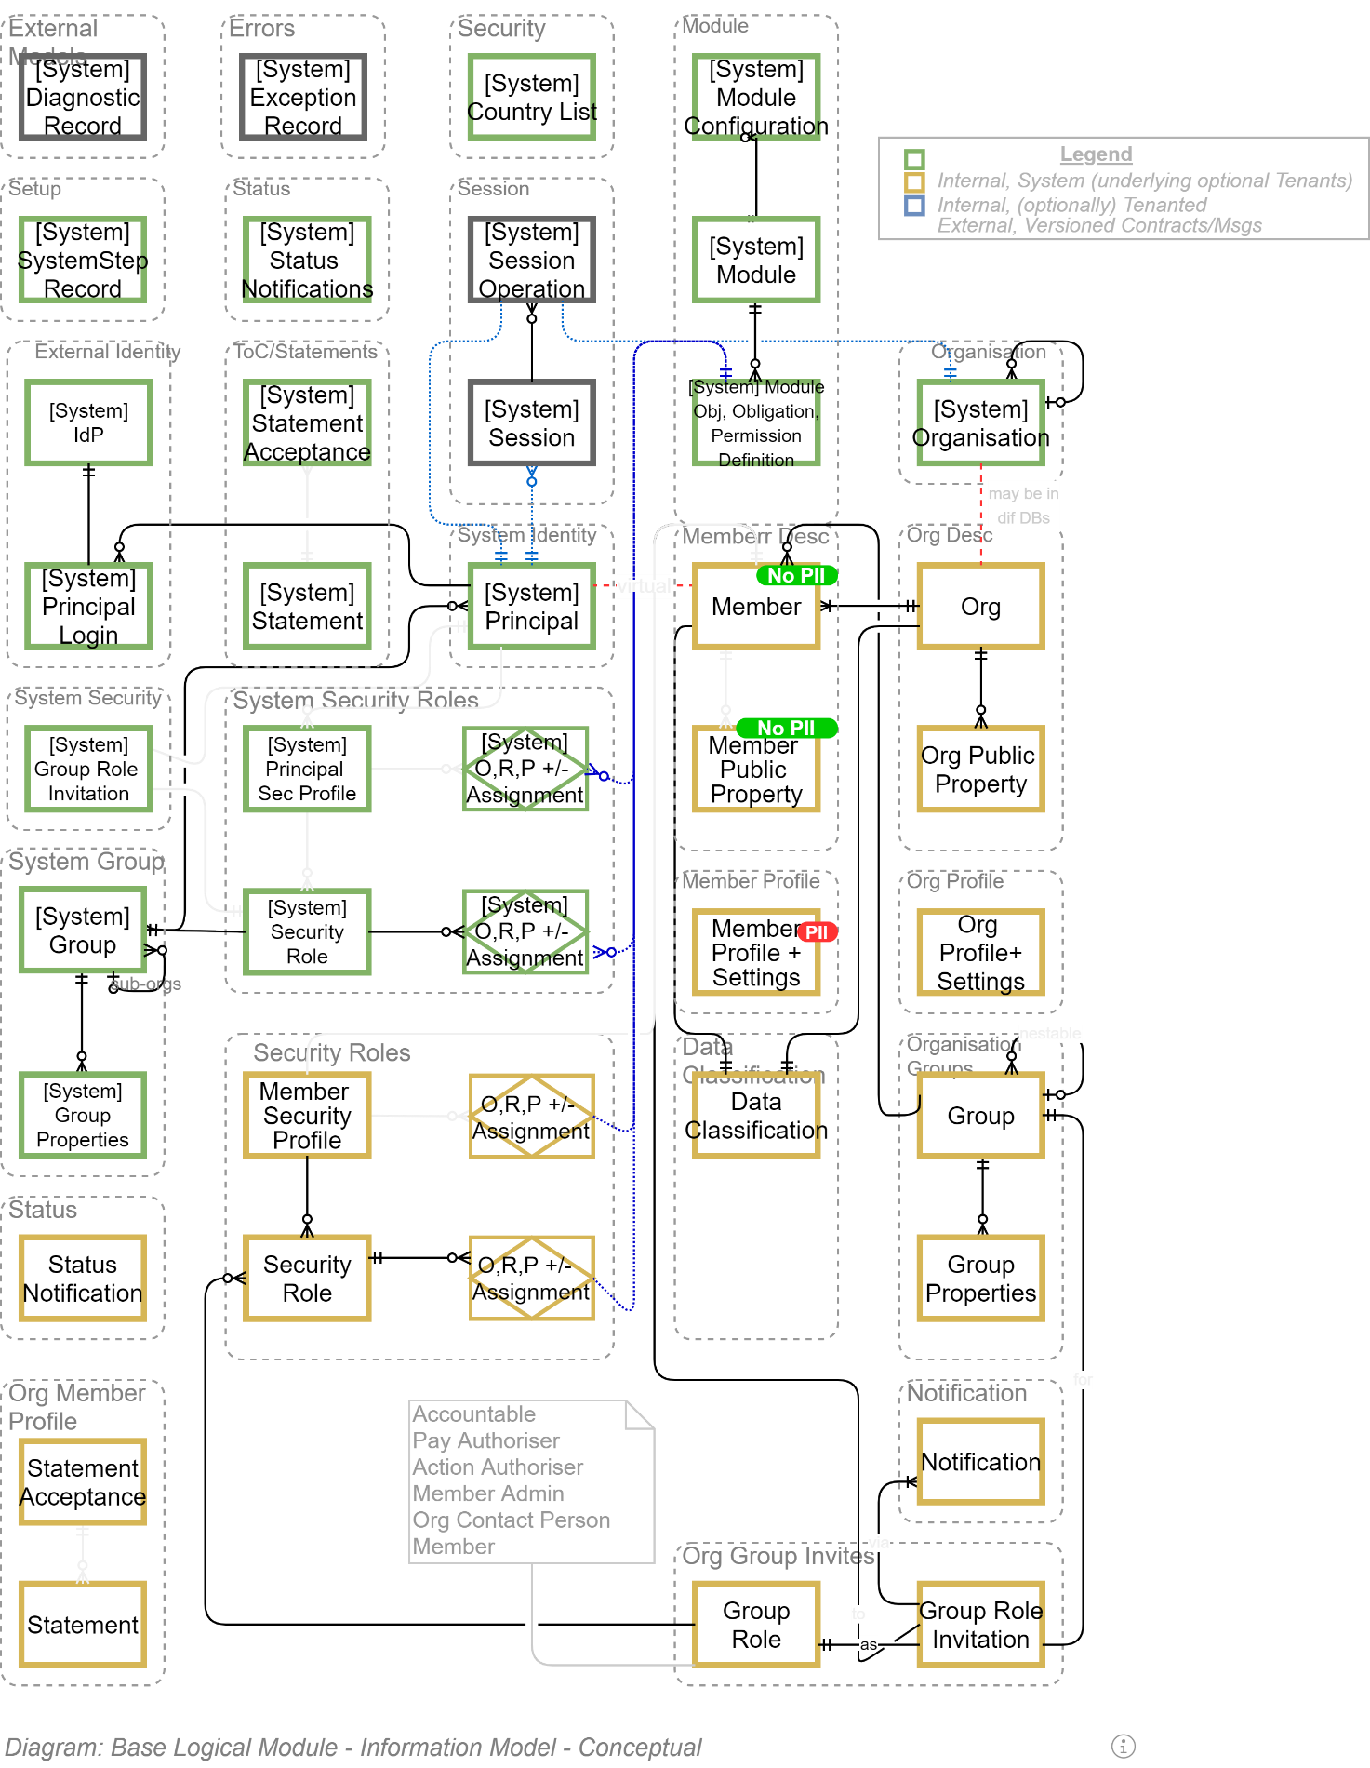

* **Errors**:
  + **Exception Record**: records of unexpected errors, containing the UTC date and time the behaviour happened, level and cause (if known), who’s session it is, and optionally a sanitised serialization of the execution stack trace,
* System Security Role:
* Security Role:
  + Member Security Profile
  + TODO: the rest of the objects.

### System Module Management

The system is expected to be modular and extendible by uploading functionality packages.

In addition to making the system more usable by being extensible a modular development approach ensure higher maintainability by keeping aspects discrete from each other.

An extension module may contain as many classes and features as it needs to perform its intended function.

  
**Note:**  
An extension module package is associated to one or more Users with a Role (Owner, Contact Person, Admin, etc.).   
  
The default behaviour is that the person uploading the module is automatically associated to it in an Owner role.

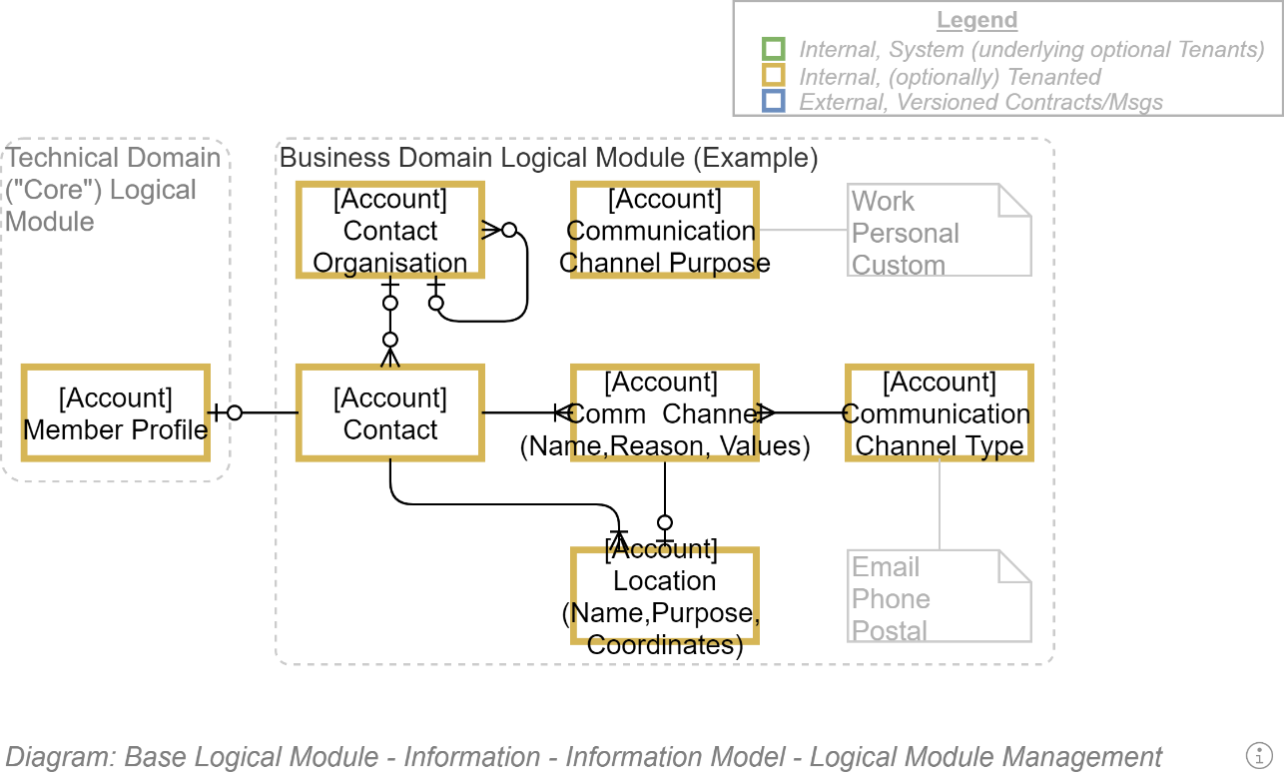

Entities:

* Technical Domain
  + Member Profile: ....
* Business Domain Logical Module

TODO

### Diagnostics Management

### Error Management

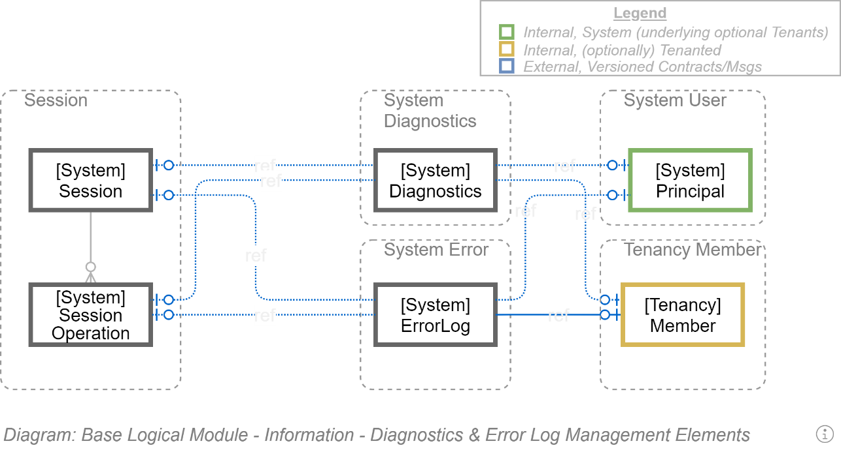

### Disclosure and T&C Management

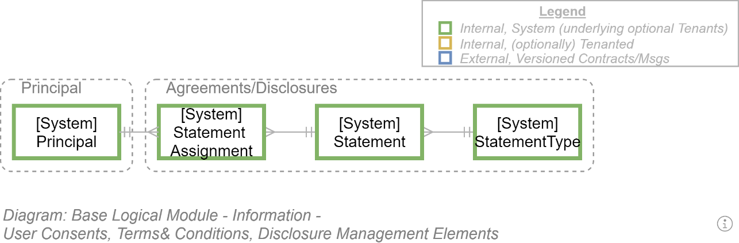

### Settings Management

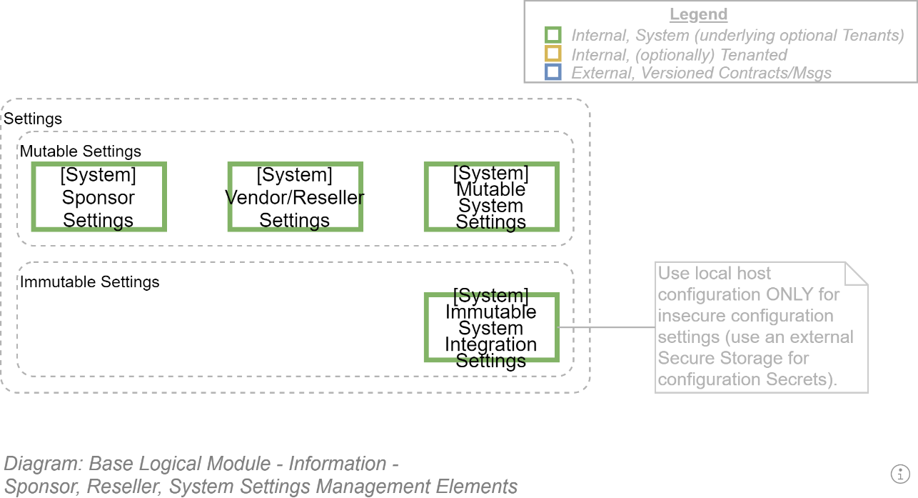

### System Status Management

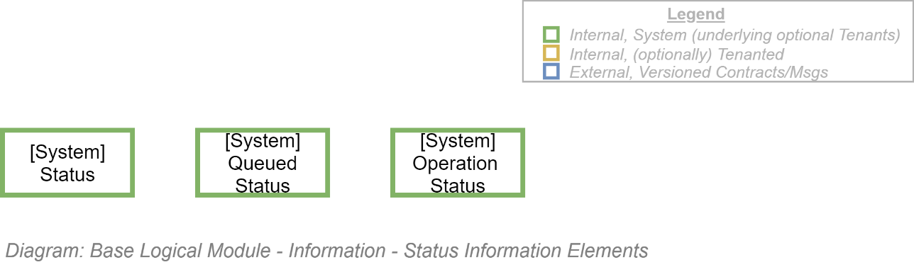

### Session Management

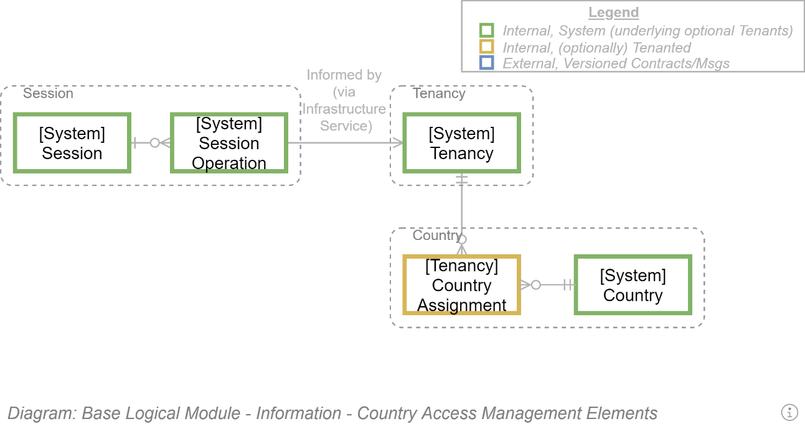

#### Elements

* **Session**: an element to record the current Service Client User Agent (i.e., Browser), the UTC time it first connected (in order to terminate a Session after a configurable Duration).
* **Session Operation**: the current Request’s UTC Date & Time, Service Client User Agent’s IP, calculated source Geographic Location (Latitude & Longitude) and Country (used to exclude requests from embargoed countries),  
  Note that IPs are per recorded per request as they can vary over a Session, due to Operations being on different days, or initiated from different cell towers.

#### Supporting Elements

* **Group:** a group of Users, and nested child Groups.

  
**Note:**   
any group can be defined as a legal entity (and its nested child groups would probably be departments – but could also be child Organisations if so needed).

* **Country**: a reference list of all Countries, which are associated to a [parent] Group.
* **Country Assignment**: a bridge table element to assign Countries that are excluded from access to a specific **Group** and its nested **Group**s.

### User Management

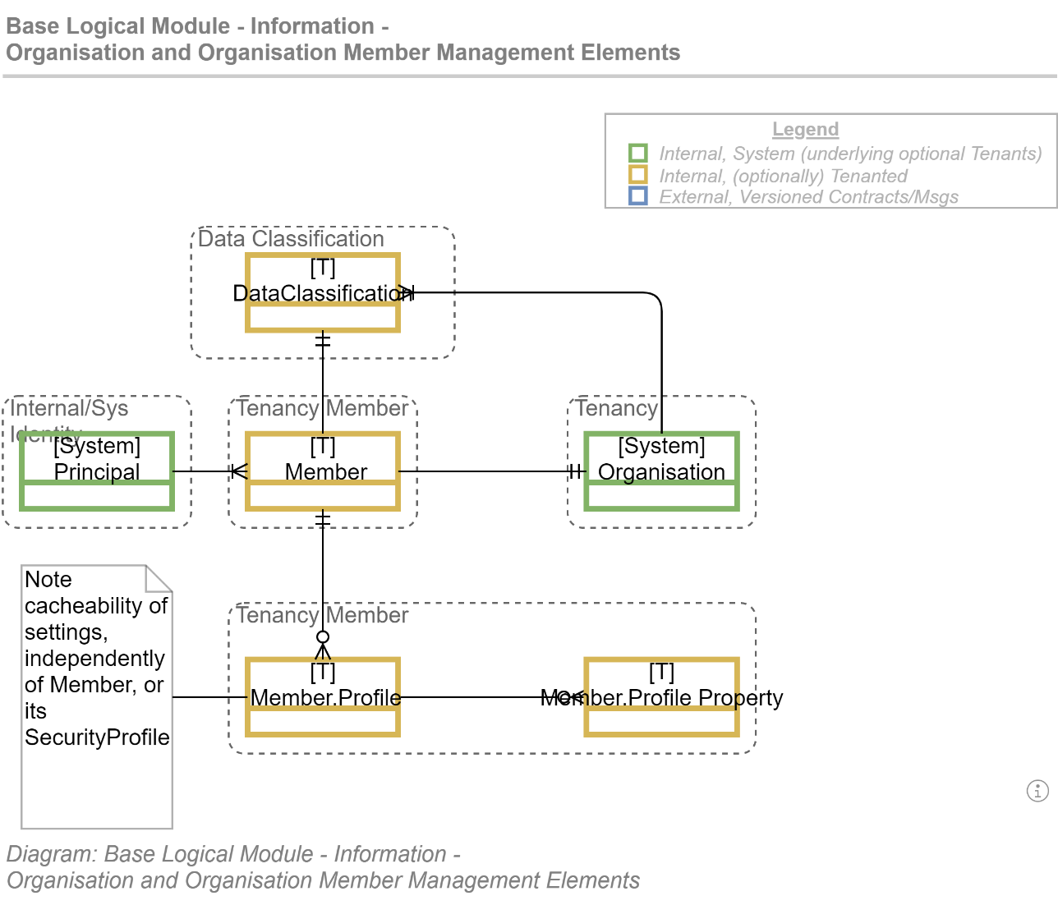

#### Elements

* **Principal:** a system User**.**
* **Group**: a collection of Members, and nested child **Group**s.
* **Member**: a User’s as projected/viewed within the context of a *Group*.   
  A Member within the Group may have a different Profile to the base User’s information, as it can be to a different Profile within another Group. An example may be User123 may be known within the “Acme, Inc.” *Group* as “JSmith”, and known just as “Jonno*”* within the local “FabFootball” club *Group*.
* **Member Profile**: a *Member*’s set of *Member Profile Properties* to capture preferences (e.g.: preferred culture, preferred view schema, preferred layout, etc.)  
    
  Note:  
  An advantage of separating the Profile from the Member is that it can be globally cached across host devices as it changes rarely.
* **Member Profile Property**: a single key/serialised value within a *Member Profile*.

  
**Note:**   
the related ORM object described in the Development View automatically handles the deserialization and serialization to provide a Typed value.

* **Data Classification**: Data Classification of the material a specific Member within a Group and its nested Group is allowed to access.

  
**Note:**  
A Member must have a Data Classification equal or higher to a Resource before they are granted access to perform Operations on it.

#### Supporting Elements

* **Principal**: a human user, remote service account or daemon service account of the system.

  
**Note:**  
The system contains an Unidentified/Anonymous/Public Principal to which all unauthenticated Sessions are associated until the session user is authenticated – at which the Session is detached from the Unidentified/Anonymous/Public Principal and attached to the identified Principal.

### Identity Management

A system Principal/User may use multiple external Open Id Connect (OIDC) capable identity providers (Google, MS Accounts, LinkedIn, etc.) to authenticate themselves.

#### Elements

* **Identity**: an element that persists information that describes the Principal User within the remote Identity Provider (IdP), associated to a remote Identity Issuer / *IdP[10]* .

  
**Note:**  
When a user enters a System Principal User’s unique system name or an email address (again, unique) the system scans the Identity table to find a) the associated Principal, and the remote IdP to send them to in order to enter their credentials.  
Depending on the API capabilities of the remote IdP the entered email can be successfully used to seed the credentials form of the IdP so that they only have to enter the missing associated Password.

* **IdP**: a small set of administrator-trusted Identity Issuers that have been configured for this system. Contains the ISS value of the remote identifier, it’s URL, etc.

#### Supporting Elements

* **Principal:** a system User**.**



**Note:**  
When a Principal User first joins the System, values extracted from the (DisplayName, etc.) Claims returned by a remote IdP are used to populate the customisable fields of the Principal’s Profile.

### Access Management

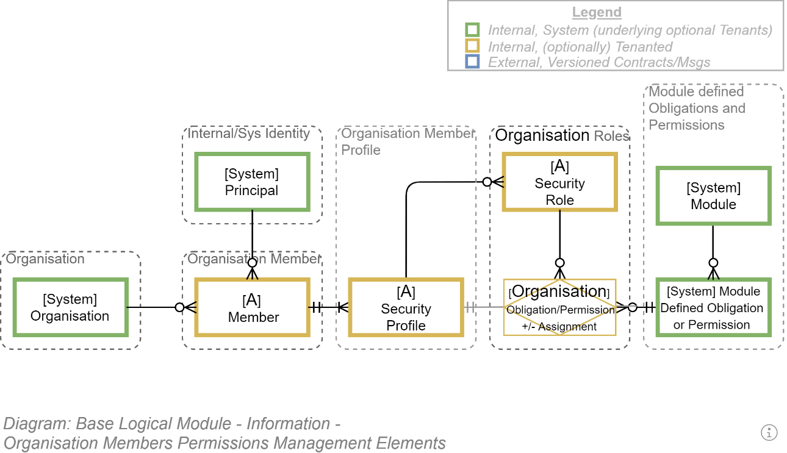

#### Elements

* **Member**: a *Principal* User in the context of a Group and its nested Groups.
* Member **Security Profile**: the cacheable Security Profile of a Member, containing a collection of Module defined Obligation titles as unique strings (e.g.: “*/SomeModuleName/SomeResource/SomePermission*”)

  
**Note:**  
a direct relational DB managed relationship between the Security Profile and a Module defined Obligation/Permission – as opposed to using a string -- is not permitted as it means a) the Module must be part of the core DB schema, and b) the Module could never unloaded.

#### Supporting Elements

* TODO

### Notification Management

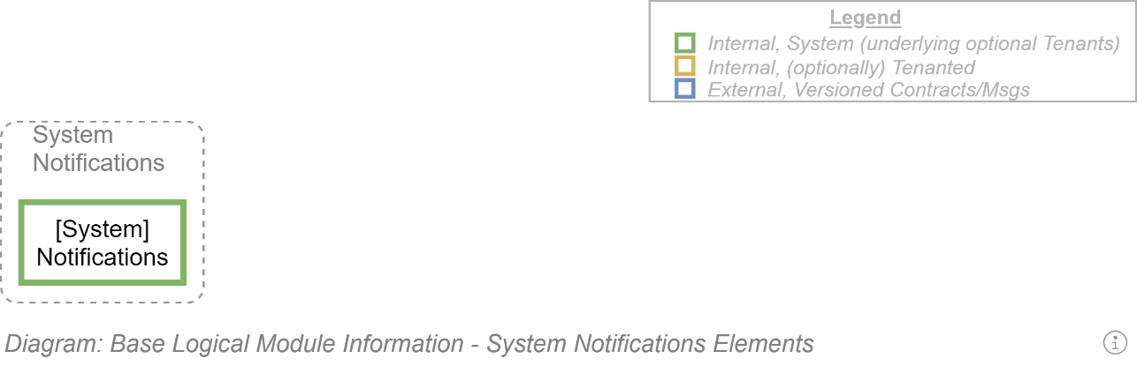

#### Elements

### Group Management

### Organisation Management

  
**Note:**This system does not manage Organisations as entities separate to Groups.   
Instead, an ad-hoc Group is flagged as an Organisation. Instead, an ad-hoc Group is flagged as an Organisation. Instead, an ad-hoc Group is flagged as an Organisation.

### Resource Collection Management

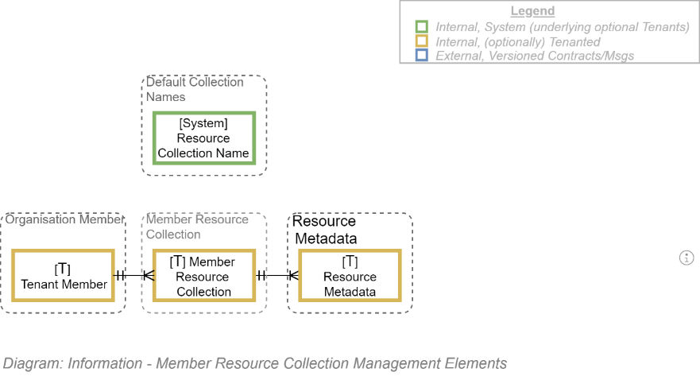

## Resource Lifecycle Management ERM Diagrams

### High level ERM

The following is an ERM showing the entities needed to persist Media/Resources, within one or more orderable **Collection**s, findable by Metadata, and Tags.

Each Resource that is uploaded into the system is persisted outside of the relational database and associated to a set of **Metadata** records within the database. At it's very minimum, the Metadata tracks where the document was stored, it's byte size, it's mime type.

Each Resource that is uploaded into the system can have one or more **Tag**s attached to it for easier finding and filtering later.

Each Resource can be associated to a **Schema**, which describes its structure. Many Resources do not have one (e.g.: an Image would not), but it is relevant to text-based media to inform the UI as to what headings to use, how long to allow content under headers, etc.

Each Resource can be associated to a Media **Template** to transform the content before display. Again, this is less relevant to images as it is to text-based media (e.g.: an XML document would be associated to an XSLT document to transform it before display).

Each Media Resource may or may not have **Usage Terms** & Conditions shaping interaction with it. These constraints can be intellectual or cultural rights. They can constrain a Resource to be used within a specific set of countries only, by members of a specific group and its child groups, for a set duration of time, for specific uses. These conditions need to be presented to the user, accepted, and recorded as a agreement by the Member. If the Conditions are updated, the next time the Member interacts with the Media they will be asked to re-agree to the changed conditions.

**E.g.:**A culture's image resources may have been lent for viewing only (not duplication or reuse), for a set purpose (on this system only), for a set duration of time (e.g.: 10 years).

A Media **Collection** is a set of Media Resources with a Natural Order (created from one or more of the media's Creation Date, Uploaded Date, Last Edited Date, Title, Mime Type, etc.)

Each Media Resource has **State** to capture its Natural Order overriding Order within a collection (e.g.: a collection may order its resources by Title – but bring attention to some resources nearer the top than they would normally sit.

Each Resource has one or more Members associated to it, in different **Roles**. A picture may have only one Accountable/Owner Member, whereas a Document may have an Accountable/Owner, several Collaborators, one or more Reviewers, etc.

**Important:**that these Roles are Media Roles, distinct from previously discussed Group Roles, and are defined in an ancestor Group.

Each time a Text based Resource is uploaded or edited, the contents are scanned for URLs, which are duplicated and persisted separately in the **Hyperlinks** table. The system periodically initiates scanning of known Hyperlinks and based on the HTTP codes returned flags the URLs to say that it has found broken links that need addressing.

Each Resource that is uploaded can be referenced via different **Aliases**. For example, a document called "OCH SAD" can be Aliased as "Online Curriculum Hub SAD", "OCH Solution Architecture Description", and "Online Curriculum Hub Solution Architecture Description".

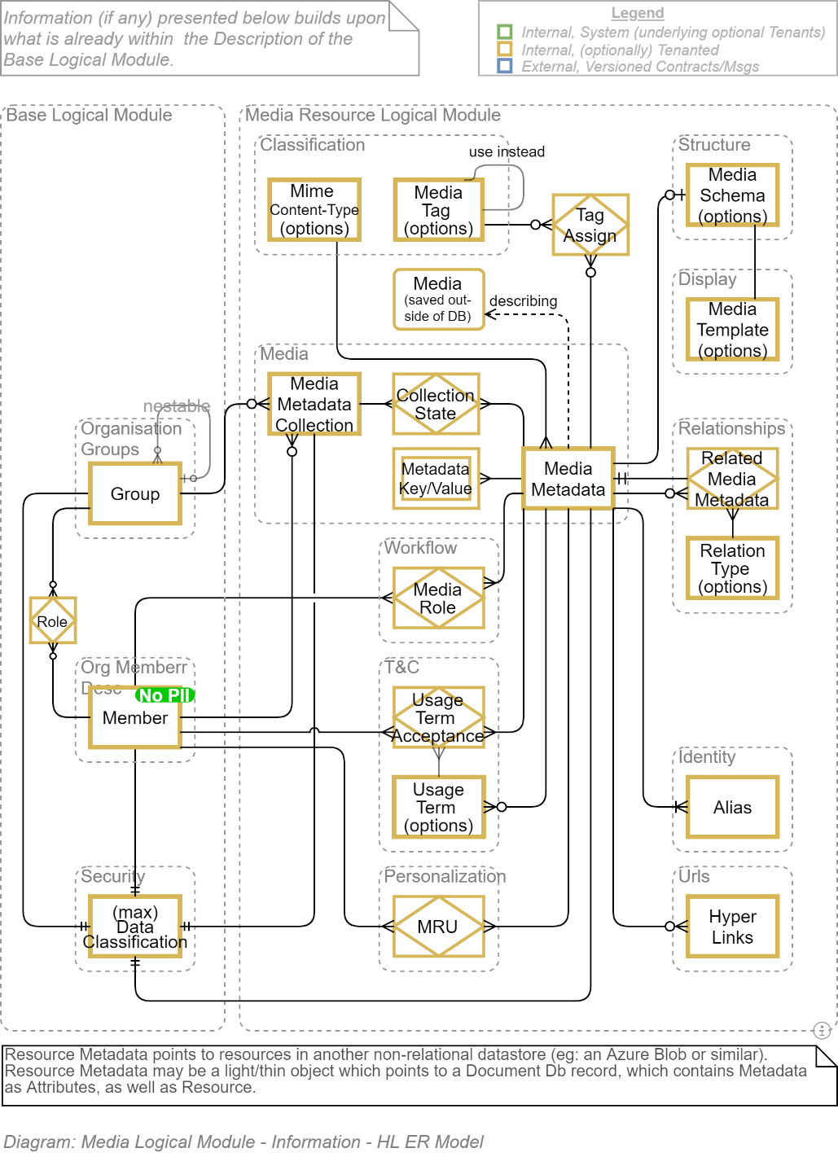

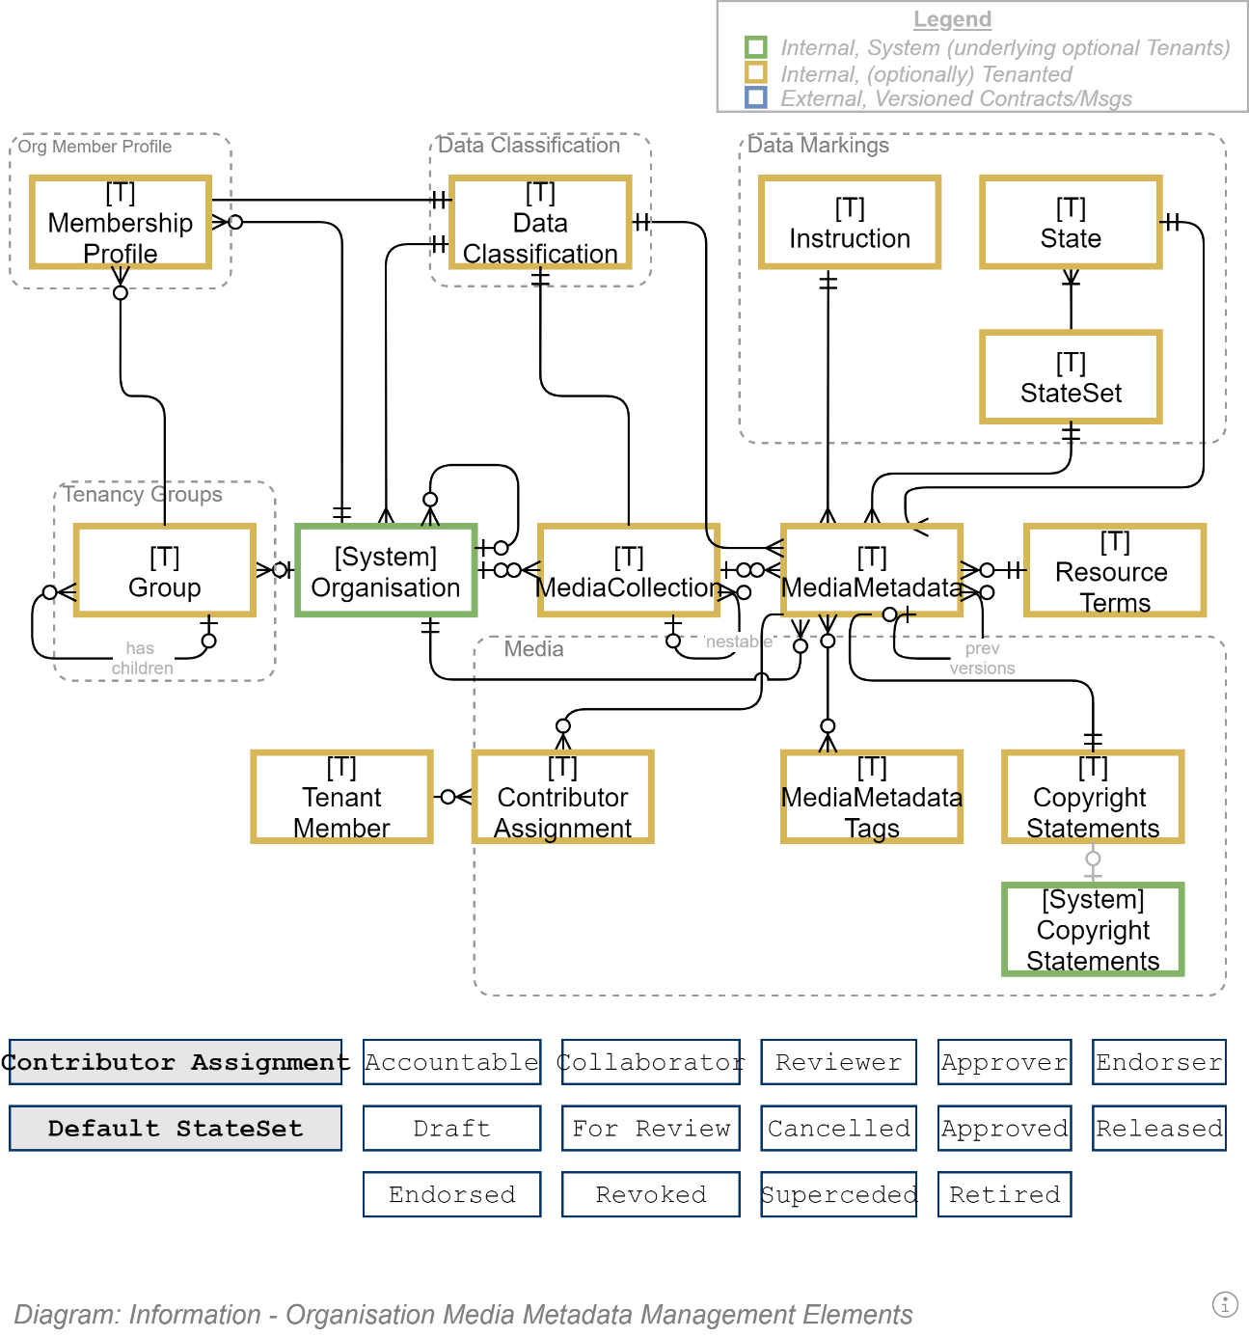

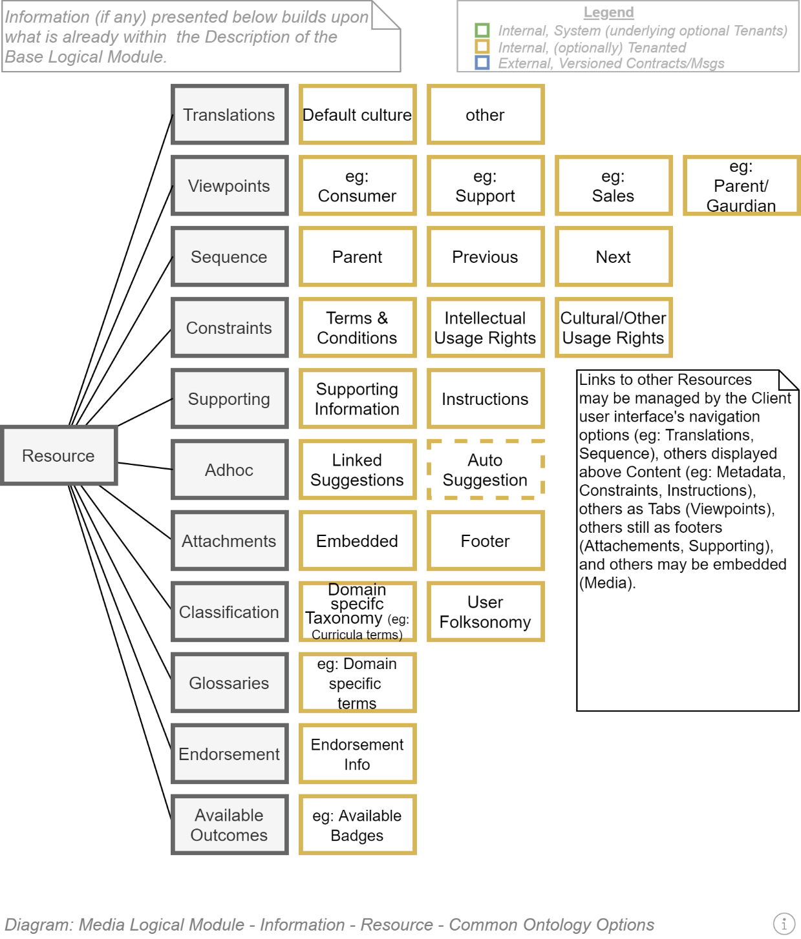

### XXX

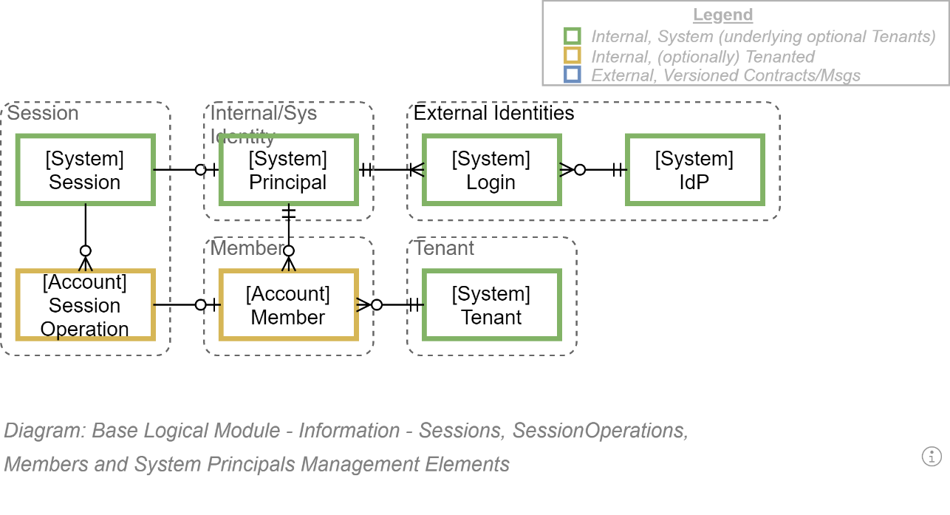

### YYY

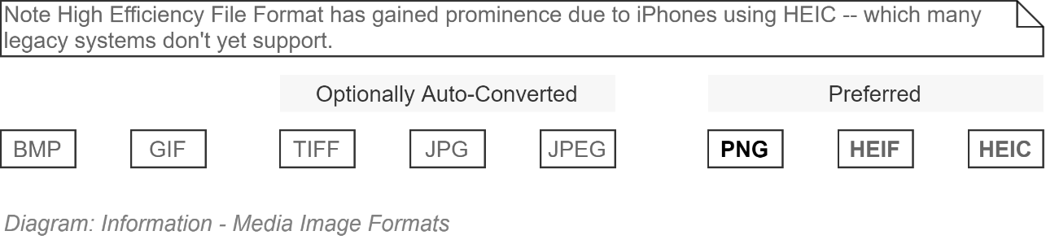

# Service Messages View

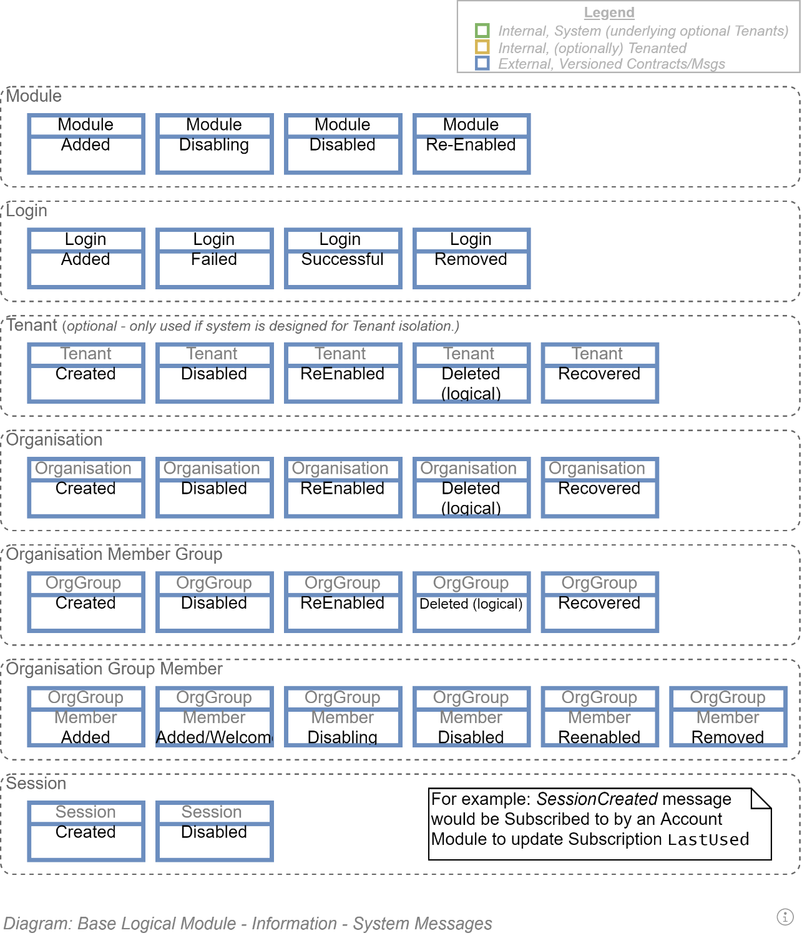

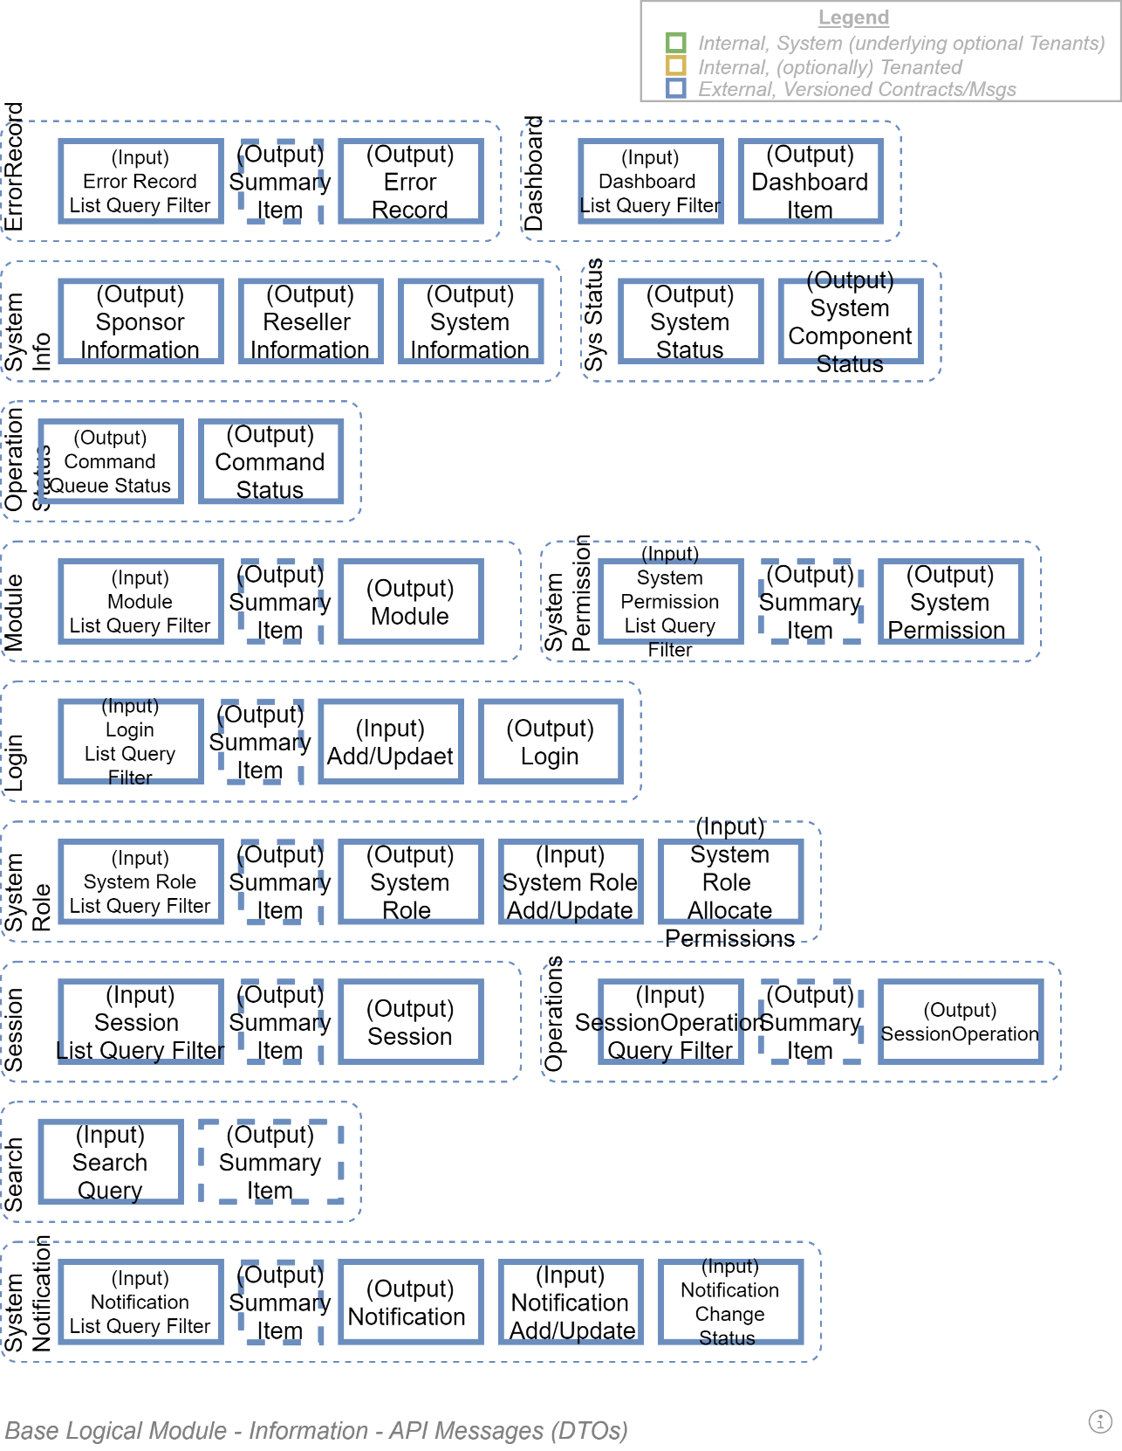

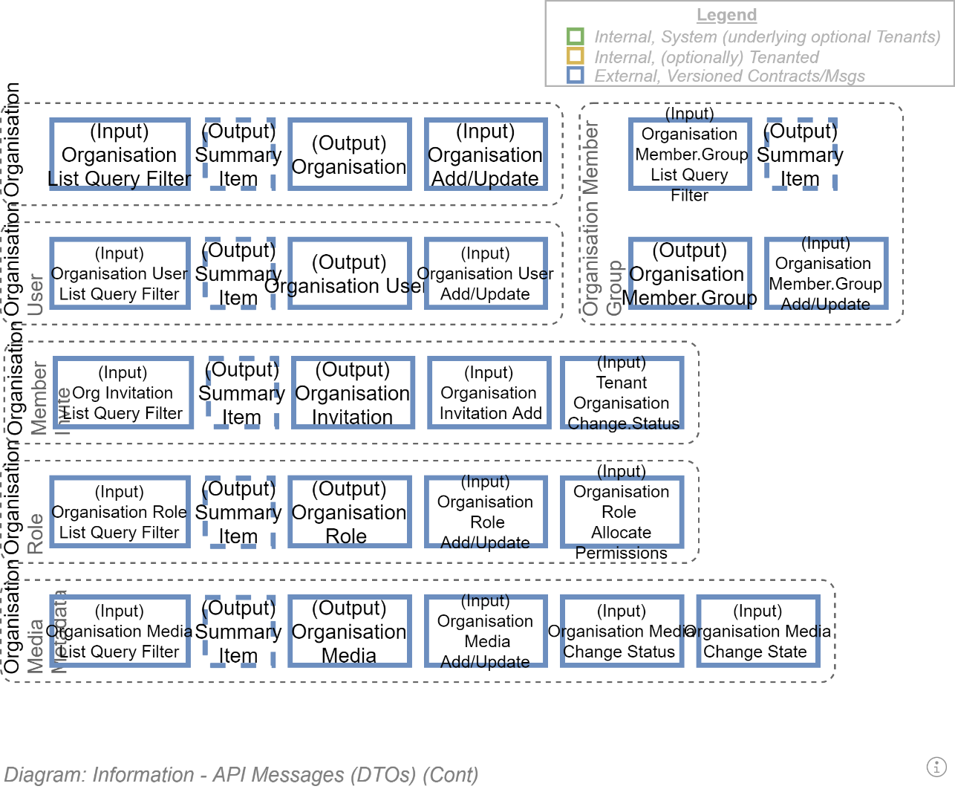

# Service Information Development View

This section describes the development of Content to be recorded within the Service Information model described in an earlier View.

## Synopsis

Systems are used to record the operations of Agents (Users) relating to Groups/Organisations. The System can be developed correctly, but still have no value if the information recorded within it is incorrect, unfindable, unrecognisable or unfinishable.

## Qualities

Information quality objectives include the following:

* **Targeted:** defining the intended audience and writing from their perspective.
* **Comprehensible:** the information's scope is limited to what is relevant and absorbable.
* **Correct:** the dissemination of factually correct truths is more valuable to society than the dissemination of misinformation
* **Relevant:** information must stay focused on topic, linking to -- instead of including -- related information.
* **Accessible:** the use of Plain language, simple diagrams and illustrations, translations, localisation, and equitable accessibility allows the widest dissemination of factually correct information.
* **Succinct:** paying attention is the diversion of energy from other achievements. Make the information quick and easy to understand, absorb and put into effect.
* **Restrained:** keep it succinct, targeted, relevant, comprehensible.
* **Action focused:** resources which take attention and time to read, but do not enable decisions that lead to immediate or deferred change do not change anything -- they just waste time and attention.
* **Classifiable**: the resource and its child elements can be classifiable and traceable within domain specific taxonomies.
* **Inter-connected:** rather than be developed and presented in isolation, information should be developed as part of a larger ontological network of resources, linking to other resources that are or may be related to the current resource's topic.
* **Atomic:** information should be designed as navigable discrete elements that are part of a larger whole, allowing for reference from multiple contexts.
* **Legal:** resources must abide by legal, commercial and cultural constraints, giving proper attribution, respecting and protecting the privacy of individuals, and using 3rd party resources within their stated conditions of access and use.
* **Recognisable:** information that reuses the same patterns and schemas are more easily recognisable and navigable, allowing for quicker finding of answers to specific areas of interest.
* **Discoverable:** metadata data must be developed about the resource to facilitate finding appropriate information via internal and global Search engines.

## Metadata

ISO-23081 provides principles and classification of metadata used to find resources within an information system.

Metadata can be classified in many ways:

* Point of Capture Metadata (type, content, structure, context, aggregation)
* Process Metadata, accumulating over the lifespan of the record (record keeping).

## Processes

ISO-15489 describes processes of record management.

## Intellectual Copyright Types

A key premise of the internet is the hyperlinking of information. An inadvertent side-effect of the internet is the ease by which users are exposed to and can reuse information within their own resource development.

It is internationally illegal to not adhere to intellectual rights and constraints. It is correct to respect cultural constraints on access and usage.

A system that allows the development of text resources should provide functionality to attribute to the resource one of several common copyrights:

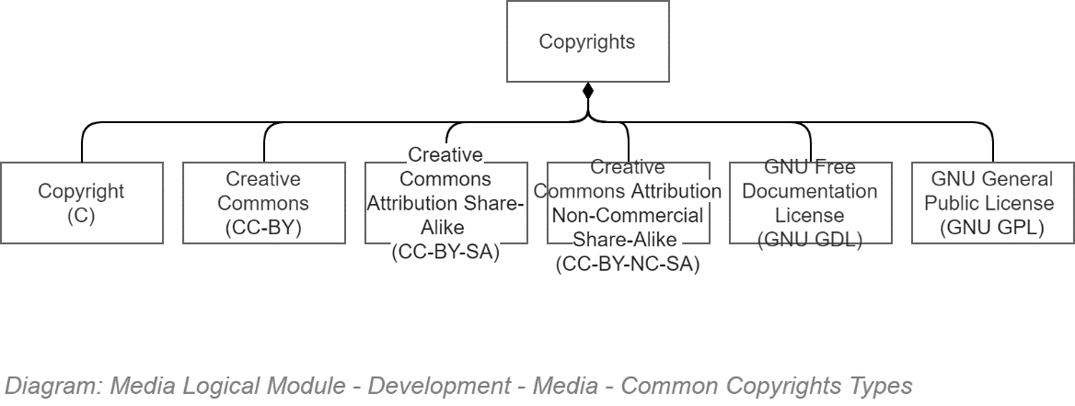

## Custom Access & Usage Terms & Conditions

Copyright or copyleft are only well-known terms & conditions on the access, usage, copying and distribution of content.

# Service Qualities View

This section outlines the Qualities expected to the service while executing its Functions.

## Section Synopsis

The solution addresses evenly and to a high level the System Qualities Objectives recommended within ISO-25010.

## Qualities versus Non-Functional Requirements

Although the terms Functional Requirements and Non-Functional Requirements are common well-known industry terms, they can produce a negative impact on system delivery. Functional Requirements developed by business stakeholders are too often perceived as first-class requirements, leaving all other stakeholders' functional requirements as second-class requirements. This observation of human behaviour, and its impact on delivering services is the basis of ISO-25010’s recommendation to not use either term and instead use the term “Qualities”.

As we are a Standards based organisation, the term Qualities is used within this View, to summarize the High Level Functional and Non-Functional Requirements, and how the solution meets these Quality Requirements.

## Constraints

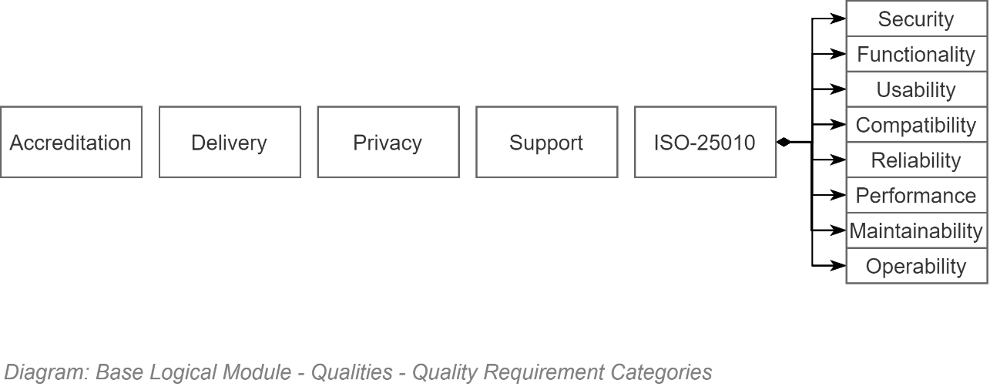

### ISO-25022:2016

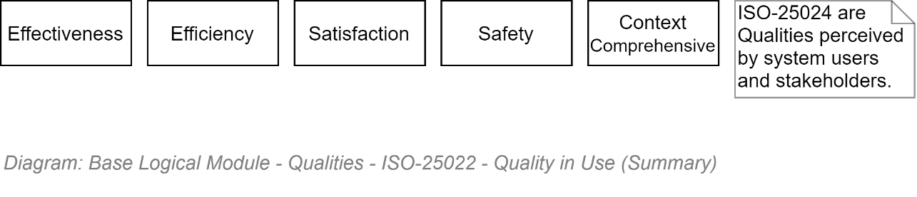

### ISO-25012

TODO: Find and add diagram

### ISO-25010

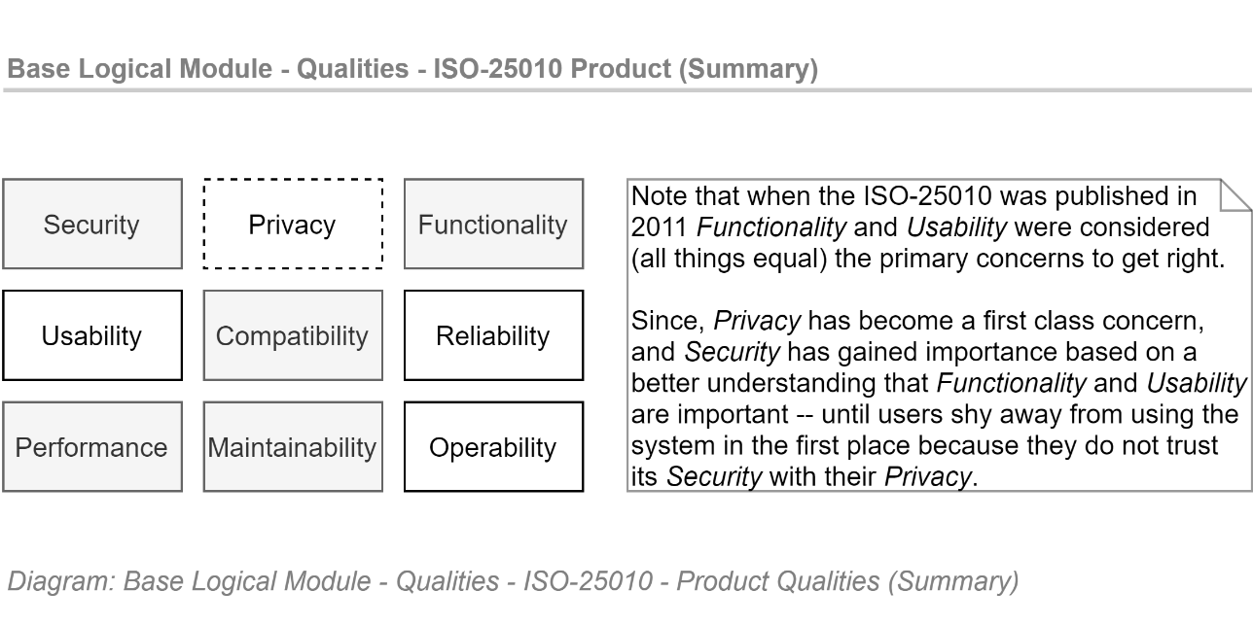

## Security Qualities

* The Core system is designed to be deployed to Microsoft Azure Infrastructure which meets ISO27001, ISO27018 Certifications and undergoes regular SOC2 reporting, addressing:
  + ISO-25010/Security/Integrity qualities.
  + ISO-25010/Security/Accountability qualities. Access to physical premises is Limited and Accounted.

**ISO-25010/Security/Confidentiality:** the design of the system allows for Core to provide itself and any additional Modules that rely on it, the following features:

Communication channels between Client and Service are only functional over HTTPS.

HTTPS encryption is negotiated between Client and Server, preferring TLS 1.2 (IETF, 2008) or better.

Note that at this point in time (Q4 2017) Azure PaaS infrastructure limits negations between Client and Server to agreeing to a minimum of TLS 1.0, which could be used by a dedicated malicious agent as a building block for a ‘POODLE ‘or ‘Heartbleed ‘exploit. The risk of a successful exploit remain Highly Unlikely.

On January 9th, 2018 Microsoft announced it will meet the PCI Data Security Standard (PCI DSS) for safeguarding payment data existing deployments 30 June 2018 deadline, by transitioned existing app services to a minimum of TLS 1.1 or 1.2 by April 30th 2018. All new App Services deployed after June 30th 2018 will be configured to agree to a minimum of TLS 1.2.

Ccommunication initiated by Core to cloud hosted services it relies on (e.g. Malware Detection Services, external IDPs, etc.), are over HTTPS.

All HTTP communication between Service Clients and the Service are redirected to HTTPS.

HTTP Cookies round tripped between Clients and Service are marked as Secure only (i.e., they are not issued by the server over HTTPS, and the Client User Agent is instructed to not transmit them over unsecured HTTP).

HTTP Cookies round-tripped between Clients and Service are marked as HTTPOnly instructing the Browser to not allow Client-Side access or manipulation of cookies, effectively ensuring they are only used for round-tripping Server state, and not used as a manipulatable instruction Message, even if well intentioned.

Communication between Core and its relational databases use IntegratedSecurity in order to not transmit the Solution’s Service Account in the clear.

**ISO-25010/Security/Authenticity** the design of the system allows for the Core to authenticate Principals (ie human Users or other Services or Systems) using the Open ID Connect (OIDC) protocol to communicate with external Identity Providers (IdP).

**ISO-25010/Security/Non-Repudiation** is provided by Core to itself and any dependent Module by having all incoming Operations permanently recorded against the current Session, for future Auditing purposes.

**ISO-25010/Security/Integrity** is provided by Core to itself any dependent Module by multiple means:

* + 1. Azure Storage Service Encryption (SSE) is applied to any Data at Rest stored on Azure Storage Service, whether it be Blob, Queue, File storage (Microsoft, 2017) or relational database (Microsoft, 2017). All data is encrypted using 256-bit AES encryption.
    - Digitally Signage of Operation Audit records is done using the host’s TLS certificate’s private key, significantly increasing the difficult of tampering with audit records.

**ISO-25010/Security/Accountability** is provided by

* + 1. The system is deployed to Azure infrastructure which (as part of its ISO27001, ISO27018, SOC2 obligations) limits, monitors and audits all access to the infrastructure and changes thereto.
    2. by Core to itself and all dependent Modules by having all incoming Operations recorded against the current Principal’s current Session, for future Auditing purposes.

## Functionality Qualities

Refer to the Functionality Qualities View for a high level view of the Functionality designed to be in Core, for use by the various User groups, including but not limited to:

Infrastructure Support Specialists

Application Support Specialists

Security Specialists

Business Support Specialists

Business Users

Public Users

**ISO-25010/Functionality/Appropriateness** exceeds the immediately required functionality.

**ISO-25010/Functionality/Compliance:** the system meets:

Privacy Requirements: the system keeps records in-system for the duration, and no longer, the records are needed to meet functional requirements while meeting regulatory obligations.

Auditing Requirements: the system performs logical deletes and auditing of records to meet its security and archiving obligations.

## Usability Qualities

Core functionality is exposed via

**ISO-25010/Usability/Learnability** is provided by

the Core adheres to Well-Known REST URL patterns aiming towards Semantic URLs (Wikipedia, 2018),

adheres to the easily learnable ODATA (OData, 2017) query syntax.

Self-documents itself using the OpenAPI Specification (Open API Initiative, 2017).

Provides a human readable and testable Swagger (Swagger, 2017) page to investigate API functionality.

**ISO-25010/Usability/Error Protection** the Core and any dependent Module by capturing Unexpected Errors and logging them along with their associated Stack Trace. The service can be configured to publish the error itself (but of course only in Debug/Non Production mode) or replace the error with a general error message, with the unique reference identifier of the Error Record, for subsequent analysis by Customer Support.

**ISO-25010/Usability/Accessibility**

Language accessibility: the design of the system allows for Core to provide for itself and any dependent Module the ability to switch languages where appropriate (eg: from English to Maori, and back again).  
  
Note that this functionality is expected in order to meet compliance objectives and obtaining accreditation to operate from an accreditation review board.

Visual Impaired accessibility issues are generally associated to visual user interfaces (which Core does not provide), and not APIs. That said, the APIs can be utilized by Accessible client user agents.

**ISO-25010/Usability/User Aesthetics** is associated to visual user interfaces, and not APIs, and therefore are largely irrelevant. That said, if a Decision to include interfaces within the System, they will be bound to the Principles, which constrain the system being developed while addressing these constraints.

**ISO-25010/Usability/Operability** is associated to user agents, and not APIs directly.

## Compatibility Qualities

**ISO-25010/Compatibility/Interoperability:** all resources are appropriately accessible via secure confidential APIs that conform to NZ Government API standards:

New Zealand Government API Standard and Guidelines (ICT, 2016). Specifically, Part B (Technical), which recommends the use of Representational State Transfer (REST) (Fielding, n.d.).   
REST is a industry accepted assembly of well-established standards such as URI, HTTP, HTTPS, etc. to deliver the following characteristics:

* + 1. Client-Server Architecture
    2. Statelessness
    3. Catchability
    4. Layered System
    5. Code on Demand
    6. Uniform Interface

Resource Identifiers in Request

Resource Manipulation through representation.

Self-Description Messages

HATEOS

**ISO-25010/Compatibility/Interoperability:** The information is serialized to:

ISO/IEC 21778:2017: JSON (ISO, 2017) (default format)

XML (W3C, 2006) (optional format)

**ISO-25010/Compatibility/Interoperability:** API data is queryable using:

Open Data Protocol (ODATA)

* + 1. ISO/IEC 20802-1:2016: Core (ISO, 2016) and
    2. ISO/IEC 20802-1:2016: Part 2: JSON Format (ISO, 2016)

**ISO-25010/Compatibility/Coexistence:** the Core service and its dependent Modules are deployed to Azure PaaS infrastructure shared with other systems.

the service does not read or write any user media from the underlying file system, mitigating against loss.

Note: It is an Azure feature that systems are deployed to different infrastructure as and when needed based on load. In rearranging system instances, Microsoft cannot guarantee systems are deployed to the same hosts. This in effect means that any files written to the underlying Filesystem will be “left behind” when moves happen.

## Reliability Qualities

The Service is

Deployed to Standard Azure Infrastructure which:

Has an overall Service Level Agreement (SLA) of 99.9% per billing month (Microsoft, 2017).

Note:  
Microsoft surpassed the above SLA in 2016 by almost 100x, having consistently had global uptime upwards of 99.9979% for Compute in the past 12 months alone (Microsoft, 2017).

Is deployed to Standard Azure App Services (again, with an SLA of 99.9% per billing month), to handle traffic surges by automatic horizontal scaling to and from additional PaaS host instances, triggered when customizable CPU minimum and maximum average thresholds are reached.

Although largely irrelevant when Horizontal Scaling is implemented to provide instances as needed, each individual Standard instance can be expected to be able to handle 4000 sustained client-server requests per second.

**ISO-25010/Reliability:** the Core provides to itself and any Modules that depend on it Reliability by the combination of multiple solutions:

the system uses client-side caching instructions to minimize unnecessary duplicate requests for Media (Images, documents, etc.).

**ISO-25010/Reliability/Availability:** the system is deployed to Azure’s Standard PaaS AppService infrastructure which by default

Is backed with an SLA providing 99.9% availability per month billing cycle.

Provides dynamically horizontally scalability to handle sudden peaks in demand.

the Core service implementation protects itself and any reliant Module by providing protection from Denial of Service (DoS) attacks at two levels:

* + 1. within the System level: by allowing only a customizable number of similar requests from the same IP within a period of time (e.g.: 30 resource requests /sec to allow for a page of data).
    2. at the PaaS infrastructure host level: Azure offers a baseline Web Application Firewall (WAF) protection of its infrastructure and their clients applications deployed to it based using active AI.

An Additional Client-Customizable WAF Service is available from Microsoft Azure that can be subscribed to, but should not be implemented until there is observed risk requiring active control.

**ISO-25010/Reliability/Fault Tolerance:** the system is stateless, captures unexpected exceptions, logs them, and returns a meaningful but sanitised error message to end users, before releasing resources in order to process another operation.

**ISO-25010/Reliability/Recoverability:** the system recovers from operational errors. See ISO-25010/Reliability/Fault Tolerance above.

## Performance Qualities

* **ISO-25010/Performance/Time behaviour/Start-up performance:** the start-up time required by the system after a new deployment is dependent on the Database as Code (DbaC) operations that are scheduled – but in general new deployments will take less than a minute to perform. During this start-up time

Client User Agents making API calls will receive a recoverable timeout error code if the transition takes several minutes – otherwise simply take longer to complete their operation.

If any Business User facing MVC Interfaces are developed (there are absolutely no plans to) Users will instead be presented with an offline.html page explaining the delay.

**ISO-25010/ Performance/Time behaviour/Response times:** the system is expected to be optimizable so that basic Core API Operations complete on average in <150ms. More complex operations could be optimized to complete on average will complete in <800ms.   
  
Note:   
By design no Core API operation will take longer than 1sec. “caching closest to source, in the format closest to use”, is a design principle extensively used to improve responsiveness and therefore user experience.

**ISO-25010/Performance/Time behaviour/Recover times:** any time required to recover from an unexpected exception raised during an API operation is negligible (in most cases would be expected to less than the time required to complete the requested Operation successfully).

**ISO-25010/Performance/Time behaviour/Shutdown time:** after a shutdown command has been issued, queued parallel thread operations may take up to 60 seconds to gracefully complete activities before complete shutdown. This is a feature of how C# Threading works.

**ISO-25010/Performance/Resource Utilisation/CPU & Memory:** the Core system and its dependent Modules are deployed to Standard Azure AppService infrastructure, where available CPU and Memory is for all intents and purposes simply a question of how much one is willing to pay for. A basic Standard package of memory and CPU is sufficient.

Note that an average CPU usage is used as the trigger to elastically scale horizontally to meet ISO-25010/Availability Quality objectives.

**ISO-25010/Performance/Resource Utilization/Capacity & Throughput:** the Core system and its dependent Modules can handle 400 concurrent Operations per host instance, elastically horizontally scaling as required to meet peek and surge needs.

Note: this dynamic scaling is (economically) untestable but this feature is a key driver behind the Decision to using Azure PaaS infrastructure to host the system upon. Testing should be limited to reproducing escalation from 1 server to 2, based on a CPU trigger artificially low for proof of logic reasons. Soak testing the system for long durations with high loads is specifically out of scope.

## Maintainability Qualities

**ISO-25010/Maintainability/Modularity:** the component architecture follows Domain Driven Design (DDD) component design patterns, which promotes clean separation of domain functionality into distinct logical deployment components.

**ISO-25010/Maintainability/Reusability:** the code base is hosted in Git, can be cloned in order to develop clones. The system functionality allows for the reuse of executing systems for additional tenancies.

**ISO-25010/Maintainability/Analysability:** the system records Exception Report Records that can be accessed via API by analysis tools of the organisation’s choice. In addition, the system is hosted on virtual infrastructure for which free Monitoring tools are available (such as App Insights).

**ISO-25010/Maintainability/Modifiability:** Development of the code within BASE is stipulated to follow base practice SOLID development patterns.

**ISO-25010/ Maintainability/Stability:** the system is deployed to dynamically horizontally scalable virtual infrastructure, is monitored, records error logs, recovers from unexpected errors and is by design stateless.

**ISO-25010/ Maintainability/Testability:** fully automated testing is managed within the delivery pipeline. Automated testing is used to cover Static testing, logical Code Tests, Integration Testing, Functional Testing, Horizontal Scalability.

**ISO-25010/ Maintainability/Configurability:** the system follows industry conventions for configurability (namely deployment pipeline management of deployment target specific web.config settings).

**ISO-25010/ Maintainability/Installability:** the system is deployed via a workflow based automated pipeline.

**ISO-25010/ Maintainability/Scalability:** by the components used to develop the system are both dynamically horizontally scalable to handle operations requests and deployed to infrastructure that can be vertically scalable as required.

Note:   
The system is expected to be able to be optimizable to handle the execution 2000 operations second within a 1 second delay, on a single instance of standard virtual infrastructure.

**ISO-25010/ Maintainability/Localizability:** the system incorporates cached resource localisation services that Modules can use for the purpose of localizing text resources within User interfaces.

## Portability Qualities

ISO-25010/Portability/Adaptability

ISO-2510/Portability/Installability

ISO-25010/Portability/Replaceability

## Supportability Qualities

ISO-25010/Supportability/Principal Provisioning

ISO-25010/Supportability/

ISO-25010/Supportability/Principal Password Reset

ISO-25010/Supportability/Principal Role Assignment

ISO-25010/Supportability/Principal Delegation

ISO-25010/Supportability/Principal Status Reporting

ISO-25010/Supportability/Principal Off-ramping

# Service Functionality View

This section of the document describes the operations available to users to manipulate the information managed by the information system described in this SAD.

## Section Synopsis

Multiple user groups use the system – at least five foundational groups other than business users and customers. This section describes the operations the system provides for each one of these groups.

## Overview

Multiple user groups use the system. From the foundation parts up, there are the operations specialists who deploy and configure the system, the security specialists who monitor the system, the support specialists who answer user inquiries, investigate and sometimes act on behalf of the user for general system issues, the business support users who can help business users and customers with specific issues beyond general support issues, business users

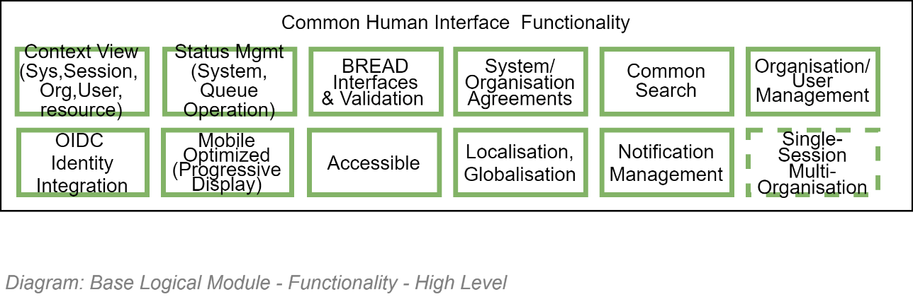

## System Management Functionality

### High Level System Information Management Groups

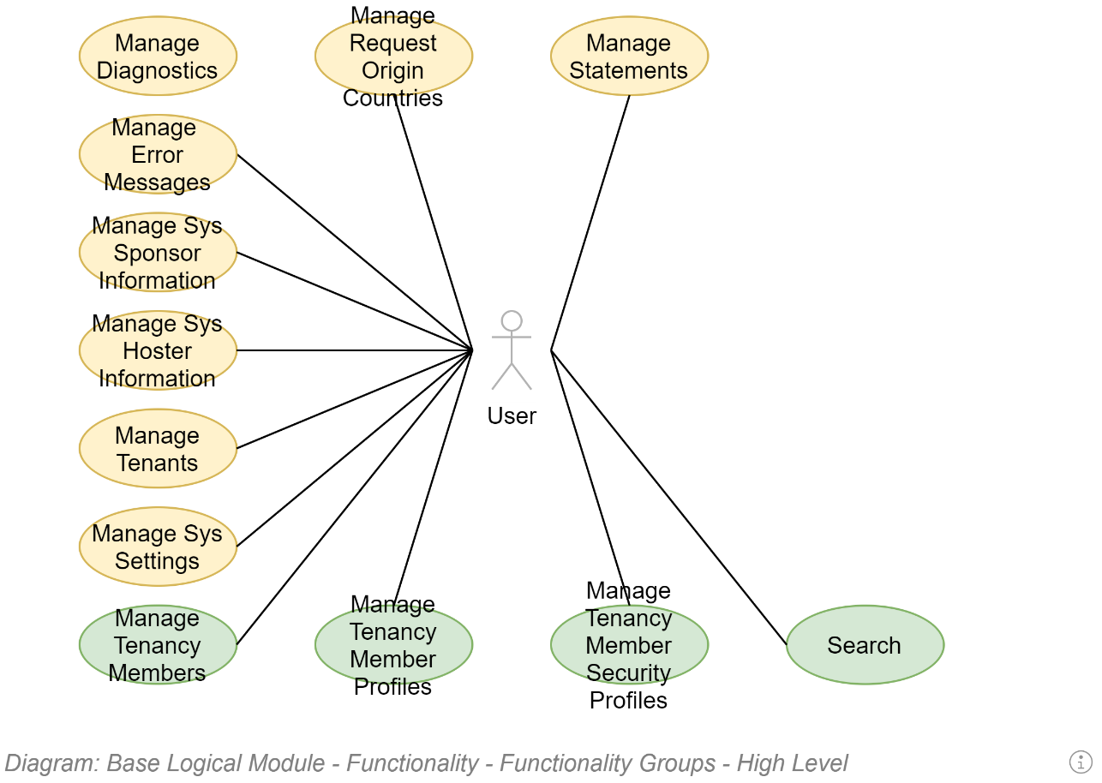

### System Configuration Management Operations

Configuration can be broken down into immutable (unchangeable) configuration and mutable settings (that can be changed without re-deploying the system).

#### Objectives

A maintainability quality objective is to have the least number of immutable settings so that operations specialists can accommodate change without requiring a notified and disruptive re-deployment of the system. The general pattern in to locally cache all immutable settings[11].

#### System Configuration Management

#### 3rd Party Service Integration & Configuration Management

All mature systems rely on a standard set of core service components:

##### Data storage Configuration Management

A system generally manages a variety of information types:

* **Configuration settings**: a combination of a minimal use of the solution’s local configuration file where configuration settings can be found to subsequently find a remote secure storage service -- such as a key vault – to retrieve secure configuration credentials and settings to access other forms of services.
  + **Local Host Configuration**: a local INI, XML, YAML or similar configuration file, which has the URL for the remote secure storage service, where most configuration settings are persisted (see Deployment and Security Views for an explanation of why the local configuration file is not to be used for persisting service account information).
  + **Remote secure storage**: a remote storage service specialised at persisting configuration information securely. It is in here that the URLs, credentials (usernames and passwords, etc.) required to access other 3rd party services (storage, mail, etc.) are persisted.
* **Information records**: the key point of the solution -- the user data itself -- is persisted in a relational database for fast indexed retrieval, the reduced storage infrastructure requirements associated to the use of relational data schemas, the mature backup and restoration strategies appropriate to DR, etc.
* **Media with Metadata**: text (json) based schema-less (“noSQL”) “document databases” are used for the storage of text-based media and documents, with accompanying descriptive metadata. The metadata provides classification information for faster retrieval later -- at the expense of relationality and larger storage needs than relational databases.

  
**Note:**  
It is considered poor design to persist media in a relational database: it increases database backup needs (space and time to finish), and in doing so increases the risk of failure to backup or restore correctly when needed.

* **Images Blob storage:** cloud-based file storage for storing of media when there is no need to persist associated metadata.

  
**Note:**  
although similarities exist between document storage and blob storage, the decision of which to use depends on the use case: blob storage is generally cheaper than document storage, at the expense of being searchable without an external indexing solution.

  
**Note:**  
Alternate (often custom) backup/restoration processes are needed for document and blob backup and restoration.

The services are used by the default service client user interfaces to make these operations available to appropriate end users (e.g.: system administrators).

##### Caching Configuration Management

A performance quality objective is to cache the maximum number of settings in order to make redundant the maximum number of I/O operations required on every request.

A performance quality objective is to cache information in a format closest to the intended use, rather than source – so it is common to cache multiple copies of the same unstructured presentation text, in different languages, rather than a source structured (unpresentable) record.

The information that requires being persisted in a secure storage service includes:

* **Service URL** (protocol, URL including port) of a remote, shared (global) caching service
* **Service configuration flags**
* **Service Credentials** (Username and Password -- unless authentication is being handled by something like Microsoft Secure Identity (MSI)).

  
**Note:**   
The use of caching impacts development approaches so significantly that it is the reason for it being a requirement that it be implemented early -- before or just after data access logic is developed -- rather than put off till later.

The services are used by the default service client user interfaces to make these operations available to appropriate end users (e.g.: system administrators).

##### Authentication Configuration Management

The remote secure storage service must be used to persist the URL, optional configuration flags, service agent credentials of the remote service.

The system must provide an externally appropriately accessible service to retrieve these values. The configuration value is most likely immutable (i.e., unchangeable), therefore the service is not required to manage updating these values.

The services are used by the default service client user interfaces to make these operations available to appropriate end users (e.g.: system administrators and security specialists).

##### SMTP Configuration Management

All services are expected to send out asynchronous notifications of key information to system users regarding.

Common asynchronous message types may include some of the following:

* Onboarding/offboarding messages welcoming new users and providing system specific (as opposed to organisation-general) tips
* Changes to Terms & Contracts explaining why users will have to reaccept T&C’s when they next sign in.
* Upcoming Site maintenance work that will take the system offline for a small amount of time.
* Password reset instructions – although the actual workflow messages should be issued from the remote Identity Provider (IdP) service in question.

The remote secure storage service must be used to persist the URL, optional configuration flags, service agent credentials of the remote service.

The system must provide an externally appropriately accessible service to retrieve these values. The configuration value is most likely immutable; therefore, the service is not required to manage updating these values.

The services are used by the default service client user interfaces to make these operations available to appropriate end users (e.g.: system administrators).

##### Search Configuration Management

Users take the time to persist information into an information system, with the expectation that they will be able to find the information again later.

Users expect to be able to easily find information without having to know or remember all the specifics of where and how it has been stored.

Users expect to find publicly accessible records via Google web services.

Users also expect to be able find non-public records to which they are permitted access -- to use a system specific, text based search service, much like Google’s web search, that forgives spelling mistakes, accepts input in different languages, and makes reasoned guesses as to the users’ actual intent.

The remote secure storage service must be used to persist the URL, optional configuration flags, service agent credentials of the remote service.

The system must provide a service to retrieve these configuration values. The configuration value is most likely immutable; therefore, the service is not required to manage updating these values.

The services are used by the default service client user interfaces to make these operations available to appropriate end users (e.g.: all users).

##### Malware Validation Configuration Management

Users upload media. In the most trivial of cases, they upload an image of themselves for their User/ Group Membership Profile and images to distinguish User Groups from each other (Logos, etc.). More mature systems allow for end users to upload documents.

Anything that is added to the system beyond the initial deployment process must be validated as being free of Malware in order to protect viewers/downloaders of the media, and – by proxy – the reputation of the organisation[12].

The remote secure storage service must be used to persist the URL, optional configuration flags, service agent credentials of the remote service.

The system must provide a service to retrieve these values. The configuration value is most likely immutable and therefore the service is not required to manage updating these values.

The services are used by the default service client user interfaces to make these operations available to appropriate end users (e.g.: authenticated users invited to work collaboratively in a group).

##### Reporting Configuration Management

Decision making stakeholders do not always actually use the system they are responsible for providing governance for. Instead, they rely on reports developed by others.

The remote secure storage service must be used to persist the URL, optional configuration flags, service agent credentials of the remote service.

The system must provide a service to retrieve these configuration values. The configuration value is most likely immutable; therefore, the service is not required to manage updating these values.

  
**Tip:**It’s worth considering generated reports as Views that are in many ways the most important Views, as they are those used to report on the project to sponsors, who determine if and when a service is no longer valuable…

The services are used by the default service client user interfaces to make these operations available to appropriate end users (e.g.: project owners).

##### Analysis Configuration Management

What to report to project sponsors is developed from analysing existing data.

Common analyses include single or combinations of the following:

* Change over time of number of non-authenticated users over time, indicating exposure.
* Change over time of number of authenticated users, indicating satisfaction with service.
* Change over time of number of authenticated users who have not logged in over a longer period, indicating non-relevance of resources.
* Change over time of number of sequential search requests per page before a link is clicked, indicating reliability of search.
* Change over time of duration between page request and next operation, indicating usability and operability.
* Change over time of sequential links within resources clicked, indicating cohesion of material offered.
* Change over time of the device resolutions used, indicating movement towards or away from smaller or larger devices.
* Change over time of number of requests processed over a duration, indicating performance.
* Sum over time of infrastructure used (storage, caching, etc.) indicating future costs coming up.
* Change over time of the number of errors per duration (e.g., per day) indicating quality of system.

The remote secure storage service must be used to persist the URL, optional configuration flags, service agent credentials of the remote service.

The system must provide a service to retrieve these configuration values. The configuration value is most likely immutable; therefore, the service is not required to manage updating these values.

The services are used by the default service client user interfaces to make these operations available to appropriate end users (e.g.: operations administrators).

### System Mutable Configuration Management Operations

The local relational database is used to persist mutable system configuration settings.

Settings include:

* Localisation:
  + Preferred user interface culture-locale.
* Performance:
  + Duration of short, medium and long global/distributed caching durations.
* Recognisability:
  + Host Organisation’s Title, Description, Logo.
* Supportability:
  + Support group’s contact channel identifiers (email, phone, address, etc.)

The system must provide a service to retrieve, update, and reset to default settings these configuration values.

The services are used by the default service client user interfaces to make these operations available to appropriate end users (e.g.: system administrators).

### System Module Management Operations

The system is modular, such that it lets System Administrators load or unload discrete packages of functionality.

System Administrators must be able to see what modules have been installed, by whom, when, and the version of the module. Service Administrators must be able to disable and re-enable a module’s functionality without having to redeploy the whole system.

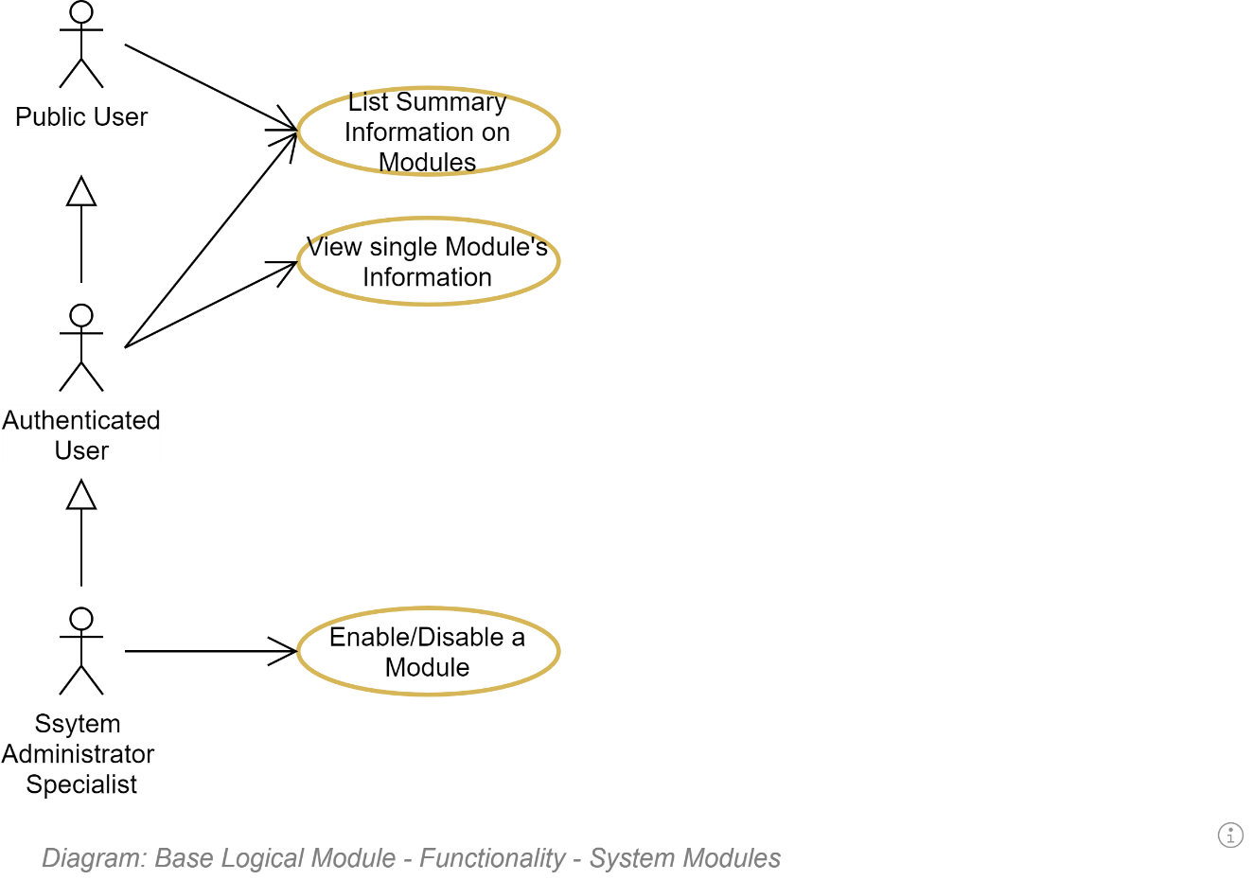

### System Module Permissions Management Operations

Each Module – i.e. discrete section of the whole system – defines its own set of immutable Permissions.

Which can later be associated to default or custom Group Roles.

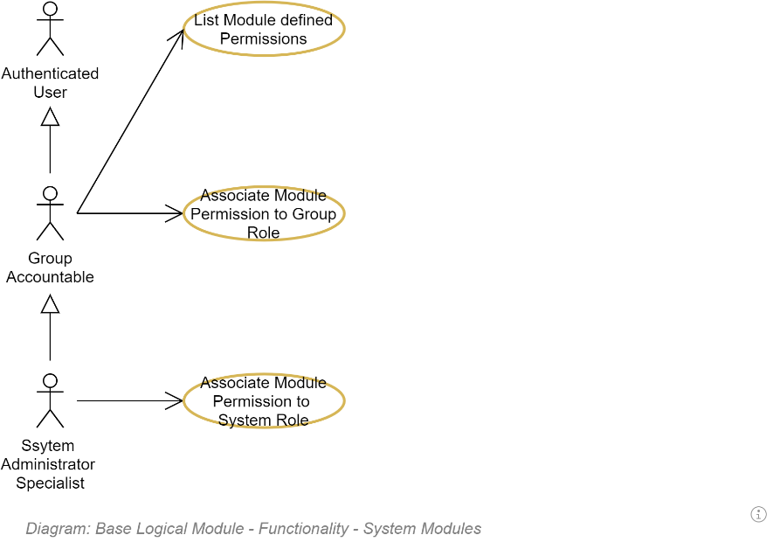

For example, if loading a Business Module to handle Contacts, it may define the following Permissions.

* Contacts/List
* Contact/Read
* Contacts/Write
* Contacts/StateChange

Which can be allocated as needed.

**Note:**Permissions are not the same as API Operations – there can be multiple Operations to write to a Contact, all associated to a single Permission (Contacts/Write).

**Note:**some of automatically associated to System Roles and do not need to be setup for Admins to use them.

### System Diagnostics Management Operations

System Operators need to diagnose activity and error logs to determine the cause of unexpected behaviour.

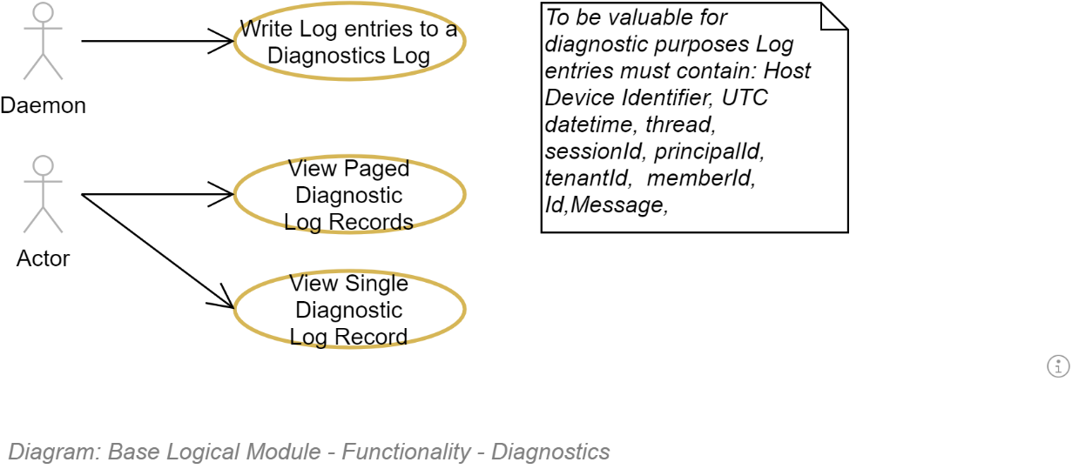

### System Information Management Operations

Systems are often deployed with hard coded Name, Description, etc.

But both the automated deployment pipeline’s service agent and the human system administrators must be able to update the name and logo of a system without having to redeploy the whole system.

The name, title, description of an installation can be provided by the automated deployment pipeline.

The information can later be overridden by the Service Administrator, writing to a mutable value store.

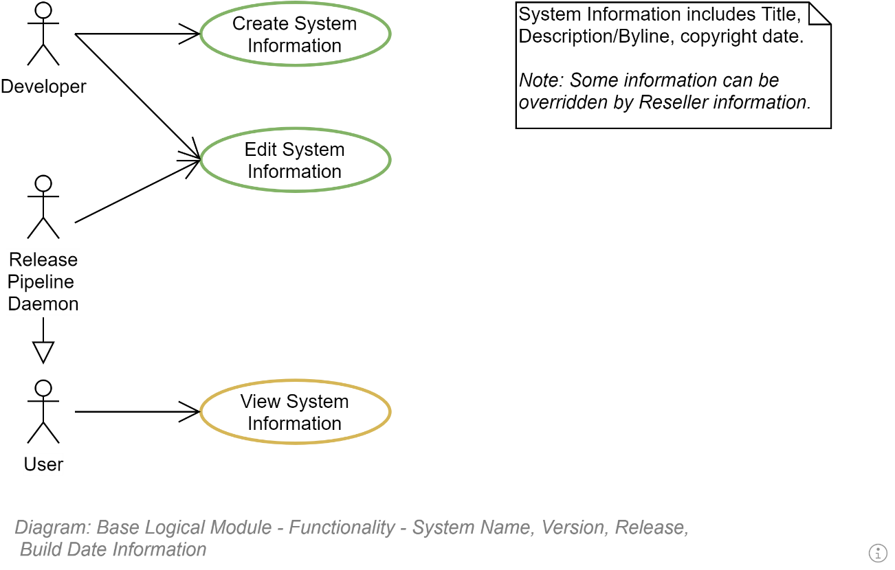

Developer information – who wrote the software – should also be readily accessible in order to contact for in-depth knowledge of the system.

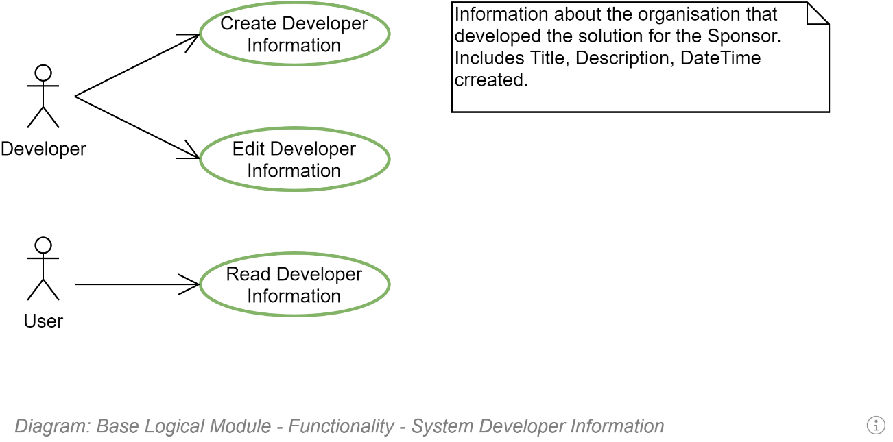

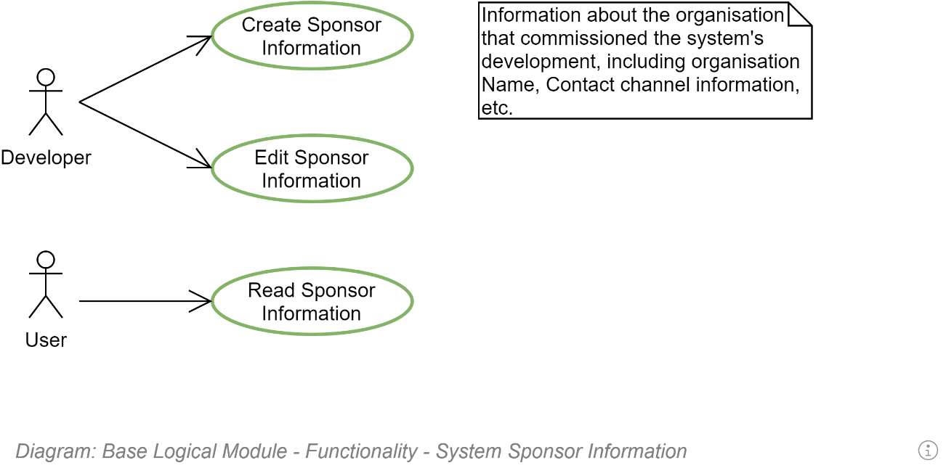

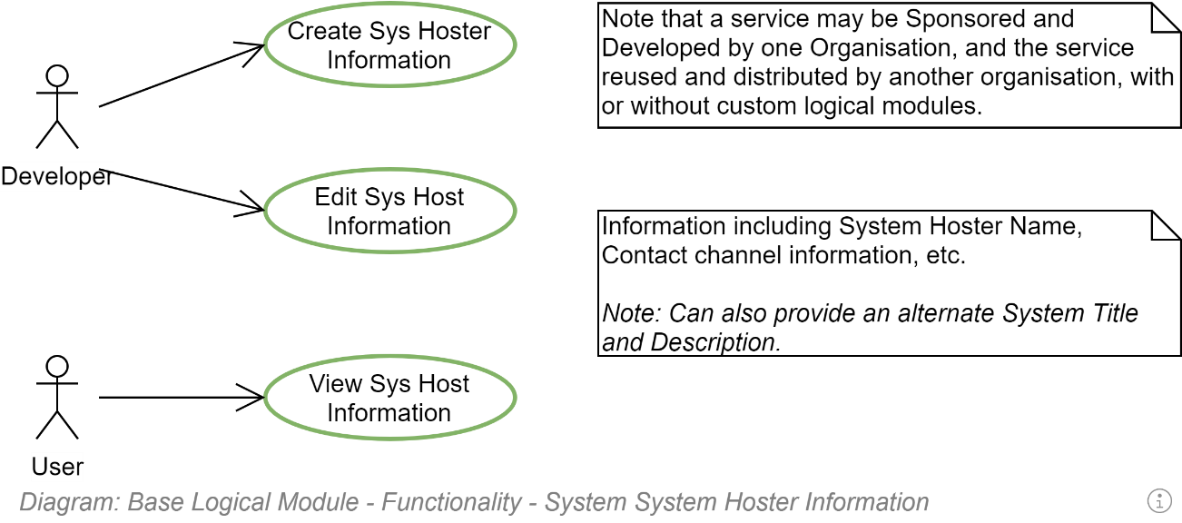

### System Error Management Operations

System Administrators must be able to view the reports of unexpected behaviour which occurred in the system.

Error reports should contain the time they occurred, the session, request identifier, thread, a title/description as to the cause, a sanitised copy of the execution stack trace and -- if the diagnostics tracing service is correctly configured to be able to do this -- a copy of the trace messages that occurred during the same request, to provide context information.

The information should be available via API to be invoked from the service’s dedicated service client user interface, and optionally imported into an organisation wide error management service.

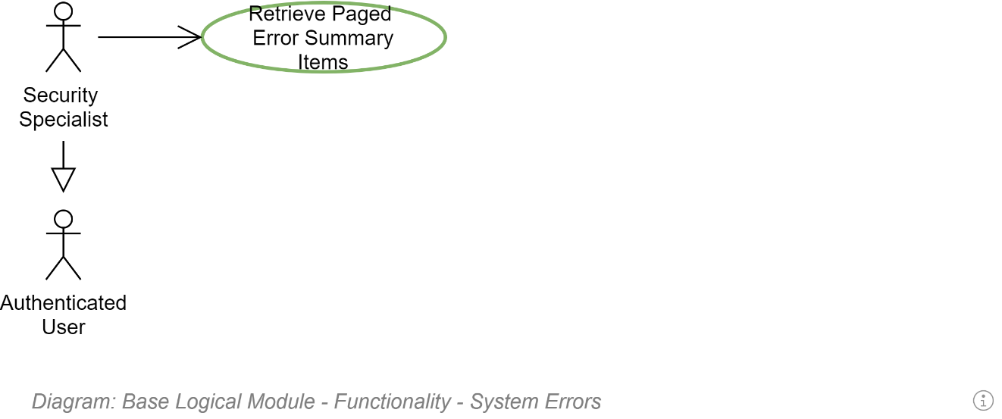

### System Status Management Operations

System administrators must be able to alert users to upcoming changes (most often planned outages and redeployments) to the system.

System administrators must be able to present more than one message at a time (although one or two is probably the max that is reasonable before an alternate method of broadcasting information is used).

A Notification has a nullable start and expected end date, a title, description, and icon.

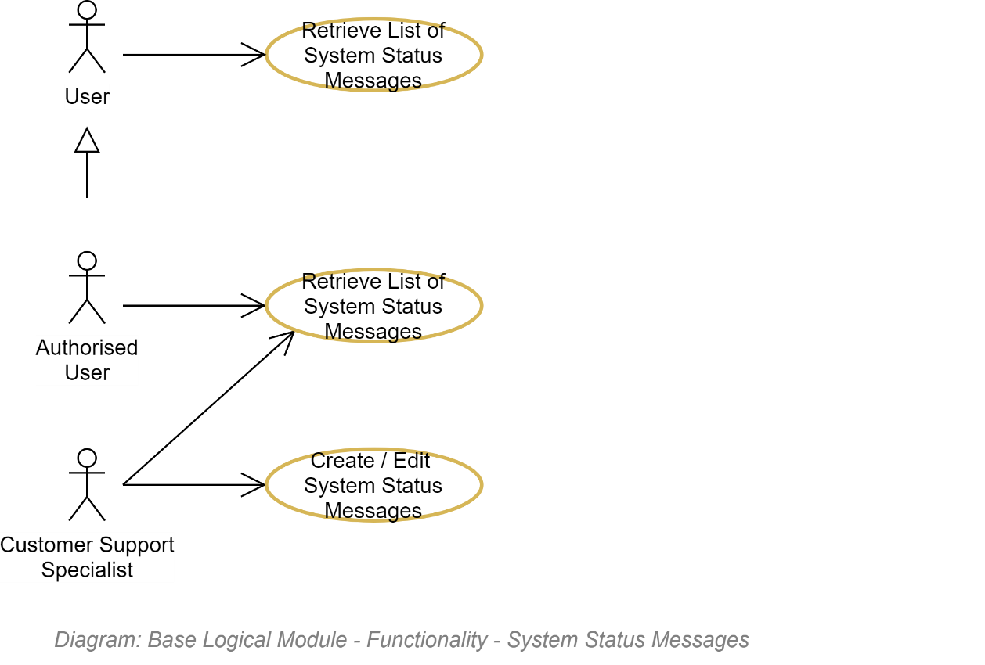

### Session Management Operations

A user may wish to view how many other active sessions are open.

A security specialist may wish to immediately shut down a session after noticing unexpected behaviour.

TODO

### System Authorisation Management Operations

### System Authentication Management Operations

### System Auditing Management Operations

During each Request associated to a User Session, a User will perform one or more Operations.

A synopsis of the Operation is permanently recorded.

A Security Specialist may wish to review the Session Operations for a User to determine if all activities were legitimate.

TODO

### System Search Management Operations

Users expect to be able to find information.

System administrators must be able to create synonym word associations (e.g.: link “course” to “lesson plan”, or the Māori term to the English term, so that users can find the same resources, no matter which terms they used.

TODO

### System User Management Operations

Instead of managing users centrally, new or existing users are invited to join a user’s existing group, as a specific role within the group.

For example, a user may invite a user to become a Member within the role in which they are an Administrator.

The traditional core roles are:

* Accountable (Owner)
* Administrator (Responsible)
* Contact Person (the Group’s public contact person)
* Member
* Guest (Informed)

More roles can be added per group, as needed (generally dependent on the custom workflows of a group).

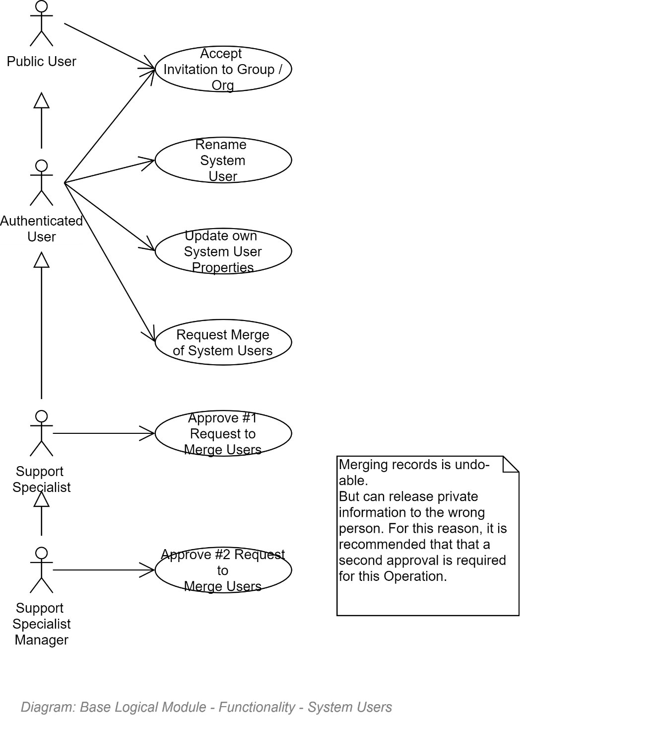

### Notification Management Operations

Members need to be able to end Notifications to other Members. For example:

* to invite them to Roles within Groups, etc.
* To invite other Members to collaborate on Resources.

Email is a traditional notification channel – but in-system notification allows for an easier mechanism to .

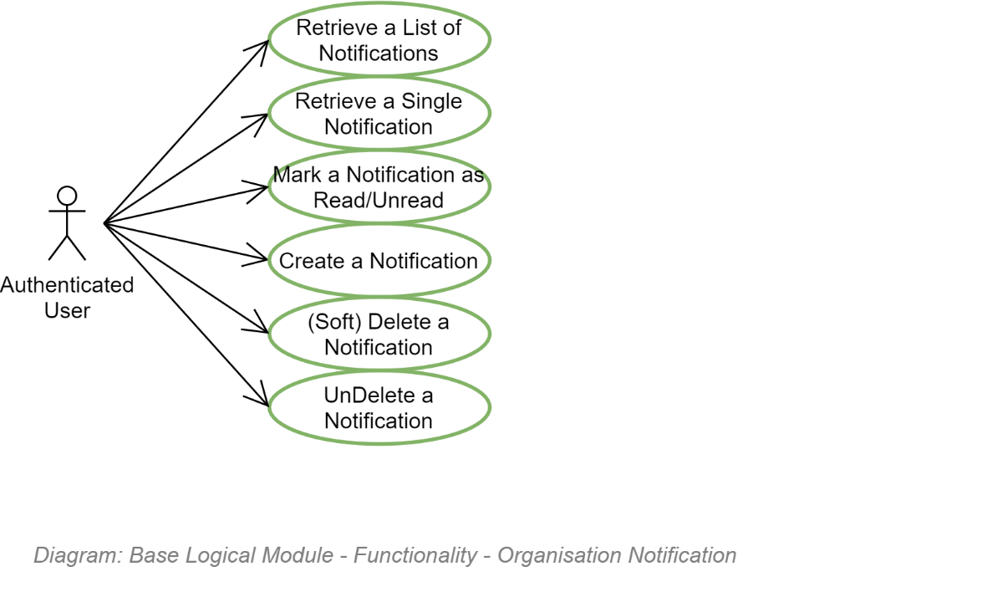

### Group Management Operations Organisation Management Operations Group Role Assignment Operations

### Media Resource Management Operations

### Media Resource Role Assignment Operations

### Reporting Operations

### Monitoring & Alerting Operations

### Dashboard Management Operations

Dashboards are often the primary page for Authenticated Users, providing a head's up access to important information, and providing a quick way to navigate to it.

Dashboard's are personalisable so that each User can focus on only information relevant to them.

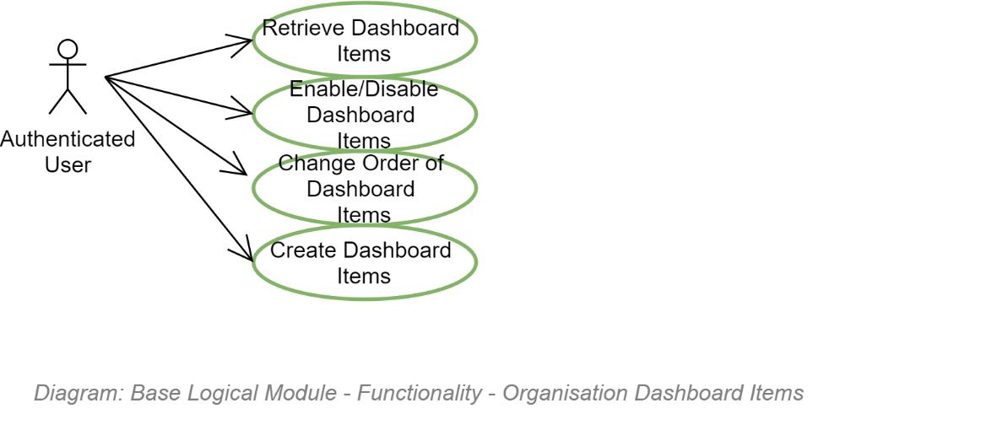

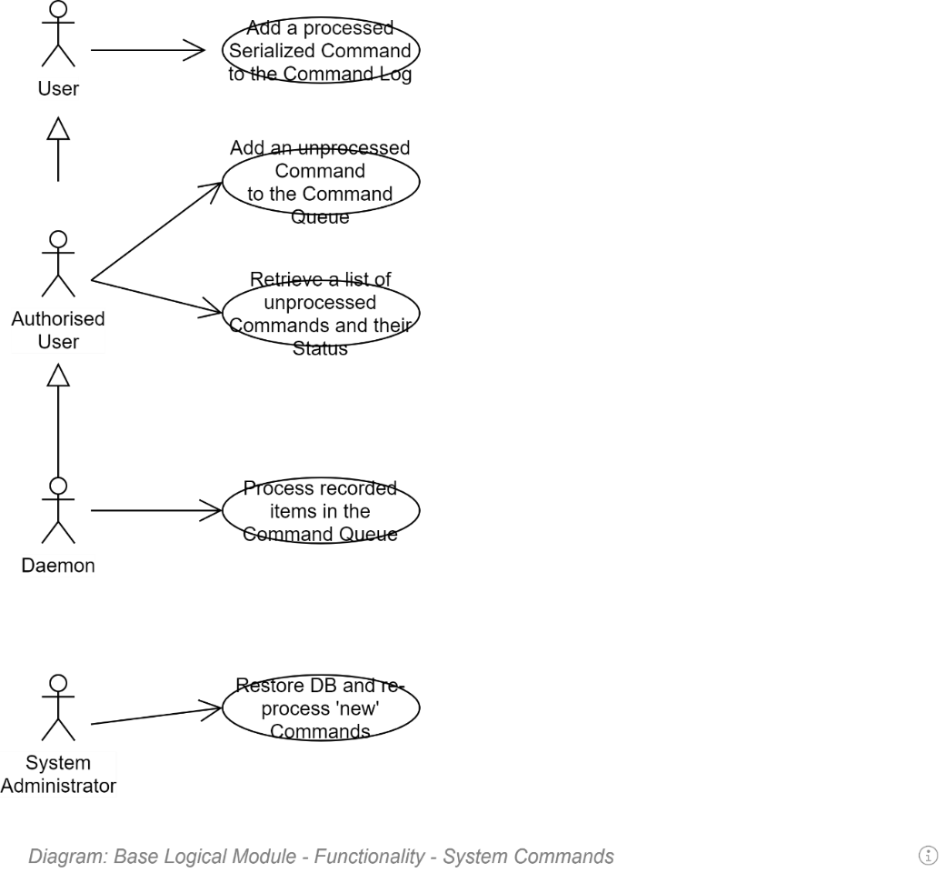

## Media Management Functionality

### High Level Overview

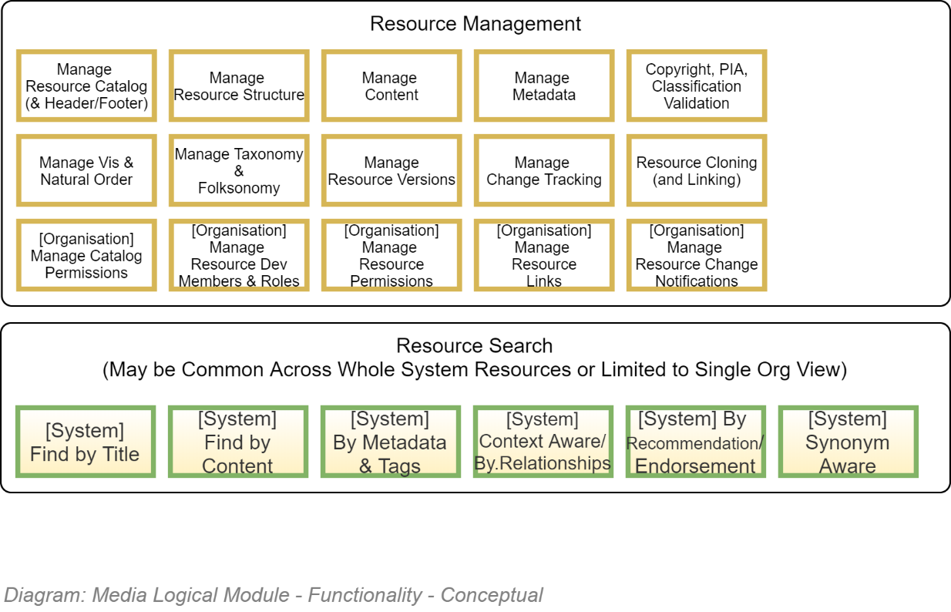

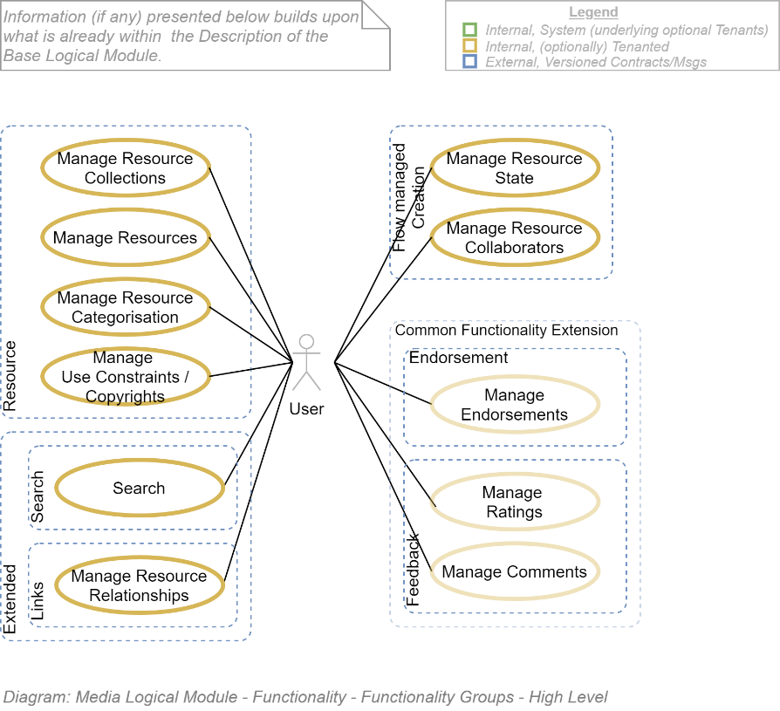

### Media Metadata Functionality

When Media Resources are uploaded, the system daemon attempts to fill in as much Metadata about the uploaded resources as possible.

Metadata that can be determined automatically by the system include:

* Mime type
* File size in bytes
* Original filename
* Created DateTime UTC
* Last Modified DateTime UTC
* Saved under filename
* Passed Antimalware Validation (by scanning the file using an Antimalware service)

More can potentially be determined by scanning the contents of uploaded text files. Especially if the resource has a defined schema, telling the system where to look for each value.

Values that *may* be determined using a 3rd party ML service:

* The Title
* The Subtitle
* The Author
* Number of words, paragraphs, sections, etc.

### Media Validation Functionality

Uploaded Media Resources need to be scanned.

**Note:**There are not too many worse ways to harm a company's reputation than allow a Member to upload a malware infected file that others then download and harm their own resources (Malware, Hijackware, etc.).

### Media Feedback Validating Functionality

Public feedback on available Media needs to be validated for abuse of the T&Cs governing behaviour and harm to other Members.

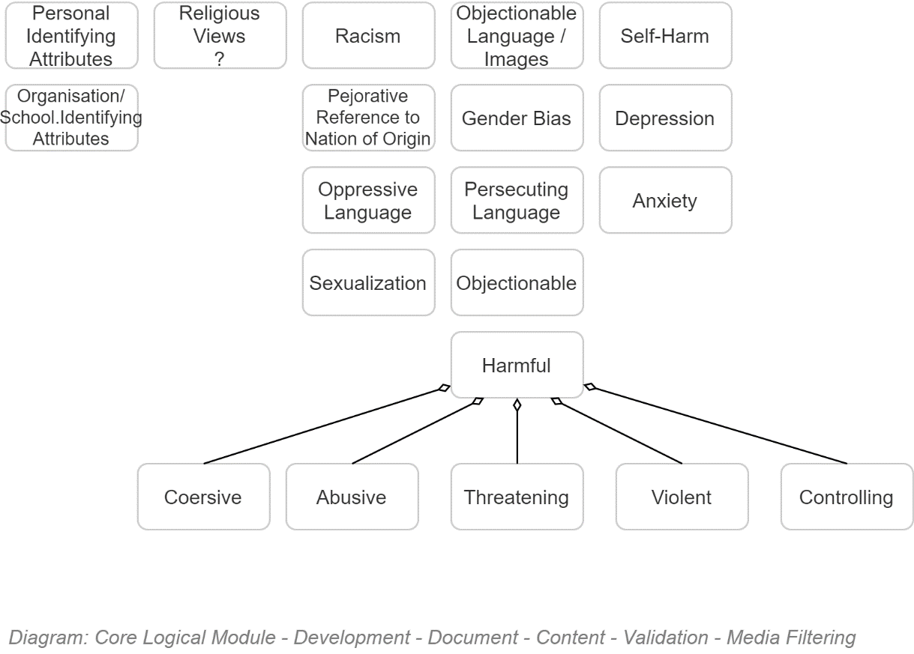

### Media Semantic Structure Enforcement

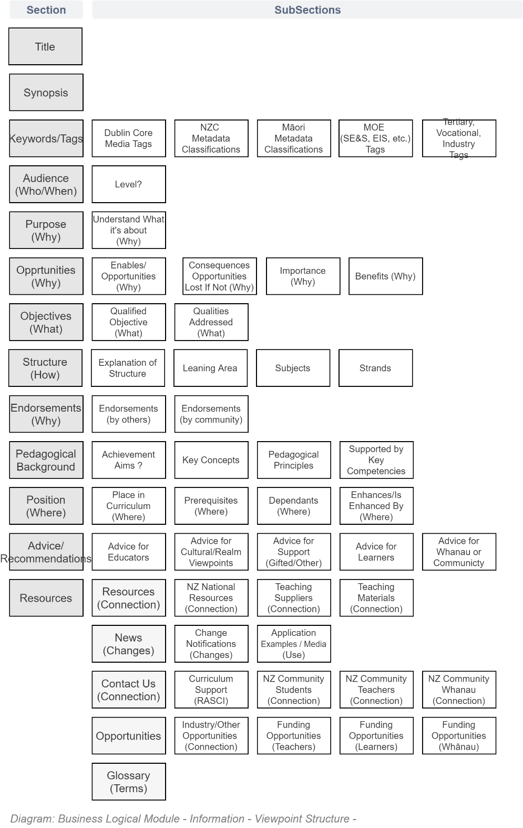

### Media Association Functionality

Media should not stand alone – it should have its place within an ecosystem of related information.

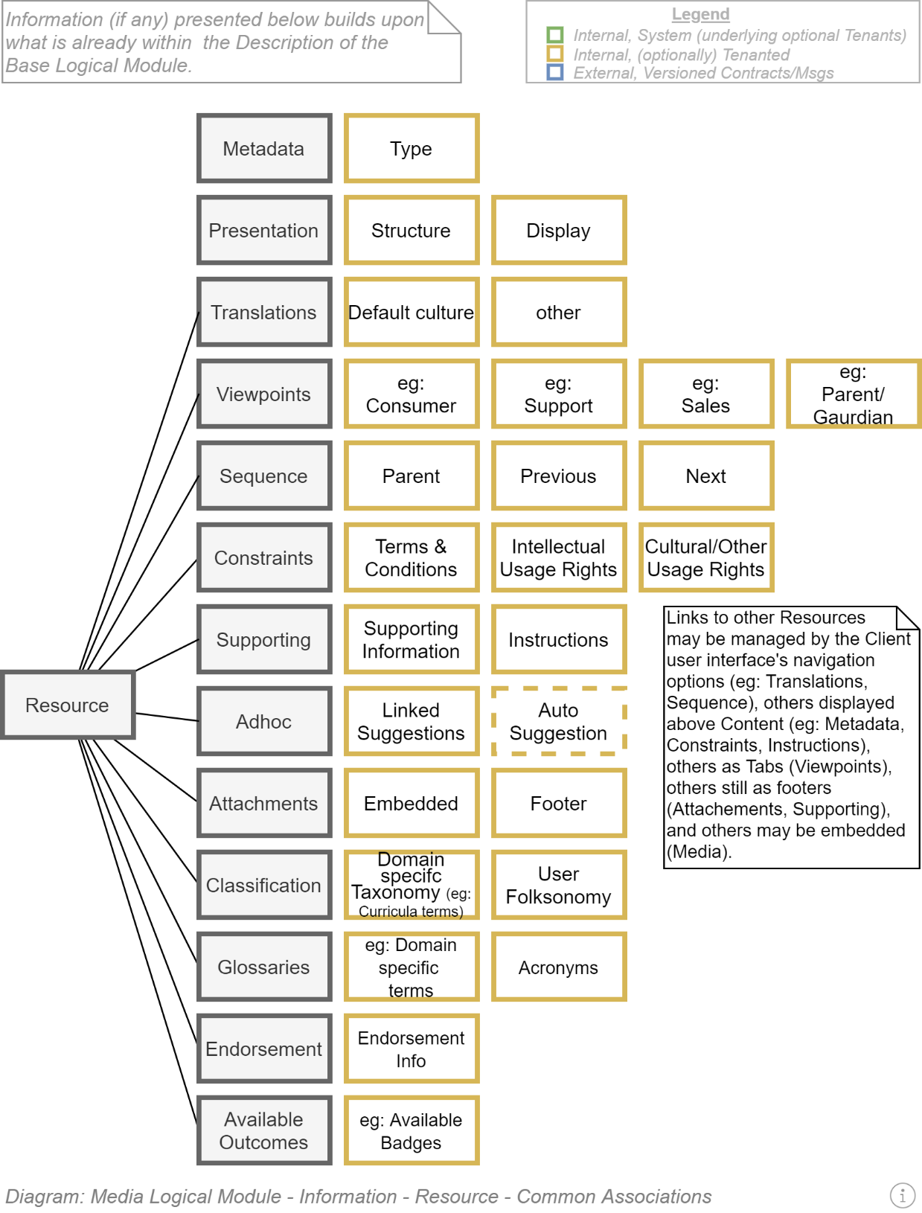

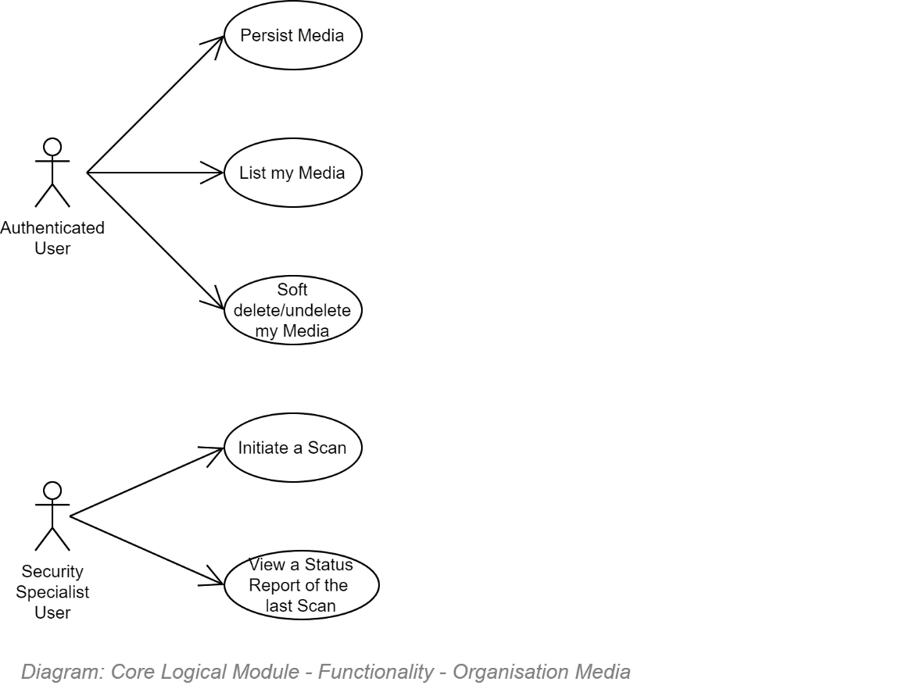

# Service Workflows View

This section of the SAD describes workflows of functionality within the system.

## Section Synopsis

The service works according to several base workflows, including the workflow used to invite a user to become a member of a group.

Development of workflows is dependent on developing an engine to asynchronously p when resources are available and alert the appropriate person that the next task in the sequence is available to be performed (or that the sequence has been completed).

## Command Queue

## Async Operations

## Batch Operations

Batch operations (reporting, notifications, etc.) are processed asynchronously, as queued Commands.

Batch operations must NOT be invoked after-hours, when there are no specialists available to manage errors of execution, and when every other application is competing for the same infrastructure resources after-hour resources for deferred batch executions. Instead, batch operations must be invoked throughout the day, in a slow-drip manner, whenever there are sufficient existing resources.

**Note:**  
The **command pattern[13][14][15]** is an OO behavioural design pattern in which an object is used to encapsulate all information needed to perform an action or trigger an event elsewhere and potentially at a later time. Encapsulate requests as an object lets you parameterize clients with different requests, queue or log requests, and support undoable operations.

Commands are then queued to be executed elsewhere in the network where there are available resources to process them[16].

**Tip:**In ASP.Core consider using excellent MediatR library to combine OO argument encapsulation and messaging in one operation.

## System Workflows

Single user systems provide operations that can be invoked by the user in sequence, without requiring collaboration with other users.

On the other hand, collaborative user systems require two or more collaborators to work together on the same deliverable. A workflow engine is used to mediate the flow of operations, often alerting the next person that work awaits when the previous step has been completed.

Common workflows in organisations include:

* Approving the Invitation of a User to a Group in a specific Role.
* Approving payments over a specific value.
* Ensuring a product has a enough specific qualities to be published and made available.

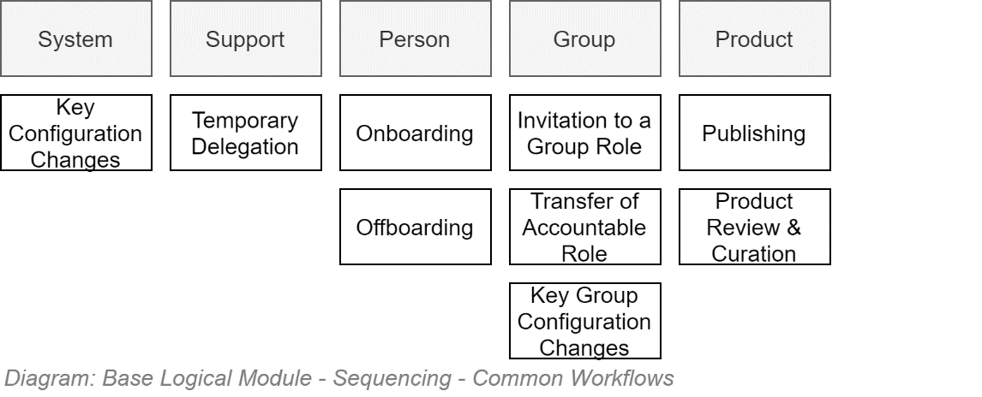

### Onboarding

Onboarding a user is essentially the process of Inviting to a Group a User who is not yet a Member of the system.

### Group Membership Invitations Workflow

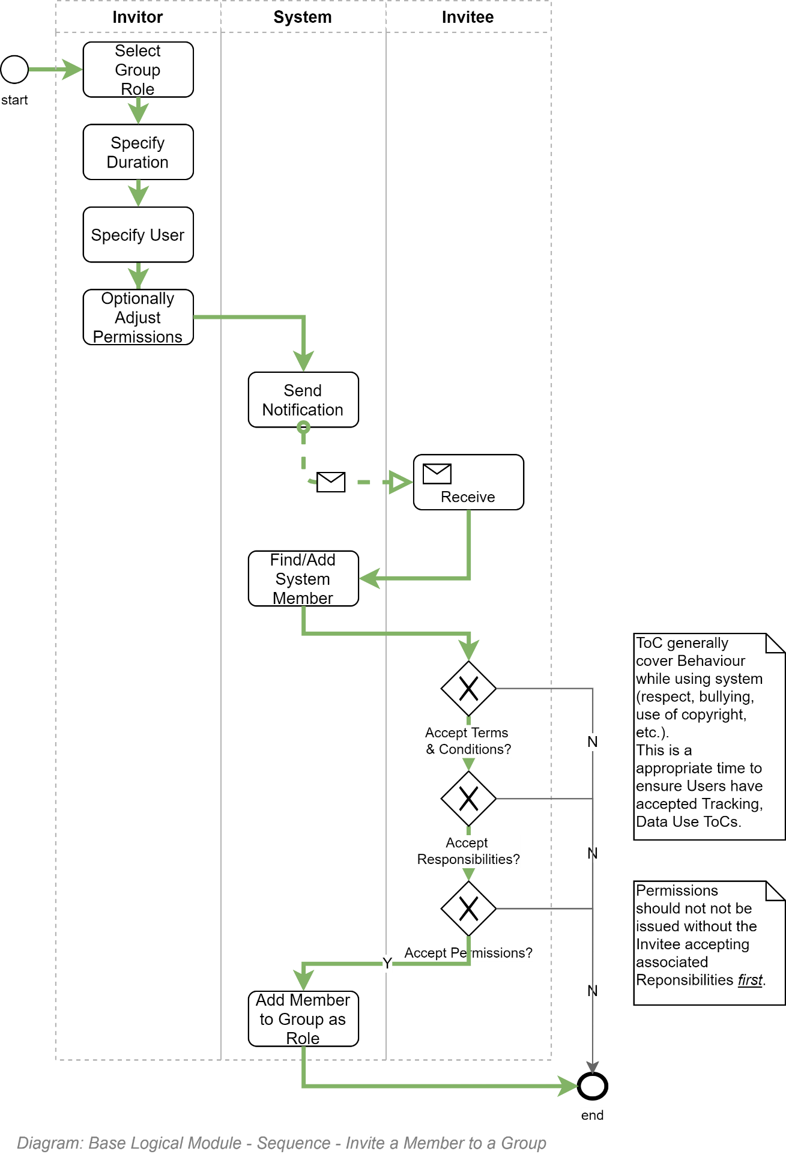

### Develop & Publish Parent Group (or Organisation) Terms & Conditions

TODO

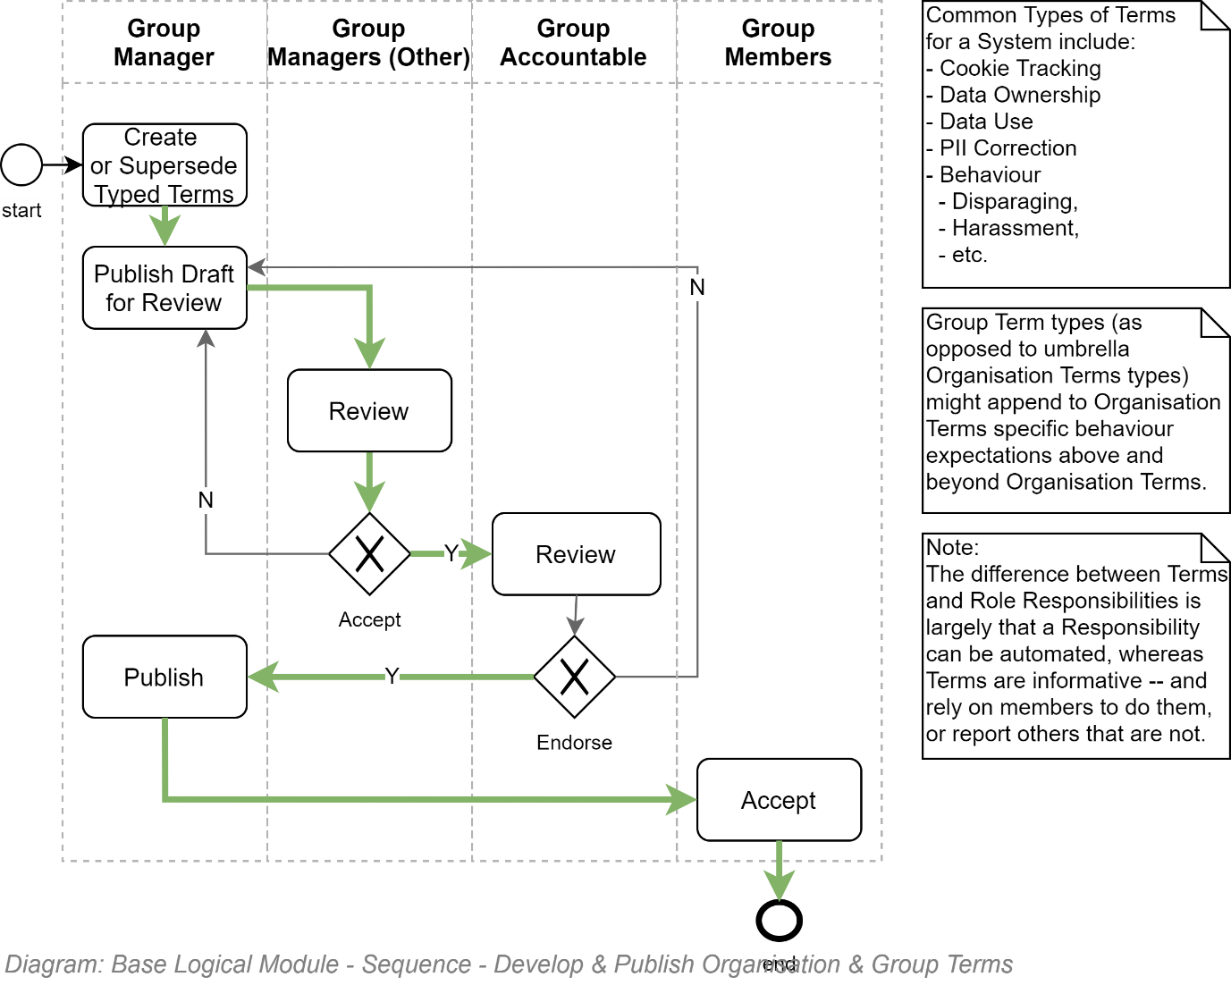

### System Notification Publishing

TODO

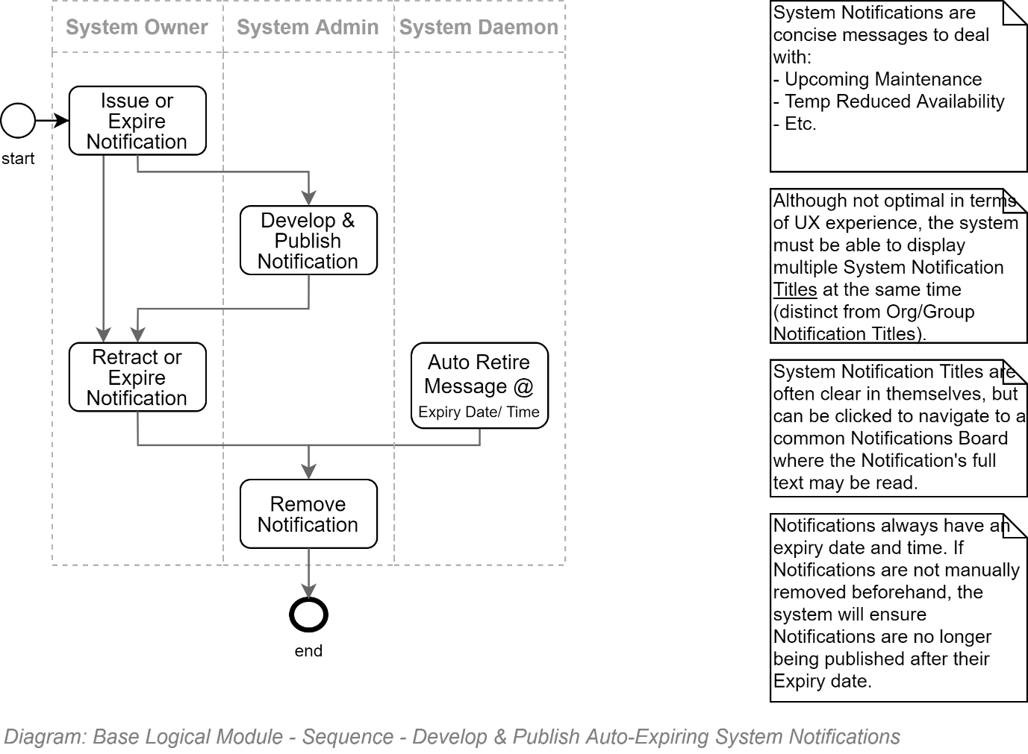

### Parent Group (or Organisation) Notification Publishing

TODO

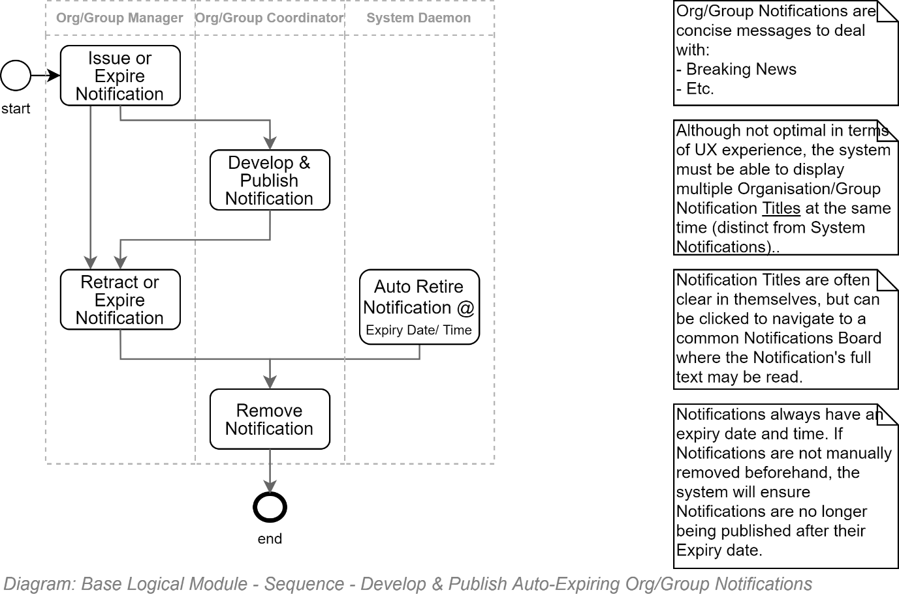

## Media Management Workflows

### Media States

Media Resource development involves lots of Members associated to the Resource in different Resource Roles: Creator, Collaborator, Reviewer, Approver, Maintainer and even Consumer (there is value in keeping track of whom has read the resource).

The following is a diagram of the of the sequence by which a Resource's State changes.

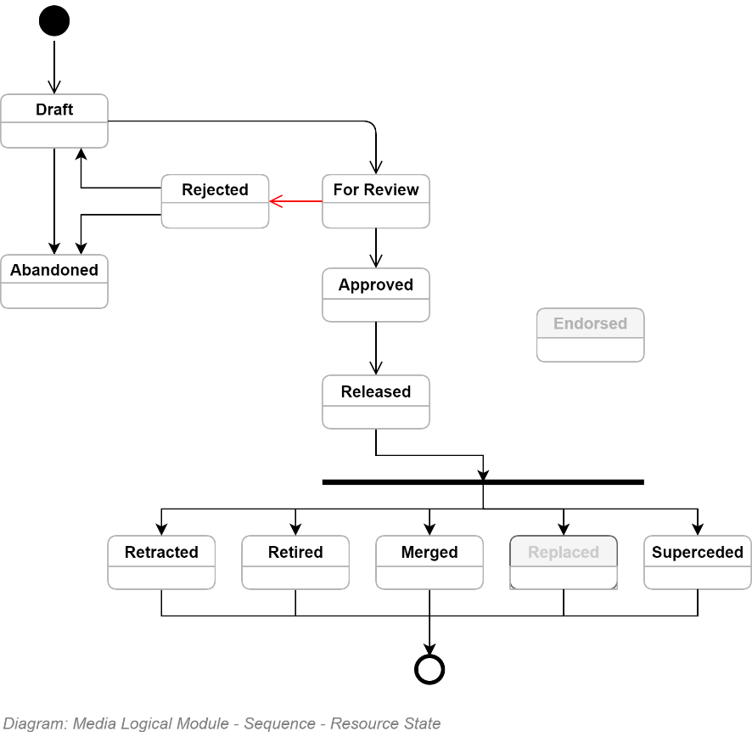

### Media Development Workflow

The transition between the above listed resource States is managed by automated Workflows as follows:

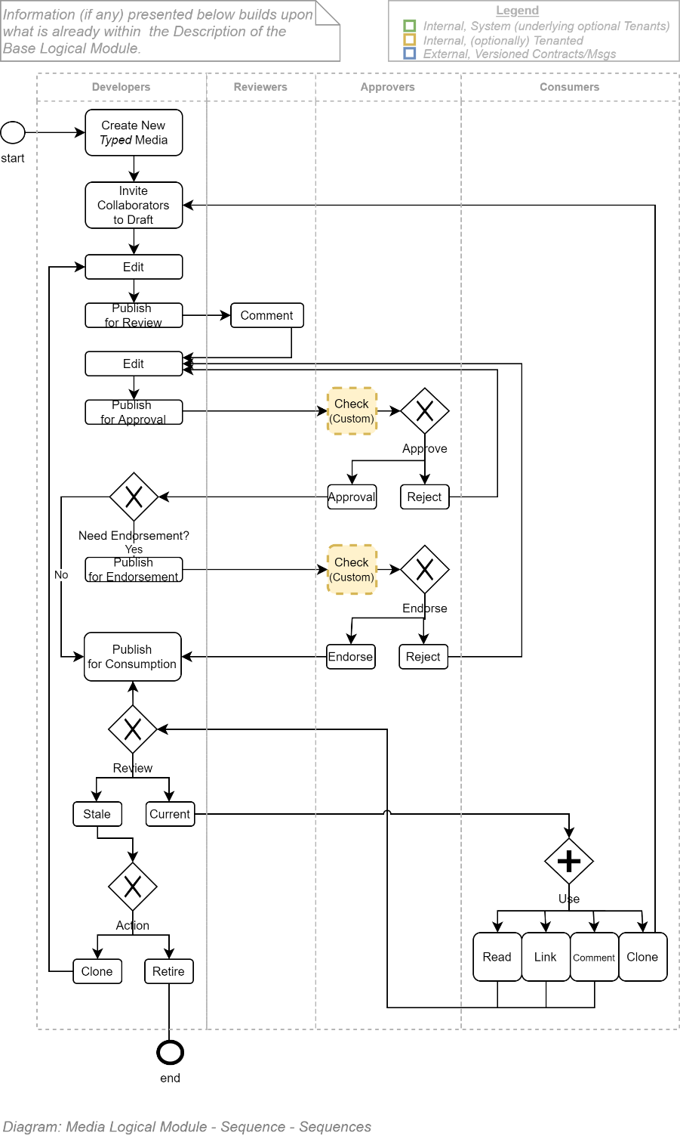

**Note:**Although the above workflow appears fit for purpose, it is to be expected that not every Group, or even Organisation, will agree with every aspect of the above. It is for this reason that every Group can clone and modify a parent Group's workflow – unless a parent Group (eg: an Organisation) has locked their workflows from cloning and modification.

### Resource Approval Workflow

A valuable resource -- whether it be an image, film, text or rich document – is one that fulfils its Purpose of meeting the Objectives of multiple Stakeholders.

Common resource development objectives include the following:

* **Correct:** the dissemination of factually correct truths is more valuable to society than the dissemination of misinformation
* **Accessible:** the use of Plain language, translations, localisation, and equitable accessibility allows the widest dissemination of factually correct information.
* **Relevant:** information must stay focused on topic, linking to -- instead of including -- related information.
* **Comprehensible:** the information's scope is limited to what is relevant and absorbable.
* **Succinct:** paying attention is the diversion of energy from other achievements. Make the information.
* **Action focused:** resources which take attention and time to read but does not enable decision making leading to immediate or deferred change, does not change the world -- and therefore can be deemed to have low value.
* **Classifiable**: the resource and its child elements should be classifiable and traceable within domain specific taxonomies.
* **Inter-connected:** Information should be developed as part of a larger ontological network of resources, linking to other resources that are or may be related to the current resource's topic.
* **Legal:** resources must abide by legal, commercial and cultural constraints, giving proper attribution, respecting and protecting the privacy of individuals, and using 3rd party resources within their stated conditions of access and use.
* **Recognisable:** information that reuses the same patterns & schemas are more easily recognisable and navigable, allowing for quicker finding and answering specific areas of interest.
* **Discoverable:** metadata data must be developed about the resource and SEO must be initiated to enable internal and global Search engines to find and present the resource appropriately to users.

To ensure the above objectives automated workflows are required to ensure different Roles approve draft Resources before they publicly published externally to the Members invited to Collaborate and Review a Resource.

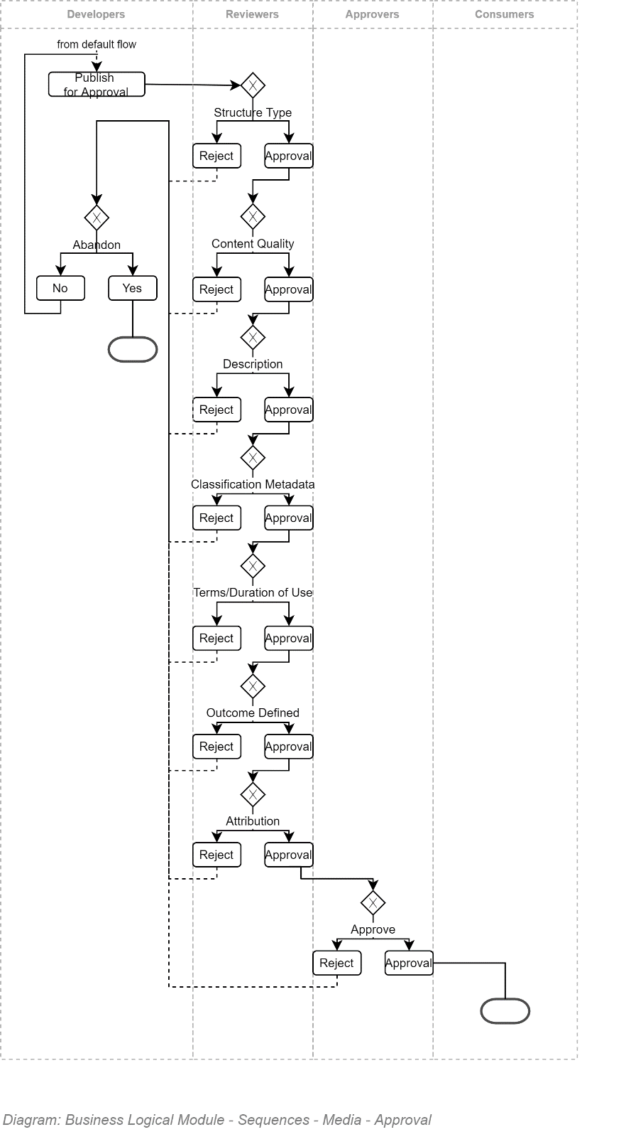

TODO: Add Attribution to other diagram.

### Collecting Resource User Voice

User Feedback of the Resource developed – in the form of Ratings and Comments.

The collecting of User Feedback is an ongoing workflow step within the product lifespan of the Resource

**Important:**It is a service design mistake to evaluate the collection and use of User Feedback as a Post-Deployment step, and not the other way around. Publishing, collecting & responding to User Feedback are the primary workflow steps of a product – it is the development, review, approval, and endorsement which – although necessary and important in their own rights -- are pre-product steps.

### Using Resource User Feedback

User Feedback in the form of Ratings and Comments is collected to improve the quality of the Resource and demonstrate to Users the resource's publishing Group is listening, is responsive to their concerns.

Doing the above on each published Resource, piece by piece improves the quality of the Service, and ultimately User's perception of the group / organisation Brand experience.

# Service Integration View

This section describes how the service integrates and orchestrates 3rd party services to provide a consistent service to other consumers of this service via interoperability standards, described in the section after this one.

## Section Synopsis

The Base module of the service integrates and utilises a small subset of 3rd party services.

Other Business Modules in the solution that are developed to reuse the functionality of the Base Module may integrate directly with additional 3rd party services.

Services are integrated using cloud-based service accounts (e.g.: AAD based MSI) or OAuth2 credentials retrieved from a secure storage account.

**Note:**  
Computer logic reuse has improved over the decades. In the beginning everything that was needed by a program had to be coded into the program. As more and more logic became standardised and available as purchasable components, programs switched to needing less custom code, while relying on orchestrating these 3rd party components. That era is moving on, and we rely more on integrating remote services (who in turn happen to leverage 3rd party components) and less and less on components. It is arguable whether any approach has really decreased the cost of deploying services.

## Integration Authentication Patterns

The following diagram summarizes the most common patterns used to securely integrate 3rd party cloud services.

The information contained therein is fundamental for correct understanding of subsequent sections of this System Integration View section.

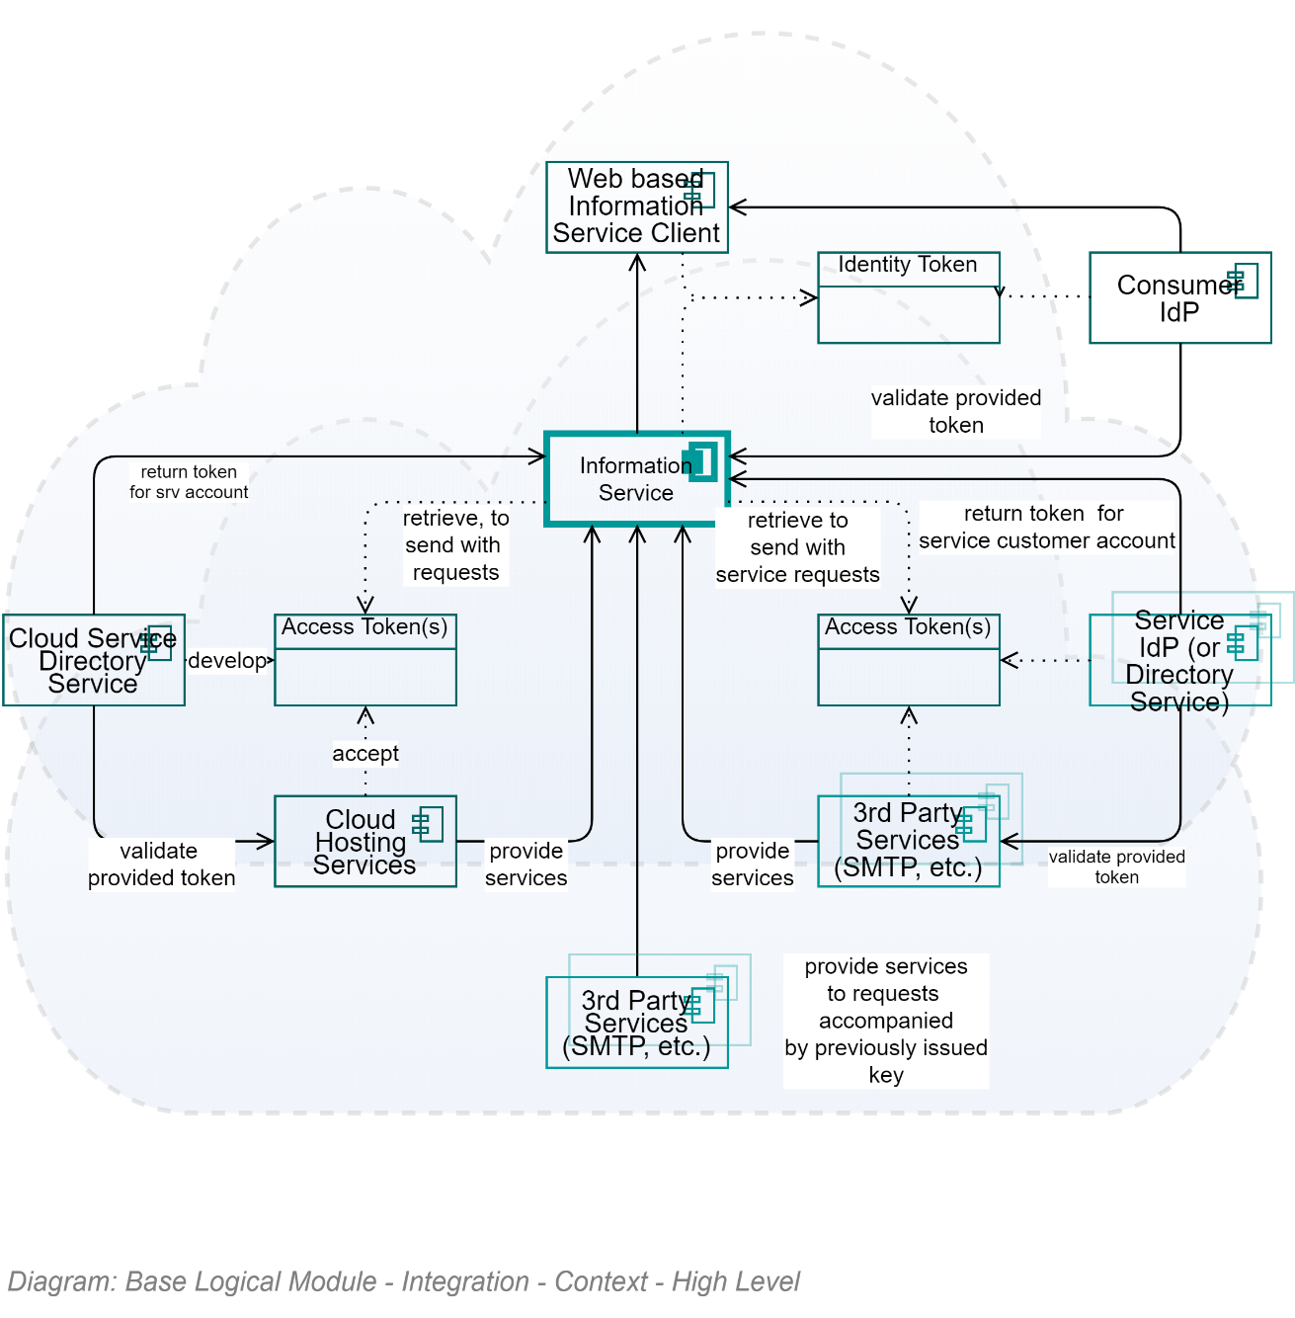

## Constraints

### Integration Principles

#### Integrate Services before Components

3rd party services are maintained, require less hardware, are more portable, have improved security when hosted within ISO-27001Stage2+ cloud data centres, and over time can be cost effective versus having to maintain oversight over security and hardware for the lifespan of the service being offered.

#### Cache before re-questing

As solutions shift to using WAN networked services, rather than components on the same device, latency is increased. Careful, consistent and pervasive use of caching in the format needed closest to use becomes a necessary mitigation tool.

**Note:**most ORMs will provide some form of caching to decrease the number of queries made to a remote database.

#### Integrate using International Standards over Homebrew Standards

We're not only mandated to, they're designed by be interoperable with other international services (allowing reuse, maintainability and modularity), are more portable to decrease the risk of vendor lock in, and almost always higher security than home-brewed solutions.

#### Use Global Value Encoding Standards

Prefer the use of international standards for transferring values such as IDs, Dates & Time, Country Codes.

UUIDs are specifically developed to allow synchronisation between international deployments and local data warehouses,

Date & Time synchronisation allows deployments to be done anywhere, consumed anywhere, recording transactions in the sequence they happened across integrated systems.

Global Country Codes (recorded in every Session Operation) facilitates data warehousing storage needs while ensuring data used for international reporting is non-ambiguous.

Where recording of Gender is pertinent to the functionality of the system, Global Gender Codes are used to fulfil the same objective. Record any Localised Codes of a larger range of gender options in addition to the base Global Gender Codes.

## Protocols

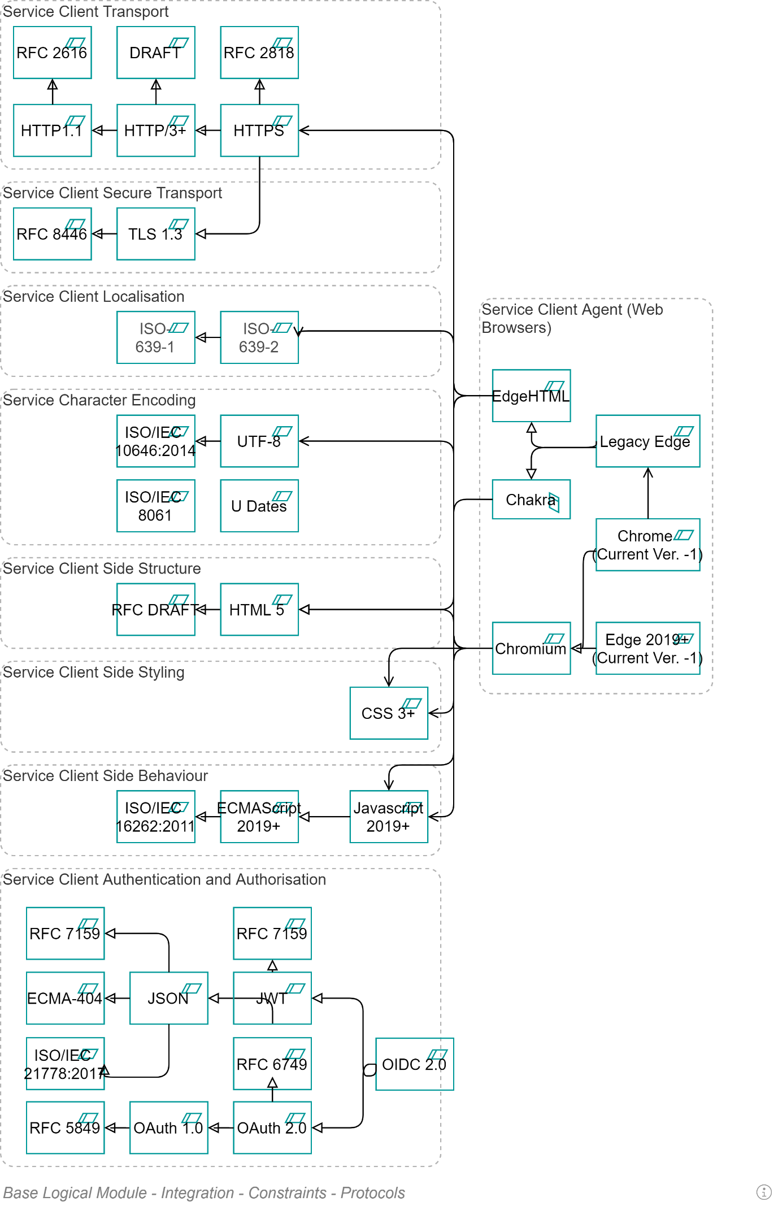

### ISO-27001 Stage 2+ Physical Environment

The solution’s service must be hosted in a data centre that has achieved ISO-27001, Stage 2+ accreditation from an impartial 3rd party.

## Network

Integration between components – whether internal or external to the local area network -- must be encrypted.

For example:

* all traffic over HTTP must use HTTPS, always maintained to use the latest supported TLS protocol.
* Connection strings to databases over TCP should include the flags necessary to encrypt the message.

## Message

Where network channel encryption is not technically possible, the message transmitted over the unencrypted channel MUST be encrypted.

## Service Devices

The system must be designed to run on commodity devices offered by ISO-27001Stage2+ certified cloud providers, rather than require being run on specially hardened containers or virtual machines.

**Note:**This implies that storage of information is carefully considered such that as little information is persisted – and certainly not unencrypted – on the device itself. Use 3rd party services for storing media, databases, documents, and confidential configuration settings.

## Components

It is important to recognise that over the past 20 years, development of software has changed from a process of developing custom code, to integrating components to finally integrating services.

A trivial example is how collecting, validating, and persisting customer credentials went from being developed in a custom way per project, to buying and integrating dedicated Assemblies/DLLs to manage the operations and encryption, to finally using external IdP services, such as AAD, B2C or other. The latest change has simply been to use cloud-based Service.

Deployment requirements in turn have changed – from developing complex build pipelines that compiled and built and deployed multiple Assemblies/DLL’s, to simpler pipelines that only deploy the system, and configure it to invoke 3rd party cloud services, caching results to improve responsiveness.

The above changes to the development process explain why the deployment of Components is not covered in this document.

## Services

The basic 3rd party services which this service relies on are straightforward:

* **Key Vault Services:** to retrieve confidential configuration and credentials, in order to to communicate with other services listed below.
* **Identity Provider Servers:** to retrieve identity tokens for authenticated users,
* **Email Servers:** for notification purposes,
* **Malware Detection Services:** to verify uploads of images and documents,
* **Caching Services:** to reduce the number of calls (and latency) to 3rd party services
* **Various Storage services:** (DBs, Blob, etc.) to persist data.
* **IP/Geo Service:** to determine where the user is located, to inform security and property right control decisions.

Services don't work in a vacuum. There are often enterprise services that are expected to be hooked up to the service, to delegate to:

* **Shared Drives:** although far from ideal, many organisations still share networked drives in order make documents available to peers.
* **EDMS:** Electronic Data Management Services (e.g.: SharePoint, FileNet, etc.) are common to more mature companies -- once they've moved past Share Drives.
* **Enterprise Services:** other common enterprise services that may need hooking up include Financial, Personnel, Training, Case, Bid, CRM, Contract, Risk, Configuration services.

But that is only the beginning in most cases, as these also should be considered

* **Service Bus:** well used sites are horizontally scaled across multiple servers and need messaging between them to keep them in-synch.
* **WAF:** services are protected from unwanted attacks (e.g.: DDoS). Admittedly few services integrate directly with WAFs – although their needs & constraints should be considered when designing the system.

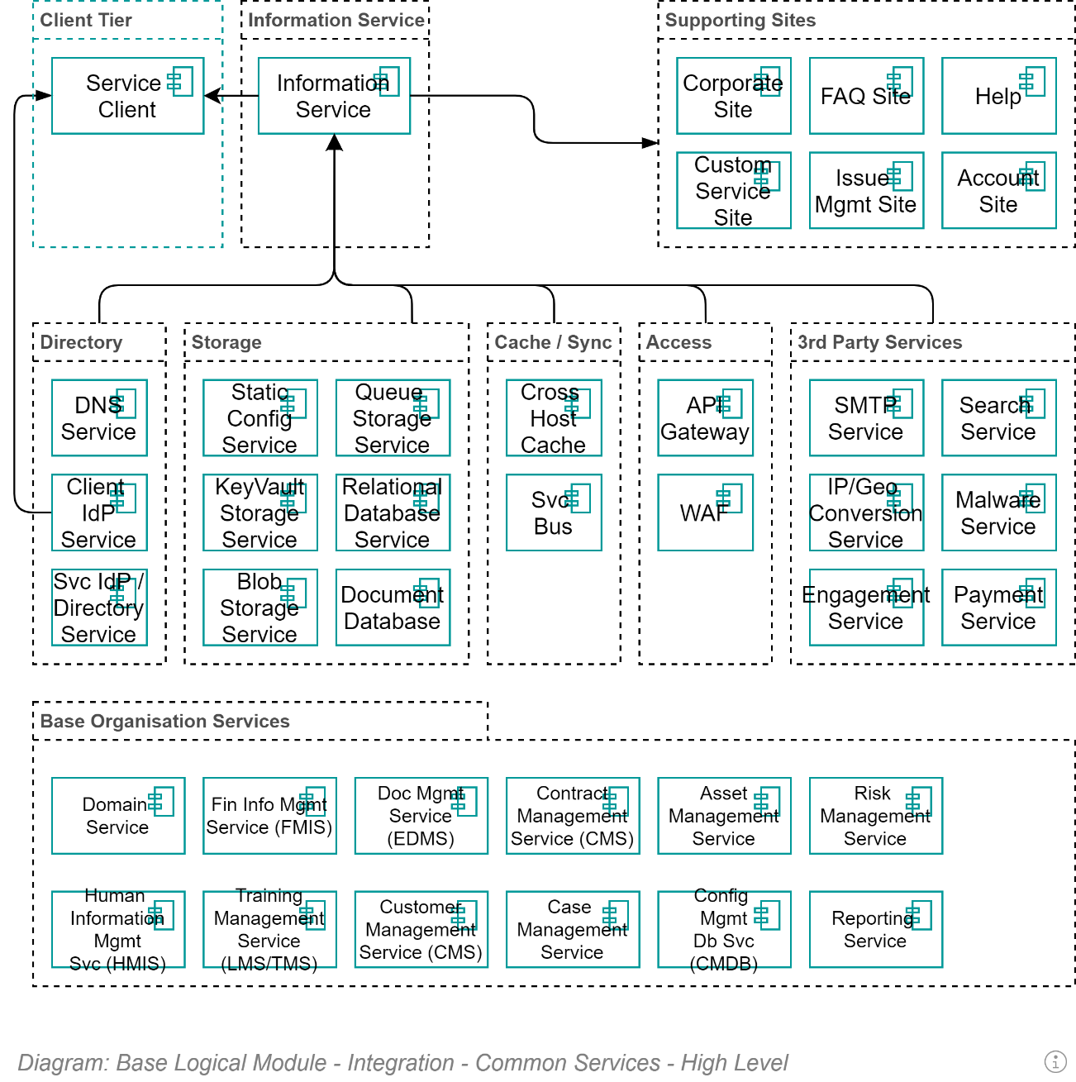

### Storage Services

##### - Confidential Storage

##### - Blob Storage

##### - Relational Storage

### Caching Service

### Notification (SMTP) Service

### Identity Service

### Malware Detection Service

### Search Service

There’s little value putting information into an information service if it cannot be rapidly and intuitively retrieved when needed, forgiving mistakes and incompleteness of the search terms.

Basic characteristics of valuable search service include:

* Takes written search term
* Forgiving of spelling
  + Forgiving of spelling in different cultures (for example Māori, “wh” is closer to an ‘f’, whereas in NZ English it’s closer to maybe “wer” or “wo”).
* Capable of finding information via synonyms
* Searching by qualities (e.g.: metadata) describing resources (e.g.: filtering for images as opposed to sounds or text)
* Rapid
* Inexpensive

Additional characteristics to seek within search services include:

* Developing personalised search, using previous search patterns of the identified user to influence the scoring and ordering of returned data.
* Reporting is available to report on
  + which search terms were used the most,
  + which search terms did not produce usable results, as can be seen by immediately following it with a similar but different search clause.

At this point in time (Q4/2020) consider the value of the following cloud services to your service:

* 3rd party services:
  + Elastic Search
  + Algolia
  + Other
* Custom:
  + Azure Search
  + Amazon

  
**Tip:**  
In order to get to MVP quicker, it is highly required that the project does not develop a system specific search engine (e.g.: Azure Search) unless service costs due to high usage warrant looking into it.

## Enterprise Services

### Analysis & Reporting Database Development

The service’s data must be made available for dynamic analysis and reporting – but only in a manner that PII and other sensitive information is protected.

There are several ways to duplicate a database, some better than others.

#### Custom ETL

Developing a custom ETL operation to sync changes between databases was common at the turn of the century but is no longer a recommended approach: they are difficult and expensive to develop, difficult to maintain in a functional state, require extensive testing, require both source and target to be within the same LAN, require an appropriate ETL engine, limit schema changes without careful analysis and testing of the impacts.

#### Pub/Sub Messaging

An alternate solution is to develop a secondary system to listen for data change messages and update a local database that is only accessed for reporting.   
Developing a secondary system to manage a reporting database is a non-trivial and costly undertaking.  
In addition, the constant writing of changes to the database – and the associated temporary locking of tables -- decreases the responsiveness required of the database to assemble the data requested by reports.

#### Backup Restorations

A right-sized approach to duplicating an operational database for reporting needs is to schedule the restoration of the backups that have already been taken for Disaster Recovery (DR) reasons.

There are several advantages to the approach:

* Continuous proving that the DR backup and restoration data is fit for purpose.
* The reporting data is appropriate up to the last incremental database backup – a configurable amount of time that is by default agreed to be 15minutes.
* Incremental backup restorations will implement data schema changes.
* As the reporting service does not have access to the key vault stored key to encrypted columns, sensitive data is protected by default.

Downsides of the approach include the following:

* the reports will not include any data changed since the last incremental data. Even if the default 15 minutes is changed to 5 minutes, or even 1 minute, this may not be satisfactory for all business use cases.
* By default, cloud services will expect database restorations to be applied to the database from which they were developed. Make sure the restoration target is specified.
* Database restoration may require some logic to only apply the full restoration once a day so that restorations are rapid.

### Data Warehouse

The service’s data must be made available to the data warehouse for cross-system enterprise analysis.

The production data MUST be made available in both a secure and insecure manner, depending on the needs.

There are several ways to accomplish the transfer of data.

#### By ETL

A traditional/legacy way of preparing system data for a data warehouse is by ETL.

The reasons why this approach is no longer recommended are already addressed above, under *Analysis & Reporting Database Development.*

#### By Database Cloning

An alternate approach is to allow the data warehouse to access the backups of the system production data and restore them to their copy of the database.

If the data warehouse requires sensitive data, they will have to have access to the key vault, in order to retrieve the key.

The approach is not recommended as it contravenes good security practice by letting another group of users – beyond this project’s users (specifically it’s delivery service account) -- access production data and keys.

Another service has no business accessing this service’s infrastructure.

#### By Service Façade API.

The preferred approach is recognising that a data warehouse is an system external to this system and it should access this service’s data like every other external service – via API.

The data warehouse can develop an ETL workflow that invokes this service’s APIs to request changes since the last time they asked for changes.

Advantages of this approach include:

* Operations are authenticated, audited and diagnostically logged like any other operation
* The updates can be performed over HTTP over the global Web WAN.

Disadvantages of this approach include:

* Some changes to data require APIs to be invoked in a certain order to capture the cascaded changes in such an order that they can be updated within a relational target database.
  + Note that changes may not occur in quite the same order as production data so reporting may have edge case issues.
* The data warehouse has to develop a script or system to invoke the APIs.   
  The development skillsets required may be beyond their capabilities.

## Integration Schedule

TODO

* Protocol
* Trigger
* Cycle
* Volume

# Service Interoperability View

This section describes the Service Façade APIs exposed to 3rd party service consumers (as opposed to the Service Integration View which demonstrated how it integrated with and consumed 3rd party services).

## Section Synopsis

The solution is developed in such a way as to have no visible user interface itself, but expose *all* its operations in an appropriately secure manner for a separate, thin, web based Service Client to be developed to expose the functionality to users.

Exposing all operations allows for the most flexibility, maintainability, and integration options with other enterprise services (such as Data warehouses, security monitoring, etc.).

## About APIs

### Service Façade

The system's APIs are exposed via API specific versioned REST-ful Controllers at the Service Façade layer of the Service Tier.

### Web based APIs

It is poor design to use another channel than HTTPS for APIs (the security provided by WAFs is not available on other ports than 80/433).

### Service Web Redirection

At a lower processing layer (the API controllers should not know anything about this), calls to the APIs over HTTP should be redirected to HTTPS.

If the insecure call includes a session Id cookie or any other cookie containing confidential information, the call must raise an exception, to inform the remote client's developer that they must remember to decorate their cookies with the *secure* attribute.

### Service DTOs

As per security expectations, Internal data/system (they are often the same when developing using ORMs) entities are NEVER exposed outside a system.

**Important:**  
The above is a requirement because exposing to the outside the shape of ORM developed objects expose the schema of databases. Exposing the storage IDs of internal objects discloses sequencing information, allowing for a greater chance of malicious injection into the system of seemingly valid malicious information.

An Infrastructure Object Mapping Service is employed to Map internal object to outgoing DTOs – which is all the Service Façade API Controllers know or work with.

Returned DTOs are validated then mapped back to appropriate internal data/system entities, where they are validated…again.

**Warning:**Although a duplication of effort, Validation errors should be caught at the Service Façade to not disclose internal system/data object attributes.

### Service DTO Security

A strategy exists to ensure that DTO attributes are only mapped to from the internal system/data object *if* the target's attributes are not decorated with information indicating the current user does not have permission to see the information.

This is of course an additional level of security under the underlying security applied to all service façade controllers, that ensure that the invoked Operations are permitted to the user's Role's permissions.

**Note:**Control of the distribution of system data is not enforceable when remote systems are given the ability to download complete DTOs. The remote service may or may not (more probable) enforce per-attribute display rules.

### Service Versioning

All exposed APIs are Versioned and must be invoked using Version identifiers.   
API calls received without version information must return an exception. API calls received with a term implying something like "LATEST" or "LATEST_VERSION" must not be accepted, and instead return an exception.

### Service Information Queryability, Selection, Projection and Paging

The service's GET operations MUST be exposed using queryability functionality.

As a government organisation we are mandated to use international standards when available.

At present ODATA is the only queryability protocol that fits this constraint.

**Note:**  
That said, many developers prefer using GraphQL (in Q3/2020). If the project agrees it is important to deliver this functionality as well, a second set of APIs adhering to this standard must be developed.   
  
But the use of OData remains a mandated constraint that must be delivered.

### Service Headers

Selection, Projection & Paging Information should be embedded within the URL as URL arguments.

Version should be part of the URL.

**Note:**There are many robust discussions on the web as to why Version should be a Header – but note that Version is used to distinguishing it from other available versions. It is therefore most suited of part of the publicly visible universal unique resource locator (ie URL), and not a hidden security descriptor (more suitable an HTTP Header) or case specific result modifier (more suitable as an URL Argument).

### Service Discoverability

Remote services must be able to automatically scan and discover available services, their schema, and messages. OData provides this functionality. Other solutions may exist as well.

Note:  
This functionality provides over HTTP what the earlier WSDL provided to SOAP based interfaces.

### Modular APIs

The Services APIs are described below according to the Module they belong to.

## Base Module REST APIs

The Base module exposes the functionality of the system itself – it's Diagnostic Logs, Error Logs, Sessions, Session Operation Auditing, Users, Members, Groups, Roles, Role Allocations, Media Collections, Media, etc.

Note:  
The Base Module is not concerned with business specific functionality, which is described within subsequent Module sections of this View.

### Diagnostics Management Service Facade API Schema

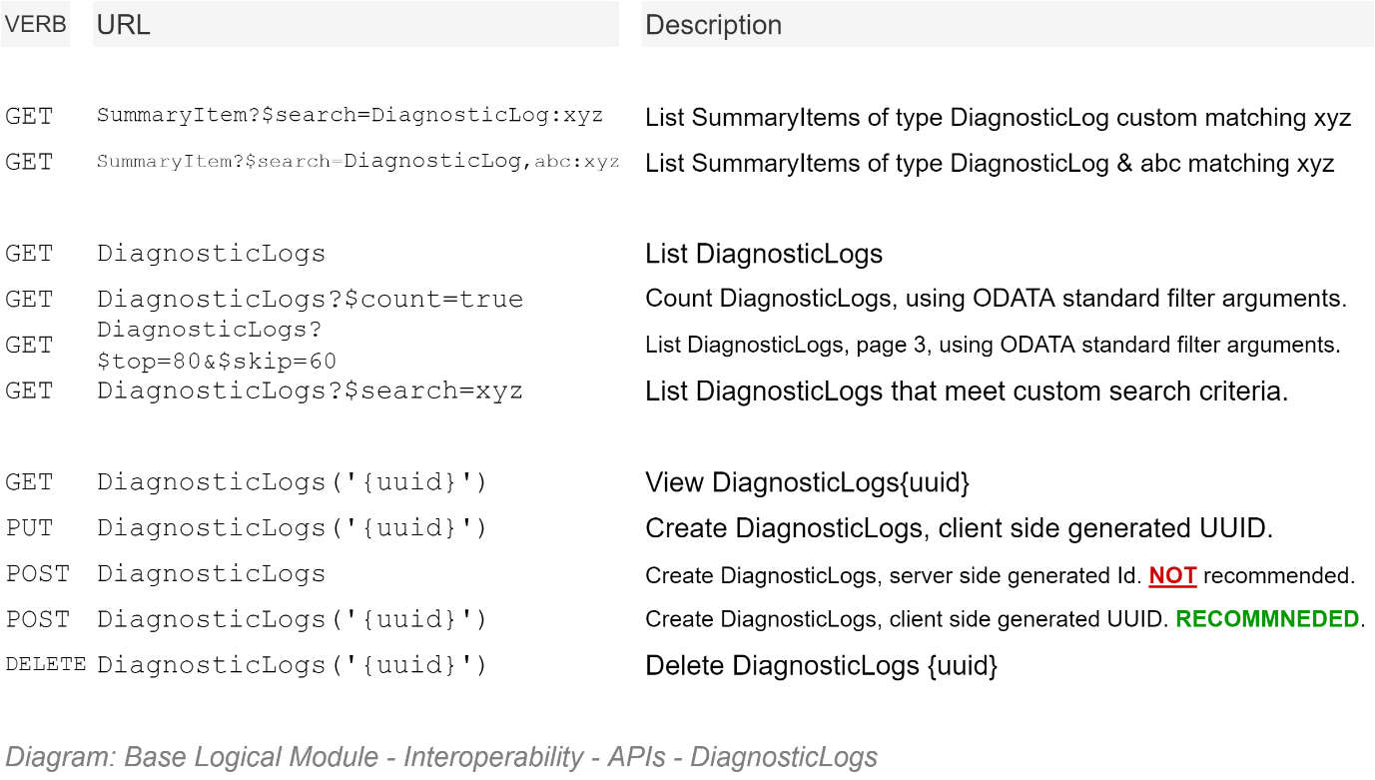

### Error Management Service Facade API Schema

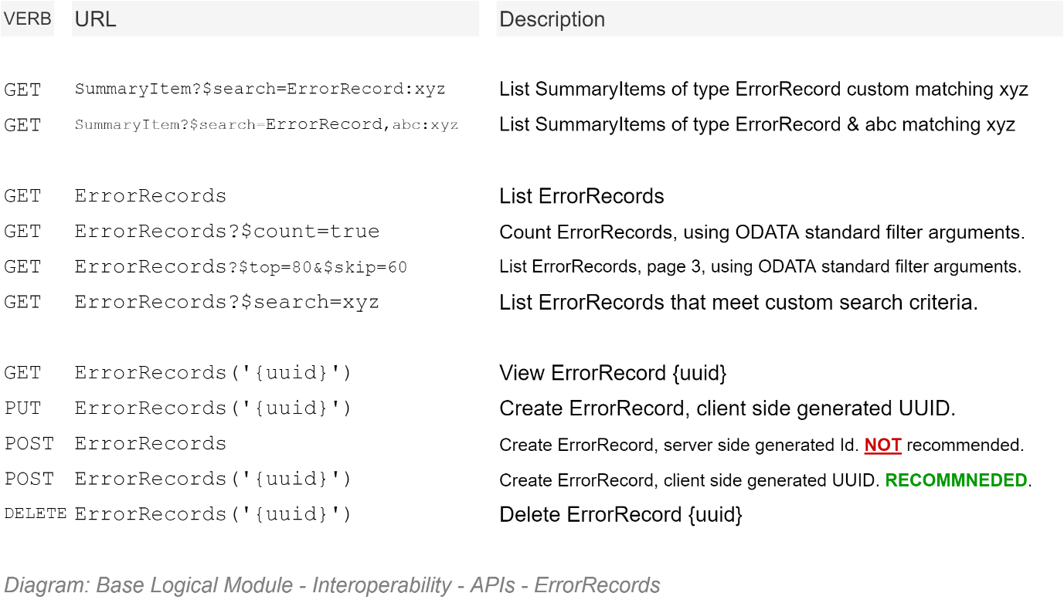

### Session Management Service Facade API Schema

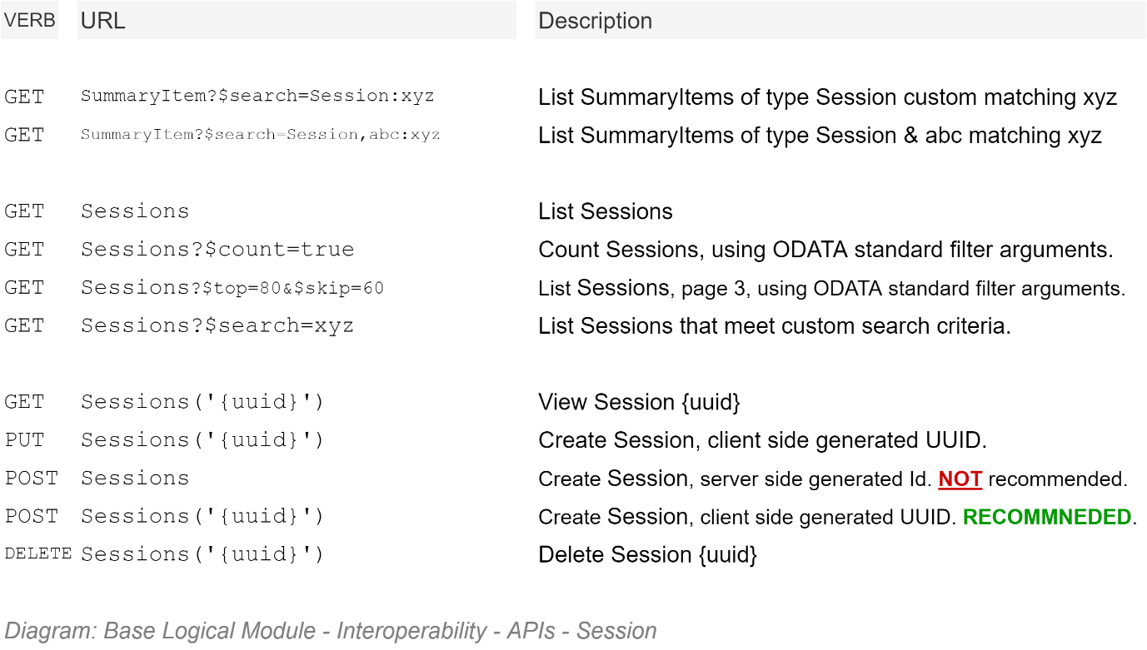

### Session Operations Management Service Facade API Schema

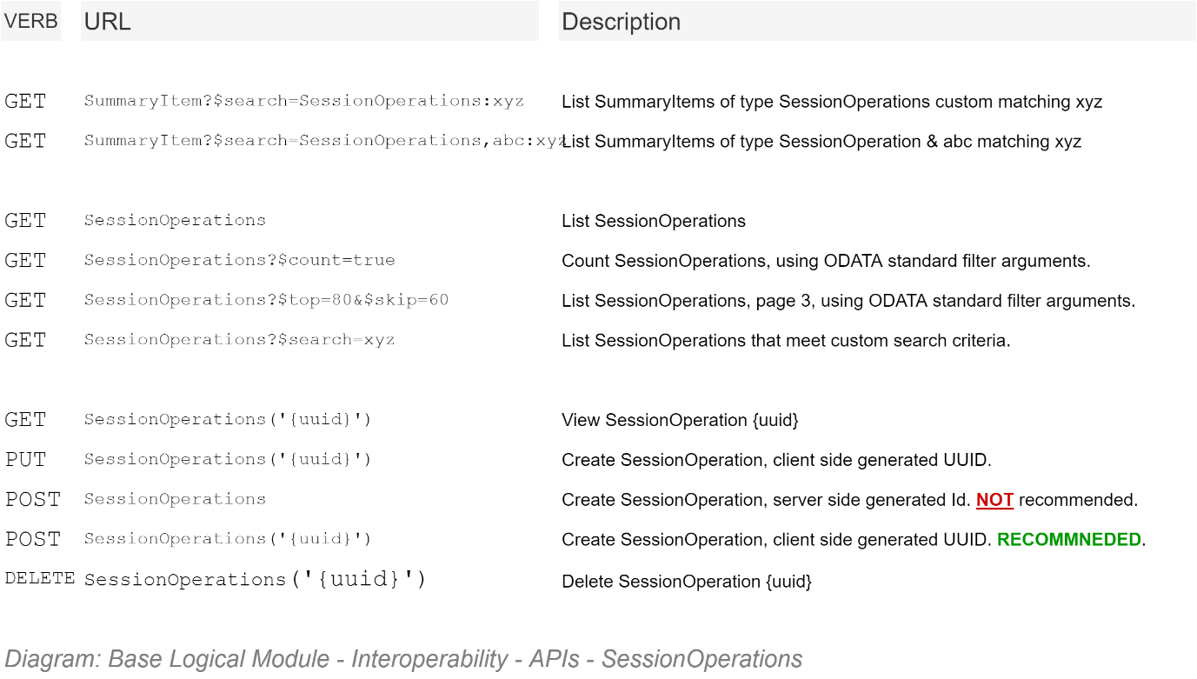

### Tenancy Management Service Facade API Schema

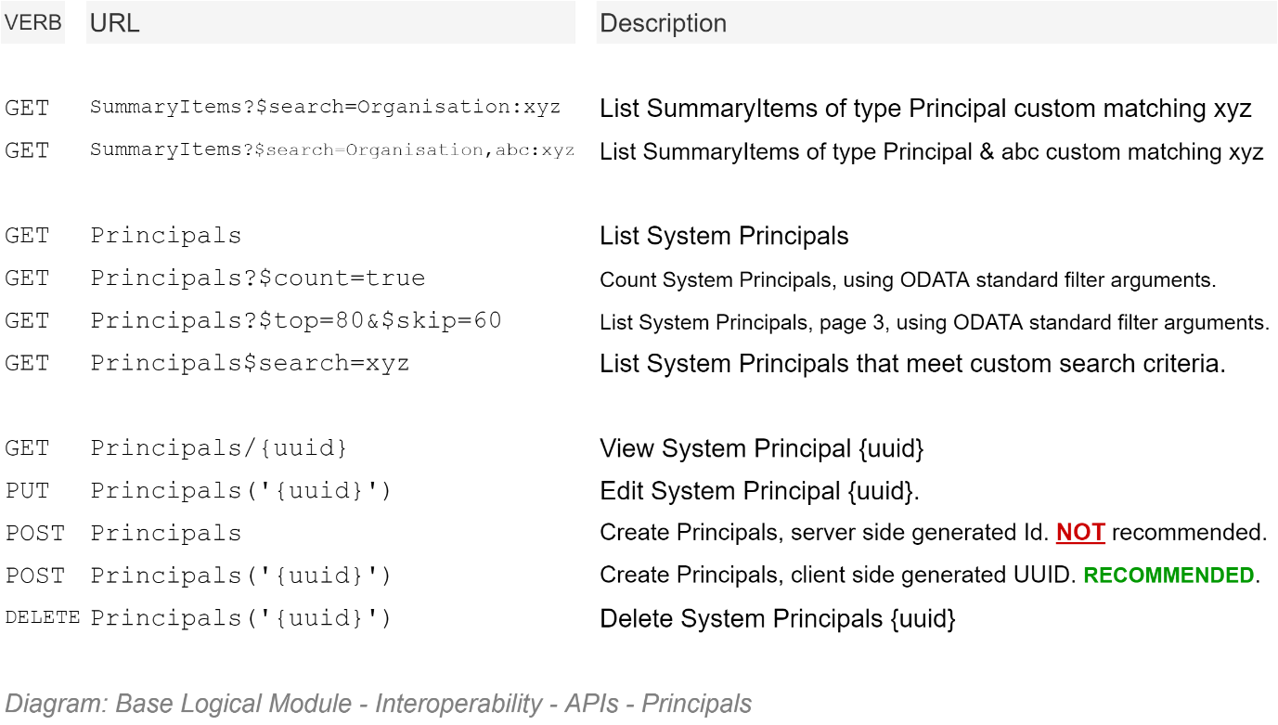

### Group Management Service Facade API Schema

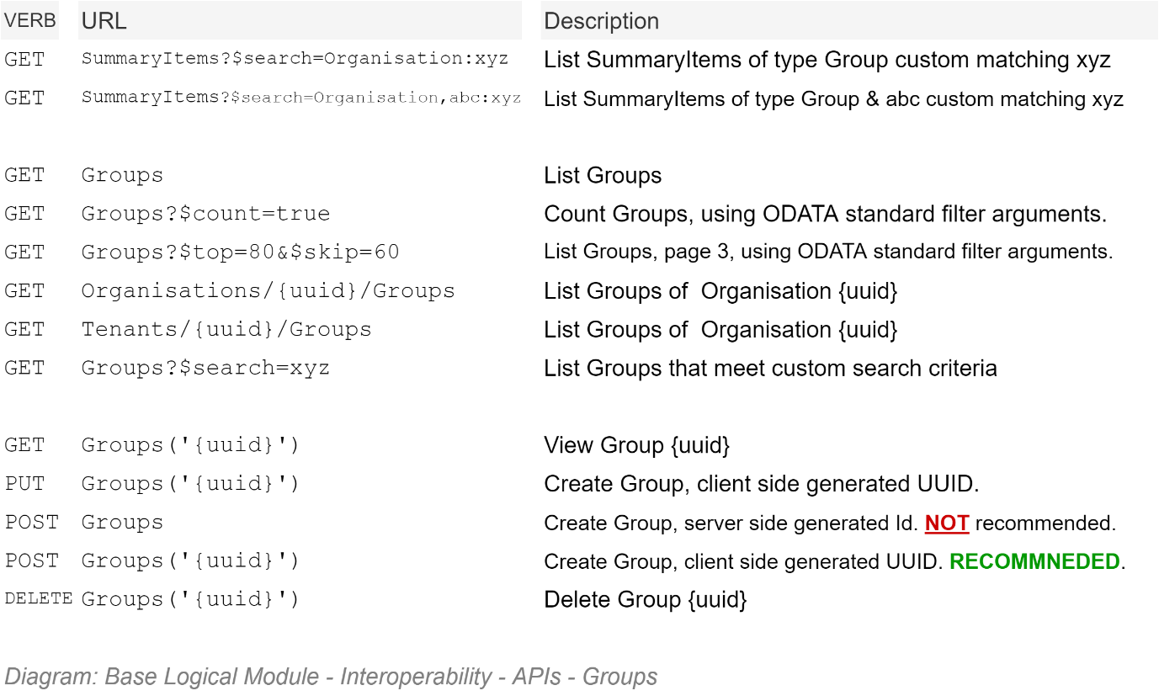

### Organisations Management Service Facade API Schema

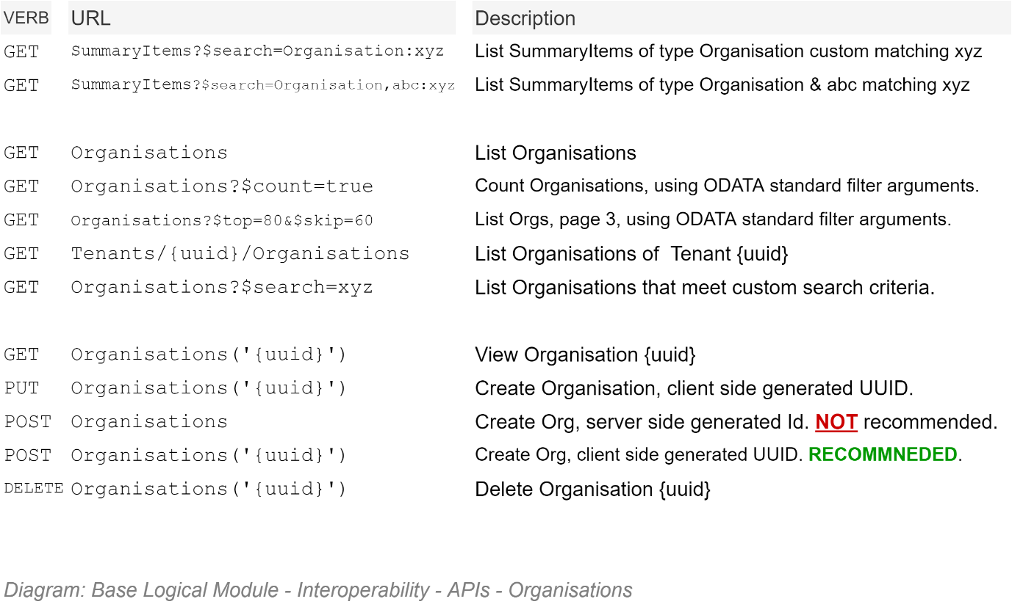

### Member Management Service Facade API Schema

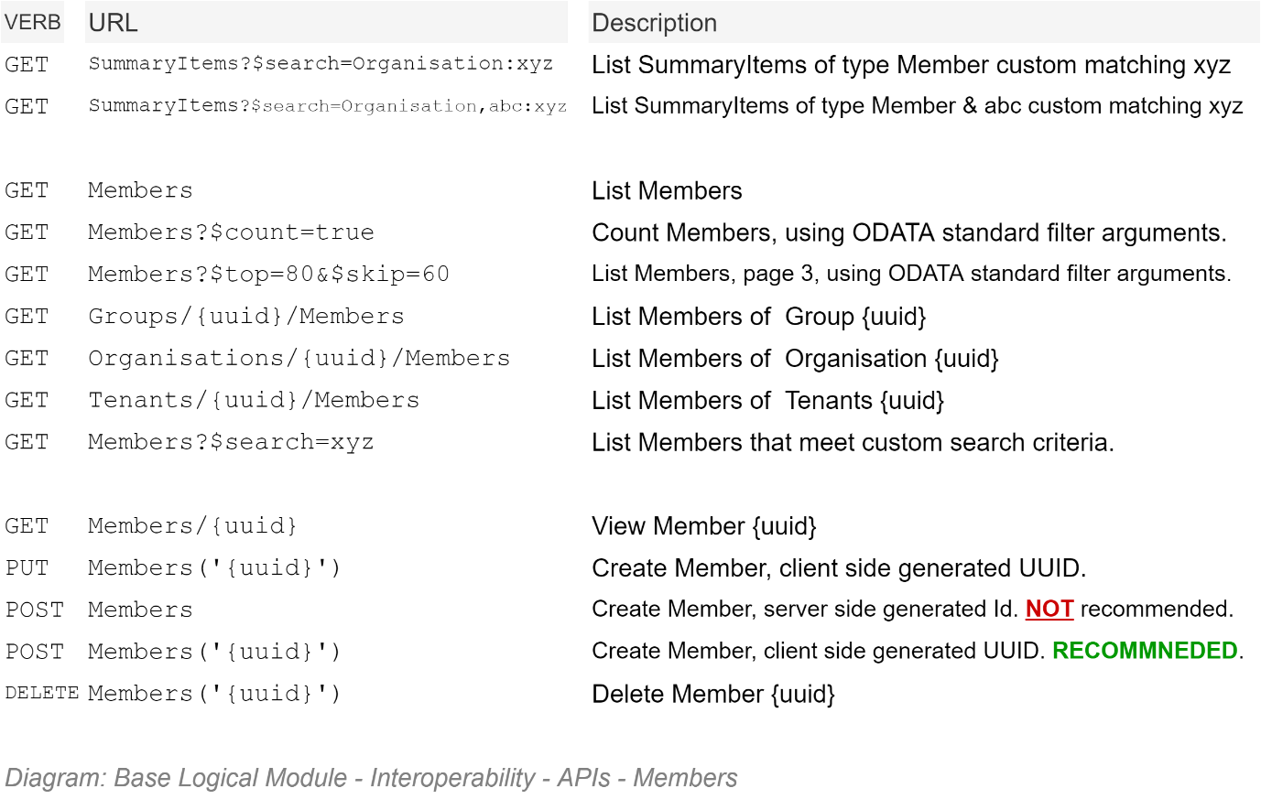

### [Origin] Country Management Service Facade API Schema

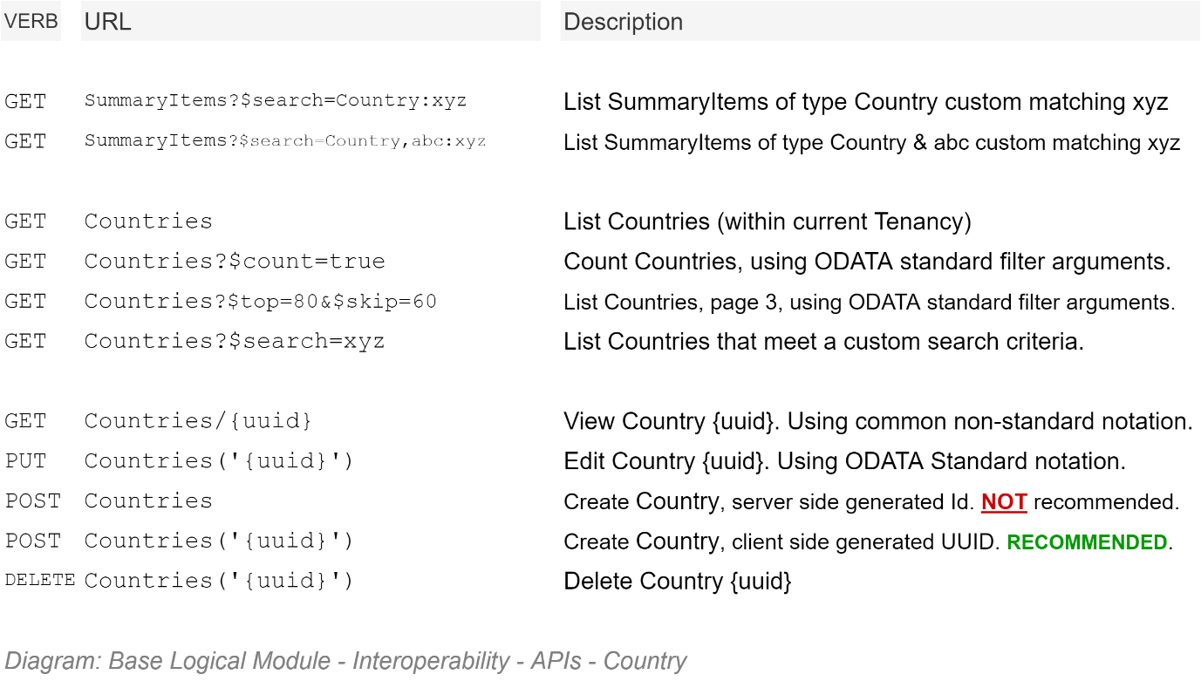

### Parent Group Role Management Service Facade API Schema

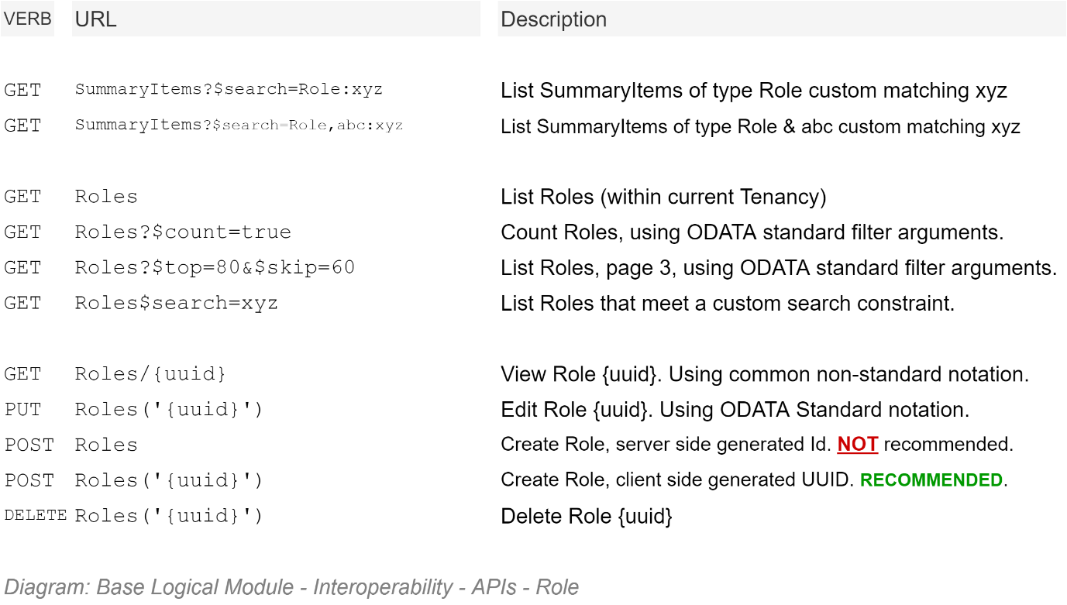

### Data Category Management Service Facade API Schema

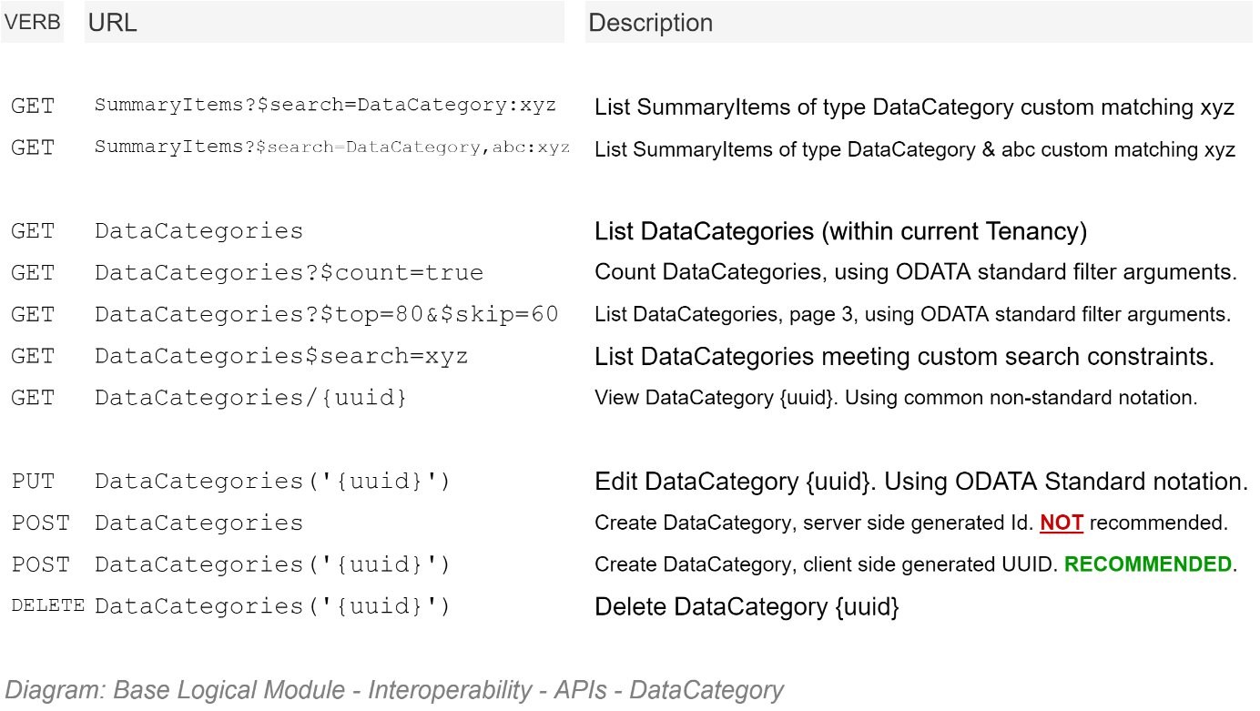

### Notification Type Management Service Facade API Schema

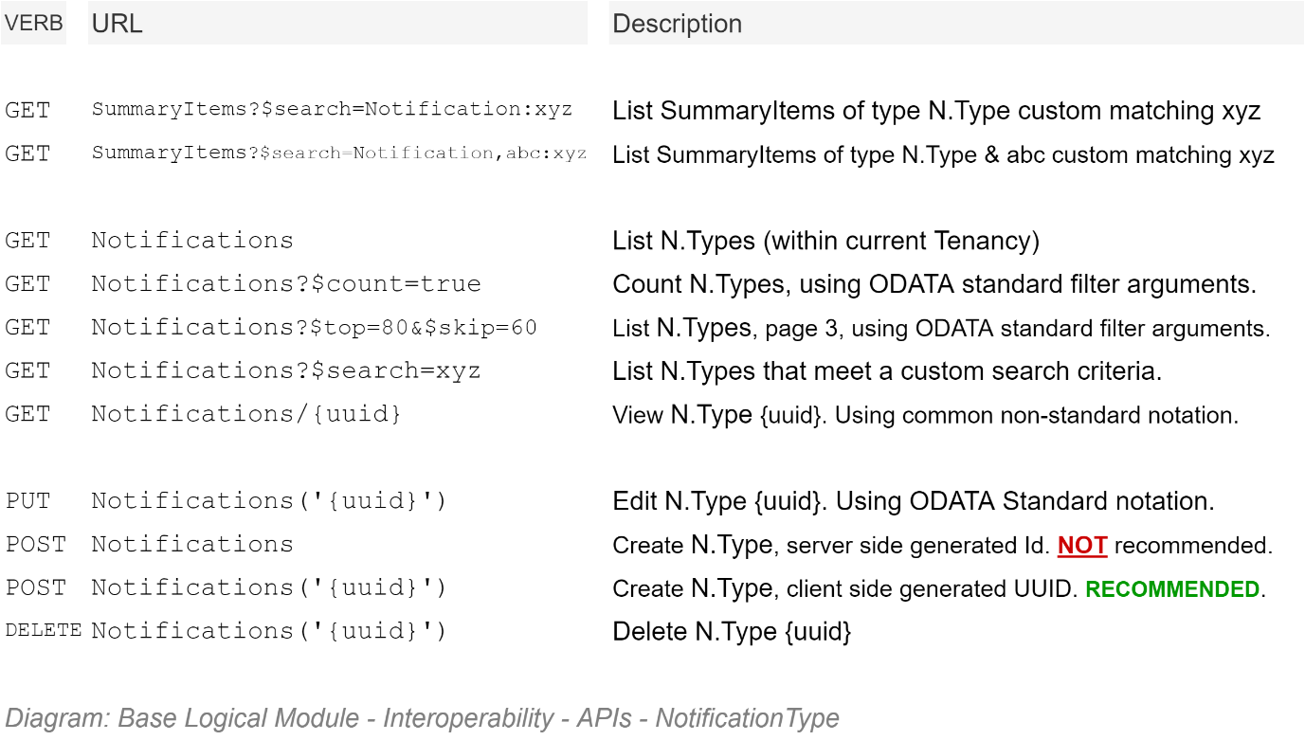

### Notification Management Service Facade API Schema

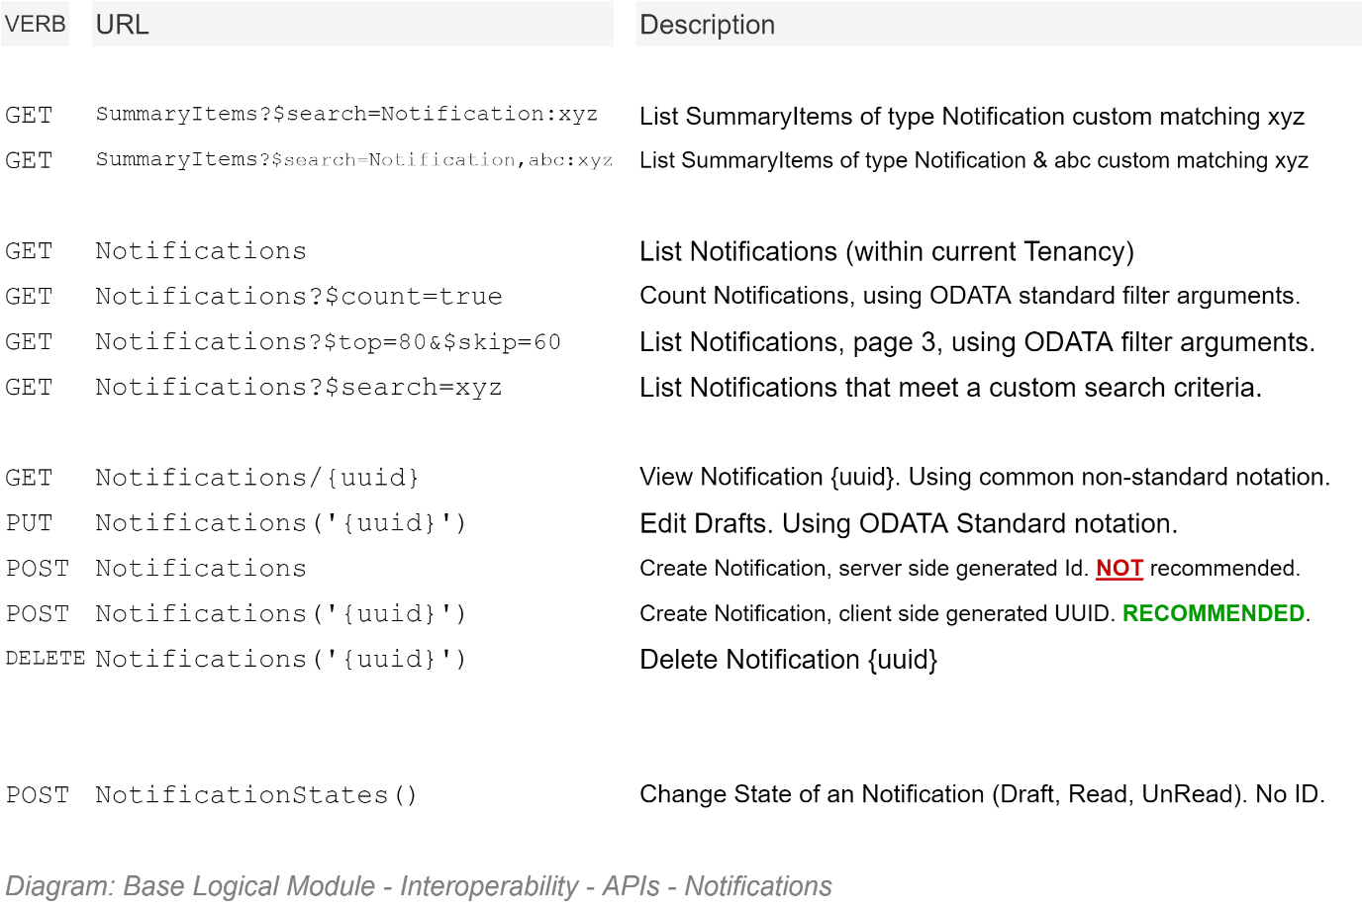

### Invitation Management Service Facade API Schema

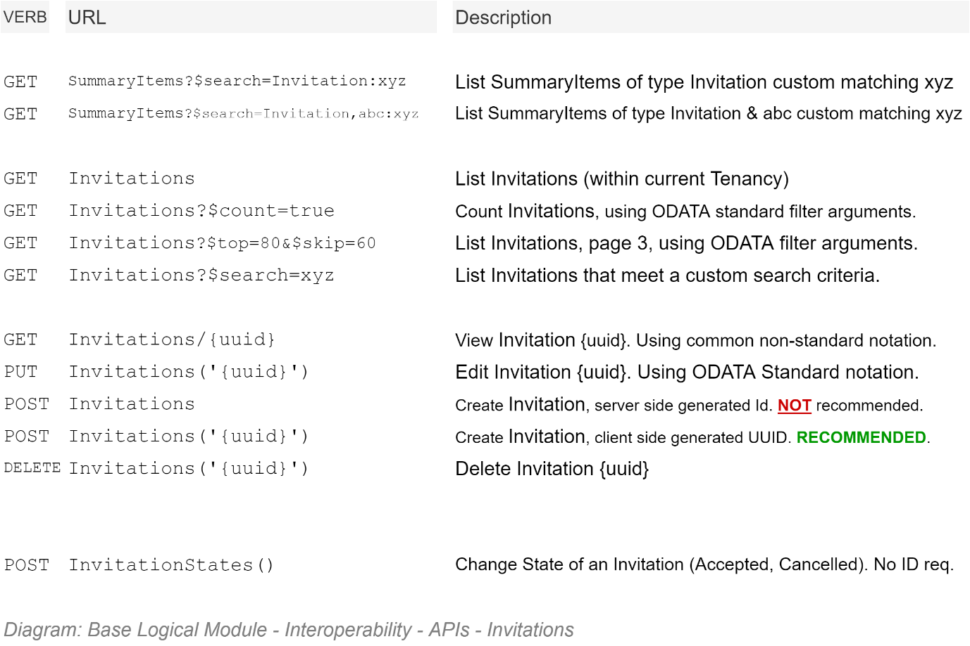

### Search SynopsisItem Service Facade API Schema

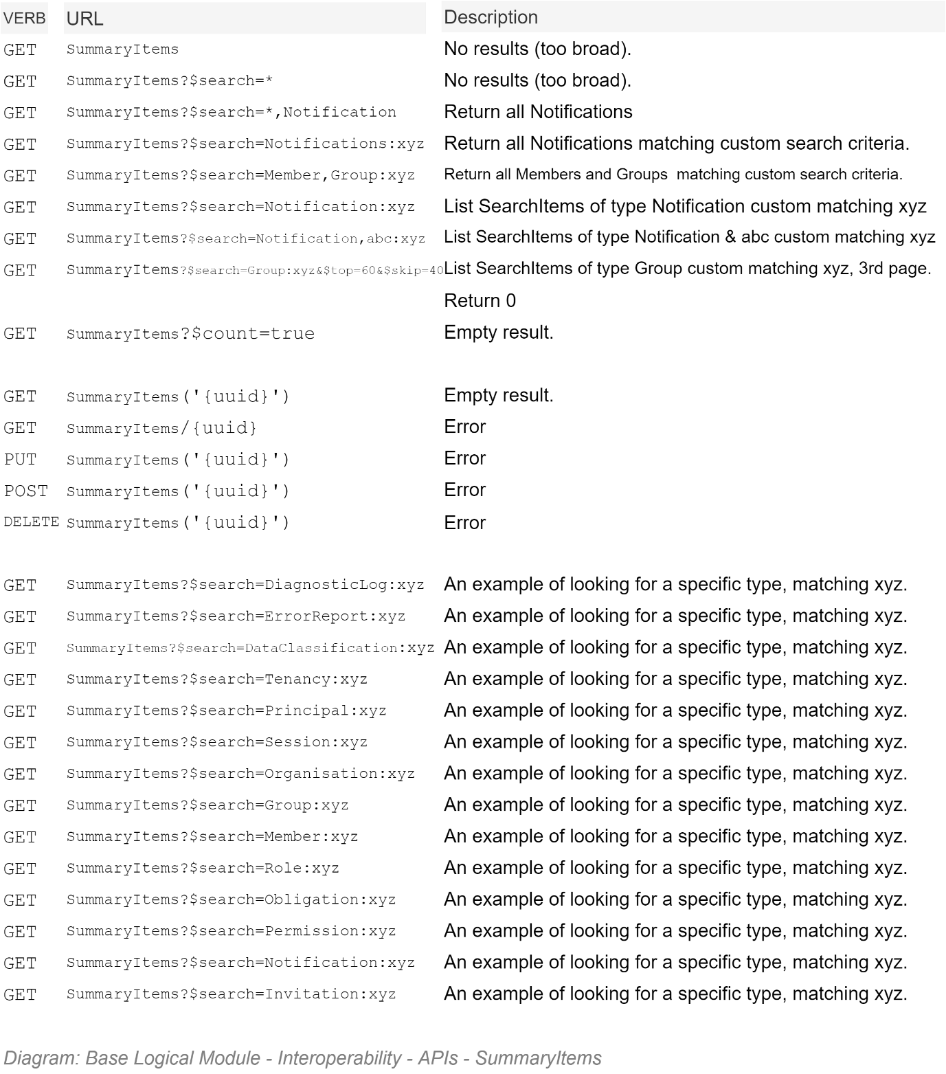

## Media Functionality Service Façade REST APIs

## OCH Functionality Service Façade APIs

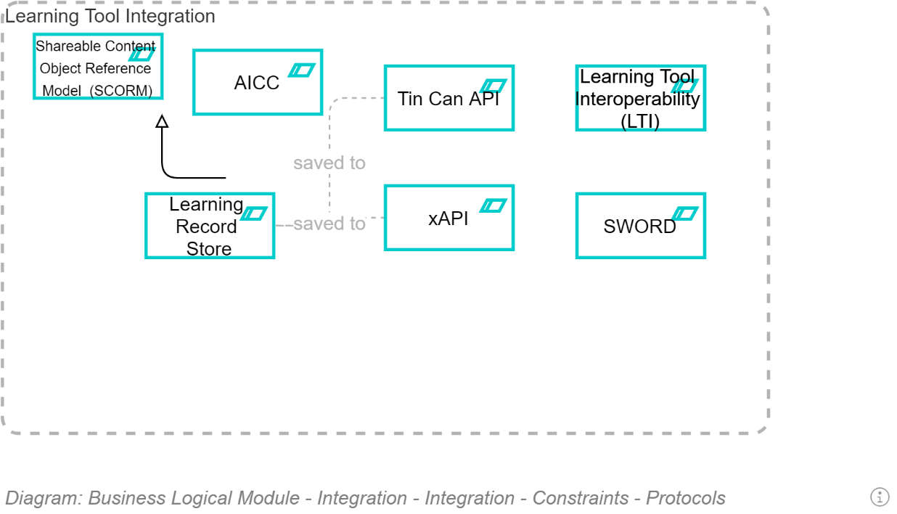

# Service Deployment View

## Section Synopsis

## Environments

Traditionally, the deployment of Services are tightly related to a one or more of a small set of distinct Environments, defined according to test purpose, putting testing objectives before security objectives:

* **Build Test (BT)**: used by the Automated Build Service to validate the code passes automated functional tests as well as unit tests, using a combination of the service account and provisioned accounts, on *non*-production test data.
* **Developers Test (DT)**: used by developers to investigate their work on a different device than their own developer workstation, using their own identities, and seeded *non*-production data.
* **System Test (ST)**: used by system testers to perform investigative testing (but *not* scripted automated functional testing, which is done by the build engine, based on their specifications), using non-production data and a combination of either their own specific digital identities or provisioned test-specific *non*-production data.
* **User Test (UT)**: used by user representative stakeholders, using *non*-production test data, and their personal digital identities.
* **Training Environment (TE)**: used by new users, using *non-*production test data, with their own digital identities, to learn how the system operations.
* **Integration Test (IT)**: for 3rd party service providers to connect to and verify their integrations – using seeded *non-*production data -- prior to connecting to the production site.
* **PreProd (PP)**: [redundant] used by operations specialists to ensure the expectations of the automated deployment and integration configuration are met, using *production* data.
* **Production (PROD)**: for end users, using their own digital identities, using *production* data.

A flaw with the above traditional approach is that Production Data is used in other environments than just PROD, increasing the area that a malicious actor can attack.

An alternate way to organise environments is to consider safety first, and define environments according to data used, and only then consider quality testing requirements:

* Non-Production Data:
  + Epic XX:
    - BT
    - DT
    - ST
    - UT,
    - TE,
    - IT
* Production Data:
  + PROD

This project relies on Infrastructure as Code to implement the second approach -- in order to benefit from being able to create as many secure environments as necessary, even working on multiple Epics in parallel.

### Common Resource Groups

In general, most resources of a project use the same deployment resource group.

There are some use cases that warrant being outside of a specific test environment.

* **[Legacy] Integration Resource Group**: a resource group to contain services to manage the integration with legacy on-prem services (e.g.: ETL workflows, etc.).   
    
  Advantages of reusing these services across multiple environments include:
  + connections between environments because these connections resources are non-trivial,
  + cannot easily be automated,
  + and take time to configure because they involve configuring the other half of the connection (installing certs, cloud generated UUIDs, etc.).
* **Shared Cloud Services Resource Group**: a resource group to contain service clients for some 3rd party cloud-based services.   
  Advantages of these services being shared across services include:
  + **Speed:** signing up to remote services may include a processing delay, as well as may not be automatable.
  + **Cost savings:** services may be billed per service account.
  + **Cost overruns:** multiple accounts make it easier to forget to shut down accounts that are no longer required.
  + **Security & Bottlenecks:** setting up services may require a billable credit card managed by a designated role.
* **Shared Data Resource Group:** system data persisted in the same resource group as system components can be inadvertently deleted when resource groups are deleted.

   
**Warning:**  
Backups that are not explicitly stored in a separate Resource Group get deleted as well!

* **Shared Backups Resource Group:** Backups stored separately to System Component Resource Groups, in a resource group that is only accessed by the automated deployment pipeline’s service account has the least chance of being inadvertently deleted.

Overall Context

The following key objectives:

* keeping production data – whether system data or backups thereof -- inaccessible to any security principal other than the deployment pipeline’s service account,
* Keeping backups separate from system components
* Allowing for multiple environments to be created as needed, using Infrastructure as Code (IaC)

Are highlighted in the following high-level diagram:

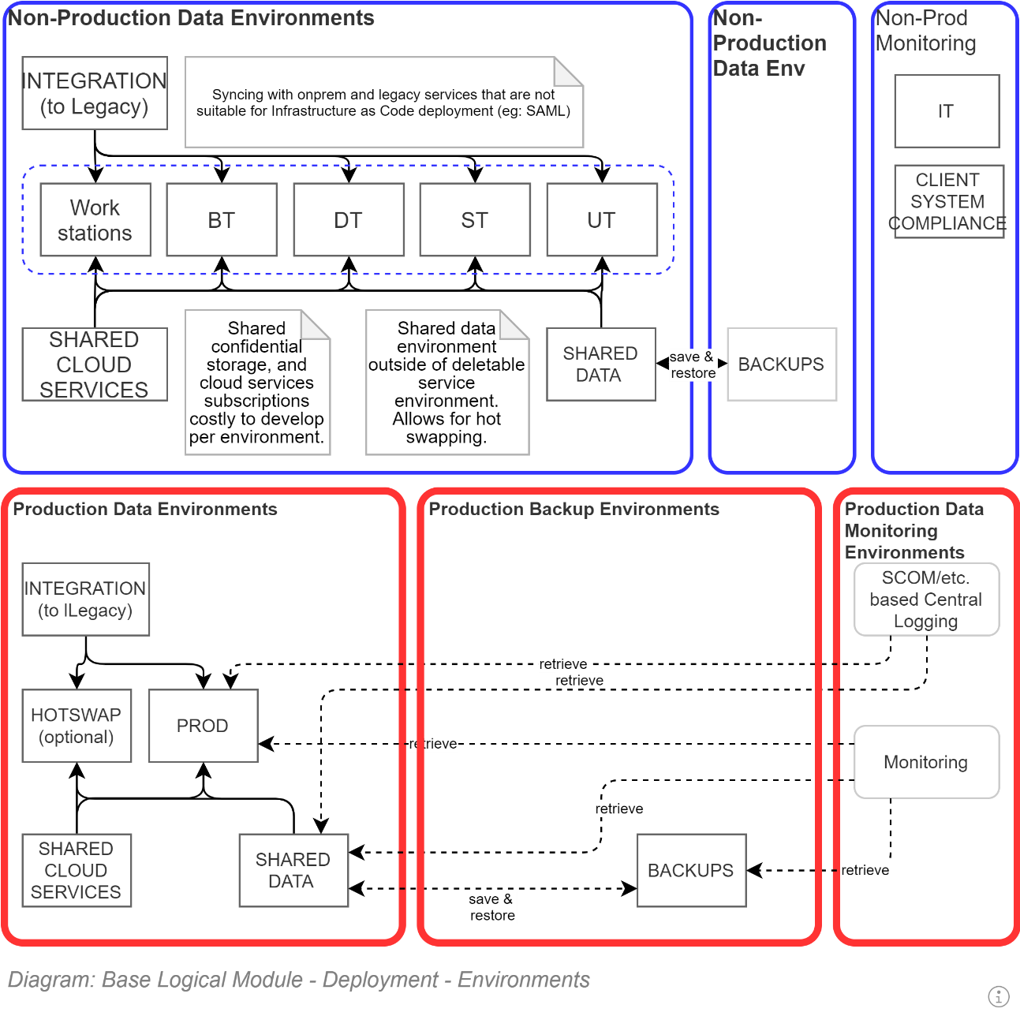

## Packages

The automated deployment pipeline packages and executes a number of different deployment packages:

* **Infrastructure as Code:** idempotently creates or modifies an existing resource group according to coded instructions defining how to develop the necessary infrastructure and services and configure them to work together.
* **Logic as Code:** the traditional information service code package, containing the latest version of the service to deploy to the newly configured infrastructure and Services.   
    
  Mature information systems use an Object Relational Mapping (ORM) based service to handle the following tasks:
  + **DB Schema as Code:** idempotently updates the schema of the database to the latest version.
  + **DB Seeding as Code**: idempotently ensures immutable reference data is seeded within the information system’s database.

  
**Warning**:  
If an ORM is not used, the deployment pipeline must manage these two database operations as deployment tasks prior to starting the application.

TODO

# Service Operations View

This section describes how the Solution’s Systems will be monitored, administered, supported and operated while running in a Production and/or Training environment.

## Synopsis

Operations are greatly reduced as Deployment is automated to a single button push. Deployment is to a PaaS environment which has an SLA of 99.99% or better. Being a PaaS environment, Infrastructure and Application Support Specialists do not need to worry about underlying OS patching, Execution Environment Patching, etc. Monitoring and Alerting is done via Application Insights, which by default provides insights to throughput and bottlenecks, and can be extended via custom dashboards to integrate more fully with the APIs provided by Core.

## Project Documentation

* Project ALM:
* Project Wiki:
* Project Work Item Kanban/etc:

## Internal Corporate Registries

The project is expected to be have an entry in the Organisation's architecture and systems catalogues, pointing interested parties to the Project Space for further information.

## Operations Manual

An Operations Manual is not required to be desired or produced –Operations Specialists are expected to refer to the searchable Project Space's Wiki.

## Domain Name Service (DNS)

The deployed systems, require Domain Name System (DNS) entries in order for stakeholders to access the system.

The system may be associated to multiple DNS records, and associated Certificates.

This procurement of DNS and Cert names will be handled as BAU processes by Operations Specialists.

The information will be configured within the automated deployment pipeline as required.

## Host Environments

As per the Service Infrastructure View.

Note:  
Target Infrastructure environments are developed from scratch by Infrastructure as Code instructions.

## Key System components

## Service Accounts

Two service accounts are key to this project's successful deployment and operations.

### Deployment Service Account

the Deployment Pipeline's Service Account must be equivalent to an infrastructure Owner role in the Cloud Provider's (e.g.: Azure) Project Subscription Account.

#### Using Azure

When deploying to an Azure environment, the Service Account which runs the pipeline must have sufficient rights to:

* Retrieve code from the project's Code Repository
* Compile the code on a Build Agent
* Create, Update & Delete as required Azure Infrastructure Resource Groups & Resources
* Run 3rd party Test Services (can be via retrieving Service Credentials from an Azure Key Store service, where the credential has been previously recorded, manually)

#### Using Amazon

* Retrieve code from the project's Code Repository
* Compile the code on a Build Agent
* Create, Update & Delete as required Amazon Infrastructure Resource Groups & Resources
* Run 3rd party Test Services (can be via retrieving Service Credentials from a secure store service, where the credential has been previously recorded, manually)

### Service System Service Account

#### Using Azure

When hosted in Azure the Service Account MUST be automatically developed by the Deployment Pipeline as a Microsoft Secure Identity (MSI).

**Note:**The advantage of using an MSI as a Service Account is that its password is never divulged, nor requires storage. Being not divulged to any human, it is more secure than a Service Account developed manually, with the Password – no matter how long or complex it is – known to an Operations Specialist, and persisted in a key store which needs protection, and can become corrupted.

#### Using Amazon

TODO

## Service Credentials

### Certificate Development

##### Account Credential:

##### Account Payment Information:

### Cloud Provider Services

#### Caching Service

##### In Azure

The system's MSI Service Account, having been granted enough rights in the Caching Service, is sufficient to interact with the Caching Service.

TODO: Verify

##### In Amazon

TODO: Verify

#### Notification Service (SMTP)

### 3rd Party Services

The following are dependent services that are required by the service but are not available via the cloud provider.

#### Search Service

##### Provider

##### Account Credentials

##### Account Payment Information

##### Credential Cycling Schedule

#### Malware Detection Service

##### Provider

Acceptable services include: Scanii.com

Unacceptable services include:

* TODO: add list.

##### Account Credentials

##### Account Payment Information

##### Credential Cycling Schedule

## Certificates

Certificates are developed by coded instructions within the deployment pipeline, with an expiration date <= 90 days.

The only operations action required is ensuring the Certificate Provider Service's credentials remain valid and rotated as per the service's terms & conditions – the deployment pipeline will take care of the rest.

**Note:**A re-building of any environment will ensure that the Certificate Provider Service is functioning as expected.

## Infrastructure as Code

### In Azure

Using the Cloud provider's ALM is Microsoft's preferred solution to deploying code.

Developers with less capability in infrastructure than system development may prefer Terraform.

More abstract approaches…

TODO: Complete

### In Amazon

TODO: Describe

## Operating System and Execution Environment Patching

### Azure

When deploying to Azure, the system is deployed to a PaaS environment. Microsoft takes care of

* OS Patching
* Security Update Patching
* Execution Frameworks Maintenance:
  + .NET (multiple versions)
* Execution Environment Maintenance:
  + Web Server (IIS and/or the more performance .NET Core replacement).
* Realtime and Periodic Malware Scanning of IO to Host hard-drives.  
  Note: Scanning is not done Blob Storage – hence the use of a Malware Service to scan uploaded media before persisting to Blob Storage.

## System Configuration

System configuration is an Automated Delivery process.

No manual operations are to be performed during or after any deployment.

## System Diagnostics Tracing

Diagnostics Tracing is able to be routed to Application Insights such that it can be – when activated – viewed in the Azure Portal.

Error and Warning Messages are routed to the system database, and made available via the APIs such that they can be queried using PowerShell, Postman, curl or similar:

Invoke-RestMethod https://target.tld/api/odata/exceptionrecord/

A simple query from an appropriately authorised Principal (refer to the Access Control Model) for errors that have occurred lately – without any ODATA based filtering or shaping applied – would be similar to the following:

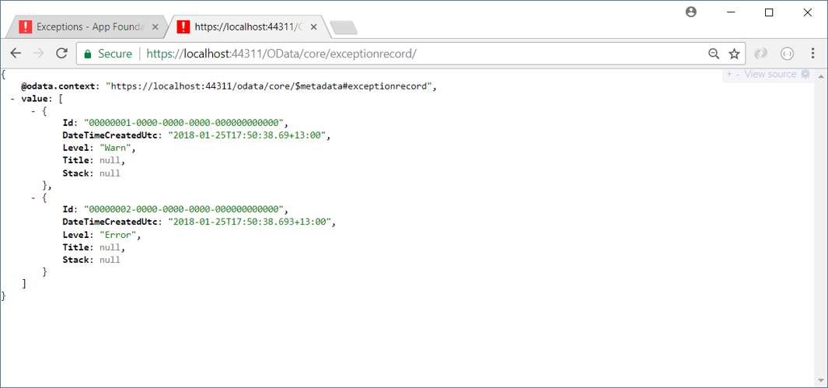

## System Monitoring

### Deploying to Azure

When deployed to Azure, the system is deployed with Application Insights monitoring, which can be configured to collect information on queries received, their average duration, and the average number of errors that occurred.

This type of monitoring requires blob storage to save information for a duration of time.

Note that this collection of data should be temporary, to trace bugs. It should not be on continuously, due to reasons that include the following:

1. It negatively affects performance
2. The storage requirements for the collected metrics do add costs that should be avoided if their advantage is not defined against an actual problem that needs solving.

### Deploying to Amazon

TODO: Describe

## System Alerting

### Deploying to Azure

Application Insights can be configured to respond to configurable metrics and alert a support specialist.

Of specific importance are expiration alerts, including:

* TLS certificates backing the HTTPS communication between Clients and Service
* Single Access Signature (SAS) Tokens between the Service and Azure Storage Containers.

TBD: An interface could be developed to connect alerting to Application Insight.

### Deploying to Amazon

TODO: Describe

## Data Archiving

No external archiving capabilities are required: archiving is achieved using Logical flags within the Operational database.

Records are archived in one of the system’s data stores, including:

* The system’s sequential database.
* The system’s storage accounts:
  + Publicly addressable media storage account.
  + Private diagnostics storage account

## Reports

TODO

# Service Security View

This section describes the security risks and controls used to mitigate risks within the processes and services of this solution.

## Section Synopsis

Security of a system does depend in part on the system’s technical design – but it is only one part of a system’s security.

### Overview

Security starts with people.

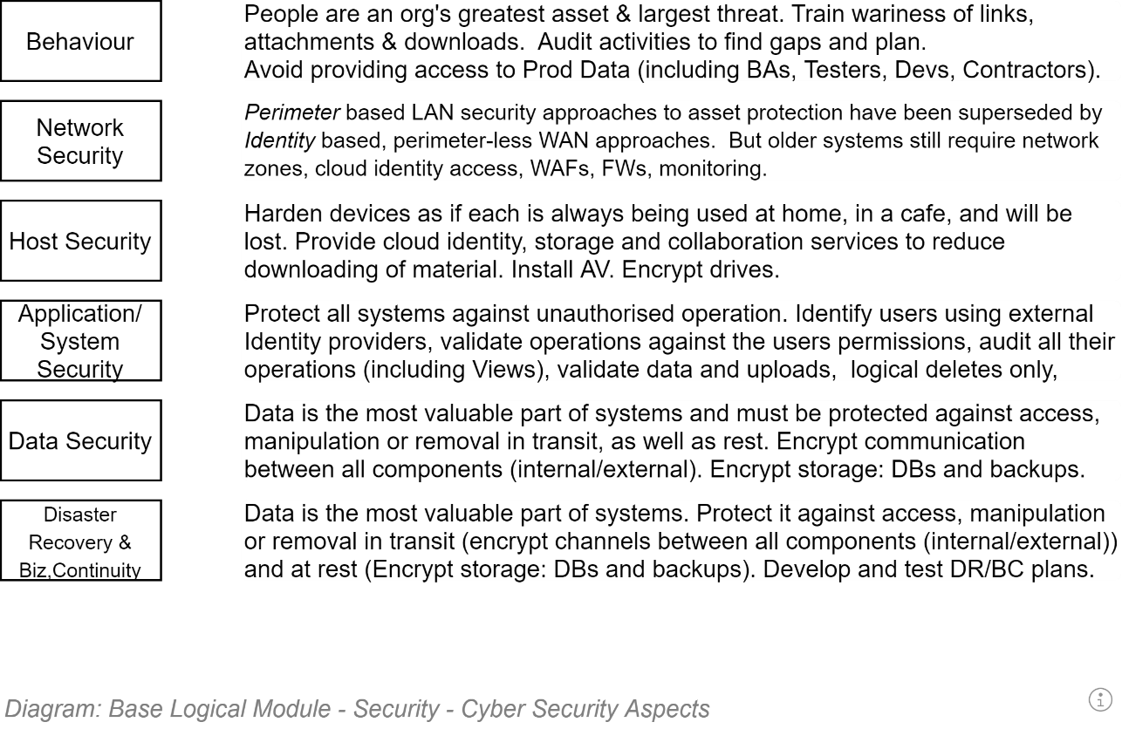

## Behaviour

### Non-Access to Production Data

Irrespective of the data classification[17] of the data, production data is entrusted by end users to information systems in the belief that the data is not accessible by others without specific consent.

Based on the above, only the automated delivery pipeline’s security principal is given access to production data – whether it being live production data or backed-up production data (which is still *production* data, just only slightly out of date).

Traditionally Testers, DBAs and other technical Specialists who have had access to production data on other projects, complain vociferously about not knowing how to work when this security restriction is implemented.

Their complaints are addressed by:

* Continuously performing exploratory tests to find new failure points
* Use the found failures to inform the continuous updating of test data, to use in automated tests performed by the deployment pipeline (in order to never have to repeat those tests physically).

## Production Tools

The tools provided to Production personnel to communicate and develop a solution impacts on the behaviour of team members, and therefore the security profile of the solution.

* **Web based team collaboration and wiki services**: Easy onboarding of collaborators (e.g.: using AAD, which allows for inviting Guests) to a system accessible from anywhere at any time improves collaboration (e.g.: using Teams) over secure channels (HTTPS), decreasing the feeling that there is a need to transmit information by another channel outside the provided system (e.g.: using Email, which is -- by default -- an insecure channel).
* **Web based ALM Services**: complete suites offer mature build services that are already integrated to secure credential stores, removing the perceived need to persist integration credentials into source code.

## Physical Environment Security

The physical environment used to host the service must meet ISO-27001 Stage 2+[18].

ISO-27001 ensures the data centre that hosts production data is assessed as having many security controls in place, including the following:

### Confidentiality

N/A

### Integrity

* Physical perimeter hardening (CCTV, alarms, patrolling, etc.)
* Security trained personnel
* No access to hosted devices unless requested, approved, logged and accompanied by a second person observing their actions remain within the scope of the approved task.

### Availability

* Automated Backups, Fallback & Recovery capabilities
* Power, traffic and access monitoring and alerting
* Optionally, remote self-service administration capabilities

## Network Security

If the device is within a LAN, the LAN’s perimeter is hardened, uses a firewall to close unnecessary ports, uses traffic monitoring and alerting.

Even if within a LAN, Communication between Devices must be secured, as if the system were not protected by a LAN’s perimeter defences. Specifically, communication between all components and services should be secure. Refer to *Security in Transit*, and *Security at Rest*, in the next section.

### Azure Cloud Service Network Environment Characteristics

TODO: Copy from BASE

### Amazon Cloud Service Environment Network Environment Characteristics

TODO:

## Host Security

TODO: Clarify

### Azure PaaS Characteristics

TODO: Copy from BASE

### Azure Container Characteristics

TODO:

## System Information Security

Several data specific controls are used to secure the system’s information.

### Confidentiality

#### Security at Rest

Protection of the data at rest is accomplished at several levels, as shown below.

##### Encrypted Hard drives

The hard drives used to persist the production data on must be solid state (for performance) and encrypted.

By using encrypted hard drives, if the disk drive is replaced, or disposed of without being wiped first, the database on the drive remains inaccessible.

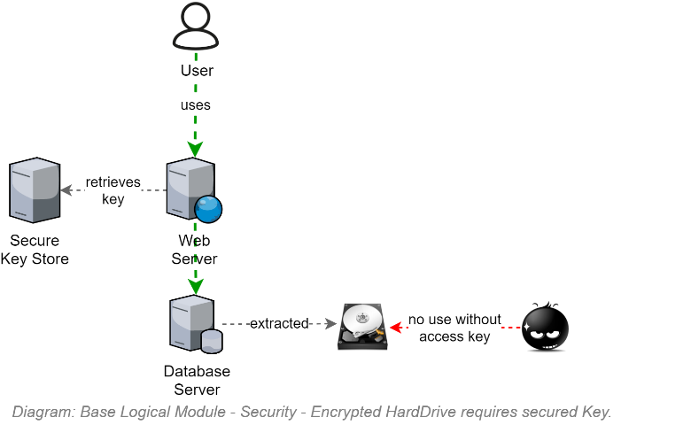

##### Encrypted Databases

The databases created on the hard drives are created using a cloud service provided key.

By encrypting the database, if it downloaded via Remote Desktop Protocol (RDP) or similar, the database remains inaccessible even when removed from a secure backup environment.

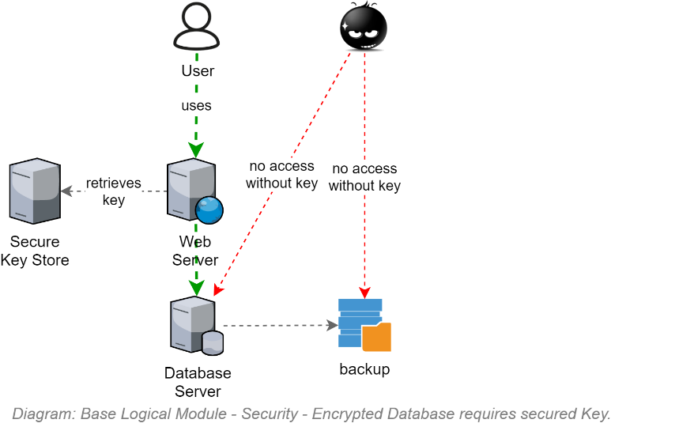

##### Encrypted Database Columns

The columns of the tables containing the Personally Identifiable Information of Users are encrypted using a key, persisted in the environments key vault in such a way that the cloud provider’s database service can access it.

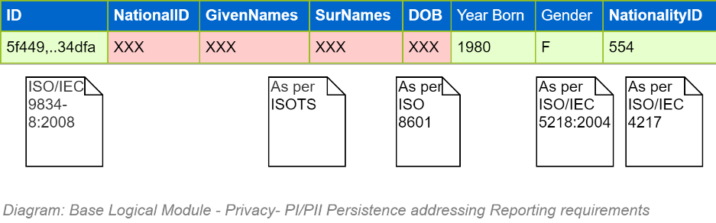

By encrypting the columns containing PII information the database can be cloned for analysis and reporting by others with less of a chance of disclosing sensitive data via the analysis and reporting tools.

  
**Note:**  
Not all database engines can deliver encrypted database columns. This is one of the reasons why we stipulate the use of certain database engine types (e.g.: SQL Server) as opposed to accepting other recommendations.

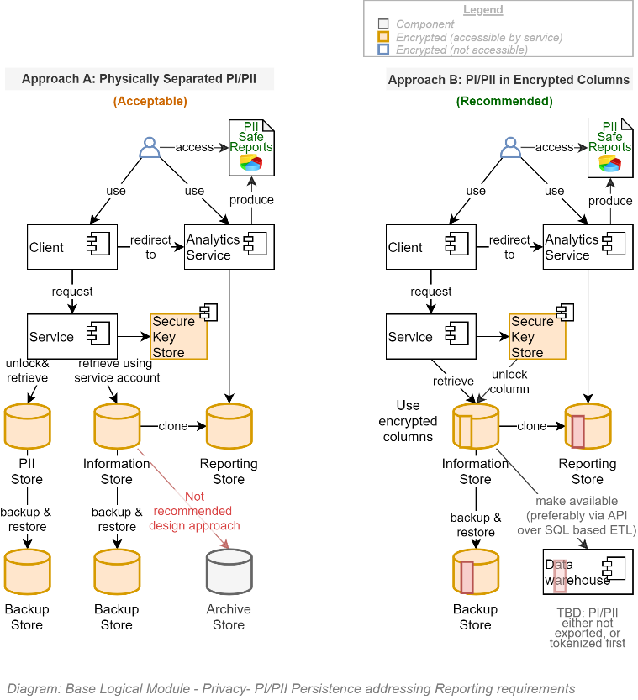

##### Limited Database Access

The only service accounts that are given direct access to the database are:

* **The deployment pipeline’s service account**, used to create the database, update its schema, seed its reference data, and develop and restore backups.
* **The information system’s host’s service account**: the service’s ORM component uses this account to the same as above, as well as read/write additional data.

Limiting the accounts that can access the system’s data to only two system service accounts is another way of ensuring Users (Testers, DBAs, Specialists) do not have unaudited access, nor know credentials that they may inadvertently commit to the code repository or transmit over a system.

#### Security in Transit

Security in Transit is met primarily by using appropriate encryption of channels between devices.

##### Encrypted Channels

Communication between Components and Services must be secured by encryption where-ever technically and reasonably achievable.

For example, HTTPS, using the latest TLS specification, is always used over HTTP channels. Connections to relational databases use security flags where they can be implemented[19].

ed in this solution.

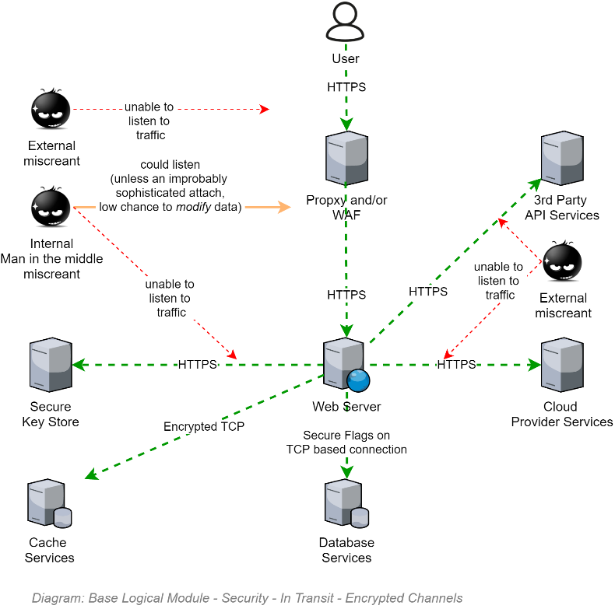

###### Redirection

If a user specifically requests communication over an insecure channel – ie, they type <http://myapp.tld>, instead of <https://myapp.tld>, the web server issues an HTTP 302 Code, redirecting them to the same URL, but this time over https (i.e.: <https://myapp.tld>).

Note: Redirection is not an application setting: it is a server setting that is put in place via Infrastructure as Code (IaC) instructions issued by the continuous deployment pipeline, prior to the software package being deployed to the web server.

###### Secure Cookies

An important aspect of secure communication is ensuring that secure objects are not transmitted over unsecure channels.

If a user specifically requests communication over an insecure channel (see above), the service client (i.e., browser) MUST NOT send its SessionId cookie over the cleartext channel.

The way to stop that is ensure that cookies developed to roundtrip the session id between service and service client and back again, is decorated with the secure=true flag. This tells the browser that the cookie can only be transmitted if the channel is deemed secure (i.e. encrypted).

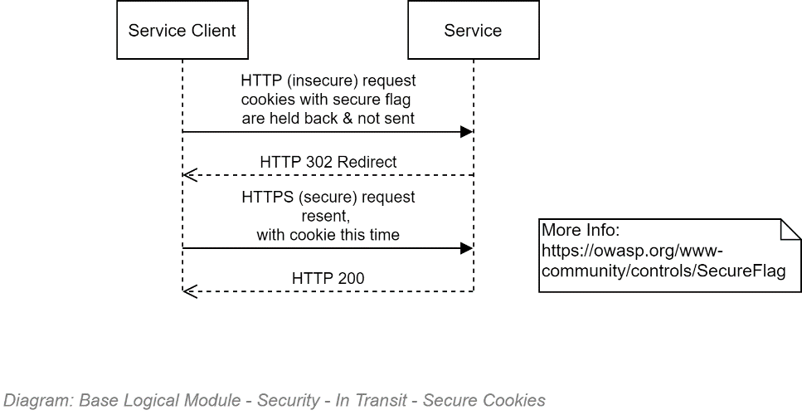

##### Encrypted Messages

Not required.

### Integrity

#### Sessions

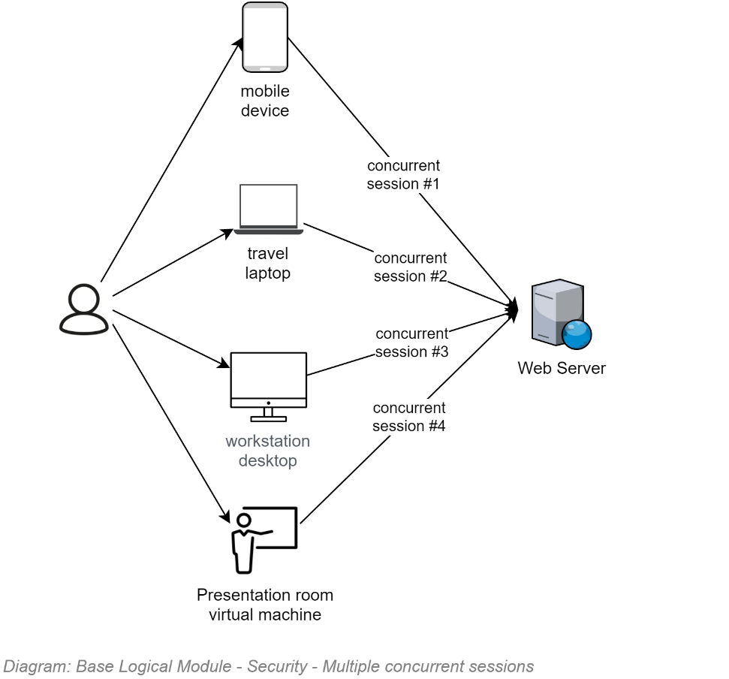

  
**Requirement:**  
Sessions must be permitted to be as long as possible, while being short enough that their security tokens cannot reasonably be decrypted by brute force before they expire.  
The rationale is that in order to make the service user-friendly, the service must not force them to re-enter their credentials more times than required.

#### Session Operation Auditing

All Operations – including List & View Operations that do not actually change system data – undertaken by users -- irrespective of whether the user is Unauthenticated or Authenticated (both user categories get a Session) -- are permanently and immutably logged.

The SessionOperation record created for each HTTP request captures the UTC Date and Time, users current IP (IPs issued to all devices – especially mobile ones can change over the duration of a Session), the geo location of the WAN IP address if known, etc. and associates it to the Session record.

If an Unidentified user signs in, all operations attributed to that Session before and after the sign in event are attributable to the identified User associated to the Session record.

Note:  
Auditing of operations like List & View, which do not modify data, is still required to better understand the impact of poor security controls (i.e., who has seen a specific record or resource).

If a System Session token times out it will redirect the user back towards the remote IdP, which will challenge the User for their credentials if the IdP Session (an IdP Session is different than a System Session…) has timed out, or reuse a still-open IdP Session to issue a new System Session token.

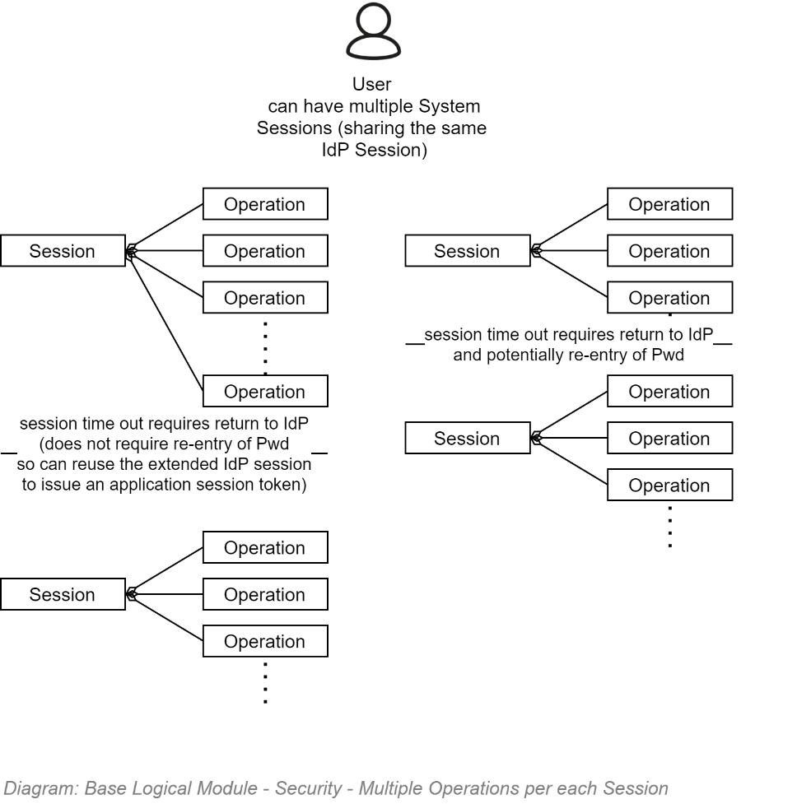

### Availability

#### DDOS

TODO: BASE

#### High Availability

The infrastructure as code (IaC) instructions executed by the continuous delivery service ensure that the cloud infrastructure is instructed to horizontally scale up to handle peak surge demands.

The trigger used to decide when to instantiate another host is when the CPU has been above a Quality Requirements specified amount for a Qualities Requirement specified duration (eg: 50% for 3 minutes).

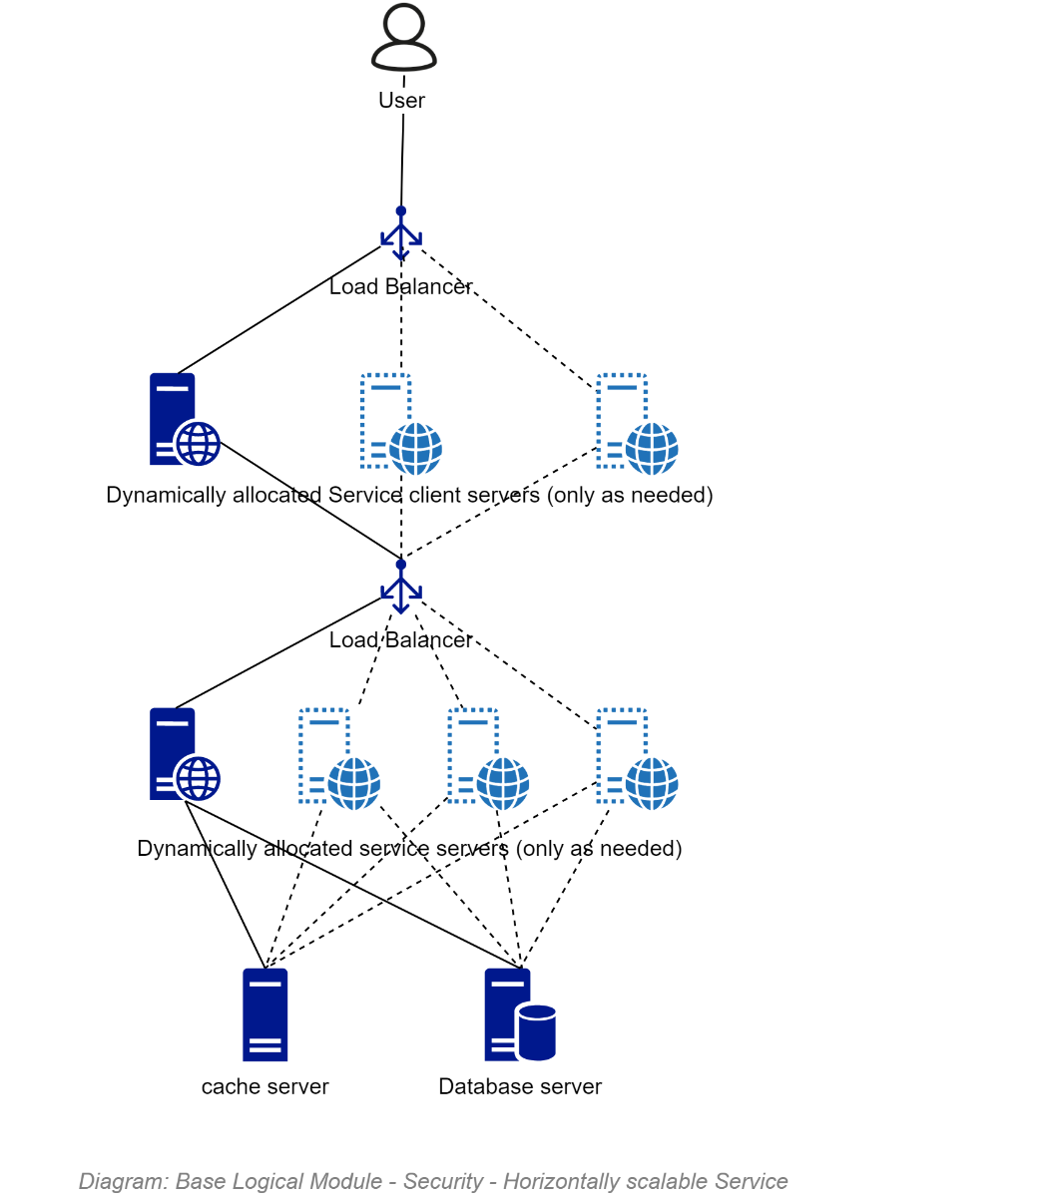

**Note:**  
The icons used above show virtual servers – but it’s only for lack of a more suitable image to use for a non-proprietary Container/PaaS based architecture. This point is made to ensure there is no confusion over our position that the use of VMs – and IaaS – are a legacy approach which have little to no remaining value in current system design.

#### Redundancy

If the cloud service goes offline, we are reliant on our contracted SLAs for the service to rebecome available.

#### GeoReplication

We are not committing to geo-replication at this point based on the cost versus vanishingly small risk.

#### Disaster Recovery

##### Automated Backup and Restoration

The Infrastructure as Code instructions which the Continuous Deployment Pipeline execute include instructions to configure full and incremental backups to meet RPO and RPT obligations as specified in the Quality Requirements.

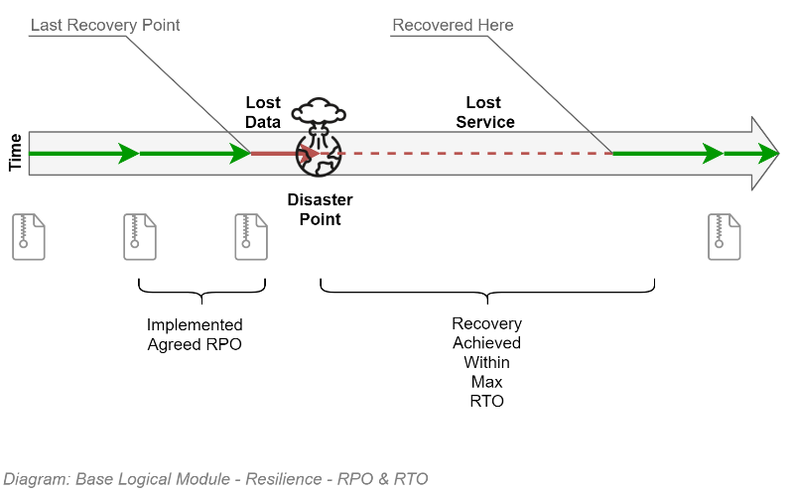

##### Recovery Point Objective (RPO)

Disaster recovery is implemented by using the cloud provider’s database backup service taking full backups every day, and incremental backups at intervals satisfying the RPO objectives specified in the quality requirements (between 1 and 15 minutes apart).

##### Recovery Time Objective (RTO)

The automation available by the cloud provider allows the initiation of a full redeployment of the environment and full restoration of the backups within an interval satisfying the RTO value specified in the Quality Requirements (less than an hour after the automated task is initialised).

#### Business Continuity

The Infrastructure as Code instructions which the Continuous Deployment Pipeline execute include instructions to setup long term storage of the database in the event everything else is deleted.

Whereas GeoReplication is not required to run the service, it is wise to persist the Long-Term Storage in a geographically different location – within a country with an acceptable legal system.

The exact implementation depends on the Cloud platform.

###### Azure

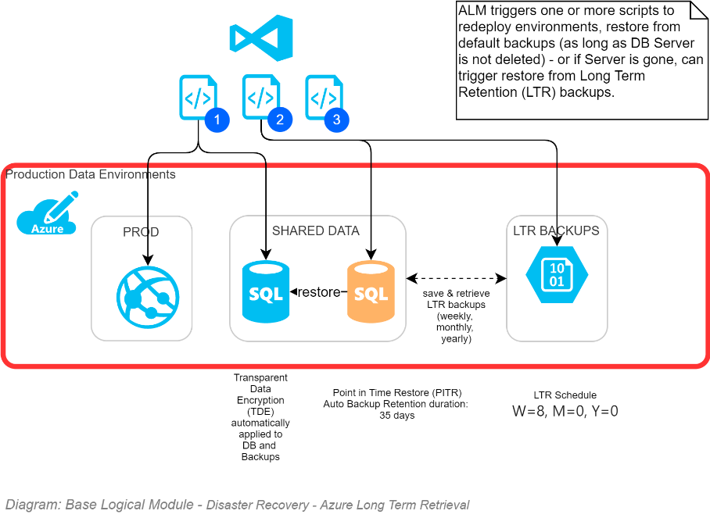

###### Amazon

TODO

### Data Classification

The data’s classification is determined according to the following workflow.

 **Warning:**  
even if an information system manages UNCLASSIFIED data, the system manages some form of private identifying information (PII) of users, the disclosure of which would harm a person or organisation, making even if an information system manages UNCLASSIFIED data, the system manages some form of private identifying information (PII) of users, the disclosure of which would harm a person or organisation, making even if an information system manages UNCLASSIFIED data, the system manages some form of private identifying information (PII) of users, the disclosure of which would harm a person or organisation, making some of the data managed by the system IN-CONFIDENCE.

 **Note:**  
even if some of the information managed by a system is IN-CONFIDENCE, the system MUST meet its other Open & Transparent Data obligations to NZ and the UN. even if some of the information managed by a system is IN-CONFIDENCE, the system MUST meet its other Open & Transparent Data obligations to NZ and the UN. Therefore, a system must and can expose most of its data – excluding its IN-CONFIDENCE data.even if some of the information managed by a system is IN-CONFIDENCE, the system MUST meet its other Open & Transparent Data obligations to NZ and the UN. even if some of the information managed by a system is IN-CONFIDENCE, the system MUST meet its other Open & Transparent Data obligations to NZ and the UN. Therefore, a system must and can expose most of its data – excluding its IN-CONFIDENCE data.

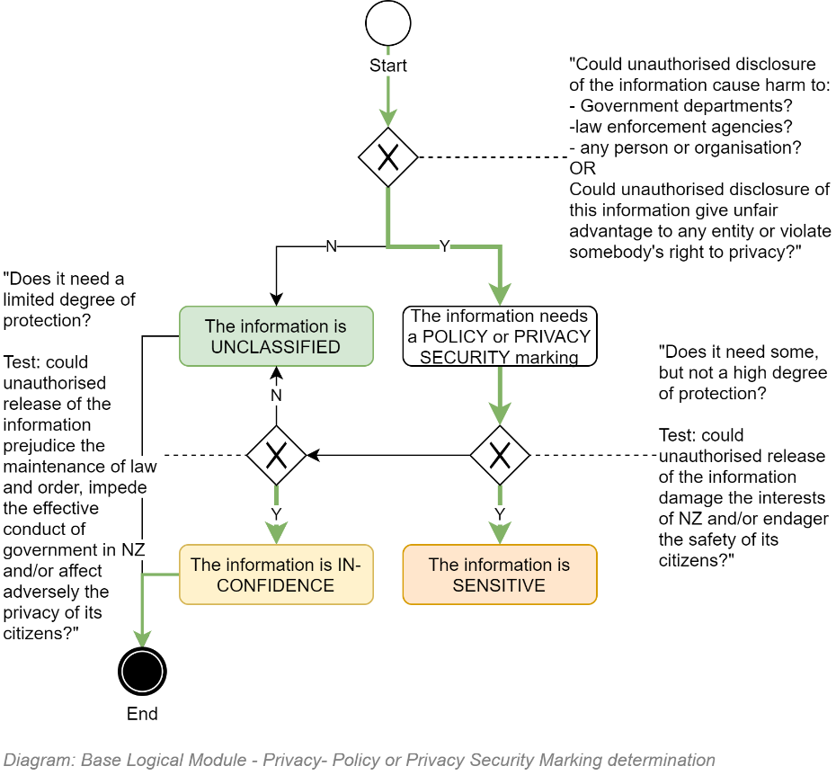

## Roles to Permissions Schedule

TODO: Include Image

Availability

Disaster Recovery

# Service Privacy View

This section of the document describes how the privacy of system users is respected and

## Section Synopsis

Privacy is a first-class concern, as managed by following this country’s Privacy Principles.

## Constraints

This public service – whether offered manually or via automation – is mandated to follow the country’s Privacy Principles.

### Regulation

* **The Privacy Act** which governs how all individuals and organisations collect, use, disclose, store and give access to personal information (PI).

### Principles

TODO: Add Image and Principles

## Use Cases

The following are examples of how the system ensures the privacy of users who have entrusted this organisation with their information.

### Privacy & Minimum Data Collection

The Privacy Principles dictate that a service collects only PII information that is needed to correctly function.

By using a 3rd party Identity Token Provider Service (IdP), the service ensures that the only requestor of PII is the external IdP service, and not this one. The external IdP requests only the information required to function correctly and safely as an IdP.

Whereas the IdP keeps the PII information in order to identify the user, this service does not ask for it. It has no need to know the user's PII (Given/Surname, etc.) to function. All it will ask for is the value the IdP has on record as the person's DisplayName (e.g.: SmithP), in order to populate a new Member's record. The user can change this value at any time (e.g.: to RoadRacer015) to protect their privacy.

The Privacy Principles dictate that a service clearly communicates what PII data the service is collecting and for what purpose.

A user cannot authenticate until they have recorded that they have read and accepted the statement (although it is not required to peruse public information).

The Agreement of the User to accept the Statement is recorded on a per User/per Statement basis, in such a way that when the Statement is updated in any way, the end user will be asked to agree to the updated terms before continuing.

### Privacy & Tracking Policy

The Privacy Principles dictate that a service clearly communicate that the service needs to create a "memento" cookie on the service client to correctly function (at the very least, to round-trip the SessionID).

A user cannot authenticate until they have recorded that they have read and accepted the statement (although it is not required to peruse public information).

The Agreement of the User to accept the Statement is recorded on a per User/per Statement basis, in such a way that when the Statement is updated in any way, the end user will be asked to agree to the updated terms before continuing.

### PII & Analysis and Reporting Requirements

The Service Security section described how the database uses encrypted columns to persist PII information while ensuring PII information is safe, even when cloned and made available to Analyse and Reporting tools.

### PII & Data Warehouse

Data warehouses may not need PII information to be able to meet their analyse and reporting services.   
If such is the case, refer to Reporting above.  
Providing this information is feasible but is not implemented in this delivery.

### PII & "Right to be Forgotten (R2BF)" Requests

Removing bricks from walls without replacing them with an alternative material weakens the structural integrity of walls, introducing uncertainty as to side effects. The same is relevant to software: one cannot remove records from databases without causing uncertain outcomes.

But one can paint out a brick -- and one can do the equivalent with database record fields.

Given an R2BF Request, one can honour it as follows:

* blank or replace a record's PII information, while leaving the rest of the information anonymous, ready for summative reporting.
* go around all tables that could have records that have been created by the user (e.g.: Messages, Comments, etc.) and either:
  + blank out those records, or
  + ensure there is a default "R2BF: Record Removed" Message and Comment in their respective tables, and then point the message threads and comments to the "R2BF: Record Removed" Record, then specify that the original record is logically deleted so that they no longer show up in search results.
* optionally, one can have a record for users who have been forgotten (e.g.: an "R2BF User") and replace all references to the removed user with the R2BF user.

**Note:**the above described steps solve the classical issue of cleaning up Archives datastores (physical duplicate Archives are not taken in this system – any logically archived records remain in the database).

# Service Quality Assurance View

# Service Data Storage Development View

## Section Synopsis

## Governance

### Self-Governance

## Technologies

Several technologies are used to persist data for the system:

* A blob storage to store images.
* A relational database to store relational data.
* A document database to store semi-structured non-relational data.
* An ORM to manage interactions with the relational database.
* An automated workflow to manage the deployment of schema changes and ensuing migration of data.

### Object/Relational Mapping (ORM)

**Requirement**  
The solution must be developed using an OO based ORM service to manage CRUS operations.  
The rationale is recognising the limited local market availability of developers capable of consistently & quickly developing and maintaining optimised SQL operations.

#### .NET Core / Azure based development:

The ORM must be capable of updating database schemas on demand (note that Microsoft Entity Framework has this capability, marketed as “Code First Migrations”).

## Security

### Service Account

The service Accounts that are registered in the service database are:

* The deployment pipeline’s service account, to create databases, update schemas, seed reference data.
* The information system’s service account, for its ORM to manage the creation of databases, updating of schemas and seeding reference data as required.

### Connection Strings

Within an Azure environment, the connection strings MUST not include the service account’s name or password in cleartext. Instead, use Microsoft Secure Identity (MSI)[20] or an equivalent password-less service account approach.

### Security in Transit

The connection between a service and its datastore must be secured. This is especially true when using Cloud provider databases.

  
**Requirement:**If using SQL Server, the connection string MUST include the following flags[21]:  
  
- IntegratedSecurity=true;  
- -   
- Encrypt  
  
In addition, ctruel;[22]  
In addition, cTrustServerCertificate[23][24]  
In addition, consider the use of the hostNameInCertificate attribute[25]

  
**Note:**  
As of .NET4.5 When TrustServerCertificate=false and Encrypt=true the serverAs of .NET4.5 When TrustServerCertificate=false and Encrypt=true the serverAs of .NET4.5 When TrustServerCertificate=false and Encrypt=true the server name in a SQL server Cert MUST match the server name or IP in the connection string.

### Security at Rest

  
**Requirement:**  
Towards Security/Confidentiality objectives, the Database must be persisted on an encrypted hard drive.

  
**Requirement:**  
Towards Security/Confidentiality objectives, the database must be encrypted.  
   
The rationale is such that if the data centre were broken into, a stolen hard drive device would still be difficult to read – and if the database were downloaded, it would remain unreadable without a key.

  
**Requirement:**  
Towards Security/Confidentiality and Privacy objectives, the database columns used to persist sensitive data (e.g.: PII) must be encrypted.

### Database Backups and Restorations

 **Warning:**The loss of user data due to a database being unable to be restored has the potential of causing irreparable damage to an organisation’s reputation. Therefore, Data Backups and Restoration must not be afterthoughts – their automated execution must be an integral part of the service design.

In addition to the databases being backed-up and restorable, they backups must be handled as securely as production data databases.

  
**Requirement:**  
Backups MUST be encrypted.   
The Rationale is that backups are still production data – only very slightly stale.

  
**Requirement:**  
Full backups and Incremental backups MUST be performed at a configurable cadence – generally a full backup every day and incremental backups every 15 minutes, or shorter, depending on the service.  
The Rationale is that accidents happen, and it is important to minimise the data loss between the last backup and error condition, in order to meet strict Restoration Point Objectives (RPO).

  
**Requirement:**  
Backups MUST be kept for a minimum of 31 days.  
The Rationale is being able to provide Point-In-Time-Recovery (PITR) as needed to meet Restoration Point Objectives (RPO).

In addition to meeting requirements specific to the safety of the database backup, the backup location has to be carefully chosen.

**Requirement:**Backups MUST be persisted to another resource group.  
The rationale is ensuring the database backup is not deleted if the system resource group is deleted, which should relatively regularly to ensure the infrastructure as code instructions are still correct and the environment can be quickly rebuilt as needed to meet DR requirements.The rationale is ensuring the database backup is not deleted if the system resource group is deleted, which should relatively regularly to ensure the infrastructure as code instructions are still correct and the environment can be quickly rebuilt as needed to meet DR requirements.The rationale is ensuring the database backup is not deleted if the system resource group is deleted, which should relatively regularly to ensure the infrastructure as code instructions are still correct and the environment can be quickly rebuilt as needed to meet DR requirements.

### XXXX: TODO

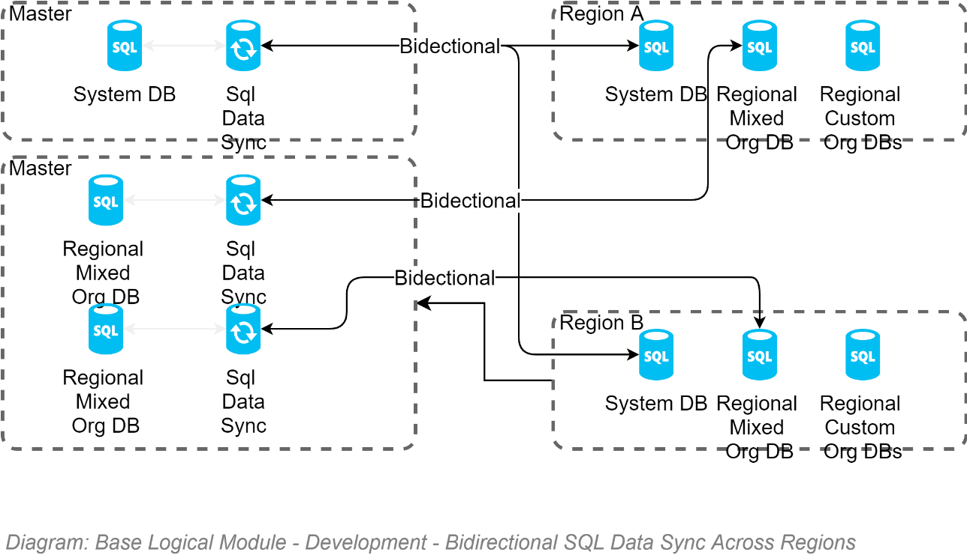

# Service Development View

## Section Synopsis

## Governance

### Technical Decision Registry

Deviations from the above guiding Principles should be very rare (or else the Principles need to be updated) must be recorded in a Technical Decision Registry.

  
**Tip:**  
It is recommended to make the Technical Decision Registry an easily accessible section of the project ALM’s Wiki.   
  
Keep in mind that it may need to be sometimes formatted to print and present to Governance boards.

### Standards

As a government agency we are mandated to always use international standards before inventing home-brew solutions.

As per the NZ Digital Standards:

* *“Standards compliance is consistently applied. Agencies are obliged to responsibly self-regulate standards compliance. Where policy demands, an agency or a supplier must comply with a standard and provide evidence to verify or certify compliance.”*
* *“Adopting international standards should be first. If one is not suitable, consider a NZ profile of an international standard, rather than developing local NZ or NZ government standards.”*

The following are core standards expected to be used within any and all system used within this organisation.

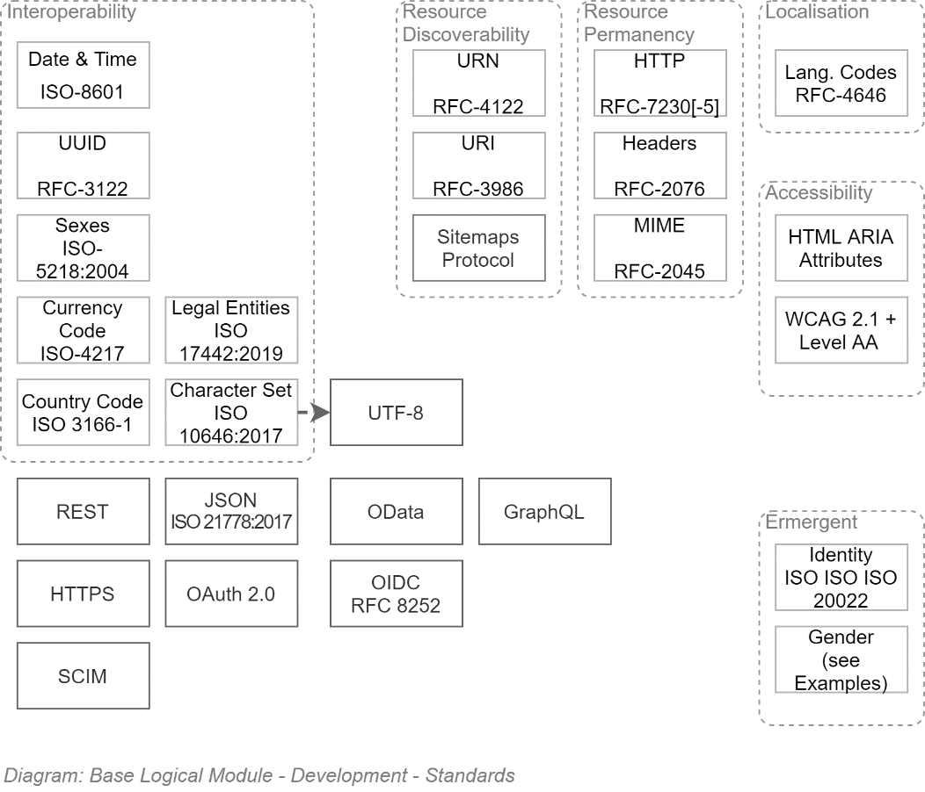

The above is less difficult that it may first appear. At a high level, the gist of above diagram is:

* Use *Application Logic* (*not* Database!) generated UUIDs for IDs
* Persist values using ISO standards.   
  Avoid home brew solutions for values (e.g.: "NZ". Or "N.Z." Or "New Zealand" all look like reasonable decisions, until systems need to synchronize and match against 3 different possible values)
* Persist text without stripping macrons, umlauts, etc. Accept international characters.
* UTF-8 is the standard for web pages now. Don't use anything else.
* Use the most precise Mime definition available (JSON is not TEXT, for example).
* Use international standards to make UIs accessible to visually impaired users.
* Use OIDC to authenticate Users. Use OAuth to authorise systems.
* Use OData over REST over HTTPS for APIs. GraphQL. Is an acceptable duplication of OData (although not as a replacement).
* And ensure Support staff can provision lots of users and groups, using SCIM.

Really not difficult at all once you get into it (SCIM probably can be done just by buying a library to help out).

#### Protocols

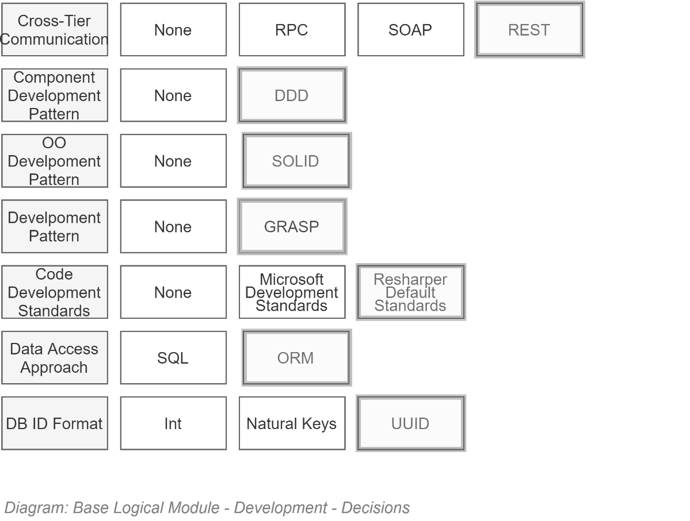

#### Development Technologies

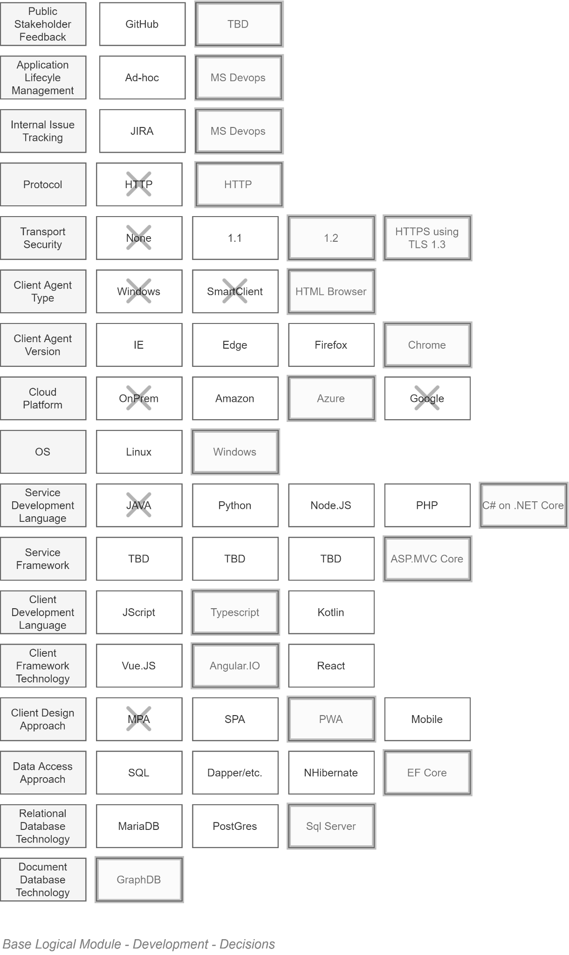

TODO: Fix Diagram (HTTP/HTTP…)

Organised by deployment Tier, the above is as follows:

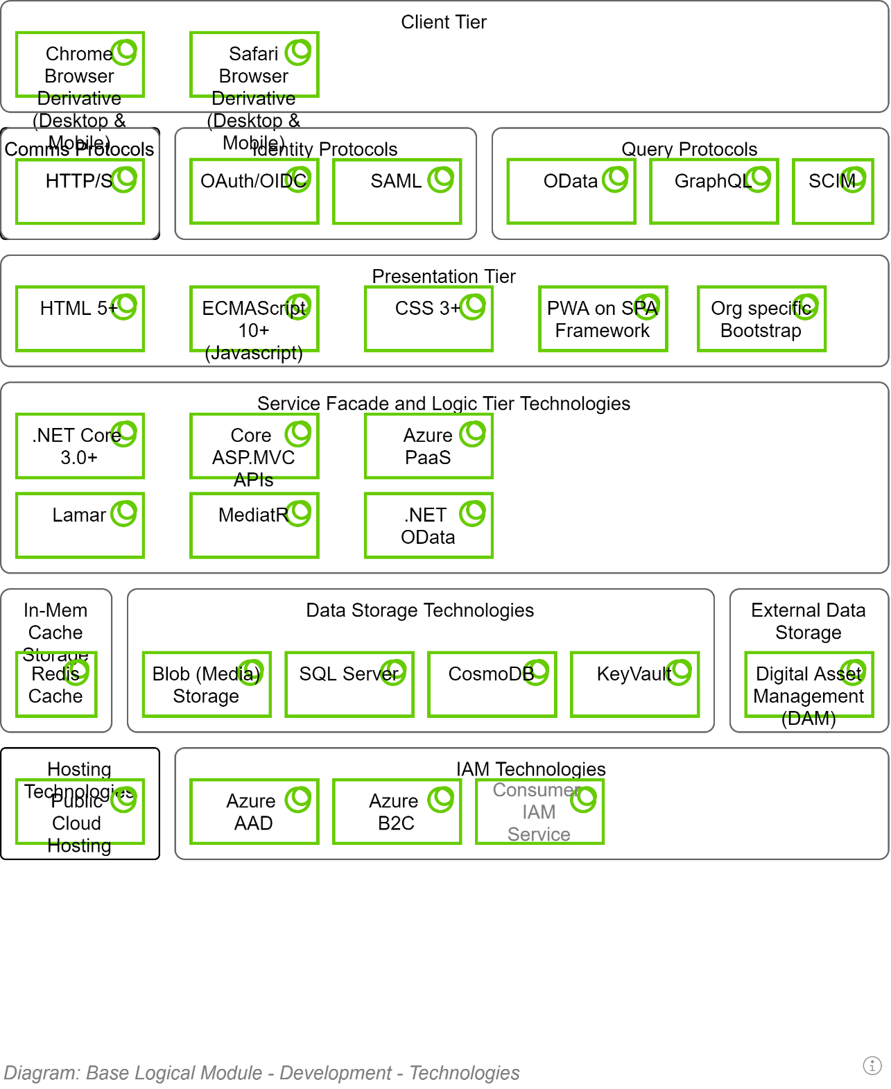

#### Maintenance Latest Version as Standard BAU

For maintainability, interoperability and security reasons the system must be maintained to update to the latest version of each standard when 20% of the market is using it, or within a year – whichever is shortest.

These updates must be a BAU operation, and not require a request from project stakeholders to initiate the work.

## Constraints

### Regulations

TODO

## Protocols

## Development Patterns

The use of a distributed Version control system is a key productivity driver.

Competent ALM Services – as referenced in the Delivery View –providing

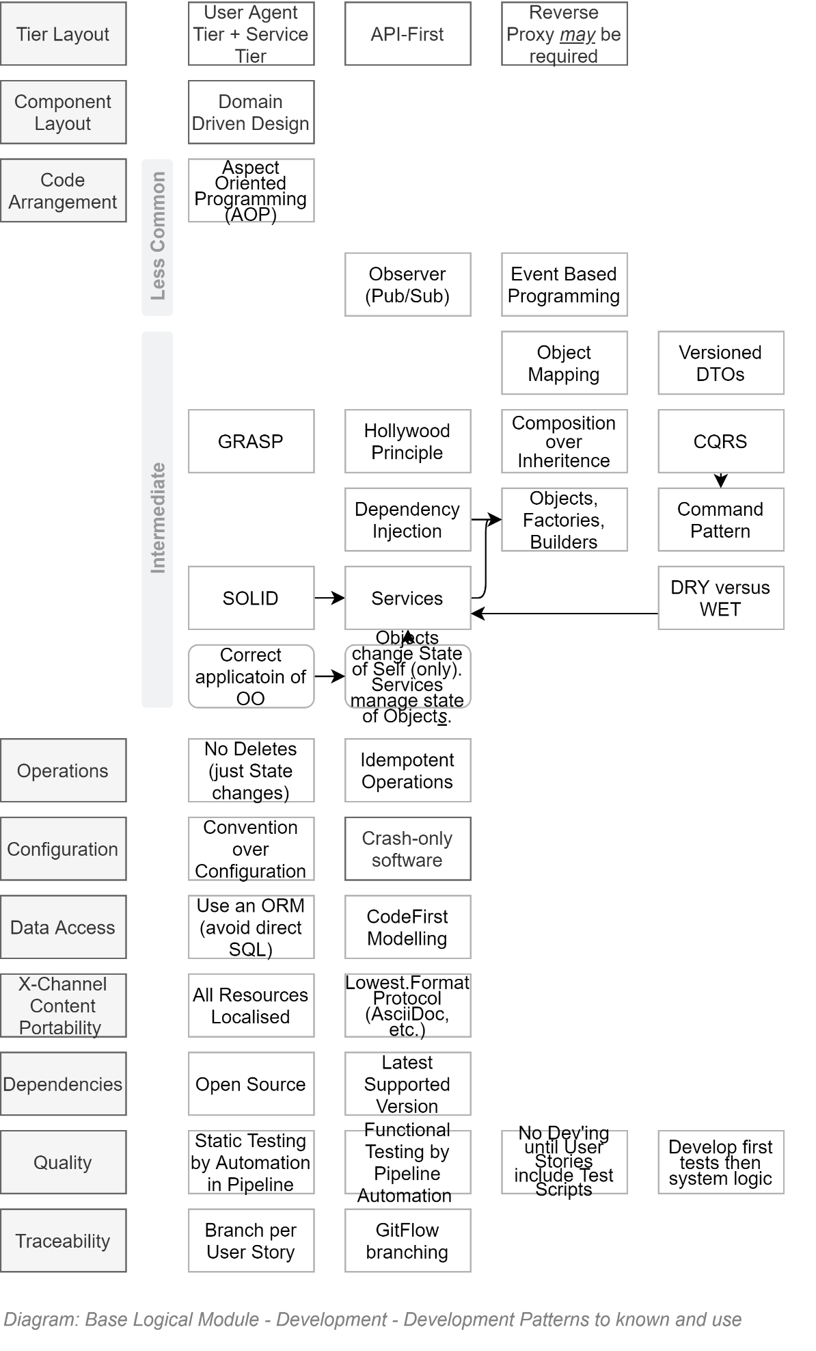

### Pull-Requests

The Agile Manifesto was put together by top-notch developers. Even for them – and certainly for everyone else -- review of code submissions is a valuable process to protect the code base.

Pull-Requests for Review of changes must be issued before branches are merged into target branches.

Mature code integration pipelines can be configured to automate reviews of code formatting, code complexity, unit testing, functional testing, etc – basically taking care of the minutia -- before the submitted code is reviewed by a human team member for opportunities to optimise the code.

**Note:**   
if the continuous pipeline has been configured to automate the review of format, complexity, unit testing, and functional testing, review by a human can often be skipped – most apps are not required to be race cars (they really just need to be functionally correct, while meeting quality expectations).

### Verified Code Branch Integration

The Version Control Service employed to deliver the solution performs *Continuous Integration* activities and verifies submitted code feature branches before integrating the code with the protected `master` branch.

If the Version Control Service rejects the code due to it failing tests -- or a `Pull Request` reviewer (see elsewhere in this View) has manually rejected the submission -- the developer has to fix it and try again before the Version Control Service will allow the submitted feature branch to be integrated with the protected `master` branch:

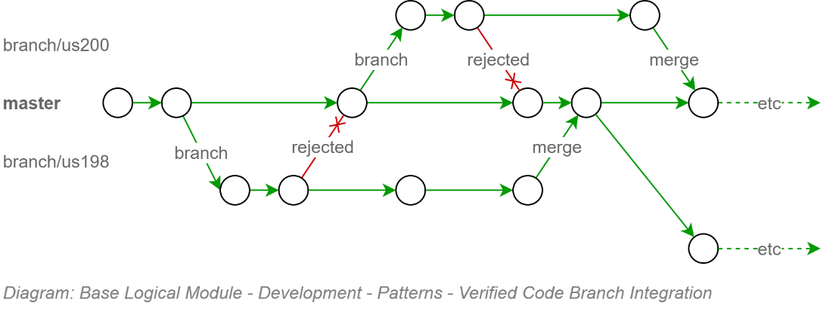

This upfront effort configuring the continuous integration pipeline to protect the code base from getting polluting, protects other developers from downloading poor code and working around it – only to have to remove the work arounds when the original poor code is fixed.

**Tip:**  
This is no different than the kinds of real-world safeguards that would be put in place if we were talking about a communal water reservoir, with everyone tasked with filling it up, and everyone drinking from it. Unless catching typhoid was an objective.

### Component Design Patterns

Domain Integration (DI) Service Design

Domain Integration is the recognition that Services are the composite result of integrating multiple Domains around their unique information.

#### BITS

A Business IT Service, in its simplest form, can be envisaged as the merging of two domains:

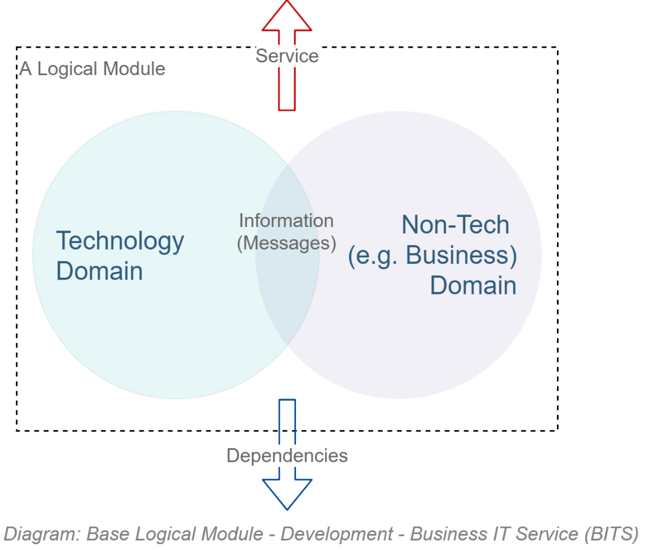

Reality is a little more complex: the actual number of domains involved in an IT product is higher:  


But that just means a couple more Logical Modules.

#### Domain Driven Development

Domain Driven Development is a well-established and successful approach to developing OO systems.

It recognises that there are disparate domains that MUST be kept distinct -- to not become one big unmanageable indistinct mess of logic across multiple domains – and handle the orchestration between them in a thin way.

**Note:**  
Domain Driven Design is more holistic than the above short introduction to it and is well worth reading Eric Evan’s seminal work on the matter.

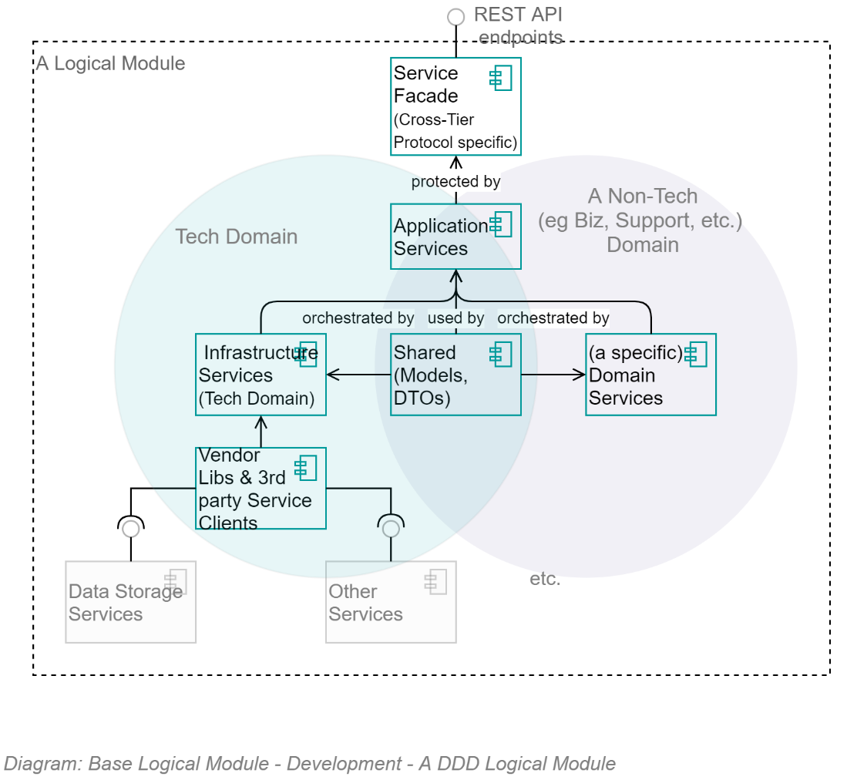

The above diagram demonstrates that, as per Domain Driven Development component composition pattern, all logical Modules are composed of 5 key parts:

* **Infrastructure Services:**   
  a set of infrastructure/technology domain services.  
  Note that a key benefit of the Infrastructure Assembly isolates the rest of the application from dependencies on 3rd party open source and vendor libraries by providing system specific wrappers that provided simplified, app-specific methods, returning to the rest of the system app-Specific messages.
* **[Non-Infrastructure] Domain Services:**  
  A set of (business or other non-infrastructure) domain services
* **Application Services:**  
  A set of Application Service over both of them, orchestrating calls between the two distinct domains, while keeping them separated
* **Shared Entities/Messages:**  
  A shared set of messages/entities that all three sets of services can be passed between them.
* **Service Facade Controllers & DTOs:**  
  A service facade to expose the Application Services to external users as APIs and DTOs.

The same information – this time in a straightforward classic UML Component diagram -- is as follows:

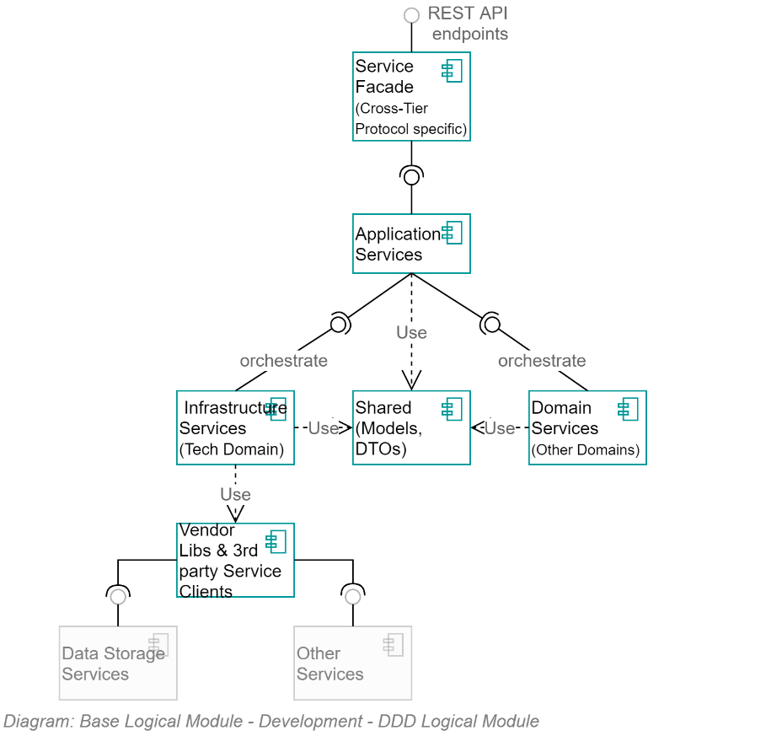

### Object Oriented Development

DDD builds upon and therefore has a dependency on developers applying correct Object Oriented (OO) development patterns.

Object-Oriented development means, in essence two things:

Object definitions are used to create Instances which have public and/or private properties and optional methods to manage their ***own*** properties. Objects do not invoke external services or change the properties of other Objects.

Vice versa, stateless singleton instances of Services definitions are used to manage multiple **other** objects (think of them as specialised helper classes).

This clarity of each object type’s role is easily demonstratable as follows:

* A bank account object has a read-only Balance property and two methods: AddAmount(amount), RemoveAmount(amount) -- but no TransferTo(accountEntity) method as that would be meddling with another Entity. It also has no Save() method, as that would mean it is invoking/has a dependency on another class, in this case a Service.  
  Note: the ActiveRecord pattern is not conformant with OO theory.
* A BankingService would have no balance value, as Services are Stateless, but would have a Transfer(fromAccountEntity, toAccountEntity) to invoke the RemoveAmount(amount) on one and the AddAccount(amount) on the other.

### SOLID Object Oriented (OO) Development Patterns

Robert C. Martin’s SOLID development patterns decrease complexity, improve maintainability and decrease the risk of non-delivery to expectations.

  
**Prohibition:**  
Developers that do not adhere to these development patterns for OO development MUST not be permitted to work on the project until they remedy this lack of experience and technical maturity.  
  
It’s a MUST, and not a SHOULD, as it is that crucial to the modularity, reuse and maintainability of any custom development.

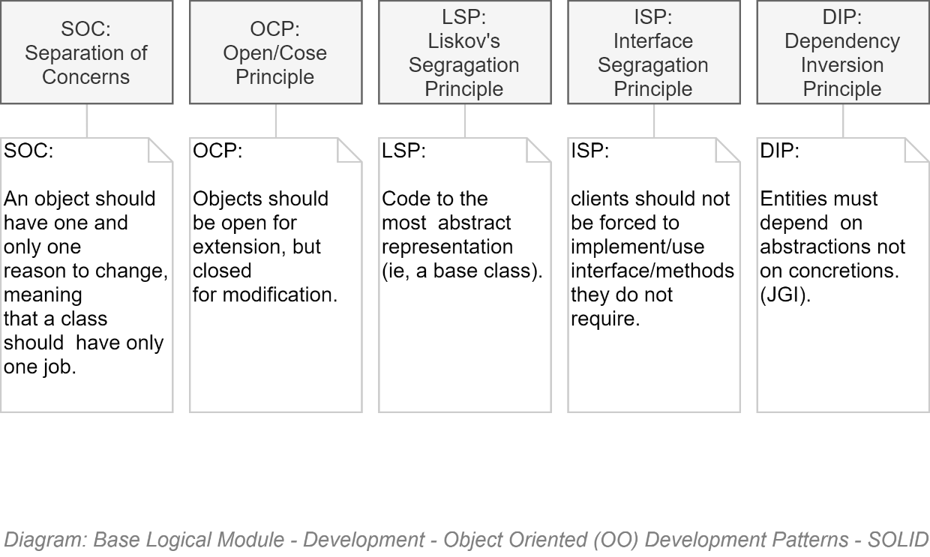

## Technologies

The technologies used depend on the development platform chosen.

The following are those expected if the development platform is .NET Core

### .NET Core Based Development

TODO:

## Stakeholders

### Testers

## Components

### Packages

Modules are a set of assemblies arranged in the classic DDD formation of the following:

* App.ModuleX.Application
* App. ModuleX.Infrastructure
* App. ModuleX.Shared
* App. ModuleX.Domain

**Tip:**  
The Base Module generally has lots happening in its Infrastructure Module and little in its Domain Assembly – whereas other Modules (Business Modules) have generally little to nothing in their Infrastructure Assembly, and more happening in their Business Domain Assembly.

A solution is composed of a Base Module, on which multiple Business Modules can be developed in parallel:

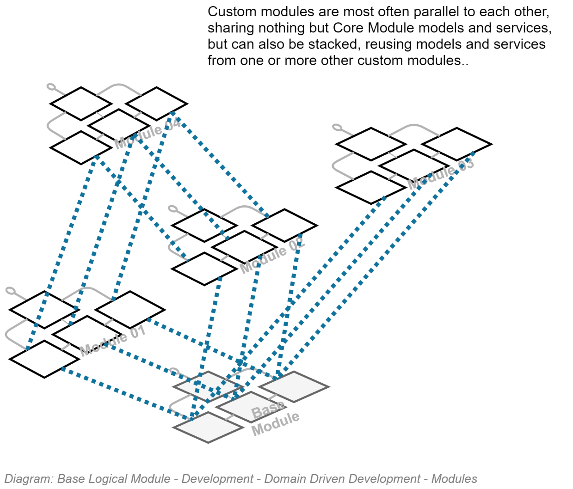

### Classes

## Security

### Configuration Information

### Service Integration Credentials & Key Vaults

### In Transit

As per the Design Principles and summarised in the Security View, all communication between internal and external devices must be secured by encryption. Therefore, all HTTP based traffic must over HTTPS, maintained by BAU to use the latest version of the TLS standard.

### OWASP

The Open Source Foundation for Application Security Project (OWASP) has developed the API Security Top 10[26]. The latest version at this point in time (2020) is the 2019 version, the IDs of the risks being:

* API1:2019 Broken Object Level Authorisation
* API2:2019 Broken User Authentication
* API3:2019 Excessive Data Exposure
* API4:2019 Lack of Resources & Rate Limiting
* API5:2019 Broken Function Level Authorisation
* API6:2019 Mass Assignment
* API7:2019 Security Misconfiguration
* API8:2019 Injection
* API9:2019 Improper Asset Management
* API10:2019 Insufficient Logging & Monitoring

## API Development

### API Versioning

API Version information is an essential element of a complete URI.

Requests using an URL that does not include an API Version number in the URL must return an error HTTP code.

  
**Note:**  
The use of a term such as “LATEST” [version] is **not** an acceptable solution, as client systems will stop working as expected upon breaking changes in APIs.

**Requirement:**  
Older versions of APIs MUST be kept functioning in parallel for a published period (e.g.: 6 months) to allow service clients time to update their code to consume the latest version.

### Notification & Redirection

  
**Quality Requirement:**  
Older versions of APIs must indicate to consuming service clients that they are not consuming the latest version of an API.   
The rationale is that although older versions of APIs are to be kept running in parallel for a duration, this state is not permanent.

Use HTTP headers to return:

* A non-200 HTTP response code.
* A single word enumeration value to indicate the state of the API (Draft, Latest, Superseded, Removed, Retired).
* The versioned URL of the latest version of the API (if Superseded).

  
**Note:**As usual when an international standard is not yet available to guide development, avoid re-inventing the wheel, research for the latest best practices, present and obtain approval from the lead architect.

## Services

### Base Infrastructure Services

The core infrastructure services offered within the Base Module, for use by itself -- and Modules dependent on the Base module -- follow classic DDD recommendations and include (but not limited to):

* **ContextService:** a service to manage the current operation’s context.
* **ImmutableHostSettingsService:** a service to manage immutable settings of the host device (wrapping access to web.config).
* **DiagnosticsTracingService:** a service to trace rolling diagnostic exceptions.
* **ExceptionManagementService:** a service to manage and record exceptions.
* **LocalizedCachingService:** a service to cache resources closest to use, in the format closest to use, by the user agent’s culture-region code.
* **ObjectMappingService:** service to manage the mapping of application entities to versioned DTO objects, and back again.
* **ValidationService:** a service to manage the object and property validation of objects.
* **AuthorisationService: a service to manage access operations by principals.**
* **BlobStorageService:** provides managed control of private and public Blob Storage.
* **TenantManagementService:** a service to manage Tenants.
* **PrincipalManagementService:** a service to manage System Principal records.
* **PrincipalRoleManagementService:** a Setting to manage relationships between System Principals and System Roles.   
    
  Important:   
  May rely on external services (e.g.: EOI, Attributes, Relationships) to provide hints as to how to allocate roles – but role allocation is per system (not monolithic/centrally controlled).
* **SessionManagementService:** a service to manage one or more current active sessions per Principal.
* **SessionOperationService:** a service to persist untamperable auditable records of Principal initiated operations within a Session.
* **MutableSettingsService:** a setting to sync across hosts mutable Settings.
* **MediaUploadService:** orchestration service to manage the upload of media.
* **MediaMalwareVerificationService:** validates uploaded media.
* **MediaMetadataService:** develops a metadata object to describe uploaded media (mimetype, extensions, dates, whether contained malware, whether it was persisted, etc.).
* **RepositoryService:** provides managed access to relational storage.
* **UnitOfWorkService:** a service to manage batch persistence across tiers.
* **NotificationService:** a service to manage notifications to and among system users.
* **IUniversalDateTimeService:** a service to return UDT datetimes.
* **ISMTPService:** a service to deliver outward bound email notifications.
* **IDbContectPreCommitService:** a service to intercept database operations to ensure cleanup and logging is handled centrally.
* **IConversionService:** a service to convert values from one type to another.
* **ITelemetryService:** a service to manage the collection and recording of telemetry.

#### Service Design

This is a living document: as time permits further technical definitions and design of the above services will be included.

## Service Façade

The Service Façade exposes the following appropriately queryable ODATA REST Controllers.

The following list of APIs mirrors what is expressed in the Service Interoperability View.

### Base Module

* ConfigurationStepRecordController
* DataClassificationController
* ExceptionRecordController
* MediaMetadataController
* NotificationController
* PrincipalController
* RoleController
* SearchController
* SessionController
* SessionOperationController
* SystemDeveloperController
* SystemDocumentationController
* SystemInformationController
* TenantController

Note:  
The APIs are appropriately accessible – depending on the controller and data type, information will be made available depending on the Authorisation granted to the current Session’s Principal.

## Business Module's Service Facade

The APIs that are exposed via a Business Specific Module Service Façade are addressed in a separate – thin -- SAD deliverable.

# Service Client Development View

This section of the document outlines expectations of the Service Client developed to host the User Interface.

## Constraints

This organisation is mandated to use the latest version of international standards.

### International Standard Technologies and Protocols

The following diagram charts the standards that must be used for

* Transport protocol used between Tiers
* Confidential communication
* Encoding of messages
* Standard ways of formatting information and data fields within
* Authenticating Services and User Service clients.
* Developing web interfaces, styling them and providing behaviour
* Defining which web browsers UIs must be targeted to run on.

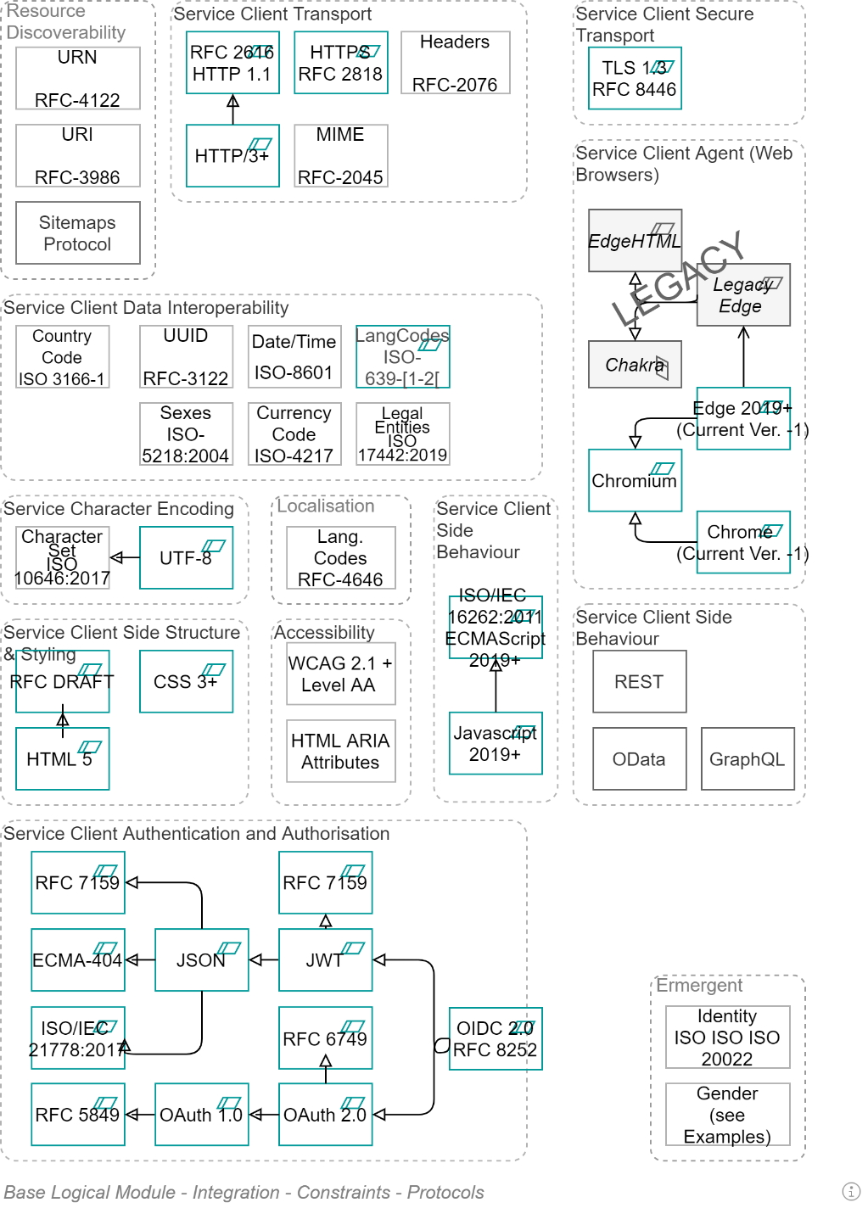

### Non-International Standard Technologies

Where Standards do not exist, it is up to the project's architect to make an experienced estimate as to which of alternative approach provides the most functionality for the least risk within budget.

## Technologies

### Accessibility Devices

The service must meet all its AoG[27] government obligations – including its Accessibility commitments.

As such, the service must be accessible by low vision screen users, using Screen Readers guided by ARIA enhanced HTML5 tags.

For reference, the following are some of the most common screen readers devices:

* JAWS
* NVDA
* VoiceOver on Mac
* ChromeVox on ChromeOS
* Narrator on Windows

**Important:**  
But being developed with ARIA tags is not enough. One MUST design and develop the interface for use by low vision readers. This affects structure, choice of controls, image choices and/or limitation

### Smallest Channel Device

The primary business user device *was* desktops. Since October 2016 it has been mobile devices.[28]

Hence the design principle to design for channel delivery via the smallest in-scope device.

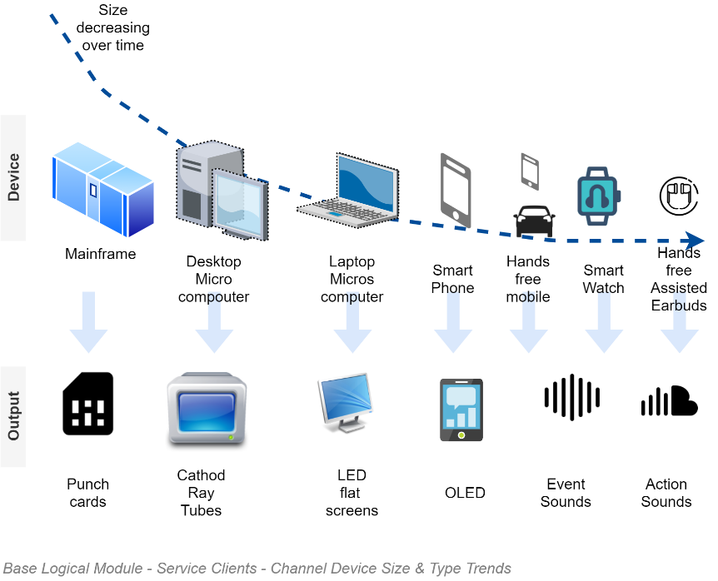

**Note:**Voice is the next smallest delivery channel that is gaining traction (evidential statistics given elsewhere in this document).

**Note:**It is not bleeding edge if our primary external customer base is of the age bracket that is using the channel. On the other hand -- for an internal-only facing app -- Voice would still be considered bleeding edge and requiring careful consideration as to whether to plan for it at this point in time (Q4/2020).

### Mobile Web Channel

Mobile platform development has become more cost effective but remains far more expensive to develop for than delivery via web – a ubiquitous platform for which there is a plethora of market available talent. The cost and the fact there are still few scenarios that cannot be sufficiently well met using web-browser based technologies is the reason that we prefer using web channels on mobile devices.

In addition, PWAs required less dependencies to be distributed: only an URL, as opposed to a registration within a walled-garden app store.

### Service Client Stack

#### PWA

The requirement to develop for the mobile phone web browser first implies the use of Progressive Web Application (PWA) design practices.

A Progressive Web Application (PWA) has several key characteristics – two of which are immediately relevant:

* While remaining a Web Application, provide access to device sensors, including:
  + Sound to capture sounds (e.g.: spoken histories, music, bird sounds on a school excursion)
  + Cameras to capture learning surroundings (e.g.: photos of artwork or plants on a school excursion)
  + GPS & compass to capture location, direction and path taken (e.g.: location of photo, path of school excursion).
* Employ a progressive screen size approach to CSS development that allows display on mobile devices, desktop devices or wall displays.

#### SPA

PWA based interfaces rely on applying Single-Page-Application (SPA) development patterns.

A single-page application works in the browser and use AJAX and HTML5 to build responsive apps that work in the browser and require no page reloads since the layout structure has already been downloaded. Only content data is dynamically fetched across the network.

The client-side SPA based developed approach – versus server-side Multiple Page Application (MPA) development approach – is the basis of meeting multiple objectives:

* Fast and Responsive: they significantly improve a website’s speed as most resources (HTML/CSS/Scripts) are only loaded once throughout the lifespan of an application. Only data is transmitted back and forth.
* Infrastructure costs: decreasing the amount of bandwidth used between service and client improves responsiveness, while decreases infrastructure bandwidth costs. In addition, by moving UI logic to service clients – and the browser device’s CPU -- the servers require less CPU to perform their service functions.
* Caching: SPAs can cache local data effectively, decreasing bandwidth use even more, as well as provide some continuity of functionality even when offline, updating the server when connectivity is restored.
* Development time: SPAs take less time to develop than MPAs.

SPAs have some challenges that require addressing:

* SEO: Google now indexes dynamic pages – if developers ensure their JavaScript files can be indexed by Google. They also need to verify that a website uses HTML5 mode in the URL scheme.
* Browser History: Work is required to use the HTML5 History API to persist navigation between anchors so that the Browser’s back button works.
* Security: care must be taken to not include data in the page that XSS attacks could profit from.

## Best Practices

### MVC Pattern

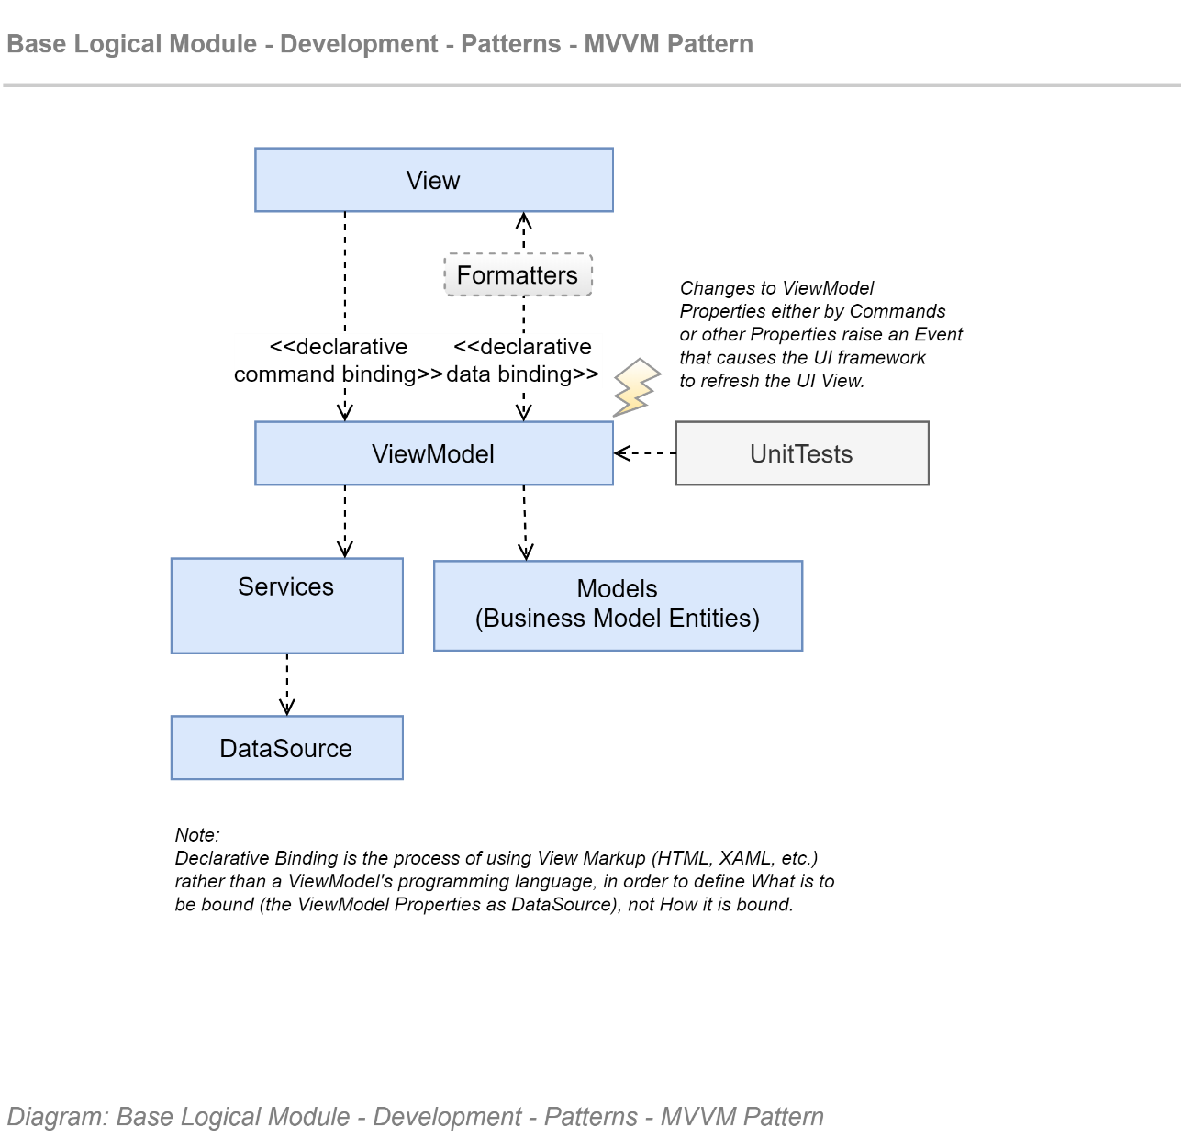

# Service Client User Interface Development View

## Section Synopsis

User Interfaces are a distinct topic to discussions about the Service Client. For one, UIs can be developed either as MPAs on the server or SPAs on the client. For another, Service Clients is about technology, and UIs is about design and user behaviour.

## Web Channel

### Constraints

#### Regulations

**Constraint:**As a NZ public service, the user interface is constrained by agreements to be accessible to the most of both internal and external users who paid for it with their taxes.

* The NZ Government Web Standards, comprised of:
  + The [latest] NZ Web Accessibility Standard
    - The [latest] Web Content Accessibility Guidelines (WCAG)
  + The [latest] NZ Web Usability Standard

**Constraint:**Rule 61 of the Government Procurement Rules enforces the above with the following:

“If a Public Service department, New Zealand Police or New Zealand Defence Force outsources web development work, it must include, in its Notice of Procurement, a pre-condition for the work to comply with the mandatory requirements in the latest version of the New Zealand Government web standards.”

#### Standards & Protocols

The standards and protocols used in the UI have already been addressed in the previous Section.

## Web Channel Structure

### Semantic Web

Despite he talk about using correct semantic structure for accessibility, HTML has historically lacked some key semantic markers, such as the ability to designate sections of the page as the header, navigation, main content, and footer. With HTML 5, these designations are possible, using the new elements <header>, <nav>, <main>, <footer> and more.

Whereas HTML4 only provided general structuring tags (div, span) that can be used for anything (and in doing so confuse low-vision readers), HTML5 provides semantic tags to better identity the role of sections:

* <article>
* <aside>
* <details>
* <figcaption>
* <figure>
* <footer>
* <header>
* <main>
* <mark>
* <nav>
* <section>
* <summary>
* <time>

  
**Note:**HTML5’s semantic tags are still not as rich as WAI-ARIA, so where HTML5 does not provide a clearly disambiguating role tag, use WAI-ARIA tag for Roles, States and Properties.   
  
It’s contestable advice whether to use both where possible (e.g.: <nav role=”navigation”>).

### WAI-ARIA

Similar functionality HTML5’s Semantic element tags was already available earlier via WAI-ARIA (Accessible Rich Internet Application) attributes developed for use with web applications, to communicate to assistive technologies dynamic changes in roles, states and relationships.

Although most of the tags are for use in web applications – as opposed to static text web content sites – almost all the HTML5 semantic element tags can also described ARIA attribute tags.

In addition, ARIA has additional useful roles to describe skippable content: role=”contentinfo”.

  
**Note:**  
ARIA does focus on dynamic web applications -- rather than within static web content -- to communicate to assistive technologies dynamic changes in roles, states, and relationships (via JavaScript updating element attributes).

### Role HTML Attributes

ARIA uses the role attribute to define areas or regions of the page:

* role=”banner” (same function as header)
* role=”navigation” (same function as nav)
* role=”main” (same function as “main”)
* role=”complimentary” (same function as “aside”)
* role=”contentinfo” (same as “footer”)
* role=”search” – not available in HTML5
* <article role=”region” aria-labelledby=”myheading”>  
   <h2 id=”myheading”>View Contact</h2>…  
   … used to show a distinct view of the application (View, Edit, List, etc.).  
  </article>

### ARIA Form Attributes

ARIA uses some attributes to clarify forms:

<main aria-live=”polite”>

<article role=”region” aria-labelledby=”contactEditHeader”>  
 <h2 id=”contactEditHeader”>Edit Contact</h2>  
 …  
 <div>  
 <label for “carLicense”>Car License:</label>  
 <input id=”carLicense” aria-describedby=”requirements”>  
 <p id=”requirements”> License plate must be least 4 characters.</p>   
 </div>  
 …  
</article>

</main>

ARIA Image Attributes

### Combined Semantic and ARIA Example

<html>  
 <head>

<link rel=”stylesheet” href=”…”>  
 </head>  
 <body>  
 <header **role="banner"**>  
 <hgroup>  
 ...a section of the header (eg, the App Logo)  
 </hgroup>  
 <hgroup>  
 ...a section of the header (e.g.: the Resource Context Info)  
 </hgroup>  
 <hgroup>  
 ...a section of the header (e.g.: the Search functionality)  
 </hgroup>  
 <hgroup **role="banner"**>  
 ...a section of the header (e.g.: the User Context Info)  
 </hgroup>  
 </header>  
 <nav **role="navigation"**>  
 on a desktop navigation nav can be thought of as an hgroup under other hgroups   
 – but probably should be free of the header – especially on mobile interfaces.  
 </nav>  
 <main **role="main"**>

<article role=”region” aria-live=”polite” aria-labelledby=”contactListHeader”>  
 <!-- the date the article/item was last updated -->  
 <time datetime="2017-10-31T11:21:00+02:00">Tuesday, 31 October 2017</time>  
 …think of ‘article’/’item’ as a blog post…  
 or specific **View (more on that in a second)**…  
  
 <detail>  
 <summary>  
 (e.g.: …visible header of the expandable detail below)  
 <h1 id=”contactListHeader”>Contact List</h1>  
 </summary>  
 …expanded content…  
 <section>  
 …what we used to use a div for – a section of the main content…  
 <figure>  
 <img href=”…”/>  
 <figcaption>the title of the image</figcaption>  
 </figure>  
  
 <aside>some optional Tip/Info/Warning advice on the side</aside>

<div …>

<div …>  
 Show buttons to order the items below…  
 </div>  
  
 (… e.g.: show a list of ContactSummary items  
 (Never ever use a Table for showing items. Ever! Ever…)   
 If a row is clicked use JS to activate the next View)  
 <div …/>  
 <div …/>  
 <div …/>  
 <div …/>  
  
 </div>

</section>  
 </detail>  
 </article>

<article role=”region” aria-live=”polite” aria-labelledby=”contactViewHeader”>  
 <h2 id=”contactViewHeader”>View Contact</h2>  
 …etc… a   
 </article>

<article role=”region” aria-live=”polite” aria-labelledby=”contactEditHeader”>  
 <h2 id=”contactEditHeader”>Edit Contact</h2>  
 …  
 <form … >  
 <div>  
 <label for “carLicense”>Car License:</label>  
 <input id=”carLicense” aria-describedby=”requirements”>  
 <p id=”requirements”> License plate must be least 4 characters.</p>   
 </div>  
 …  
 </form>  
 </article>

<article>  
 …repeat…  
 </article>

</main>  
 <footer **role="contentinfo"**>  
 .. status information ..  
 <small>small print such as copyright</small>  
 </footer>  
 </body>  
<!-- load styles first, and JavaScript last -->  
<script type=”text/javascript” src=”...”></script>  
</html>

### Additional Information

For additional information:

* <https://www.w3.org/TR/html-aria/#sec-strong-native-semantics>
* <https://www.w3.org/TR/wai-aria-practices-1.1/>
* <https://www.w3.org/TR/wai-aria-practices-1.1#kbd_layout_landmark_XHTML>
* <https://developers.google.com/web/fundamentals/accessibility/semantics-aria>

## Theming Framework

Whereas a combination of semantic HTML5 and ARIA tags define the structure of a page their purpose is not to define the appearance of the page.

CSS is the encoding of the formatting -- the appearance -- of the underlying logical structure of pages.

Don’t go reinventing the world. Use an existing well-known CSS based layout framework:

* Foundation
* Bootstrap
* Metro UI
* Materialize
* Materialize UI (MUI)
* Bulma
* Etc.

## View Copy

TODO

### Plain Language

Advice given by digital.govt.nz include using the following guidelines to develop system instructions:

* Choose easy and short words not formal, long ones.
* Jargon and buzzwords are unlikely to be clear language.
* Write conversationally, in first person, using the active voice.
* Test your content with users.
* Keep the average length of sentences 15 words or less.
* Avoid complex sentence structures (use Plain Language recommendations).

#### Tools

digital.govt.nz provides tools to assess readability[29], using the following algorithms:

* Coleman Liau index,
* Flesch Kincaid Grade Level,
* ARI (Automated Readability Index),
* SMOG.

### Copyright Material

Ensure the material used is usable in the context it is being used. This is even more true for government services.

New Zealand government agencies are bound to uphold intellectual as well as cultural rights.

  
**Tip:**  
This is another This is another This is another This is another fine rationale to avoid relying on images, and instead rely heavily on readily available, recognisable free font and svg image libraries – rather than run the risk of embarrassment and cost due to a resource using an image without due diligence required to ensure it is usable in the current context.

### Localisation

Localisation – in the context of User Interface design – means providing end users the ability to change the interface’s culture-locale code, affecting the text direction, language and images presented to end users.

  
**Note:**   
Sometimes – although it is rare, and costly to implement – localisation includes changing the screen layout to meet a culture’s expectations. SometimesSometimes – although it is rare, and costly to implement – localisation includes changing the screen layout to meet a culture’s expectations. Sometimes – although it is rare, and costly to implement – localisation includes changing the screen layout to meet a culture’s expectations.

The preferred Culture-Locale code must be persisted as a Preference within the Profile of authenticated users.

Unauthenticated Users (even when associated to a default Anonymous User in the system database) must prefer using a value persisted in a cookie, avoiding the use of Preferences (as it would change the value for all other anonymous sessions. Oops).

#### Approaches & Tools

A traditional way of developing User Interface prompts and text is for a BA to develop a spreadsheet which was then used by developers to code into the system. The approach is slow, notably error prone and costly to test.

Higher value strategies exist for developing localised text and are based on using:

* **Crowdsource localisation:** cost effective approach by leveraging interested user stakeholders, in order to develop iteratively improved text.
  + Consider using a service like POEditor[30], CrowdIn, etc.
* **Use standard formats:** use cross-development-framework formats (“banana”, etc.) for localisation files that are *dynamically* imported -- as opposed to hard-coded – so that UI text can be updated without requiring a redeployment.

#### Cultures

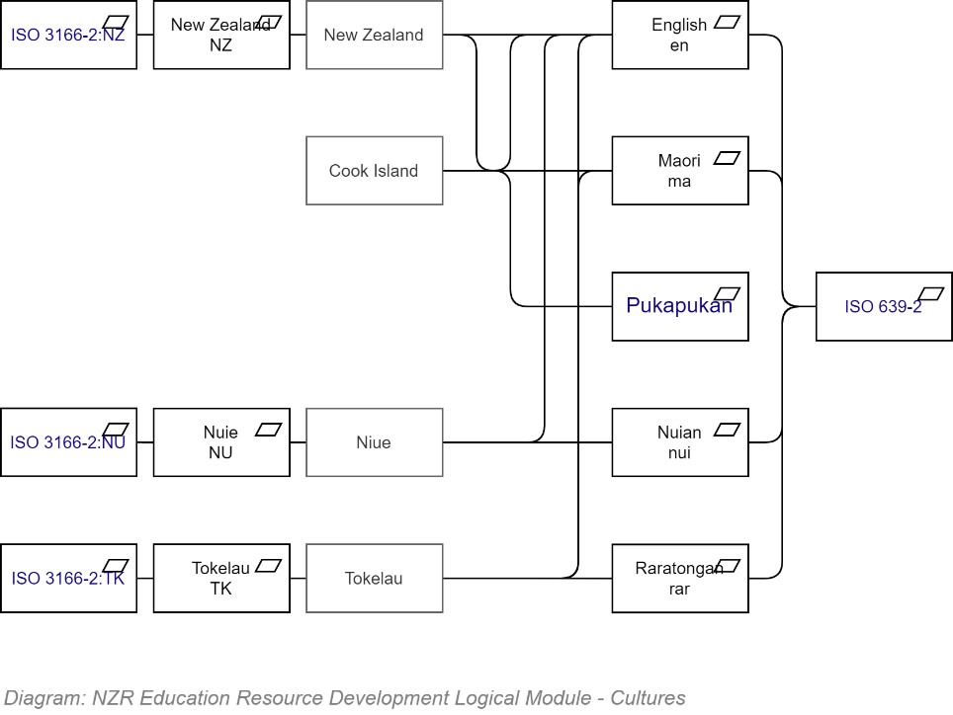

#### Terms

* **Develop Standard Terms First:** separate localised text into standard UI text, and domain (i.e. Module) specific phrases.   
    
  Common standard terms include:
  + **Navigation:** Beginning, Previous, Next, View, Back
  + **Reveal:** More, Less
  + **Action:** Sign in, Sign out, Clone, New, Edit, Save, Cancel, Undo
  + **Validation:** OK, Review required, Required
  + **Status:** Online, Offline, Authenticated, Non-authenticated
  + **Permission:** Allowed, Disallowed
  + **Areas:** Context, Status,
  + **Prompts:** Title, Description, Content, Attachment, Image, Status, Author, Start, Duration, End, Date
  + **Categorisation:** Category, Subcategory

## View Framework

### Angular

A mature full package.

### Vue.JS

### React

## Navigation

The use of a consistent, intuitive, combination of actions and view flow through resources increases recognizability and usability, while decreasing support costs.

### Action Based Design

Views must relentlessly be designed to elicit *Action*.

Presentation of information is all good and dandy – but the purpose should be to elicit a decision, then action to change the state of things in the world.

Viewing information, without action and change of state is just consuming attention & time without effect.

**Note:**  
In essence, a commercial website is a relentless drive of actioned choices by viewers leading them to an inexorable target action: the **Buy** button.

Each page should present information to elicit one of a selection of Actions from the user.

* Views must have no more than one “Primary Action” button.
  + When changing a record, the primary action is Save.   
    When writing a Message, the primary action is Send.  
    When viewing a list of records, there is no primary action (Next, Prev & View are Navigation operations, represented as Links).
* Views may also have secondary Action links – but no more than one is preferred.
  + When viewing a record, both Edit and Back are secondary action (as both are of equal weight, and there should be only one Primary Action).
  + When editing a record though, the Save button is the primary action, and Cancel is a secondary action.
* All primary actions (generally associated to changes in State) must be undoable.
  + This is achieved by designing the system based on the well-known Command Pattern.
* Navigation operations are not Actions and are therefore represented using HTML Links as opposed to HTML Buttons.

### View Flows

The inherent complexity of UI interface design is simplified when stakeholders and designers use industry standard design and development patterns, choosing a navigation flow that is reusable in the maximum number of scenarios, so that custom flows are not required.

The BREAD View Pattern is a time and cost-effective UI flow pattern to navigate between Views.

Instead of designing Views solely on Stakeholder desires, the desire is considered within the context of a system wide consistent flow through related views, using a limited pallet of Primary and Secondary Actions to improve understandability, a Forgiving approach to user errors lower training requirements, all while returning standard HTTP codes to direct the user agent to the next most relevant view.

The BREAD Flow pattern is diagrammed below.

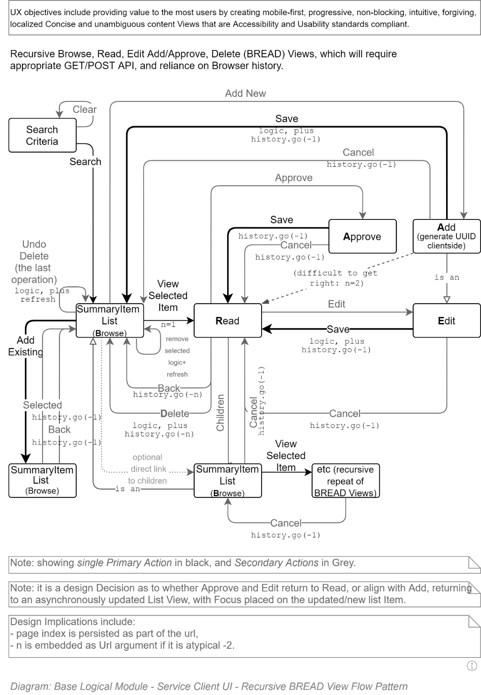

## Security

### In Transit

### Cookies

Cookies MUST NOT be used to round-trip immutable user identifiers (e.g.: the public or private id of a user).  
The rationale being that although encrypted cookies are hard to crack, they can be sooner or later -- leaving system sensitive information in a cookie that can be hacked is considered a security risk.

Cookies *can* be used to persist temporary session identifiers (the Session ID).   
The rationale being that although sooner or later cookies can be hacked, it is considered highly improbable that they are hacked within the timeframe the temporary id is still of value.

**Note:**  
Secure cookies must be decorated with the secure attribute to ensure that if the user sends a request over an insecure HTTP channel, that the cookie is not sent over the wire. Note that when the server automatically 302 redirects them to the HTTPS equivalent of the same URL, the cookie will be sent.

**Note:**  
It is highly recommended to decorate most (if not all) tracking cookies with the noscript attribute to ensure the user agent cannot tamper with the session cookie.

### Redirection

The server should issue 302 redirect HTTP requests to the same URL, but this time over HTTPS. In addition – now that a secure channel is being used – it should be sending secure cookies containing confidential session information.

This means that REST requests done via Typescript/JavaScript must be prepared for instructions being returned by the Service, and responding accordingly.

HTTP Response codes to expect include:

* Server Errors (50x)
* Authentication Errors
* Authorisation Errors
* Message Errors
* Redirections (302)
* OK (200)

### OWASP

## Related Documentation

# Service Client View Development View

This section describes the development and organisation of the screen elements – the Views – used to compose the User Interface. It does not cover how they are dynamically navigated (covered next) or how they are visually enhanced (covered in the section after that).

## Synopsis

User Interfaces are compositions of Views. Vice versa, Views are the decomposition of User Interfaces into discrete, single purpose, single context combinations of information, status and Action triggers.

## View Types

All web “Pages” can be decomposed as a set of Views.   
There are only 3 distinct types of Views:

* Input Views
* Output Views
* Container Views, which are used to contain Input and Output or child Container Views.

  
**Note:**   
It is a design It is a design It is a design issue  
(i.e., be rigorous and make a View either an I or an O, or use a Container to combine an I and an O view – but trying to make a view behave correctly for both directions of information flow unnecessarily adds more complexity and cost, while removing maintainability and organisation flexibility.

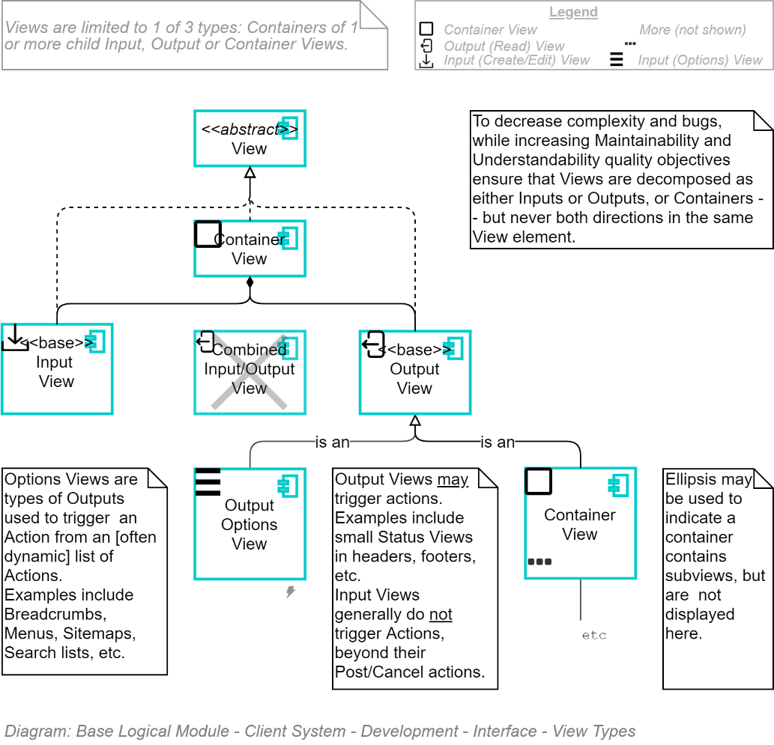

## Shell Container View

The outermost View is full sized, of type Container, containing two full size child Views of type Containers – one for overlays (modal dialogues, etc.) that are displayed over everything in the second Container, which is for displaying content (header, navigation, body, footer).

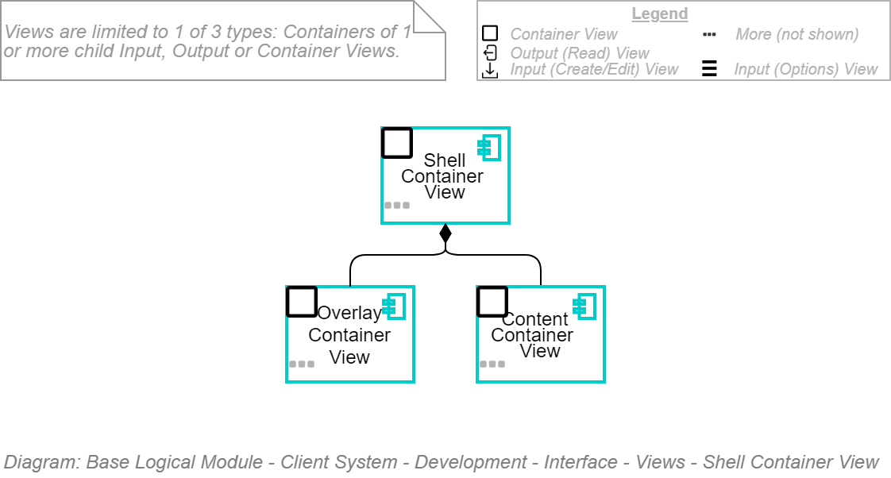

## The Overlay Container View

The full-size overlay View is of type Container and contains a set of child full-size overlay Views.

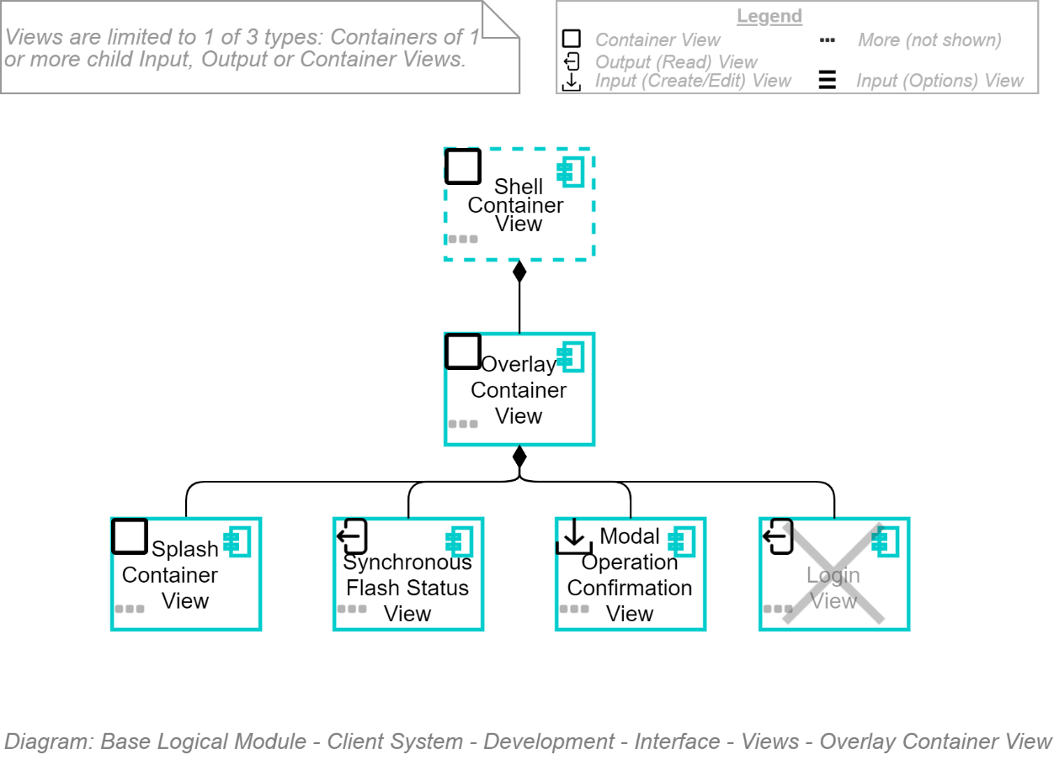

### Splash Screen View

One View being a full size one, to contain any form of CSS based (in order to not require a time-consuming image download) splash screen imagery to keep users entertained while the service client is

### Synchronous Flash Status View

Another full-size Overlay View is one to temporarily stop users from beginning additional operations while an operation is being processed.

### Modal Confirmation View

Another full-size Overlay View is a Modal Input View dialogue used to display the name of an operation and confirm operations before they are committed.

Often the only reason for a modal is to confirm an operation before doing it, but if there are more, the view can instead be a container for child Modal Views.

**Important:**Note that Modal Dialogues are the spawn of the devil when it comes to usability and must be avoided at all cost by making operations undoable (for example, by offering only Logical Deletes, and not Physical Deletes of records.

### Login Container View

It is recommended that the application does not provide a Login screen in-app, but rather uses a remote 3rd party Identity Provider (IdP) to provide the forms required to collect user credentials.

## Content Container View

Besides the level 1 Overlay Container View, the other full-size level 1 container was the Content Container View, used to show Containers for Context, Status and Body – for lack of a better term.

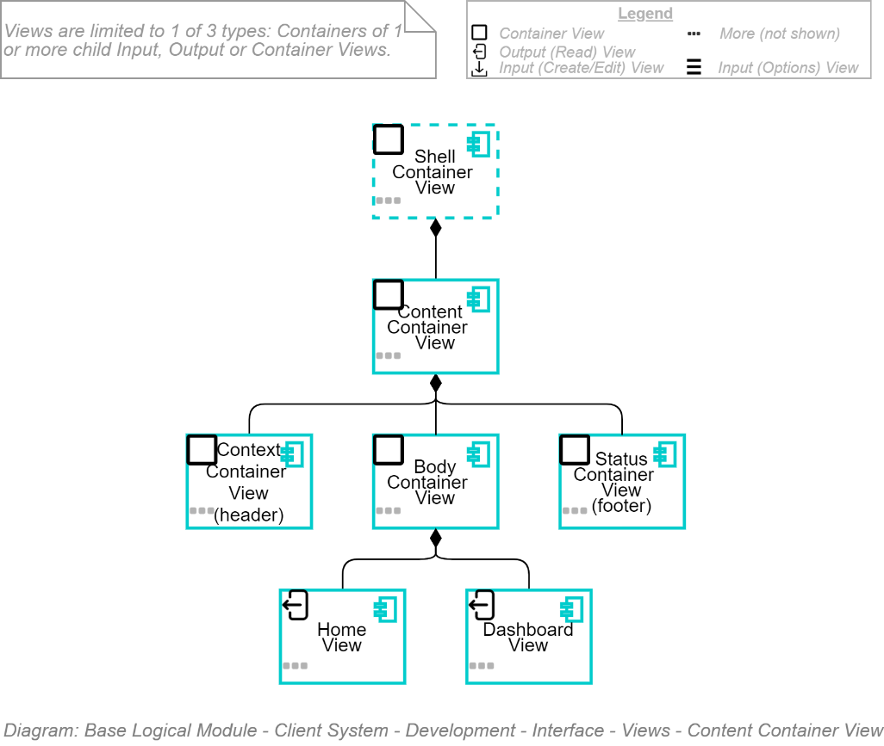

## Context Container View

The context container is in essence the "header" view and is used to display where in the world wide web the current digital session's digital identity is.

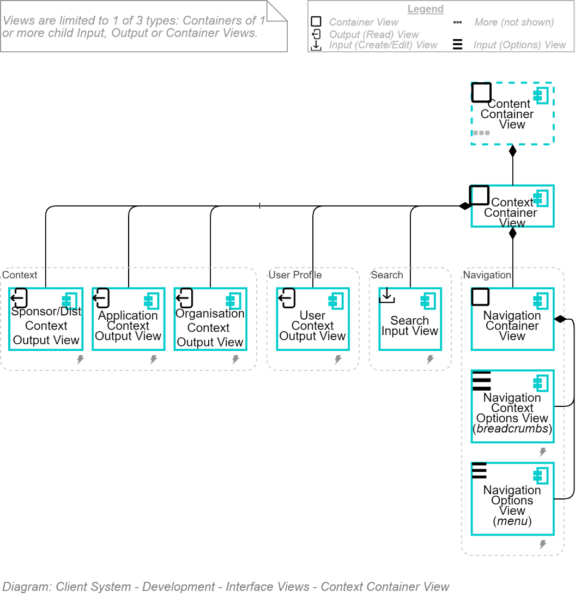

* The Sponsor Organisation (information about the organisation who funded the development of the system)
* The System (information – such as its name -- of the application itself)
* The Resource being looked at (the name of the View within the Body Container, described later).
* The current Organisation (the current tenant, within a multi-tenant solution, to which the Resource belongs)
* The User (the current Session's Identity, if authenticated).

In addition to the above Context child Views are the following child Views:

* The Search Input View (used to search for Resources based on name and Metadata)
* the Navigation Container View (used to navigate to Resources based on location)

Note:  
Being items in a list of child resources, JavaScript and CSS can be employed to reorder the header cells as needed depending on the device's screen size – even hiding some less important ones if the screen is small (generally the Sponsor Organisation can be hidden if need be).

Note:  
Don't ever use table html elements for header layout. Use UL/LI's within HTML5 header elements.

## Navigation Context View

In the previous diagram, note that Navigation is a Context View.

I'm currently of two minds on this. I still think it is context – but I also think of it as a Context that is dynamically updated (the Current Page) upon every View change, so is somewhat different than the other contexts which remain unchanged throughout a Session.

Of late I've wondered if Navigation is better placed when moved up a level to be parallel to Context, before Body, and Status.

This position is supported by the observation that HTML5's placement of recommendation to put the nav element after the header.

To be decided per project.

## Status Container View

The Status Container View is used to provide status as to the System, Client, Tenant, Organisation, client Operation queue, last Operation executed.

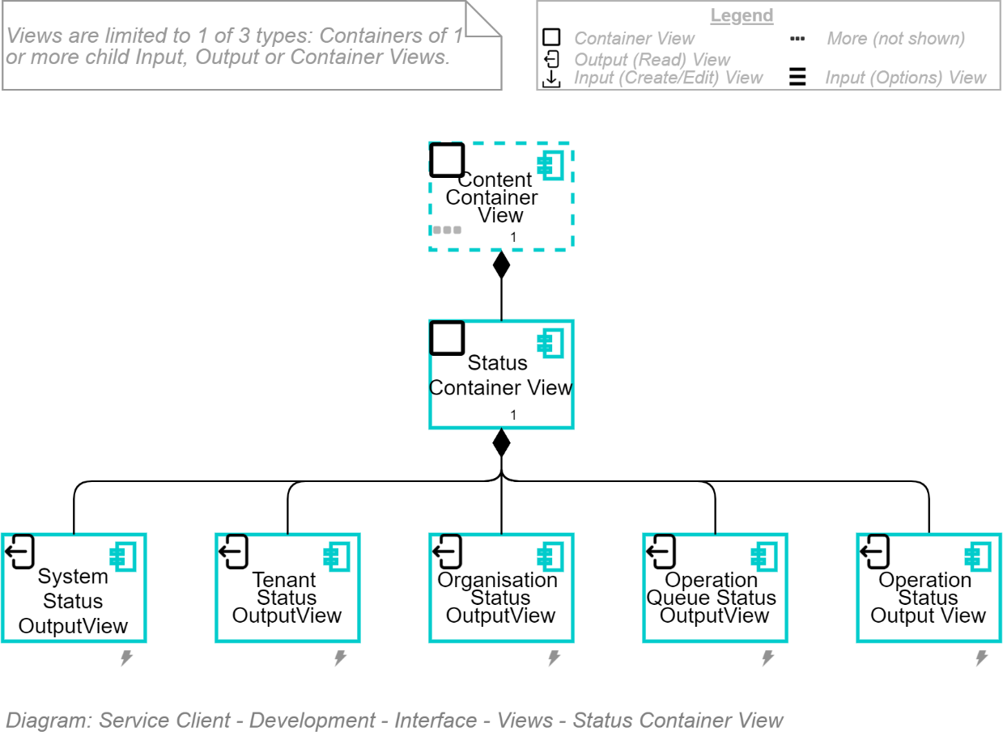

All of the child Status Views are Output Views, providing information to the end user, rather than collecting information.

**Note:**  
Remember that at the early stages of a project it is not required that all of these Views are developed right from the start of the application (could be wasted effort due to YAGNI) – but it is required to know that if/when they are gotten to that they have a planned location. That's Planning. Not wasted effort.

### System Status Output View

The System Status Output View is to indicate via the UI that the client is in contact with the service and that the service has not reported any errors.

This can be a pair of dynamically switched outline vector font icons that have a background colour that is appropriate for colour sensitive users.

Remember to add alternative descriptions for low-vision reader users.

### Tenant Status Output View

In a multi-tenant system (and frankly, there are few excuse not to invest in developing a system to be used by more than one organisation) the Tenant Status Output View is used to indicate whether the individual tenant is working correctly (e.g.: the connection string worked), or has been Disabled (for T&Cs & behaviour or billing reasons).

This can be a pair of dynamically switched outline vector font icons that have a background colour that is appropriate for colour sensitive users.

Remember to add alternative descriptions for low-vision reader users.

**Note:**  
I've personally never had to use this – but a place is planned for it in case it's needed.

Clicking the Icon could Navigate to a specific Tenant's View View where one could find out more about the Tenant.

### Organisation Status Output View

Within a tenancy (i.e., account), one can host multiple Organisations (root Groups, marked as legal Organisations).

By default, a Group are Enabled – but can be Disabled (for T&Cs & behaviour).

This can be a pair of dynamically switched outline vector font icons that have a background colour that is appropriate for colour sensitive users.

Remember to add alternative descriptions for low-vision reader users.

Clicking the Icon could Navigate to a specific Organisation's View View where one could find out more about the Organisation.

### Group Status Output View

If a need for knowing the status of a Group one is acting within the context of (Enabled/Disabled), it would go next.

This can be a pair of dynamically switched outline vector font icons that have a background colour that is appropriate for colour sensitive users.

Remember to add alternative descriptions for low-vision reader users.

**Note:**  
I've personally never had to use this – but a place is planned for it in case it's needed.

Clicking the Icon could Navigate to a specific Group's View View where one could find out more about the Group.

### Operation Queue Status Output View

Mature Service Clients can queue operations initiated when network connections are not available (e.g.: out of WIFI or mobile range).

This can be a pair of dynamically switched outline vector font icons that have a background colour that is appropriate for colour sensitive users.

Remember to add alternative descriptions for low-vision reader users.

Clicking the Icon could navigate to an Operations Summary View where one can view the Operations that have been queued, but not yet unspooled and executed to update the Server's databases.

### Operation Status Output View

The last server data *change* operation that was unspooled and executed will either work or not.

Provide this feedback to the end user.

This can be a combination of

* A pair of dynamically switched outline vector font icons that have a background colour that is appropriate for colour sensitive users.
* A succinct text console response text:
  + "Contact Update successful."
  + "Contact Update failed."
  + "Operation is queued for later execution." (even if the Service Client does not queue operations, the server side may).

Remember to add alternative descriptions for low-vision reader users.

Clicking the Icon or Text could navigate to modal dialogue showing additional information about the failed operation.

## Body Container View

The Body Container View is *almost* finally getting to the primary information that the user is using the service client for.

Domain Driven Design principles dictate that systems are developed as discrete packages of information and functionality.

Rather than lumping all views and functionality into the Body container, develop child containers for each module.

The first module is for viewing and modifying the information of the system's itself (Diagnostics, Sessions, Users, Groups, Roles, Permissions, Media Collections, Media, etc.) devoid of any business domain specific information or functionality (Contacts, Students, Schools, Documents, etc).

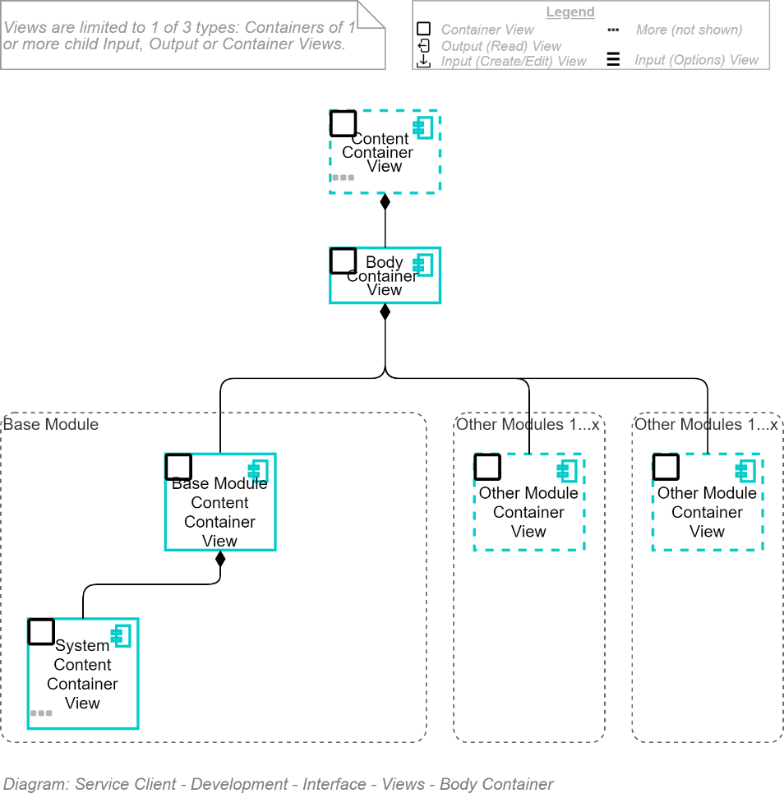

## Public Module Container View

The Public Container View contains a set of Views available accessible by both Authenticated Unauthenticated Users.

It will contain at least one public page: the Home Page.

### Home Page View

The Home Page is the Public page of the website accessible to Unauthenticated Users.

Home Pages often focus on relaying

* Alignment to readers
* a beneficial outcome and
* a Call to Action (generally a call for users to "Download/Try", "Buy" or "Sign In")

### Other Public Views

A Home Page developed for Mobile Web interfaces should be short enough to not require scrolling. Instead it should link to one or more other Public Views within the same parent container.

## Base Module Container View

The Base Module Container View contains Containers to manage the system proper.

Each child Container contains a set of nested Browse, View, Edit screens as is appropriate (a lot of the information available in Base is more fore Viewing than Editing – e.g.: Diagnostics, Error Logs, Sessions, Session Logs, Search Results, Assistance/Help etc.) – although some is for editing (Users, Groups, Permissions, Roles, Allocations, Notifications).

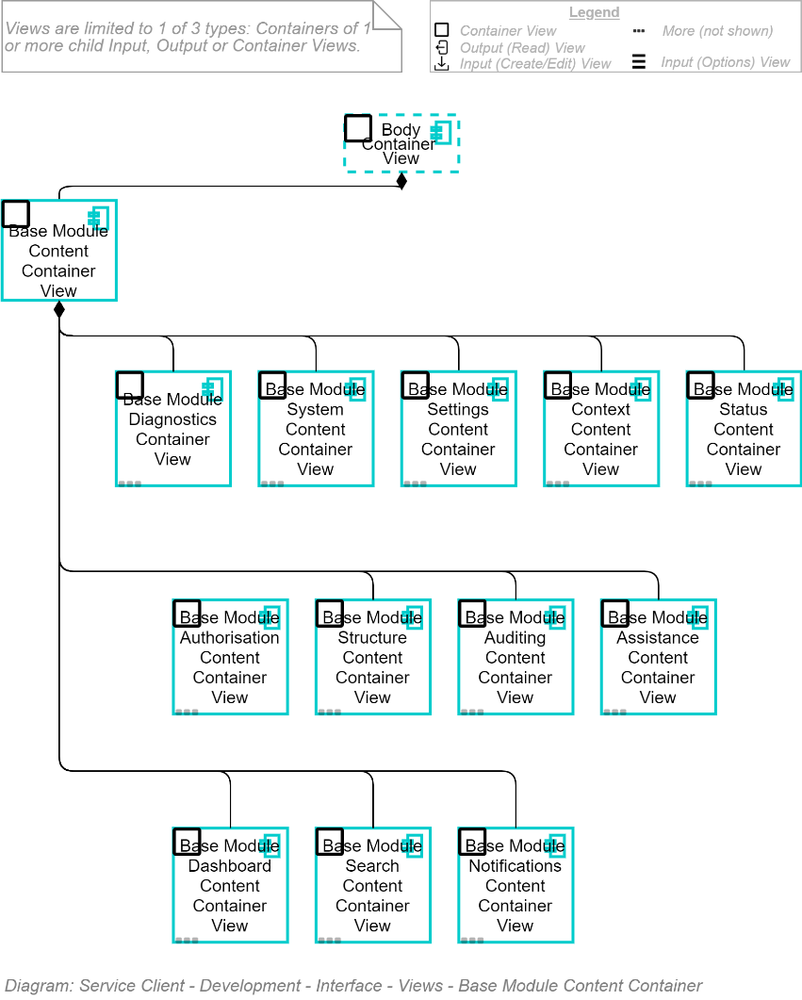

### Diagnostics & Error Content View

Access to both diagnostics and error logs of the current Session allows Users to better communicate with Customer Support to report and resolve errors.

This entails showing them record specific options to filter and order Search results.

In the case of the Diagnostics Container, they are shown a View of options (e.g.: Order By: Date, other), the values of which are combined with the Search Term used to return a list of Search Results (i.e., Synopsis Records), summarising the expected errors or diagnostic log messages.

When they click an item in the list, the View is switched to the appropriate record View.

There are – obviously -- no Edit screen of either.

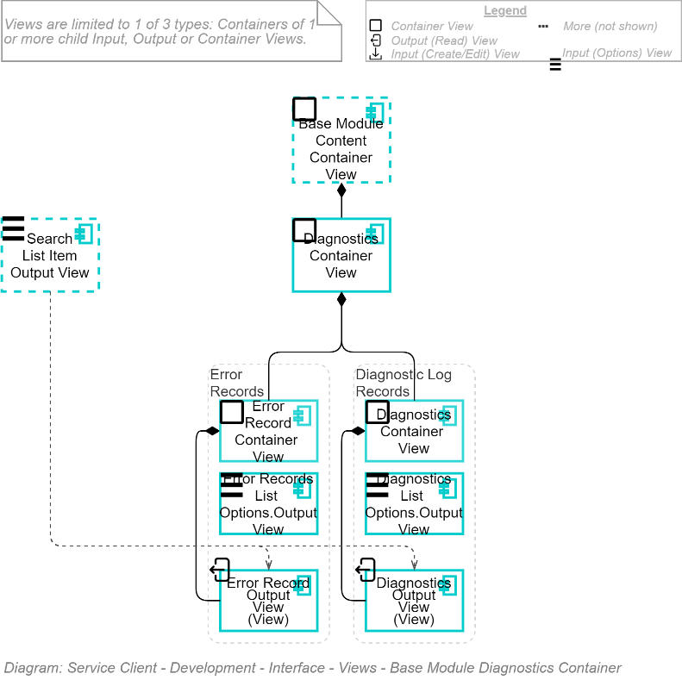

The above is intentionally reusing previously developed common Search functionality.

**Important:**This pattern of re-using a common Search is used throughout the service client to make the effort to implement new features – such as the one above -- tightly scoped and rapidly achievable, while being long term maintainable and extensible.

**Note:**It is left up to the project to consider other functionality – e.g.: clicking a record to either load the clipboard with relevant information or send an email to Support asking for information about the current error message.

### Session Auditing Container View

Keeping track of Session Operations – whether of Authenticated or Unauthenticated users – is the basis of non-repudiation and trustability.

In addition, letting users know their Operations are being recorded is an easy way to allow users to self-regulate their adherence to the T&Cs they agreed to when they first joined a Group.

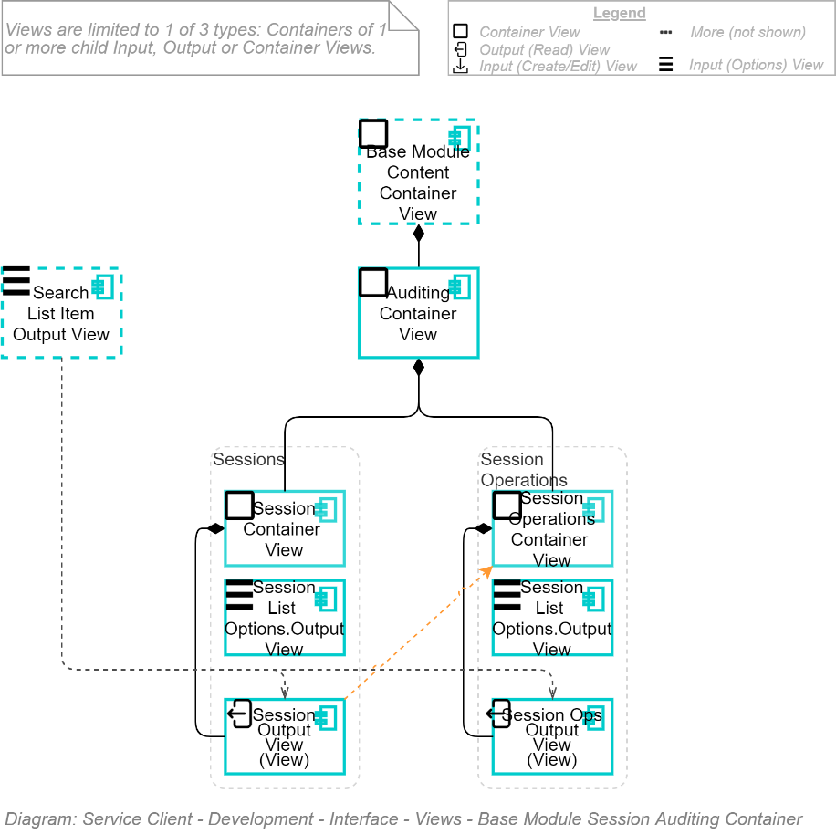

Following the same pattern as previously demonstrated with the diagnostics and error views, the Session Container View only hosts a View that provides filtering and ordering options that influence the common Search functionality.

The resulting View – the Search Synopsis items list – displays a list of filtered, ordered and paged results which when a record is clicked moves the view to the Session Output View View.

The Session Output View View displays information about the current Session (when it started, its predicted expiration, etc.) and provides secondary Actions:

* navigate to the associated child Session Operations – where similar functionality is offered, but this time to page, filter and view the individual operations that have taken place during this Session.
* If the user is authenticated, provides navigation to the User View View (described later).

### System Container View

Another set of information that is available to all users is information regarding the system they are using, the sponsor organisation that commissioned it, information about who is supporting it, who developed it for the sponsor.

By now the pattern of using the shared Search functionality, combined with local search influencers (already described with the Diagnostics & Error Container View section above) is recognisable to all.

The pattern is used to lay out the following information:

* System Sponsor information (i.e., About Us, Contact Us)
* System Information (i.e., Versions/Releases, the Developer, Licenses used, Statements and T&Cs and FAQs)

Note:  
Again, these views are relatively simple as they are only Output Views.

Note:  
As for wrapping Output Views in Container Views – even when there is only one Output View, the reason is simply, to be ready for more related peer views later. What they are, I don't know – but I would prefer having a common Container/Content approach used throughout rather than have some areas of the application use containers and other areas use Output Views without wrapping.

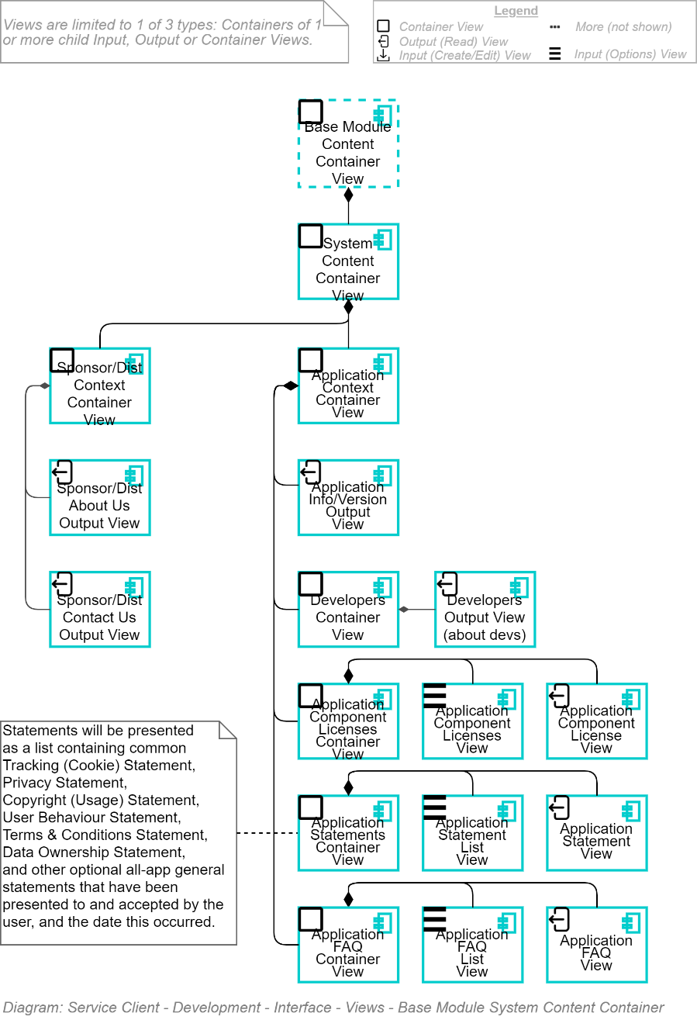

### Settings Container View

The Settings Container View is used to group together Editable Views of various types of settings:

* System Settings
* Tenant Settings
* Root Group Settings
* Group Settings
* User Settings

Note:  
Remember that Container Views are logical layout containers, but do not provide access security. That is provided by managing access to specific URLs.

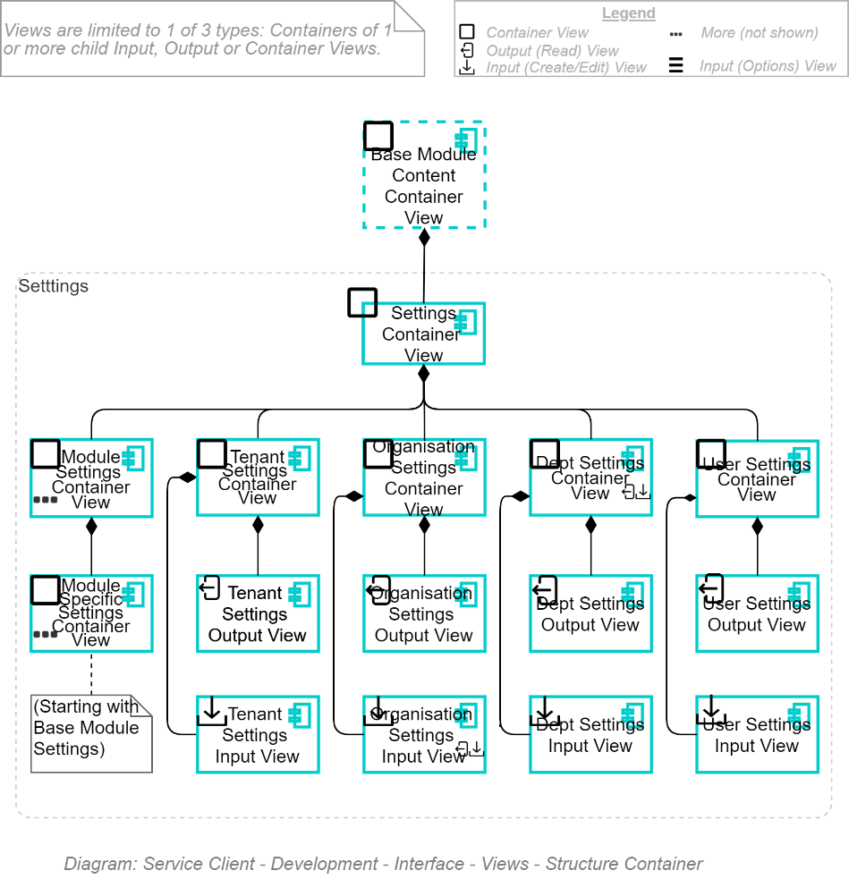

Note that in the above layout each setting Container contains a read-only view of the settings, which can be navigated to a read/write view of the settings, with no primary action (both Save & Back are secondary actions) – but one can develop simply a Read/Write view.

### Dashboard Container View

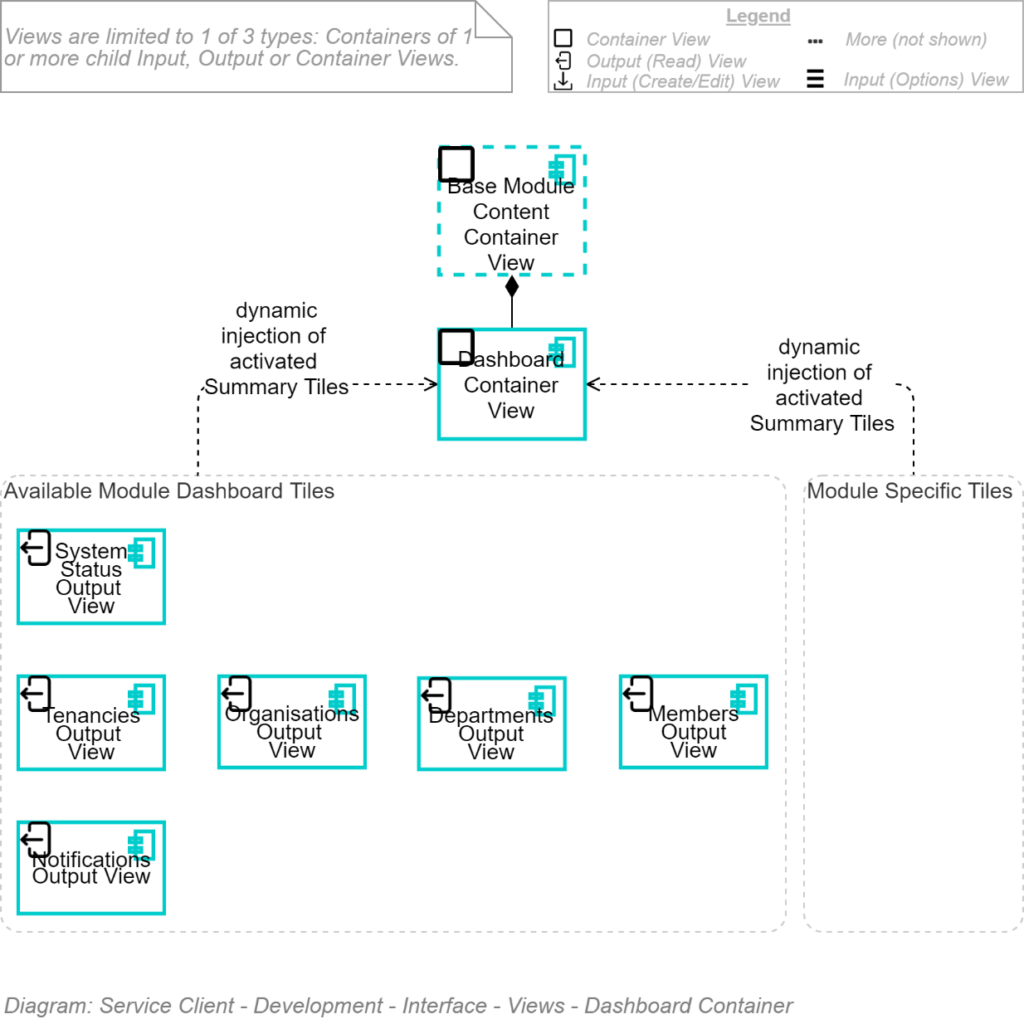

### Search Container View

Search is influenced by the Current View.

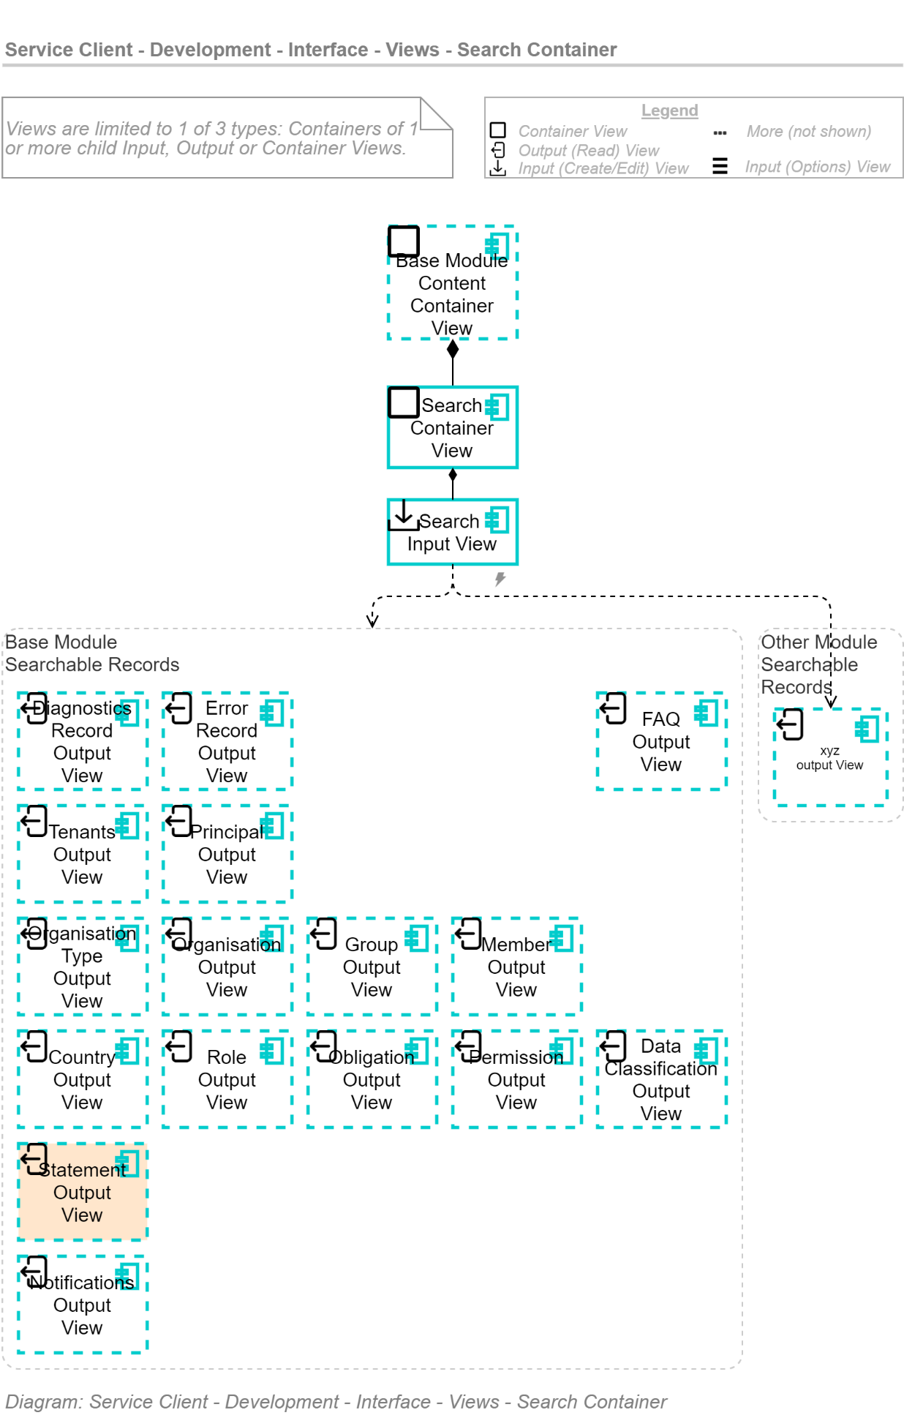

# Service Client User Interface View Flow View

TODO: Views To develop/outline

* Multi-Use Synopsis List Views
  + XYZ Synopsis List (no action beyond clicking an item)
  + XYZ Synopsis List & Back
  + XYZ Synopsis List & Select & OK
  + XYZ Synopsis List & Select One & OK
  + XYZ Synopsis List & Cancel & New & OK
    - "Choose from Available Dashboard Tiles"
* Views
  + Create a Dashboard Tile
  + Invitation Create View

## Dashboard View and Related Flows

The Dashboard may be the most used View for authenticated users. It is a collection of Dashboard Tiles that allow the user to absorb key information at a glance. Each tile summarizes and display key data about an area of interest within the system.

Each tile allows direct navigation to the specific information.

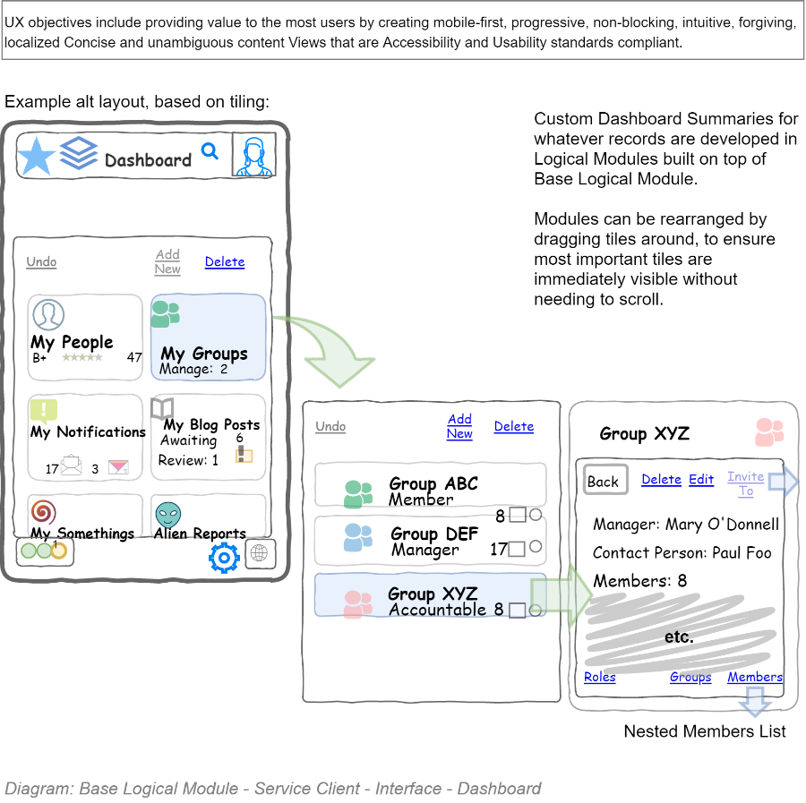

### Customizable Dashboard & Dashboard Tiles

Dashboards are user customisable, allowing tiles to be added and removed, and reordered as the user desires. If a tile is not available, custom tiles can be developed from scratch, with a custom image, reusing existing Search criteria and then applying an operation on an Attribute within the returned results (Count, Sum, Average, etc.) – the result of which is shown on the Dashboard tile.

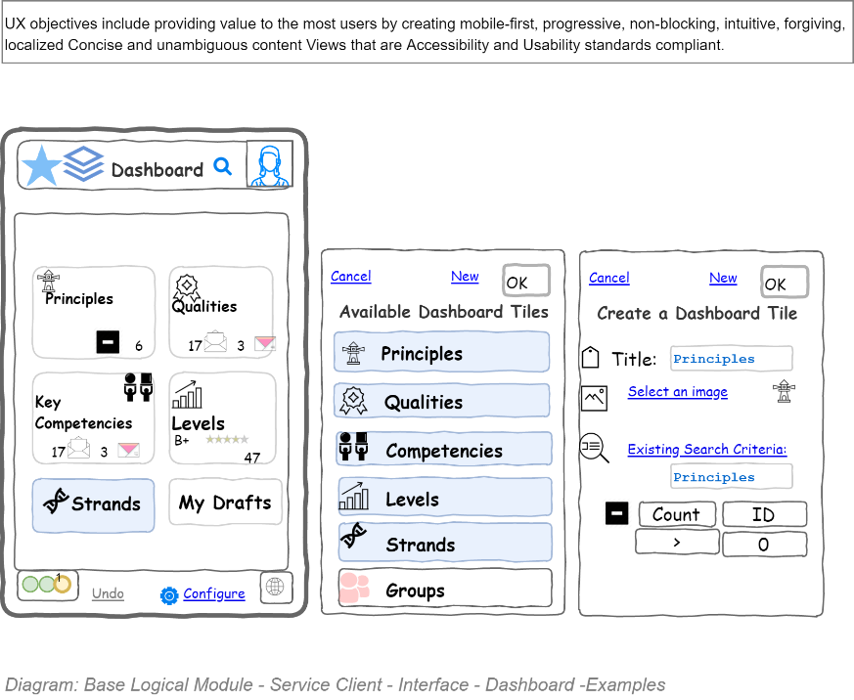

## Group View & Related Information Flows

Navigate -- either from the Navigation tree or the Dashboard -- to a Group View.

The Group View displays some summary information about the group (like who is the Contact Person for the Group and if that is not set, the Accountable/Manager of the Group, and the number of group members).

At the top is displayed the primary action (Back) along with secondary actions to edit the group, or delete it, or invite new users to the group.

At the bottom are secondary actions to view the roles within the group, child Groups, and Members of this Group.

Each List's items can in turn be clicked to bring the user to the Item's View (e.g.: a Member View), which in turn will offer Actions to edit it (if permitted to do so) or return to this list.

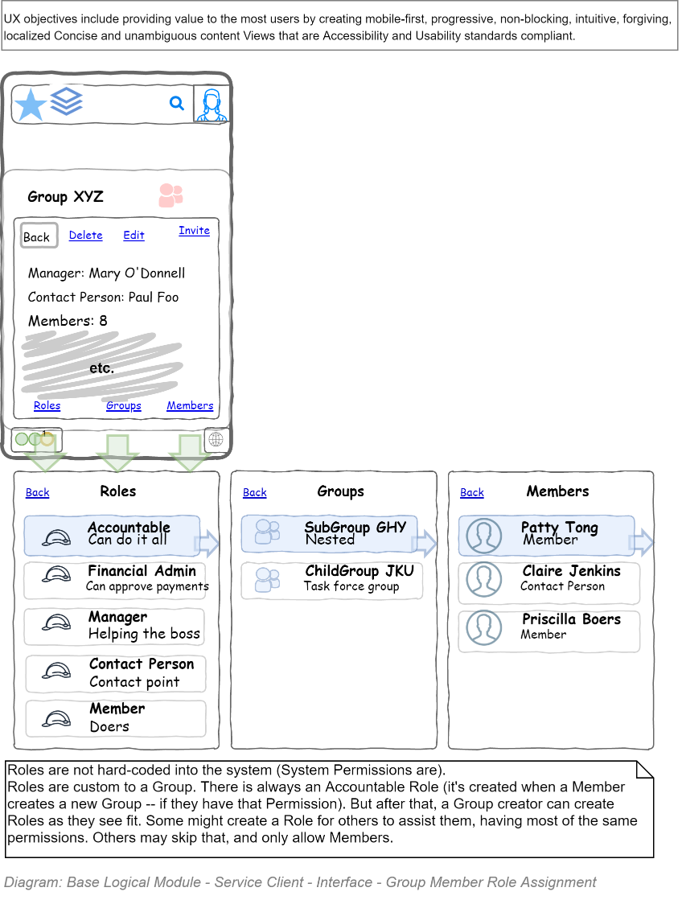

## Invitation of a Member to a Group Role

Groups are made to invite multiple users to one of several roles within the group.

A Member can be invited in the capacity of multiple Roles (they can be both a Manager, as well as Contact Person) within the group.

The following demonstrates a possible View flow to invite a Member to a Group's Role within a Group.

Starting by navigating to a Group View (e.g.: from the Dashboard), select an Invite secondary action to display an Invitation View which allows one to enter a user's email credential and Select the Role(s) the user is to have in the group from a Synopsis Item List showing the Group's available role.

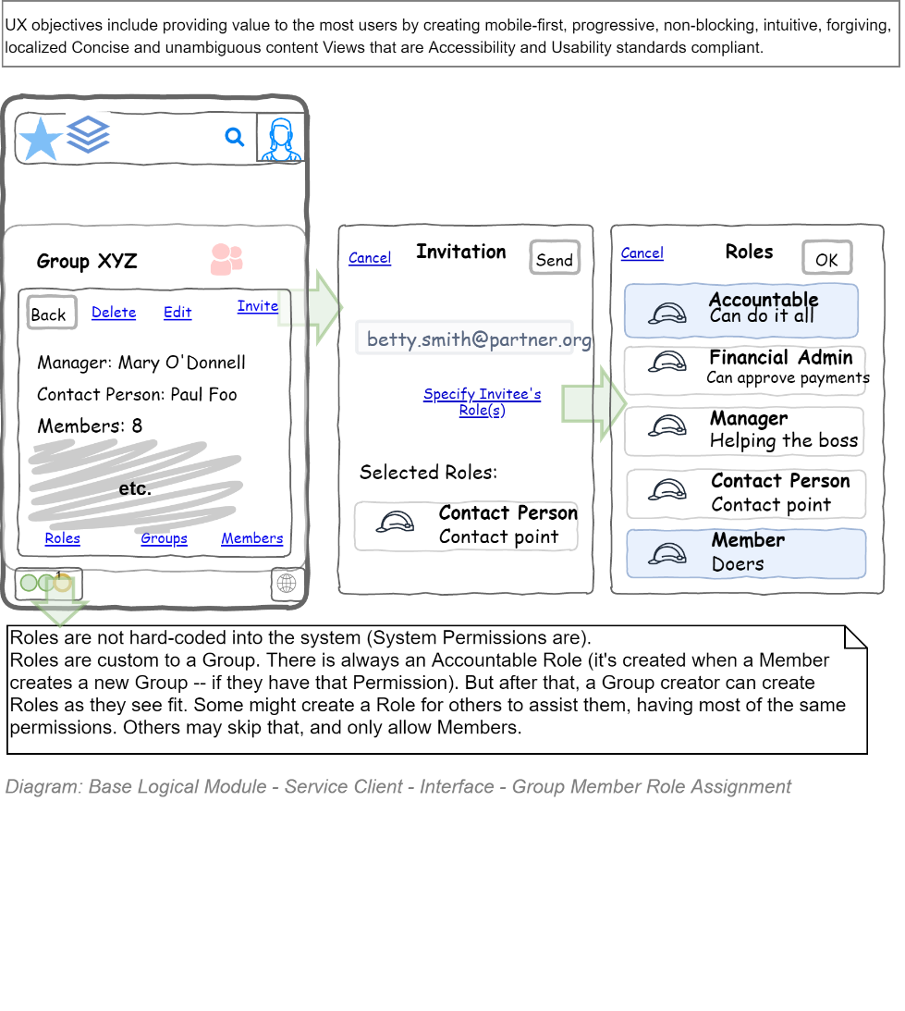

## Editing Group Roles

Roles are custom per Group -- bar the Group's Accountable (i.e. Owner) Role, which is automatically assigned to the creator of the Group, until he/she invites another Member to take it over.

**Note:**It's worth recognizing that if a Support Specialist creates a Role, they will be the Accountable/Owner of the Group, until they Invite another Member to the Accountable role.

A Group Role is a collection of Obligations (MUSTs) and Permissions (MAYs). All but the Accountable Role – which has every permission and cannot be edited – all Roles can add or remove Obligations and Permissions, via a flow similar to what is shown below:

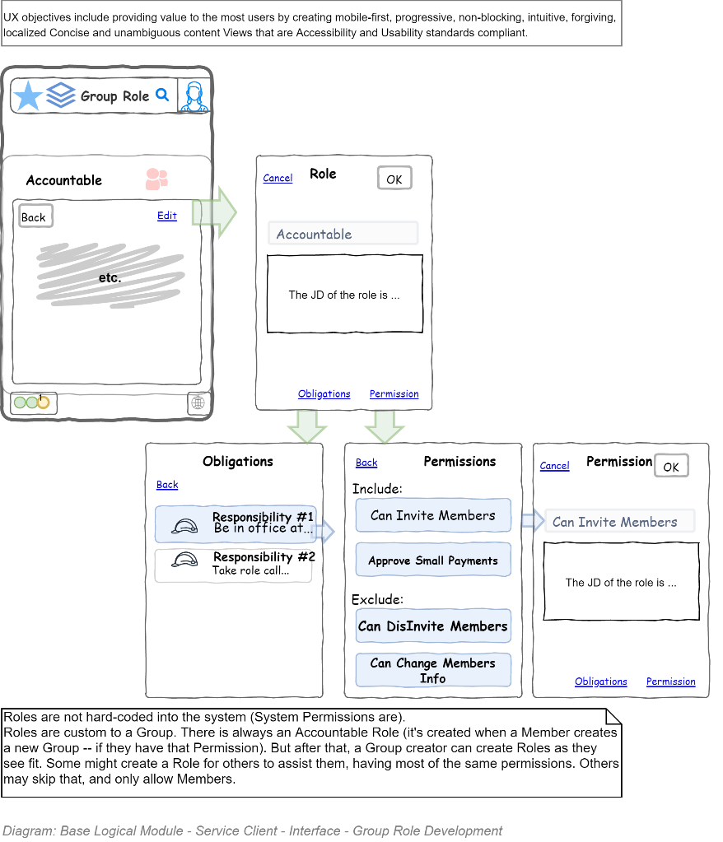

# Service Client User Interface Design View

## Avoiding Delivery Risk

As discussed early in this document, in the Business View, Branding of an organisation and product are key concerns. But there is a time to work on them – and it is *not* at the start of a project. Imagery, font and styling comes after working out how to address both technology constraints and address user behaviour.

### Identical displays are not an objective

No user – beyond testers – use two different browsers to access the same service at the same time. Therefore there is no need to waste time ensuring that displays are identical on different browsers. If they are functional, without bugs/glitches, that's good enough for real world users.

**Tip:**  
There's little as demoralising for developers to watch precious time, meetings, budget and delivery targets be squandered on moving images a couple of pixels around to meet an artificial constraint of zero impact to end users.

### Mobile Web Screen Size First

We've stated elsewhere in our design principles that we design for Mobile devices first. This implies thinking about offline behaviour, screen size and flow, "chattiness" and bandwidth usage,

## Action Driven

As per the same design principles used within the View Flow section of this document, visuals should be focused on eliciting an Action rapidly.

Reading is an acceptable activity – but it should be to elicit an action. If only to convince the user to Action the transition to another resource to read/learn further. If it the View was only read, the user was left to fend for themselves as to where to go next – by using Site Navigation or Site Search – then the page has failed to elicit an Action.

This is generally done via the placement and styling of buttons (primary Actions being shown as Buttons, and secondary actions being shown as links), but can be emphasised by the graphics and colours used.

## Action Copy

A wonderful introduction to developing succinct copy is the following – short, what else! -- book:

* <https://www.amazon.com/Your-Point-Across-Seconds-Less/dp/0671727524>

Alternatively:

* <https://www.amazon.com/Get-Point-Sharpen-Message-Matter/dp/1523094117/>

## Behaviour

### Scrolling

Although not everything can fit within one page, Scrolling is to be actively avoided. Vertical scrolling has a purpose. The need for horizontal scrolling just brings attention to poor workmanship.

Lists (e.g.: Search results) will need to be scrolled, but text-based views should not. If the point can't be made in a single un-scrolled view, consider whether the information can be further broken down into smaller chunks/views that can be linked to allowing users to read further only one or two sections that may be new information to them, skipping the rest.

## Colours

### Colour Blindness

As per the statistics outlined in the User View, a significant number of the systems users are colour impaired and/or visually impaired.

For example, an all-boys school in New Zealand with 1000 pupils would have approximately 100 colour deficient students. 12-13 would be deuteranopes, 12-13 would be protanopes, 12-13 would have a form of protanomaly and 62 would have a form of deuteranomaly. About half of those with an anomalous condition would have a moderate to severe form of deficiency. If a school website did not think of or care to address these statistics, approximately 100 students would have trouble reading material published on the site.

**Requirement**  
Red/green MUST NOT be used to indicate opposite values.   
Consider using Blue tinted Greens and red-ish Orange (or Yellow).  
The rationale is that the most prevalent colour blindness involves users having trouble distinguishing between red and green but can distinguish between blue and yellow.

As to what colours are permissible replacements, consider that the U.S. Department of Transportation specifies that for new traffic lights: Red lights must give off some orange light, but no green or blue light, and Green lights must give off some blue light, but no yellow or red light, since red-green colour-blind people can see blue.

### Colour Contrast

Colour contrast is another form of low visibility.

**Color Contrast Analyzer (CCA)**, is a free open-source tool that displays the contrast ratio for two selected colours. Use it to inspect colour contrast when contrast cannot be programmatically identified.

Source: https://github.com/ThePacielloGroup/CCA-Win/releases/tag/2.5.0

## Images

The prevalence of colour blindness in the audience, and their preference for mobile devices impacts image choices used for headers and backgrounds.

Large background images increase bandwidth consumption, delay completion of page loads, and consume mobile batteries faster than alternatives.

**Requirement:**  
The use of large banner or page background images SHOULD be avoided.  
The rationale is the reduction of bandwidth and mobile device battery consumption, as well as the delay before the View is displayable.

Prefer relying on user-configurable themed flat colour backgrounds, leaving meaningful symbolism to …symbols (i.e., icons and scalable vector art).

### Large images

Background and other large images directly impact on the limited bandwidth, battery and memory of mobile devices – as well as simply make the experience sluggish while the background image is downloaded over mobile channels.

Instead:

1. ensure the styling instructions for the view (the CSS) takes this objective into account, and downloads different images depending on screen size, and not download the largest version of the image and scale it down, and/or
2. Consider using transparent vector artwork over background colours for background images.
3. Ensure the image is decorated with a text description for readers and decorated with attributes to ensure low vision readers skip the background image.

### Colourful background Images

Decrease readability, therefore quick comprehension, therefore Action.

They also interfere with theming, and therefore User preference-based Customisation.

Consider limiting images to being displayed in gutters – and hiding the gutter when on smaller devices.

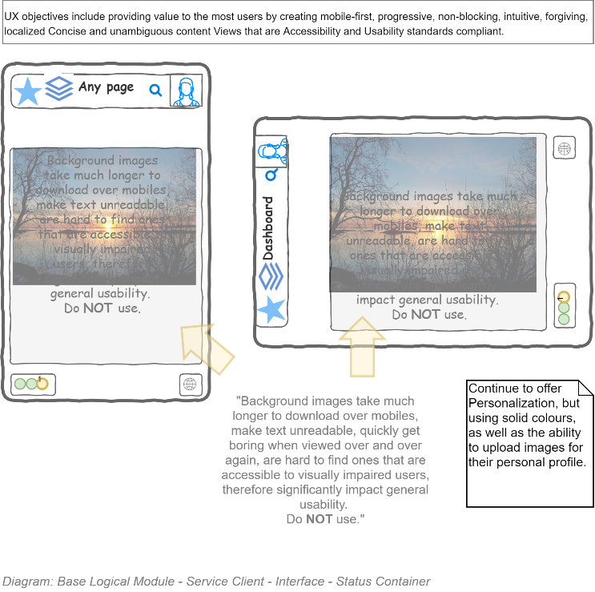

## Icons

### Single Tone, Outline Icons

* **Requirement**Navigation and Action icons and imagery MUST be simple single-tone symbols instead of using multi-colour images.

|  |  |
| --- | --- |
| **Avoid** | **Encouraged** |
| Canon PIXMA MG3060 All-in-One Printer White | Warehouse Stationery, NZ | Inkjet printer icon vector image | Free SVG |

  
**Tip:**  
A very general observation is that lighter thinner icons -- as opposed to heavier icons with large areas of the icon colour -- produce a cleaner interface, especially when viewed on mobile web interfaces where icons are squeezed together. AA very general observation is that lighter thinner icons -- as opposed to heavier icons with large areas of the icon colour -- produce a cleaner interface, especially when viewed on mobile web interfaces where icons are squeezed together. A very general observation is that lighter thinner icons -- as opposed to heavier icons with large areas of the icon colour -- produce a cleaner interface, especially when viewed on mobile web interfaces where icons are squeezed together.

Single tone images are easier to recognise by visually impaired users, and the transparent background allows for the CSS image background be dynamically set or coloured depending on the user preferred theme.

### Fonts & Vector based Icons

Navigation and Action icons must be font-based where possible and failing that vector based, as opposed to raster based, so that users can scale the screen without loss of quality.

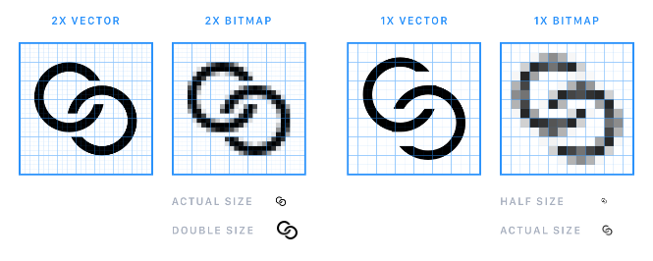

Well known sources of image fonts include but are not limited to:

* <http://fontawesome.io/>
* <http://kudakurage.com/ligature_symbols/>
* <http://map-icons.com/>
* <http://www.elegantthemes.com/blog/resources/elegant-icon-font>
* <https://www.s-ings.com/typicons/>
* <https://icofont.com/>
* <https://akveo.github.io/eva-icons/#/>
* <https://useiconic.com/open/>
* <https://ionicons.com/>
* <https://themify.me/themify-icons>
* <https://octicons.github.com/>
* <https://github.com/vorillaz/devicons/>
* <http://icon-works.com/>
* <https://freebiesbug.com/psd-freebies/80-stroke-icons-psd-ai-webfont/>
* <http://kudakurage.com/ligature_symbols/>
* <http://stackicons.com/>
* <https://shalinguyen.github.io/socialicious/>
* <https://icons8.com/line-awesome>

  
**Note:**  
Another reason to prefer vector over raster is that when the icon is rendered over a dark background (e.g.: in a mobile device battery saving “midnight black” themed interface), the vector art can be dynamically switched to an colour with a complementary luminosity.

## Space

Screen real estate is precious. Use it for purpose. Either to elicit Action -- or leave it uncluttered for clarity.

### Wasted Space

Please don't place a giant title in the middle of the screen, wasting the top half of the screen, using it only to show a large background image. It just screams an uncertainty of having anything valuable to say, can force the use of a bandwidth hogging large background image, forcing text to be succinct enough to question the purpose of the page -- or scrolling to read enough to understand the purpose of the View.

### Effective Space

The simplest way to focus on *one* thing – is not to show *two* things.

If you can communicate the essential aspects of a View – it's Purpose and its Actions -- without scrolling, use the rest of the space to put in nothing, removing secondary distractions.

**Note:**  
Prettiness (imagery) is not an Action, and – frankly -- by repetition, any image choice gets stale relatively quickly, so effort choosing them has lower value than focusing on eliciting Action.

# Appendices

## Section Synopsis

## Document

### Document Conventions



### Document Structure

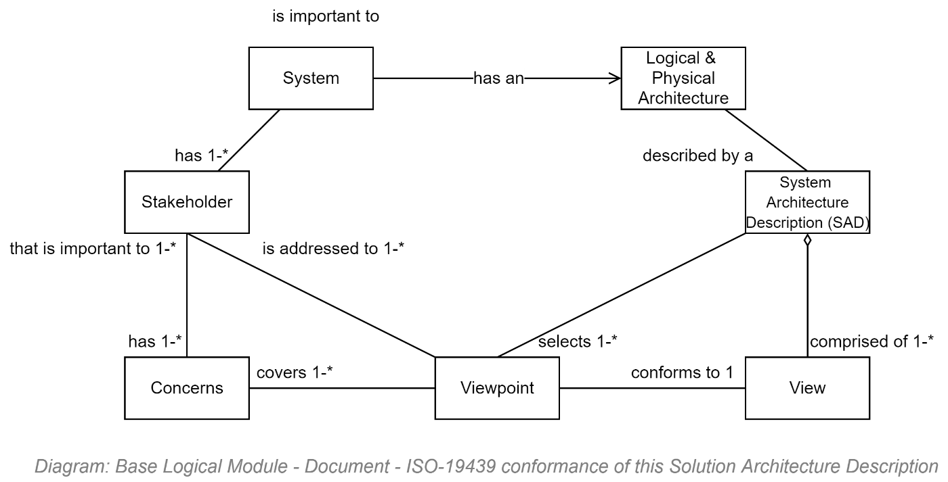

### Document Audience

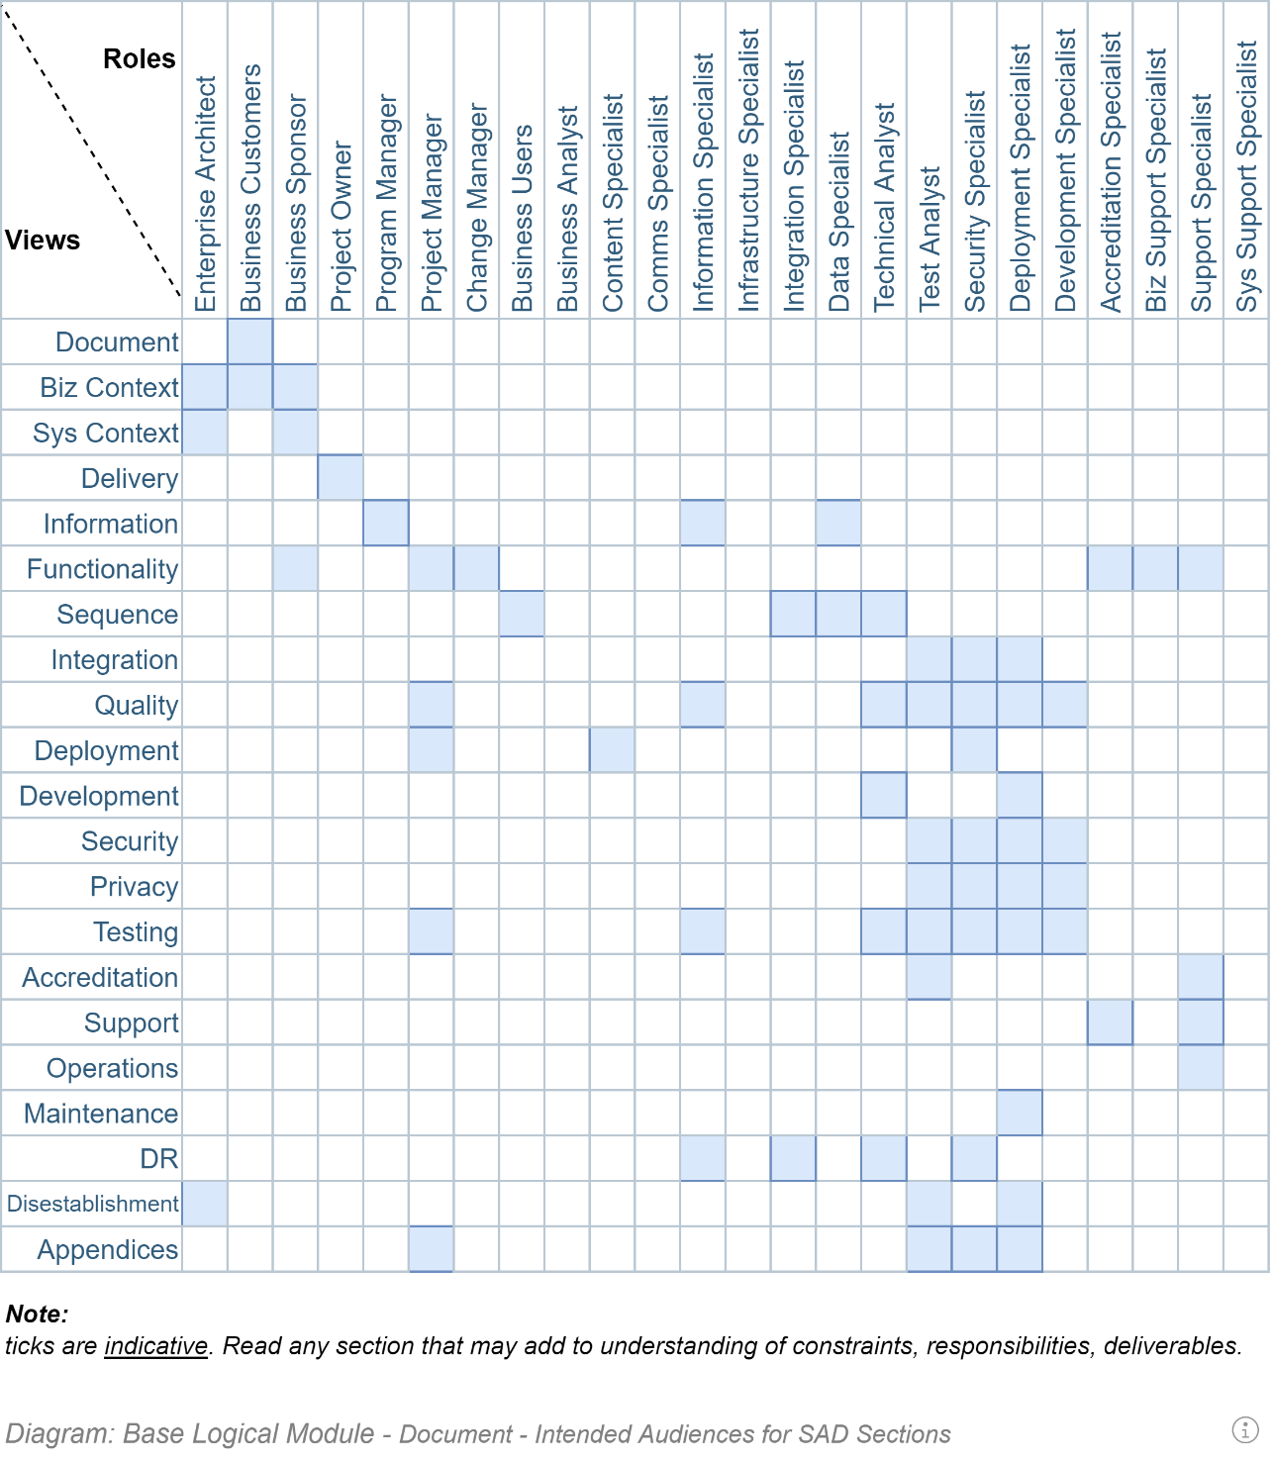

### Document Asides

This document is peppered with asides – highlighted boxes of text – that are of one of the following types:

* Information/General Note
*  Tip/Recommendation (SHOULD)
*  Warning (SHOULD NOT)
*  Prohibition (MUST NOT)
* Requirement (MUST) (which should be mirrored in the project’s requirement & therefore work items tracking service).

### Document Formatting Conventions

The following are examples of formatting used throughout the document.

Note:  
They are provided to facilitate if and as required the common task of Format Painting style.

* Text
  + Sub
  + Sub
* Text

[https://any.web.link](https://any.web.link.com)

Image or Table Caption

|  |  |  |
| --- | --- | --- |
| A | Table | Example |
| Row Header | Row using Body Text |  |

## Project

### Background History (Extended)

TODO: Add any relevant history for context.

## Acronyms & Terms

### Terms

#### Business

##### Business Capability

##### Business Service

##### Business Function

##### Business Process

##### Business System

##### Group

A set of Persons who are voluntarily associated in one or more Roles to achieve a purpose.

##### RASCI

An acronym for Responsible, Accountable, Supporting, Consulted, Informed.

Note:  
CRIMEAS is a similar acronym standing for: Consulted, Responsible, Informed, Managing, Everyone else, Accountable, Supporting.

##### Stakeholder

A Person who is a RASCI member of a purposeful Group.

##### Strategy

A long term, integrated & unified set of flexibly designed goals and objectives to take advantage of opportunities and mitigate threats to reach an organisation's goals and objectives while consuming the least amount of resources/treasury. See Policy.

##### Steward

Acting on behalf of an *Owner*, has the same responsibilities and opportunities as an Owner, bar the Accountability.

##### Owner

The single *Accountable* person.  
Data Custodian

Manages the availability of the data, ensuring provisioning, backups, servers and network are performing as required. A Data Custodian does decide who has access, nor how it is used.

##### Policy

An organisation defined framework to act as guidelines and permit rational decision making to adhere to Strategic outcomes. It is helpful in highlighting the rules, value and beliefs of the organisation. Policy is subservient to Strategy. A Strategy is a dynamic plan for action, whereas Policies are stable plans for decision making. A Strategy is to manage the exterior, whereas Policies are for handling the interior.

##### Data Owner

A data Owner is concerned with the risk and appropriate access to data.

##### Data Steward

A Steward is interested in the meaning of the data, and the data's correct usage.

##### Role

A logical assembly of Responsibilities and Permissions, which are conferred on one or more Persons within a purposeful Group of persons.

#### Technical

##### Actor

##### Agile [delivery methodology]

A respected approach to technology delivery at pace by *experienced* resources working together with minimal planning, oversight & documentation overhead.

The methodology emphasises rapid and iterative delivery of change for user stakeholders to respond as quickly as possible, informing future development direction decisions.  
  
It is a foundational concept of the more mature and complete DevOps and SecOps delivery methodologies.   
See *MVP*.

 **Warning:**  
  
Agile does not mean system development must be begun immediately at the expense of planning in order to get something in front of stakeholders.   
  
The first iterations are used to set up an online project collaboration space, where project documentation -- including this manual -- are available to all stakeholders. This project space is the first service lifetime **deliverable**.  
  
The next iterations should be a used to develop a bare-bones, “just-enough”, achievable, technical design for review and consensus by appropriate stakeholders before starting. Such a technical design roadmap, although not the final information service itself, **is also a deliverable**.  
  
The next iteration(s) are used to focus on developing an automated test and delivery pipeline**.** This too **is a deliverable**.  
  
Only after the above deliverables are well on their way, start iteratively delivering the next deliverable -- the information service itself.  
  
Finally, when the backend service is starting to expose usable APIs, start developing the final deliverable – the service client user interface.   
  
**Important:**  
Whatever you do, don’t start from the interface (that’s akin to designing a car starting with the panelling, expecting it to be a good source of information on which to design the internal engine).

##### Business Analysts:

a specialist who developers a complete listing of Stakeholders – and then interviews them for an as complete as possible list of both Functional and Quality requirements. The (combined) System Requirements are the source of the objectives an architect must meet with a system design.

##### Continuous Delivery:

the automatic building but controlled automated deployment of committed change.

**Note:**The difference between a Continuous Delivery Service and a Continuous Deployment Service is that delivery to target environments with a Continuous Delivery Service is a *decision* (by change control, accreditation services, etc.) -- whereas in the second case, every commit to the code base that passes all automated tests is trusted to be deployed to production immediately.   
  
This Project uses a controlled, audited, Continuous Delivery based approach.

##### DevOps:

a more holistic approach to technology delivery which also addresses ongoing operational needs and the collection of feedback to inform ongoing iterative development and delivery of changes to better meet expectations and changing circumstances.   
See *SecOps*.

##### Domain: an area of specialised knowledge.

Generally used to keep separate and solve business domain independently from technology domains. All IT systems are the merging of several different domains, including the following common distinct domains: Business, (Business Information and Business Processes), Users & Group management, User Support, Technology Automation & Integration, and Security, Privacy & Accreditation.

##### Domain Driven Design:

a system design approach to developing systems to equally meet the domain requirements of multiple stakeholder groups. The alternative is addressing one group above others (e.g.: Business, or IT) making it difficult for other stakeholder groups to assist with providing value to users.

##### Minimum Viable Product (MVP):

Minimal Viable Product. Due to misunderstanding and/or misapplying Agile methodology concepts too often ends up instead becoming an outcome demonstrating “*Missing Valuable Planning*”.

##### SecOps:

a delivery methodology: an enhancement of DevOps, emphasising the Security, Privacy and optionally Accreditability of every system delivery.

##### Stakeholder:

groups of people with a RASCI relationship to a system's commissioning, discovery, design, development, delivery, usage, operations, maintenance, decommissioning.

##### Stakeholder Analysts:

a more appropriate term for Business Analysts. Business Analysts, hired by project managers embedded in business groups, most often capture only business stakeholder requirements, at the expense of all other stakeholders (Privacy, Security, Support, Operations, Maintenance, Reporting, Data warehouse, etc.)

##### System Requirements:

the term to describe the combination of the Functional and Quality Requirements. Can be a living document, but preferably it is an online database that all stakeholders can reference online within the project’s ALM space.

##### Test Driven Development:

an approach to development which emphasises Test Analysts defining automatable test conditions to non-ambiguously, rapidly and repeatedly prove work item objectives are being met.

### Mōari Terms

Our nation is multi-cultural welcoming, with 2 official national cultures with 3 official languages. To ensure this system is accessible and understandable in all official languages, ensure the system is designed from the ground up to use Maori terms and viewpoints.

The following are a rudimentary selection of common terms in this country and industry.

##### Atua

Spirit ancestor, god, demon, supernatural being.

##### Āko

Learning.  
To Teach & to Learn.   
See: *Tirewa* (Framework of learning).  
Usage: *Kahui āko.*

##### Ākonga

Student.  
See *Āko* ("Learning"), *Kaiko* ("Teacher"), and *Kura* ("School").

##### ā-waha

Oral.  
Use: reo-ā-waha: oral language

##### Āheinga Reo

Language Abilities

##### Hapu

Common ancestor tribal group.  
See *whanau* ("extended family"), *whakapapa* ("grounding/lineage").

##### Harakeke

Flax.  
See *Rito* ("heart shoot of the flax").

##### Herere / Herenga

Obligation / Constraint.

##### Iwi

Tribe/Nation.

##### Ipurangi

Stream / Internet.  
Use: *Te Kete Ipurangi* ("*the internet basket"*).

##### Kahui

Flocking/Group  
See *waka* ("Container/Canoe/Crew/Flock").  
Usage: *Kahui Āko*.

##### Kāhui Ako

Community of Learning.  
As opposed to *Kāhui kura* ("group of schools"), which would be a word that does not include early learning, or community.  
See: *Tira.*

##### Kaitia

Steerer/helmsman.

##### Kaitia*ki*

Acting Guardianship.  
See *Kaitiatanga* ("Acting as guardian of nature").

##### Kaitiakitanga

Guardianship, for the sky, sea, and land.  
See *Kaitiaki* and *-tanga*

##### Kaiko

Teacher.  
See *ākonga* ("Student"), *Kura* ("School"), *āko* ("Learning").

##### Kaitaki

Chieftain.

##### Kanga

Basket.  
See *Rohe* ("Region").  
(also, To Swear / To curse).

##### Kauwhata

To recite oral/spiritual history  
Usage: *Te Kauwhata Reo* system.

##### Kete

Basket.   
See *Rohe* ("Region").

##### Kupu

Word / Vocab.

##### Kura

School.   
See *Āko* ("learning"), *Ākura* ("Student"), *Kaiko* ("Teacher"), and *Kura* ("School").

##### Mana

Honour/Face.

##### Manuwhiri

Visitor. Guest.

##### Marae

Meeting House

##### Matua

Parent.

##### Mātai

Field of Study

##### Noa

Blessing/ Restriction lifting.   
See: *rahui* ("Restriction").

##### Pae

Measure circumferance/take a reading.   
See *Pou*("Goalpost").  
See *Rautaki* ("Strategy").

##### Pāngarau

Maths.  
See *Tuhituhi* ("Writing").

##### Papa

Ground / Earth.  
See *Whakapapa* ("Lineage/Grounding").

##### Pānui

Read.  
See Tuhituhi ("*writing*"), *Pāngarau* ("Maths").

##### Pou

Pillar.  
See *Whāinga* ("Goal").

##### Puia

Volcano.

##### Puna

Well. Well up. Center.   
Use: Puna Reo: Maori center

##### Pū

Clump.  
Usage *Pu harakeke* ("clump of flax").

##### Rāhui

Restriction.   
See *Noa* ("Blessing/Lifting of Restriction").

##### Rāranga

Weaving.  
See *harakeke* ("Flax").

##### Rangatira

*Hapu* Chieftain.

##### Rautaki

Strategy.   
Use: See *Rautaki Reo*: Maori language strategy.

##### Reo

Language.  
See *Te Reo*("The language").  
Usage *Te Reo Māori* ("The Māori language").

##### Rito

*harakeke* ("Flax") heart shoot.  
See *Te Rito* system.

##### Rohe

Territory/Domain – can be time zone. Can be a small basket (see *Kete*).

##### Ta moko

Facial Tatoo.

##### Tapu

Sacred

##### Tākiwa

District

##### Te

The …

##### Tikanga [māori]

The correct way.

##### Tira

Group.  
See *Kāhui* ("Flock").

##### Tirewa

Framework for reciprocal approach to teaching & learning. See *āko*("Learning").

##### Toa

Warrior

##### Tohunga

Expert in a field

##### Tumuaki

Crown of the head. Person in charge of an organisation. Principal.

##### Tūrangawaewae

Standing place – where one has a right to standing, through whakapapa.

##### Tuhituhi

Write.  
See *Pāngarau*("Maths").

##### Whaka-

Towards/Directed towards/Make happen.  
See: *whakapapa* ("Grounding/Lineage").

##### Whakapapa

Lineage/Grounding.  
See *whaka-* ("towards") and *papa* ("earth/ground").

##### Waka

Boat, Container, Canoe. Flock.  
See *kahui* ("Group/Flock").

##### Whānau

Extended Family. See *Hapu*.

##### Whāinga

Goal. Destination?  
See *Pou* ("post").

##### -tanga

Converts a verb into a Noun.  
Usage: *Kaitiatanga*

### Acronyms

#### Business

TODO: Add business specific Acronyms

#### Technical

The following are a collection of common Acronyms used to refer to technical concepts and components.

##### AAD: Azure Active Directory

##### AD: Active Directory

##### API: Application Programming Interface

API is an acronym for Application Programming Interface. An [API](https://martech.zone/what-does-rest-stand-for-example-rest-api/) is a set of routines, protocols, and tools for building web-enabled and mobile-based applications. The [API](https://martech.zone/what-does-rest-stand-for-example-rest-api/) specifies how you can authenticate (optional), request and receive data from the [API](https://martech.zone/what-does-rest-stand-for-example-rest-api/) server.

When used in the context of web development, an [API](https://martech.zone/what-does-rest-stand-for-example-rest-api/) is typically a defined set of Hypertext Transfer Protocol (HTTP) request messages, along with a definition of the structure of response messages. Web   
APIs allow the combination of multiple services into new applications known as mashups.

##### CSS: Cascading Style Sheets

##### CURIE

A Compact URI. Learn more at https://en.wikipedia.org/wiki/CURIE

##### DSaC: Database Schema as Code

##### DDD: Domain Driven Development

A system design approach to cost-effectively design resilient and fit for purpose systems to meet the domain requirements of multiple stakeholder groups.

Most effectively used in conjunction with SOLID development principles.

##### HTML: Hyper Text Markup Language

##### HAL: Hypermedia Application Language

An RFC proposed JSON based expression of HATEOS link information within ReST-ful responses, for Service Clients to dynamically render navigation options.

##### HATEOS: Hypertext as the Engine of Application State

A constraint of the ReST application architecture that keeps the RESTful style architecture unique from most other network application architectures is the returning of related links in the response Content or Headers.

It allows the service agent client to dynamically present links to appropriate related resources.

**Note:**There is no agreed standard for HATEOS – although refer to HAL or RFC 5988 (Web Linking) as potential standards based option.

The term “**hypermedia**” refers to any content that contains links to other forms of media such as images, movies, and text.

##### IaC: Infrastructure as Code

##### IdP: Identity [Token] Provider

##### JSON: JavaScript Object Notation

JSON is an acronym for JavaScript Object Notation. JSON is a format for structuring data that is sent back and forth via an API. JSON is an alternative to XML. REST APIs more commonly respond with JSON – an open standard format that uses human-readable text to transmit data objects consisting of attribute–value pairs.

##### MPA: Multi-Page (Server-based) Application

##### OIDC: Open Identity Connect

##### OO: Object Oriented

##### PWA: Progressive Web Application

##### ReST: Representation State Transfer

See HATEOS.

##### UI: User Interface

##### UX: User eXperience

##### SAML: Secure Application Markup Language

##### SDK: Software Development Kit

When APIs are published, it’s typical to accompany the APIs with documentation that shows how the [API](https://martech.zone/what-does-rest-stand-for-example-rest-api/) authenticates, how it can be queried, and what the appropriate responses are.   
To help developers get a head start, companies often also publish a Software Developer Kit to actively demonstrate the use of the API, for investigation by developers.

##### SOAP: Simple Object Access Protocol

##### SPA: Single Page Application

##### WAN: Wide Area Network

A multi-port, multi-protocol network used to connect multiple LANs.

##### WSDL: Web Service Definition Language

##### WWW: World Wide Web

The HTTP/S over port 80/443 subset of the world-wide WAN.

##### XML: eXtensible Markup Language

XML is an acronym for eXtensible Markup Language. XML is a markup language used to encode data in a format that is both human-readable and machine-readable.  
Largely replaced by the lighter weight and simpler JSON.

## Risks

### Direction

**Lack of value focused Objectives:**   
the technical system is not the objective. The service to end users is the primary objective. The functionality to stakeholders equitably distributed amongst stakeholders is the second objective.

**Lack of Guiding Principles:**   
unprincipled delivery encourages stakeholders to compete for resources rather than collaborate.   
The principles must include principles to cover the following concepts:

Team: e.g.: Automation before manual activities

Delivery: e.g.: automated delivery pipeline before delivered system.

Device: e.g.: Small mobile screens before static desktop screens

Channel: e.g.: voice before web before print

Deployment: e.g.: separate Service/Service Façade/Client tiers

### Delivery

ISO-25022/12/10 are focused on Service qualities.   
And Roles and Personas are focused on Service Functionality.  
But there are no *Project* Delivery Qualities to guide Delivery.

Decrease Risk by working from the bottom up (clunky concrete foundations that nobody ever sees, needed to be done down in the mud, before flashy screens – rather than the other way around).

Decrease Risk by focusing on providing autonomy to work to prepared, common plans and agreed schedule – rather than focusing on controlling resources to work to plans to be developed in groups.

Decrease Risk by ensuring signed T&Cs by stakeholders (ensuring PMs, Devs & Testers have read the documents and agree to working to them, before they are accepted into the delivery team).

Decrease Risk by avoiding designing interfaces before designing services and flow between them.

The only tool PMs have at their disposal is to "descope" & "manage expectations"   
And use it too early. Projects should be allowed to fail a bit before work is necessarily descoped.

### Discovery

Business User stakeholder focused.  
  
A by-product of analysts being referred to *Business* Analysts (as opposed to *Stakeholder* Analysts) – and having the most contact with business users compared to other stakeholder groups (e.g.: Service Consumers, Business Partners, Risk Specialists, Security Specialists, Support Specialists, Operations Specialists, Maintenance Specialists), Discovery produces lopsided User Stories.  
Often, their only representation is via the project’s Architect – and even so, only in the form of Quality Requirements. This means they end up not being well represented in terms of their required Functionality.

### Definition

TODO

### Design

System Designers may try to design a WAN based service, thinking to emulate LAN concepts.

The service is not designed to API-First principles, exposing all operations by appropriately authorised APIs.

### Development

Business Owner are often biased to prioritise work items that are presentable to business stakeholders, relative to work items for other stakeholder groups.

Developers are not trained to reject working on Work Items whose User Stories and Tasks have not been reviewed and completed with Test Definitions by Test Analysts.

Developers are not trained to develop features and user stories in a separate code repository branch, which would better allow the build pipeline to abort attempts to merge non-quality assured code into the main production branch.

Developers are not trained to develop securely.

### Quality Assurance

A risk is that Quality Assurance is done by Testers, as opposed to being done by Test Analysts. Testers test the software manually according to scripts. Test Analysts analyse a Stakeholder Analyst developed User Story & Tasks and complete it with Test Definitions.  
The Developers develop the Test Definitions into Test Scripts to be run by the Delivery Pipeline. Test Analysts never repeat tests manually – they only do exploratory testing on the system.

### Deployment

The delivery pipeline only focuses on compiling code, leaving the building of environments, and running tests to manual processes.

The build pipeline does not run automated tests.

The build pipeline does not protect the merging of non-quality assured branches into the production branch.

### Support

Support Specialists are not provided a means to onboard/offboard users.

### Operations

The system is deployed without a DR process.

The system DR’s data backup & recovery functionality is continually tested (by restoring backups to a reporting database).

### Maintenance

The services’ architecture is not developed according to Domain Driven Design (DDD) principles.

The code is not developed according to SOLID OO principles.

### Decommissioning

The system is designed without a means to export key information in a machine-readable -- industry standard, if available -- format.

## Principles

### Summary of Principles Applicable to NZ National Services

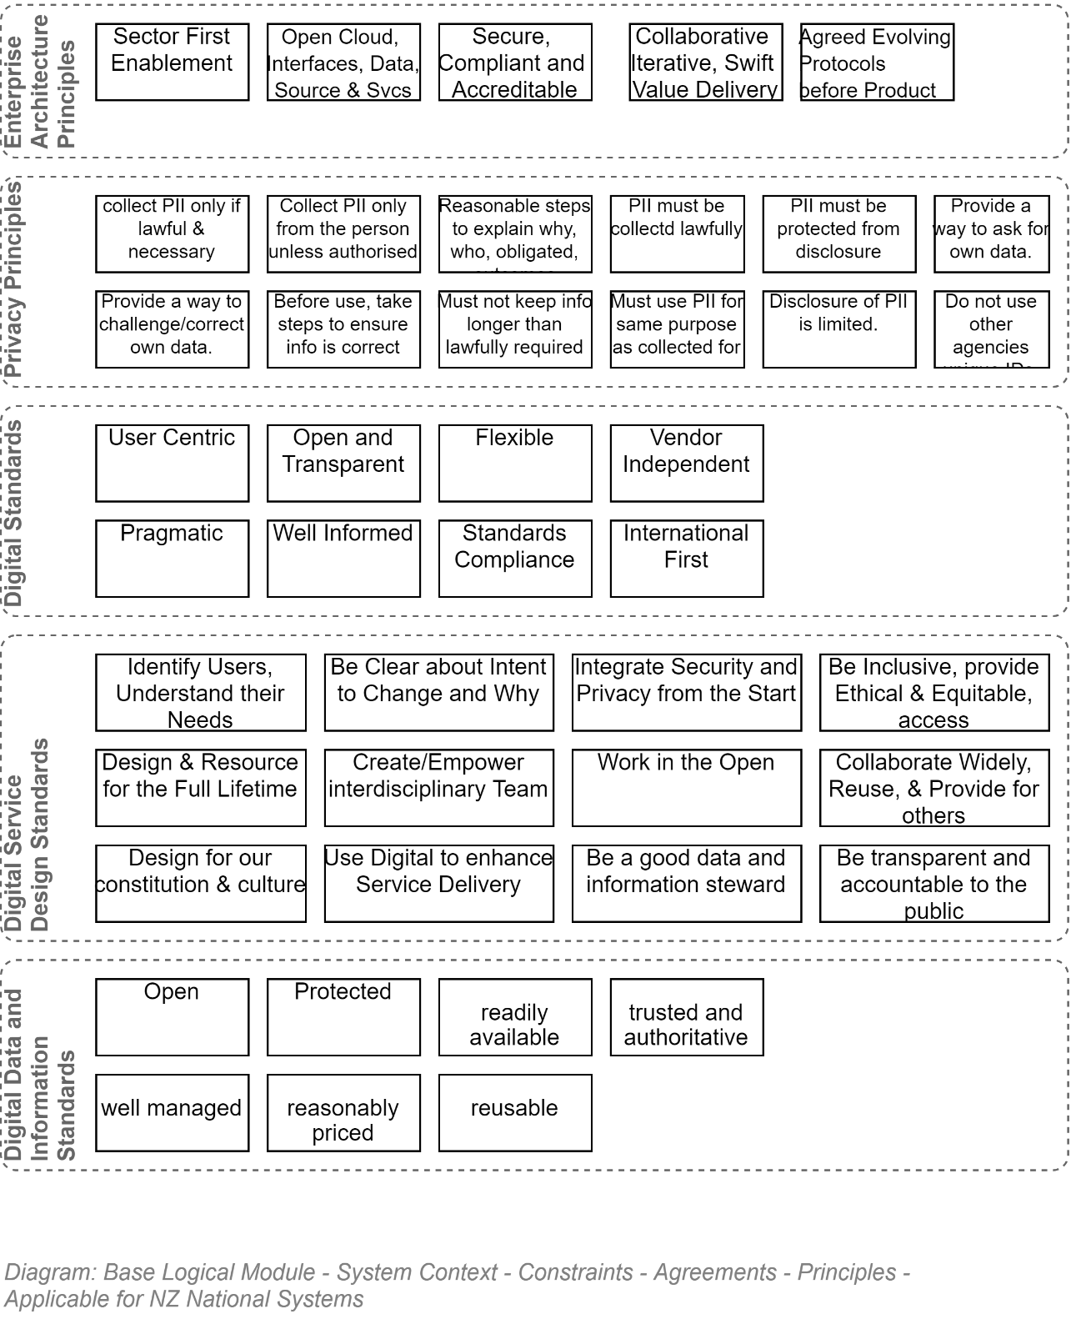

### NZ Privacy Principles

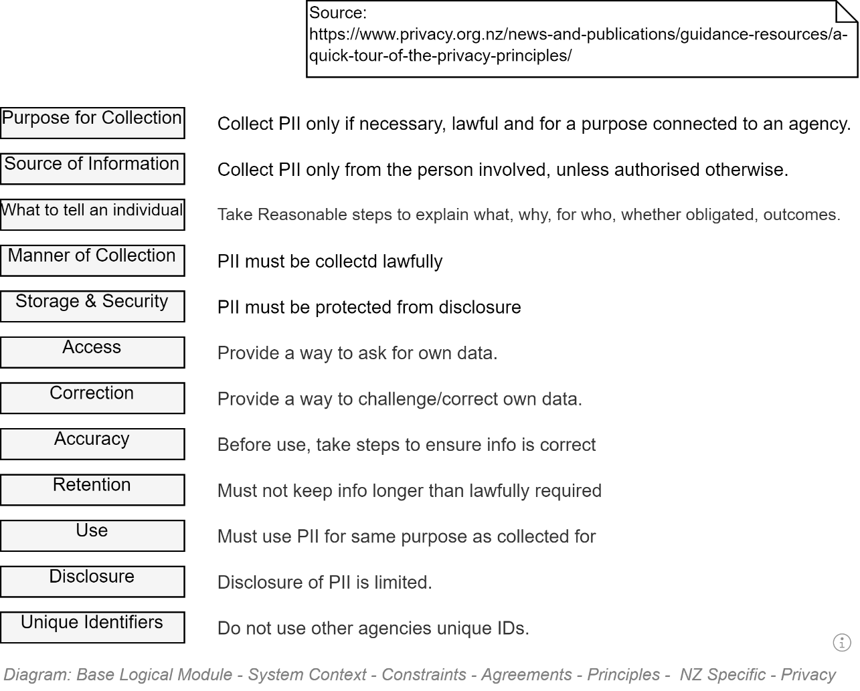

### NZ Specific - Digital Standards Principles

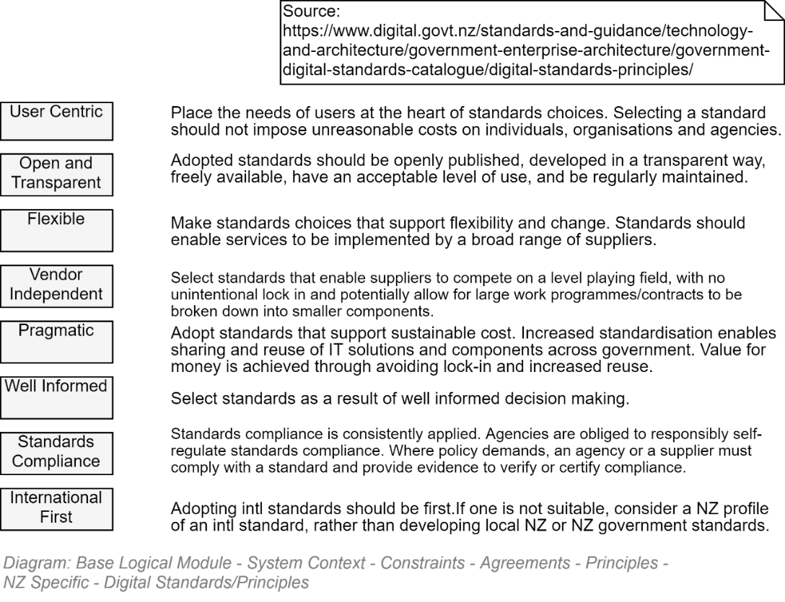

### NZ National Service Specific – Digital Service Design Standards Principles

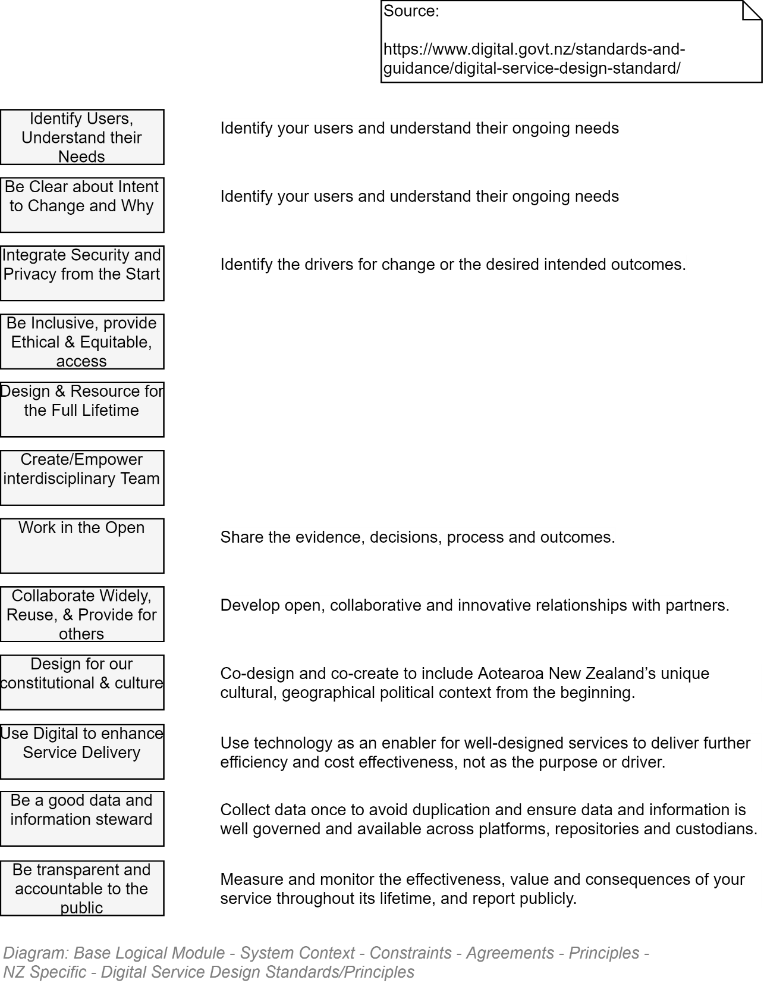

### NZ National Service Specific – Data and Information Management Principles



### NZ MOE Enterprise Design Principles

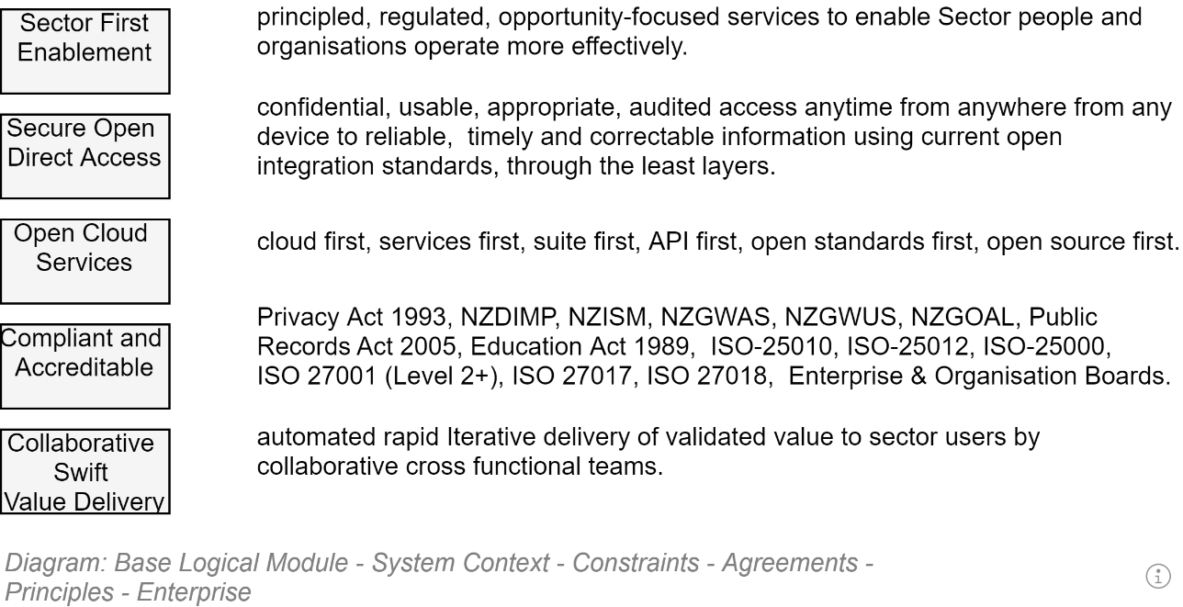

### Universal Design Principles

The basic principles of Universal Design developed under Ron Mace in 1997 are listed below:

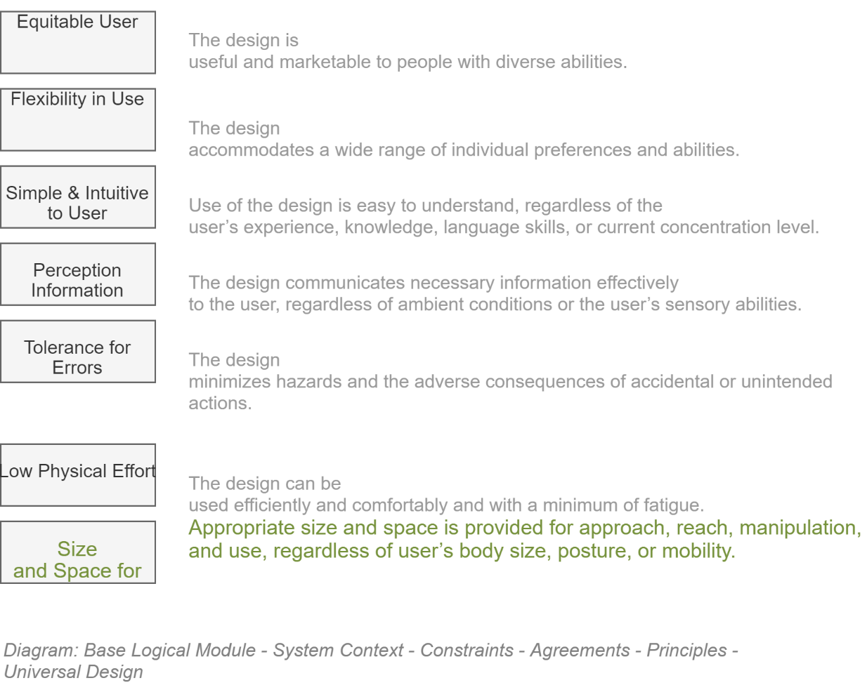

#### Equitable Use

The design is useful and marketable to people with diverse abilities.

* It provides the same means of use for all users: identical whenever possible; equivalent when not
* It avoids segregating or stigmatizing any users.
* Provisions for privacy, security, and safety are equally available to all users.
* The design is appealing to all users.

#### Flexibility in Use

The design accommodates a wide range of individual preferences and abilities.

* It provides choice in methods of use.
* It accommodates right or left-handed access and use.
* It facilitates the user’s accuracy and precision.
* It provides adaptability to the user’s pace.

#### Simple and Intuitive Use

Use of the design is easy to understand, regardless of the user’s experience, knowledge, language skills, or current concentration level.

* It eliminates unnecessary complexity.
* It is consistent with user expectations and intuition.
* It accommodates a wide range of literacy and language skills.
* It arranges information consistent with its importance.
* It provides effective prompting and feedback during and after task completion.

#### Perceptible Information

The design communicates necessary information effectively to the user, regardless of ambient conditions or the user’s sensory abilities.

* It uses different modes (pictorial, verbal, tactile) for redundant presentation of essential information.
* It provides adequate contrast between essential information and its surroundings.
* It maximizes “legibility” of essential information.
* It differentiates elements in ways that can be described (i.e., make it easy to give instructions or directions).
* It provides compatibility with a variety of techniques or devices used by people with sensory limitations.

#### Tolerance for Error

The design minimizes hazards and the adverse consequences of accidental or unintended actions.

* It arranges elements to minimize hazards and errors: most used elements, most accessible; hazardous elements eliminated, isolated, or shielded.
* It provides warnings of hazards and errors.
* It provides fail safe features (i.e., an undo operation being the best option).
* It discourages unconscious action in tasks that require vigilance (i.e. modal validation beforehand being second best).

#### Low Physical Effort

The design can be used efficiently and comfortably and with a minimum of fatigue.

* It allows user to maintain a neutral body position
* It uses reasonable operating forces.
* It minimizes repetitive actions (e.g.: the least number of clicks to get anywhere).
* It minimizes sustained physical effort.

#### Size and Space for Approach and Use

Appropriate size and space is provided for approach, reach, manipulation, and use, regardless of user’s body size, posture, or mobility.

* It provides a clear line of sight to important elements for any seated or standing user.
* It makes reaching to all components comfortable for any seated or standing user.
* It accommodates variations in hand and grip size.
* It provides adequate space for the use of assistive devices or personal assistance.

### Organisation Principles

The following are principles specific to this organisation.

#### Enterprise Principles

|  |  |
| --- | --- |
| Maximize Benefit to the organisation [EAP1] | |
| **Statement** | Information management decisions are made to provide maximum benefit to the enterprise (education inc) as a whole. |
| **Rationale** | This principle embodies "service above self". Maximise benefits to the education system (e.g. alignment to the Education System Digital Strategy).  Decisions made from an enterprise-wide perspective have greater long-term value than decisions made from any particular organizational perspective.  Maximum return on investment requires information management decisions to adhere to enterprise-wide drivers and priorities.  No minority group will detract from the benefit of the whole. However, this principle will not preclude any minority group from getting its job done. |
| **Implications** | 1. Achieving maximum enterprise-wide benefit will require changes in the way we plan and manage information. Technology alone will not bring about this change. 2. Some organizations may have to concede their own preferences for the greater benefit of the entire enterprise. 3. Application development priorities must be established by the entire enterprise for the entire enterprise. 4. Applications components should be shared across organizational boundaries. 5. Information management initiatives should be conducted in accordance with the enterprise plan. Individual organizations should pursue information management initiatives which conform to the blueprints and priorities established by the enterprise. We will change the plan as we need to. 6. As needs arise, priorities must be adjusted. A forum with comprehensive enterprise representation should make these decisions. |
| **Single Source of Truth [EAP2]** | |
| **Statement** | Single Source Of Truth (SSOT) refers to the practice of structuring information models and associated schema such that every data element is maintained and updated in only one place. |
| **Rationale** | 1. When any data element is updated this update is propagated to the enterprise 2. Data is consistent (i.e. there is no risk accessing outdated data) |
| **Implications** | Theoretically any possible linkages to this data element (possibly in other areas of the relational schema or even in distant [federated databases](http://en.wikipedia.org/wiki/Federated_database)) are by reference only. However this is rarely possible (COTS systems, performance across boundaries, aggregated functions).  In addition storing data by reference either tightly couples systems together or introduces latency at a record level which is not desirable. So generally the implementation of SSOT is via a service bus that publishes data to various other consumers of this data. |
| **Consolidate Similar Functions [EAP3]** | |
| **Statement** | Where multiple business functions exist that are the same or very similar consolidate them together. |
| **Rationale** | 1. Align IT with business function (SOA Principle) 2. Reduce duplication of both function and data 3. Reduce costs through clearer consolidated business functions (otherwise integration can be overly complex, and adds significant costs). 4. “Just because we "can" integrate independent systems, doesn’t mean that it should be first choice for developing business solutions. Integration adds overhead and additional layers of complexity that should only be done when necessary. The first choice, whenever feasible, should be to consolidate disparate systems that perform similar functions into a single system."  [From TOGAF] |
| **Implications** | * Agencies are required to architect their solutions with a holistic view across the whole enterprise (i.e. education), in order to see opportunities to simplify our integration needs. * Analysis of ‘similar’ functions needs to be made in order to determine feasibility of consolidation. * For some scenarios, integration is the only option, as system consolidation may not be cost-effective and rationalisation of the business requirements may not prove viable. The Master data management strategy is dependent on integration. |
| **Name** | **Reusable Shared Services [EAP4]** |
| **Statement** | Education agencies will only achieve reuse between services if delivery teams adhere to accepted shared messaging standards and support a sector-wide data model. |
| **Rationale** | The adoption of a service-oriented architecture supports the business goal of providing rapidity and agility in the delivery of integrated solutions. This goal is achieved through the development of loosely coupled interoperable services that promote re-use across the enterprise |
| **Implications** | The preferred approach to integration is to develop loosely coupled web services that adhere to the principles of integration. |

#### IT Architecture principles

* The IT Architecture principles are:

|  |  |
| --- | --- |
| Name | Business Driven [AP1] |
| **Statement** | Investments in information systems should be traceable to an identified business need. |
| **Rationale** | Business needs drive the IT Architecture. |
| **Implications** | * Solution investments need to be linked to the business investment process. * Changes in business needs may result in new information system requirements.   Data should not be captured unless it aligns to current or future business objectives or strategy. A business rationale is required for determining the data we expend resources on. |
| **Name** | **Maximize Education Sector Benefit [AP2]** |
| **Statement** | Maximise efficiency and minimise TCO across the sector. |
| **Rationale** | Maximise benefits to the education system (e.g. alignment to the Education System Digital Strategy).  The Ministry has an obligation to government to make best use of the funds provided to it. This includes ensuring that we don't duplicate work done elsewhere in the sector and that we ensure that all we do is done with the sector in mind. |
| **Implications** | * The ministry must cooperate with the sector to ensure that sector funds are spent effectively. * Where technology is used to maximise education sector benefit, approved technologies will be adopted as a priority (e.g. mainstream technology - see AP3 - and enterprise licensed) |
| **Name** | **Mainstream Technology [AP3]** |
| **Statement** | Production IT systems must use industry-proven, mainstream technologies except in those areas where advanced higher risk solutions provide a substantial benefit. |
| **Rationale** | The ministry does not want to be on the leading edge for its core service systems. By not being so risk will be minimised. |
| **Implications** | Only products with a substantial experienced user base will normally be considered by the Ministry. |
| **Name** | **Interoperability [AP4]** |
| **Statement** | Software and hardware should conform to defined standards that promote interoperability for data, applications and technology. |
| **Rationale** | * To ensure consistency, thus improving the ability to manage systems. * Simplification of information technology toolset. * To protect existing IT investment, maximising ROI and reducing costs. |
| **Implications** | * Interoperability standards and industry standards will be followed unless there is a compelling business reason to implement a non-standard solution (also see AP5) * A process for setting standards, reviewing and revising them periodically, and granting exceptions must be established. * The existing IT platforms must be identified and documented. |
| **Name** | **Open Based Standards [AP5]** |
| **Statement** | Industry standards selected within the Enterprise Architecture will be followed unless there is a compelling business reason to implement a non-standard solution. |
| **Rationale** | * The promotion, utilisation and adherence to industry, government and standards supported by multiple vendors will avoid vendor and platform lock-in. * Facilitate interoperability both internally and externally. * Facilitate componentisation (flexibility and speed to market). |
| **Implications** | * Interoperability standards and industry standards will be followed unless there is a compelling business reason to implement a non-standard solution (also see AP5) * A process for setting standards, reviewing and revising them periodically, and granting exceptions must be established. * The existing IT platforms must be identified and documented. |
| **Name** | **Scalability [AP6]** |
| **Statement** | The underlying technology infrastructure and applications must be scalable in size, capacity and functionality to meet foreseeable changing business and technical requirements. |
| **Rationale** | Growth capability should be a driver for all aspects of the system architecture |
| **Implications** | Component based selection approach will enable the architecture to grow with the business supporting configurable, scalable and adaptable components that can respond to the business requirements. |
| Name | Reliability [AP7] |
| **Statement** | All systems, subsystems and components must be designed with the inclusion of reliability and maintainability as an integral part. |
| **Rationale** | Learners, providers and staff depend on the availability of Ministry of Education services. They must be reliable in-order-for the Ministry to meet its obligations to these stakeholders. |
| **Implications** | Reliability must be designed in from the beginning. |
| **Name** | **Data is managed as a shared Asset [AP8]** |
| **Statement** | Data should be captured with all identified users in mind so that it can be shared amongst them rather than each of them capturing their own data. |
| **Rationale** | Timely access to accurate data is essential to improving the quality and efficiency of decision making. It is less costly to maintain timely accurate data in a single application and share it, than it is to maintain duplicative data in multiple applications. |
| **Implications** | * To enable data sharing we must develop and abide by a common set of policies, procedures and standards, governing data management and access for both the short and long term. * We will also need to develop standard data models, data elements, and other metadata that defines this shared environment and develop a repository system for storing this meta data to make it accessible. * Additional time and investment in initial application design and delivery of more generic solutions. |
| **Name** | **Shared Services [AP9]** |
| **Statement** | Data should be captured with all identified users in mind so that it can be shared amongst them rather than each of them capturing their own data. |
| **Rationale** | Timely access to accurate data is essential to improving the quality and efficiency of decision making. It is less costly to maintain timely accurate data in a single application and share it, than it is to maintain duplicative data in multiple applications. |
| **Implications** | * To enable data sharing we must develop and abide by a common set of policies, procedures and standards, governing data management and access for both the short and long term. * We will also need to develop standard data models, data elements, and other metadata that defines this shared environment and develop a repository system for storing this meta data to make it accessible. * Additional time and investment in initial application design and delivery of more generic solutions. |
| **Name** | **Data is a Valuable Asset [AP10]** |
| **Statement** | IT systems should be developed in a manner commensurate with the value of the data they manage. |
| **Rationale** | Ministry resources can be optimised by applying them to the most valuable data. |
| **Implications** | * The value of the data to the organisation needs top be understood. * The Ministry value chain will define the value of the data that supports it. * Management need to perceive data as an asset so that they apply resources accordingly. |
| **Name** | **Cloud First [AP11]** |
| **Statement** | IT systems should be developed in a manner to align with NZ Government “cloud first” policy [CAB Min (12) 19/8A], while balancing the need to meet agency business requirements and manage risk appropriately. |
| **Rationale** | Alignment to core NZ Government IT policy to maximise benefits realisation of cloud adoption (e.g. flexible computing resource, BCP agility, reduced operational overhead, work from anywhere, increased accessibility, common security controls, accelerated industry competition) |
| **Implications** | * Clear articulation of an acceptable risk profile of consuming applicable cloud services needs to be understood in the context of the intended use of the cloud platform * Requires agreement in the enterprise of the term cloud and applicable utilisation models [e.g. see NIST definition https://www.nist.gov/news-events/news/2011/10/final-version-nist-cloud-computing-definition-published] * Compliance with relevant GCIO cloud framework activities * Funding model challenges (CAPEX vs OPEX) |
| **Name** | **Test Architecture Leading to Increased Automation [AP12]** |
| **Statement** | IT systems should be developed in a manner that considers relevant test architecture to quickly demonstrate successful delivery of quality to stakeholders with increasing use of automation. |
| **Rationale** | Support common testing architecture approaches leading to accelerated solution build/testing cycles and the ability to more readily adopt automation; leading to advantages including but not limited to:   * Increased throughput or productivity * Improved quality or increased predictability of quality * Improved robustness (consistency), of processes or product * Increased consistency of output * Reduced direct human labour costs and expenses |
| **Implications** | * Test practice principles to support increased utilisation of automation * Test artefact templates to support increased utilisation of automation (e.g. common test strategy, sufficient details within test specifications to support automation scripts) * Adoption of automation tools (approved by relevant parties within MoE) * Consideration for SDLC/PMO methodology changes to streamline adoption and longer-term use of automation * Standardised format and presentation of automation based summary test results to business and technical stakeholders |
| **Name** | **Support Agile Development as Applicable [AP13]** |
| **Statement** | Projects adopting an Agile methodology must support mandatory (traditional) project and solution delivery controls as required by Ministry governance. |
| **Rationale** | * To ensure relevant governance controls within the Ministry continue to function to a required level * Support/underpin the scope of the project to run within an Agile methodology |
| **Implications** | * Granularity of a collection of consecutive user stories (an epic) is clearly understood to support overarching artefacts at the governance level (e.g. high level architecture and design) * Additional governance gates to approve lower level details as discovered and articulated from within the epic (e.g. low level architecture and design) * Governance acceptance that the level of detail within a traditional Solutions Architecture Document will be split into two deliverables:   + High level overarching architecture and design (before the start of an epic build phase)   + Lower level architecture and design (during/before the end of an epic build phase) * Rapid escalation support by Ministry governance when an Agile project requires quick decisions (e.g. update required to the original high level architecture and design to allow the project to continue) * Clear articulation and visibility of process and RASCI to enable governance * Creation of necessary templates to support common tasks within the process to enable governance |
| **Name** | **YAGNI: You Ain’t Going to Need It [AP14]** |
| **Statement** | Think twice before architecting for solution dynamics which are not yet required. |
| **Rationale** | Supporting additional complexity in a solution which is not yet required by appropriate stakeholders comes at a high price and may never be utilised. For example, over architecting for future/unknown resiliency and availability. |
| **Implications** | * Clear articulation of requirements (functional and non-functional) for current and anticipated future needs * Clear sign off and endorsement of requirements by appropriate stakeholders * Traceability to support governance of proposed architecture back to signed off requirements * A process to support future uplift of architecture dynamics as requirements evolve |
| **Name** | **Minimise Complexity [AP15]** |
| **Statement** | Actively seek to minimise complexity in solutions whilst delivering on current and future benefit requirements. |
| **Rationale** | Design solutions that optimise supportability and enterprise adoption during project and operational phases by reducing complexity where possible. |
| **Implications** | * Utilise industry standard solution design patterns * Utilise industry standard operational support models/procedures * Avoid complex and excessive automation (whilst still delivering on an agreed continuous assurance capability) * Clear sign off and endorsement of requirements by appropriate stakeholders |

#### Integration Principles

|  |  |
| --- | --- |
| Name | Data Timeliness [IP1] |
| Statement | Integration should minimise the length of time between when one application decides to share some data and other applications have that data. |
| Rationale | The longer sharing can take, the more opportunity for shared data to become stale, and the more complex integration becomes.  User expectation – The expectation from modern computer systems is that data will become available almost immediately after input. |
| Implications | Data should be exchanged frequently in small chunks, rather than waiting to exchange a large set of unrelated items.  Latency in data sharing has to be factored into the integration design |
| **Name** | **Use Open Standards [IP2]** |
| **Statement** | Integration services should be built on open standards that promote interoperability, security, and reliability. For example WS*, HTTP, Rest, etc.. |
| **Rationale** | * There is less chance of being locked in by a specific technology and/or vendor. * It will be easier for systems from different parties or using different technologies to interoperate and communicate with one another * Compliance with e-government |
| **Implications** | * Strong culture of up to date standards knowledge * Governance integrated to wider Ministry and AoG * Roadmap of standards supported (e.g. plan end of life of one standard) |
| **Name** | **Transport Ignorant of Payload [IP3]** |
| **Statement** | Integration services may respond specifically to the address or envelope of a message, but where possible, integration services should be ignorant of the content of the message. Business rules relevant to the content will be implemented by either the receiving or sending service. |
| **Rationale** | This will reduce cost and complexity for the implementation of integration services and increase flexibility. Operational support and risk is reduced since the only skills/ knowledge sets required pertain to the platform, not the business process. This reduces the number of impacted platforms on which to implement business change which reduces the time to market for all change. |
| **Implications** | Avoids poor message design requiring intermediary services to have understanding of message content to be able to handle it intelligently (e.g. when sequence is important). |
| **Name** | **Business Logic Resides in Core Systems [IP4]** |
| **Statement** | Co-locate service business logic with the system responsible for supporting the service. |
| **Rationale** | Splitting the business logic across platforms adds complexity and cost due to fragmented processes, rules, and logic. |
| **Implications** | There may be technology & governance constraints in the core system. |
| **Name** | **Develop a Common Representation of Data and Process [IP5]** |
| **Statement** | Define an enterprise domain model in canonical form for describing all web services. |
| **Rationale** | Process-driven development of end-to-end solutions.  "The goal of this principle is to create an interchange language that is common to all applications within the enterprise, generic enough to be decoupled from any given application and robust enough to be able to represent the necessary data and process information for any given application. This representation would facilitate communication among the various applications because they would all ’speak the same language’." |
| **Implications** | Gaining acceptance of the enterprise-wide model will require a consensus from diverse parts of the business and effective governance.  Can easily get to abstract, and over engineered, need to keep the process simple.   * Master data owners should ultimately be responsible for each subject area. * We should only be concerned with shared entities and attributes * Develop incrementally as required and store as a library of definitions |

## Delivery Methodologies

### Comparison of Methodologies

The following is an opinionated table of comparison between different delivery methodologies:

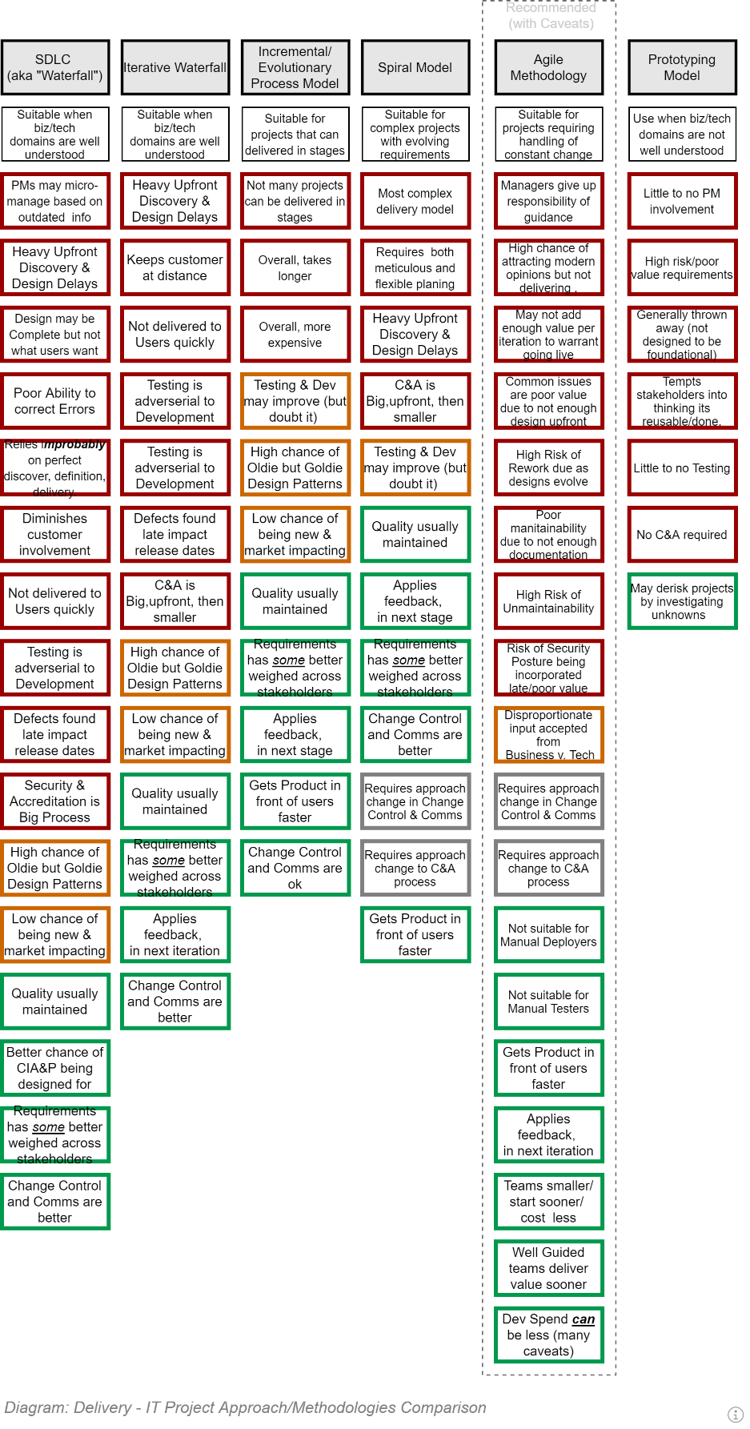

### Agile

#### Agile Epics, Features, User Stories, Tasks

Agile practices refer to Work Items by different names to indicate the scale of the effort.

##### EPICs

Epics, as the name suggests, are large conceptual divisions of the service that is to be delivered.

  
**Warning:**  
It’s a common error for developers to think of Epics as very large sets of User Stories/Tasks. Whereas they’re more of a workstream classification – specifying ongoing key concepts needed to be worked on over many releases, often across multiple features.

Epics can be nested.

##### Features

Whereas Epics are workstreams, Feature [Sets] are large but finite clumps of User Stories, focused on specific functionality.

Features can be nested.

##### User Stories

User Stories are 3-4 part expressions (Role, functionality, Purpose, Value) of purposeful functionality desired by a User role. They're scoped to be completable within an iteration, preferably within a day's work.

User stories are generally part of a larger Feature.

##### Tasks

User Stories are composed of:

a) an optional small set of child Tasks

b) each task associated to a set of one or more User Acceptance Tests defined using Gherkin syntax.

**Note:**It is a workflow error that increases the risk of projects failing for developers to begin work on User Stories that are   
a) not completed with Acceptance Tests   
b) completed with an estimated as to its dependencies and effort required (refer to "Agile Poker").

##### Requirements

Although Epics/Features/UserStories are the most well known work item elements in Agile, Requirements are also used in Agile environments.

For traceability reasons – as well as ensuring that Qualities are addressed by the Acceptance Tests -- User Stories and child Tasks must link to applicable source Functional and Quality Requirements.

## Requirements

The following are a list of Requirements recorded as being required by the previously described solution.

Use the list to verify that the Solution's Functional Requirements and Quality Requirements include them.

### Functional Requirements

* The service MUST expose all Operations appropriately via Service Façade APIs publicly accessible via the web.
* The service MUST expose APIs to manage rolling immutable Diagnostics Trace Messages.
* The service MUST expose APIs to manage permanent immutable Error Reports.
* The Service MUST expose APIs to manage immutable System Configuration.
* The Service MUST expose APIs to manage mutable Service Settings.
* The services MUST expose APIs to manage permanent immutable Session records.
* The service MUST expose APIs to manage permanent immutable Session Operations audit records.
* The Service MUST expose APIs to manage deployable Modules of logic.
* The Service MUST expose APIs to manage Search functionality that is intuitive, forgiving and culturally capable.
* The Service MUST expose APIs to manage the Permissions developed in each loaded Module.
* The Service MUST expose APIs to manage System Roles developed from adding & excluding Permissions.
* The Service MUST expose APIs to manage the connection to external Identity Services.
* The Service MUST expose APIs to manage nestable Groups.
* The Service MUST expose APIs to manage Group Roles developed from adding & excluding Permissions.
* The Service MUST expose APIs to manage Users.
* The Service MUST expose APIs to manage Users Profile/Preferences.
* The Service MUST expose APIs to manage the Logins of Users in one or more external IdPs.
* The Service MUST expose APIs to manage the allocation of Users to Service Roles.
* The Service MUST expose APIs to manage the allocation of Users to zero or more Groups according to Group Roles.
* The Service MUST expose APIs to manage the creation, sending, delivery of internal and external Notifications.
* The Service MUST expose APIs to manage Collections of Resources.
* The Service MUST expose APIs to manage the uploading of Resources.
* The Service MUST expose APIs to manage the association of Resources to Resource Collections.
* The Service MUST expose APIs to associate Users to Resources in one of a set of Resource Roles.
* The Service MUST expose APIs to manage Resource Workflows.

### Quality Requirements

* A Service Client MUST be developed on a different Tier than the Service.
* The Service Client MUST be developed as a PWA SPA.
* The Service Client MUST make available to all users on all their devices, all the Service's API exposed Operations.

#### Legal

* The Service Client MUST be developed to meet all the organisation's legal constraints, including NZ Government Service obligations towards Security, Privacy, Accessibility, Localisation, Usability, Archiving, EOI, Records, Digital Services and Education.

#### Security

* The solution's Client interface tier MUST be separate from the solutions server tier and communicate over HTTPS.
* Session ID cookies will be marked with the secure flag to ensure they are not transmitted in the open over port 80.
* The cost of public Certificates MUST be free.
* Certificates MUST have an expiration of less than 90 days.
* The Deployment Agent's Service Account MUST be provided access to a secure Key Vault, to retrieve 3rd Party Service Credentials.
* If Service Accounts developed during deployment come with a Password requiring persisting, it MUST be persisted in a secure storage service (e.g.: KeyVault).
* All communication between system components MUST be encrypted where feasible.  
  HTTPS must be used for HTTP. Encryption must be specified for TCP (e.g.: databases and caching services) based communication where feasible.
* Authentication MUST be via accredited 3rd party Identity [Token] Provider Services (IdP) specially hardened to protect user credentials and sensitive information.
* External services – including Identity Providers – MUST NOT be used for Authorisation purposes.
* Permission and Role Management and enforcement MUST be a function of the service. The service's logic can consider external information (e.g.: claims on Identity Tokens) when determining how to provision users.
* The service MUST encrypt all databases, using a key persisted in a secure key vault.
* The service MUST encrypt columns containing PII information.
* The service MUST encrypt all database backups.

#### Usability

* All HTTP servers MUST be accessible via the WWW WAN. Deploying "Internal only" web servers is not acceptable.
* The service MUST develop a copy of the database for eventually right reporting requirements, while disclosing sensitive information by not decrypting database columns containing PII information.
* The service MUST provide externally and appropriately access to secure REST-ful APIs for all service Operations.

#### Maintainability

* Certificates MUST be developed using automation in the deployment pipeline.
* Certificates MUST deployed using automation in the deployment pipeline.
* The Service Account for web servers MUST be developed using automation in the deployment pipeline.
* Infrastructure MUST be developed by automation in the deployment pipeline, using an Infrastructure as Code (IaC) approach, executed by the continuous delivery pipeline.
* The service MUST provide a standards-based API to provision Users and Groups.
* All Testing -- bar exploratory testing -- MUST be automated and run via a Continuous Delivery Pipeline.

#### Operability

* The service MUST provide the functionality required of Operations Specialists to not require them accessing the service databases directly.

#### Resilience

* The service MUST backup the Production data in full once a day, and incrementally every 1-15b minutes.
* The service MUST keep the database's Write Ahead Log (WAL) that was developed between the last incremental backup and the present.

#### Diagnostics

* The service MUST roll over the operation diagnostic logs every 31 days.
* The Service MUST keep permanent records of Exceptions raised.

Unsorted

* Requests to the service over port 80 will be redirected to port 443.
* Requests over port 80 that include a cookie containing Session ID will raise an Exception.

## Required Effort expressed as Work Items

The following is a list of tasks to ensure are added as WorkItems within the ALM’s Work Item Management Service, to be later prioritised as to which work item the group is to work on next.

### Delivery Service

### Information Service

### Service Client

* User Views:
  + Shell Container View:
    - Full Screen:
      * Splash Output View
      * App Information Output View
      * Confirmation:
      * Selectors:
        + Single from List Input View
        + Multiple from List Input View
        + ReOrder List Input View
    - Context:
      * Sponsor Information Output View
      * Application Information Output View
      * Tenancy Information Output View
      * Top Group (Organisation) Information Output View
      * Current Group Information Output View
      * Current Resource Information Output View
      * Search Input View
      * User Information Output View
    - Navigation:
      * Navigation
      * Breadcrumbs
    - Status:
      * Application Status
      * Tenancy Status
      * Top Group (Organisation) Status
      * Group Status
      * User Status
    - Body:
      * UnAuthenticated
        + Home Page
      * Authenticated
        + Dashboard Container

Dashboard Output View

Dashboard Tile Output View

Create a Dashboard Tile Input View

* Imagery:
  + Banner
  + Context Icons:
    - Sponsor
    - System
    - Anon User
    - Search
  + Nav Icons:
    - Menu
    - Breadcrumbs
  + Status Icons:
    - OK
    - WARN
    - ERROR
  + Action Icons:
    - View (Item Right)
    - Edit
    - Delete
    - More (Level Down)
    - OK
    - Cancel
    - Back
* Text Copy:
  + Context:
    - Sponsor Title (e.g.: "Fubara")
    - Sponsor Description (e.g.: "Specialists in FUBAR")
    - System Title (e.g.: "FooBar")
    - System Description (e.g.: "The official system to manage Foos")
    - Breadcrumbs Title (e.g.: "Current Location")
    - Breadcrumbs Description (e.g.: "Where you are within this system's resources.")
  + Status:
  + Nav:
    - Navigation Title (e.g.: "Menu")
    - Navigation Description (e.g.: "Where do you want to go next?")
    - Common Nav destinations:
      * About Us
      * About this Service
      * Contributors
        + Sponsors
        + Partners
        + Developers
      * License Information
      * Privacy Statement
      * User Tracking Statement
      * Data Use Statement
      * Terms and Conditions
      * Contact Us
        + Requesting System Support
        + Requesting Information Corrections
      * FAQ
      * Dashboard
      * Settings
        + System Configuration
        + System Settings
        + Group Settings
        + User Preferences
  + Actions (repeat Icons above)
  + Translations:
    - English:
    - Maori:
* Fonts:
* CSS:
* Service Façade API Controllers:
  + Base System Service Management APIs:
  + Media Management APIs:

### Epics

Almost every application

Transparent Team Communication, Guiding Principles and Work Item Tracking (continuous improvement to the ALM, documents, etc.)

Guiding Principles

Decisions, Design, Development, Deployment, Operations, Support Documentation

Work Item Management

Automated Testing & Deployment

Compilation

Quality Testing

Functional Testing

Performance Testing

Packing & Deployment

The Information System itself:

Environment (built up by Code)

3rd Party Services

Technology / Integration

Security

Configuration

Settings

Permissions

Roles

Sessions

Search

Media

Notification

Users

Role & Permission Allocation

Groups

Resources

Validation

Rules

Scheduled Tasks

Workflow Task Allocation

Service Façade

The Service Client

Comms,

Validation,

UIs

### Features

Continuing the reference to the above common Epics, an example set of nested Feature Sets may look a lot like the following:

TODO: Move to appendices, as this could get long

F: Service Façade APIs:

F: Configuration Management APIs (often only immutable, therefore GET only)

F: Diagnostics Management APIs

F: System, Sponsor, Reseller, Developer, Setting Management APIs

F: Module Management APIs

F: Session Management APIs

F: Session Operation Management APIs

F: Search Management APIs

F: Media Management APIs

F: User Management APIs

F: Group Management APIs

F: Permission Management APIs

F: Role Management APIs

F: Role Allocation APIs

F: Preferences Management APIs

F: Rule Management APIs

F: Workflow Management APIs

F: Resource Management APIs

F: UIs:

F: Diagnostics Management Views

F: Setting Management Views

F: Users Management Views (Browse, Read, Edit, Add, Delete)

F: User Preference Views (Browse, Read, Edit, Add, Delete)

F: Group Management Views (…BREAD…)

F: Group Preference Views (…BREAD…)

F: Media Management Views (…BREAD…)

F: Permission Management Views (…BREAD…)

F: Role Management Views (…BREAD…)

F: Role & Permission Allocation Management Views (…BREAD…)

### Tasks

For example:

UIs:

Diagnostics Management elements

Diagnostics Search handler

Diagnostics Synopsis Builder

Diagnostics View View

Navbar link

Group Management elements

Group Search handler

Group Synopsis builder

Group View View

Group Edit View

## Development

### Integration

#### HTTP Response Codes

HTTP Response Codes[31] to expect receiving from REST services:

* 1xx: Informational
* 2xx: Success
* 200 OK. Accepted.
  + 201: Created. Commonly used by POST. Includes a Location Header to perform a subsequent GET. See: <http://stackoverflow.com/a/1965316/1052767>
  + 202 Accepted. Commonly used by PUT. Includes a Location Header to Perform a subsequent GET. See: <http://stackoverflow.com/a/1965316/1052767>
  + 204 NoContent
    - *Note:  
      I've seen WebAPI return this when returning a void from a successfully completed action. It should ensure be accounted for.*
* 3xx: Redirect
  + 302: Redirect: Avoid for REST-ful services.
* 4xx: Client Error (syntax error)
  + 400 Bad Request
  + 401 Unauthorized, not Authenticated enough. See <http://stackoverflow.com/a/6937030/1052767>
  + 403 Forbidden. Authenticated, but not Authorized. See <http://stackoverflow.com/a/6937030/1052767>
  + 403.1 - IIS Specific (non-standard), but useful: Execute access forbidden.
  + 403.2 - IIS Specific (non-standard), but useful: Read access forbidden.
  + 403.3 - IIS Specific (non-standard), but useful: Write access forbidden.
  + 404 Not Found. Used by GET
  + 406 MIME not accepted
  + 407 Proxy Authentication Required
  + 408 Timeout
  + 409 Conflict. Used by PUTs for concurrency errors.
  + 410 Gone. Resource has been permanently deleted. Note that it's pretty rare than an app is well designed enough to know this…
* 5xx: Server Error (request appears valid, but server failed)
  + Max server cap reached

#### REST Constraints

Roy Fielding's seminal PhD paper in 2000 defined 6 constraints to be met by REST interfaces:

* Client/Server: client doesn't concern itself with storage, etc.
* Stateless: No server state used. Just Client state.
* Cacheable: Clients can cache resources, *per server's instructions on it staleness*.
* Layered system
* Code on Demand (optional)
* Uniform interface, based on resource locator (URL), method (GET, etc.), media type (JSON, etc.)

The crux of the above is mostly:

* HTTP already defines Verbs: GET|PUT|POST|DELETE, etc.
* Whereas RPC, WCF, etc. encourage the invention of arbitrary Operation names (getUsers(), saveNewUser(), deleteUser(x), (both of which are using POST, rather than POST and DELETE….)  
  This additive operations name is reinventing is the issue.   
  So instead of inventing arbitrary names, change the method.  
  Therefore, move your Operation Names out of the URL, and move them to the Http Verb, leaving the URL to refer to only the unique, permanent Resource.

#### REST Common HTTP Code Responses

The most common responses a service client request has to process are as shown below.  
That said, other response codes can be received – you just may have to lump some of them together.

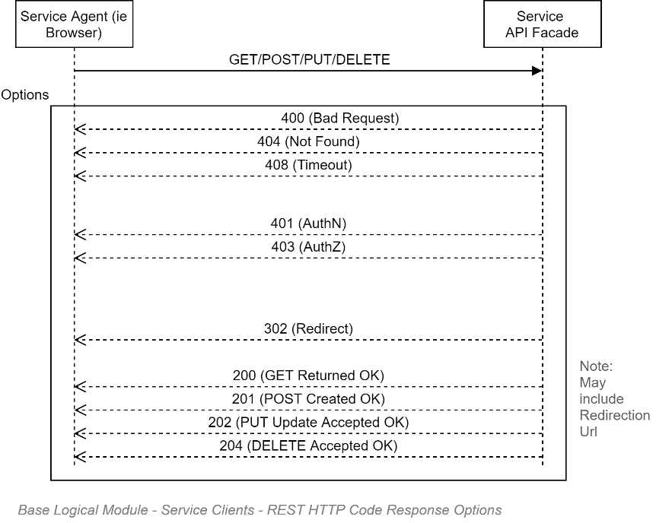

#### REST URL Format

REST Users have the following characteristics:

* The URL define a unique Resource (Item or List)
* Modifiers, such as OrderBy, Filter By, Projections, Page Size, Page Number are all modifiers, and are therefore not part of the URL.

Common conventions include:

* The URL refers to the Plural of objects (i.e. Persons, rather than Person)

The above characteristics mean that the following are valid examples:

**GET:**

* http://localhost/client/234/invoices/
* http://localhost/client/234/invoices/page/3/  
  Note: fails as URL should not have Pg info (it's a modifier).
* <http://localhost/client/234/invoices/page/3/records/20>   
  Note: fails temporal Pg or Size modifiers should be args, not URL.
* http://localhost/client/234/invoices/?pages=3
* http://localhost/client/234/invoices/?pages=3&records=20 ß URL <http://localhost/client/234/invoices/16-24> <- a specific set is ok
* <http://localhost/client/234/invoices/id/16-24>
* <http://localhost/client/234/invoices/?date=filtering> ok...

#### REST FAQ

##### Q: REST is designed for individual Updates. What about Lists?

You must develop an UpdateXXXRecords Operation that can be PUT to with a set of objects.

## Integration

### Security

A key integration point is between the system itself and an external Identity Provider (IdP). The process is complicated by the fact that the security landscape has changed over time, but older documentation still abounds.

#### Protocols

The following is a subjective attempt to remember what happened over the past 20 years. Its intent is not to be perfectly accurate record of progress, but simply be a very high level context view to facilitate discussions and decisions elsewhere[32].

##### Era #1: PreWeb: Internal Applications, inside the LAN

In the beginning, Windows based enterprises used Active Directory derived Windows Identities to dynamically authenticate users. The advantage was that it provided relatively seamless access to internal apps (e.g.: Access, etc.) to corporate users. A key disadvantage was that the protocols used were tied to non-HTTP ports limiting collaboration with partners from outside the corporate LAN.

##### Era #2: Early Web: BASIC Protocol

The web developed outside of the Windows environment and did not/could not use LAN based authentication over HTTP ports. Early web applications stored usernames and passwords within the system's database. The protocol used was clear-text BASIC over HTTP (HTTPS if one was very lucky).

##### Era #3: Early Web: BASIC over limited HTTPS

The use of HTTPS was computationally heavy before dedicated hardware changes became universal. Hence the avoidance of HTTP for anything but the login page which still used BASIC.

##### Era #4: SAML

The SAML protocol was developed by the big companies (MS, Oracle, etc.) to work on existing protocols still in use for most software at the time (i.e., corporate LAN/non-HTTP port-based software that banks were using) as well as the newly emerged Web protocol. Highly secure, highly capable, it became the standard for environments needing a non-BASIC authentication mechanism.

SAML was complex, using a lot of different mature technologies in order to remain transport channel agnostic (Signing and encryption Certificates, XML, back-channels, etc.) – when in fact, the whole world was moving to HTTP/S, where the most needed/used features were already available (HTTPS).   
  
Over time, SAML became perceived as overly complex therefore unduly expensive and time consuming to implement for the most common scenarios that people needed.

##### Era #4b: ADFS

Microsoft's reputation relies heavily on its security profile, so was loath to move away from its proprietary AD based standards to open source standards it could not control easily. MS developed a proprietary fork of SAML that larger companies (Oracle, etc.) implemented.

One could describe it as Microsoft attempting to dragging its venerable AD -- designed originally for the LAN so 25 years earlier – up to the WWW WAN, by exposing an API to broker its exposure to the web, over a proprietary variation to SAML.

##### Era #5: OAuth

In the meantime, others were trying to sever ties with LANs and move everything to the WWW WAN.   
OAuth was developed to allow web services from different LANs to communicate, over HTTPS.

##### Era #6: AAD

Whereas Microsoft developed ADFS to expose legacy LAN for reuse by Web applications, they finally saw the writing on the wall that LANs have no future, and therefore AD had no future.   
They put development of AD to rest, broke with the past, and rewrote a new directory service, from scratch, for the web era, over HTTPS.

Note:   
For pure marketing purposes they called it Azure AD. When in fact it has very little to do with the original AD beyond being also a directory service.

##### Era #7: OAuth Proprietary Extensions for AAD

OAuth is an extensible Service to Service authorisation protocol. Whereas AD is most often used to authenticate persons. Microsoft had to extend the protocol for its own use to align with its new AAD capabilities.

##### Era #8: OAuth Extensions

AAD's OAuth extensions were not the only extension to OAuth. Facebook did the same thing for their needs. Some of the ideas within the Facebook implementation made it into the OIDC protocol that is now becoming the standard for authenticating persons (you still use OAuth to authenticate systems to systems).

##### Era #9: OIDC

OIDC is an extension of OAuth specifying what information to transport over OAuth, and how to package it and sign in. This allowed OAuth – which is intended for Service to Service Authorisation – to be extended to be used to authenticate Users.

##### Era #10: AAD OIDC

Microsoft has recognised that OIDC is the most widely desired protocol and has added it to AAD, beside its original extended OAuth protocol.

##### Recommended Protocol

As it stands, it may be that the customised OAuth AAD protocol has still more functionality than can be squeezed into an open protocol such as OIDC – but it is our professional opinion, considering the above history, to err on the side of open standards, and prefer OIDC for authenticating Persons on this project. And use OAuth to authenticate remote client Systems.

1. Making the document a GLAD (Gloriously Long Architecture Document)?
2. All of (NZ) Governent
3. https://azure.microsoft.com/en-gb/blog/microsoft-azure-reaches-new-industry-leading-cloud-compliance-milestones/
4. Maybe...
5. <https://www.gartner.com/en/newsroom/press-releases/2019-01-09-gartner-predicts-25-percent-of-digital-workers-will-u>
6. <https://www.wordstream.com/blog/ws/2018/04/10/voice-search-statistics-2018>
7. <https://www.digital.govt.nz/standards-and-guidance/design-and-ux/content-design-guidance/writing-style/plain-language/>
8. https://en.wiktionary.org/wiki/journ%C3%A9e
9. Refer to the Delivery View for further information.
10. IDentity [Token] Provider
11. , and globally cache rarely changed settings as well as session user settings/preferences
12. The only task harder than keeping customers is finding customers. The only thing harder than finding new customers is regaining customers who’ve stopped using you out of mistrust.
13. <https://code-maze.com/command/>
14. <https://jonhilton.net/2016/06/06/simplify-your-controllers-with-the-command-pattern-and-mediatr/>
15. <https://medium.com/better-programming/the-command-design-pattern-2313909122b5>
16. In Azure, consider using ServiceBus. Elsewhere, consider RabbitMQ or better.
17. Even Social Media (e.g.: Facebook) data is UNCLASSIFIED – but users expect their private photos are shared only with specific users -- *not* testers, not DBAs, not operations specialists, not developers.
18. ISO-27001 Level 1 – i.e. self-assessment -- is not enough
19. Avoid relying on communication channels that rely on certs, in order to not rely on long-life certs that end up being a security risk in themselves.
20. <https://docs.microsoft.com/en-us/azure/active-directory/managed-identities-azure-resources/>
21.
22.
23. <https://docs.microsoft.com/en-us/sql/connect/jdbc/connecting-with-ssl-encryption?view=sql-server-ver15>
24. <https://docs.microsoft.com/en-us/sql/relational-databases/native-client/features/using-encryption-without-validation?view=sql-server-ver15>
25.
26. <https://owasp.org/www-project-api-security/>
27. All of [NZ] Government
28. Predictions are that the next device category will be either voice based ear-buds, followed later by mixed reality.
29. <https://www.digital.govt.nz/standards-and-guidance/design-and-ux/content-design-guidance/content-design-tools-and-resources/readability-testing-tools/>
30. <https://poeditor.com/blog/crowdsourcing-translation-software-localization-project-manage-everything/>
31. http://www.w3.org/Protocols/rfc2616/rfc2616-sec10.html
32. Feel free to recommend corrections.